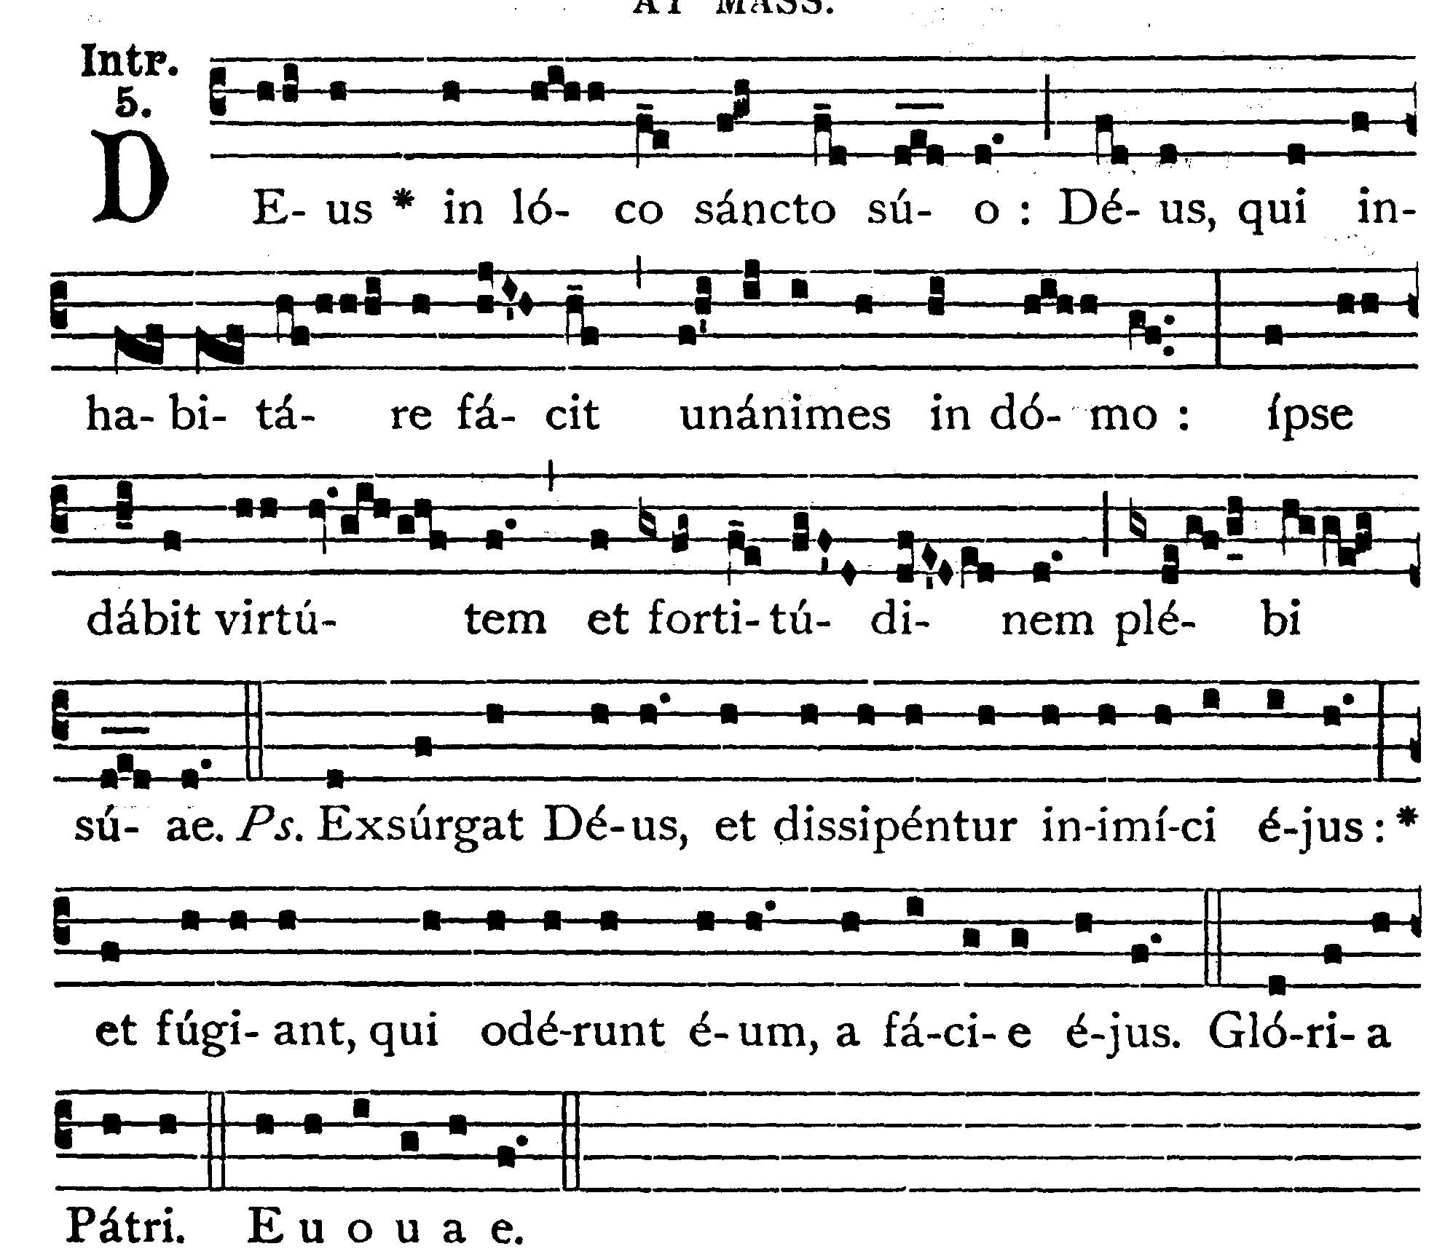
11th Sunday After Pentecost
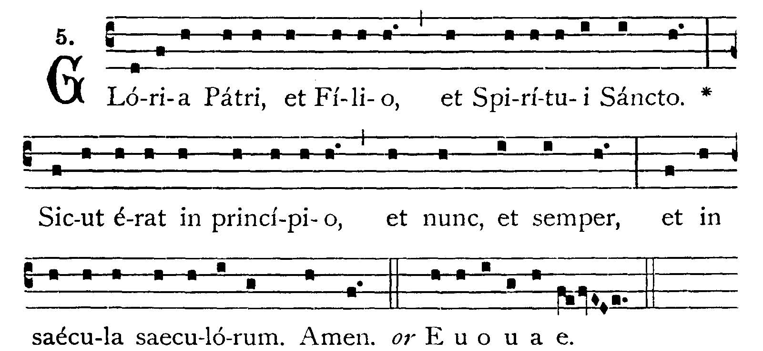
God in His holy place; God who maketh men of one mind to dwell in a house; He shall give power and strength to His people. -- (Ps. 67. 2). Let God arise and let His enemies be scattered: and let them that hate Him flee from before His face. V.: Glory be to the Father . . . -- God in His holy place


Begin singing Gradual while Father reads the Epistle if only one priest
With Deacon and Sub-Deacon, wait until Epistle is sung first
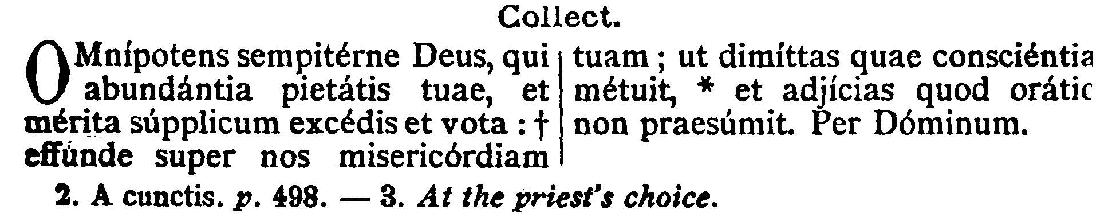
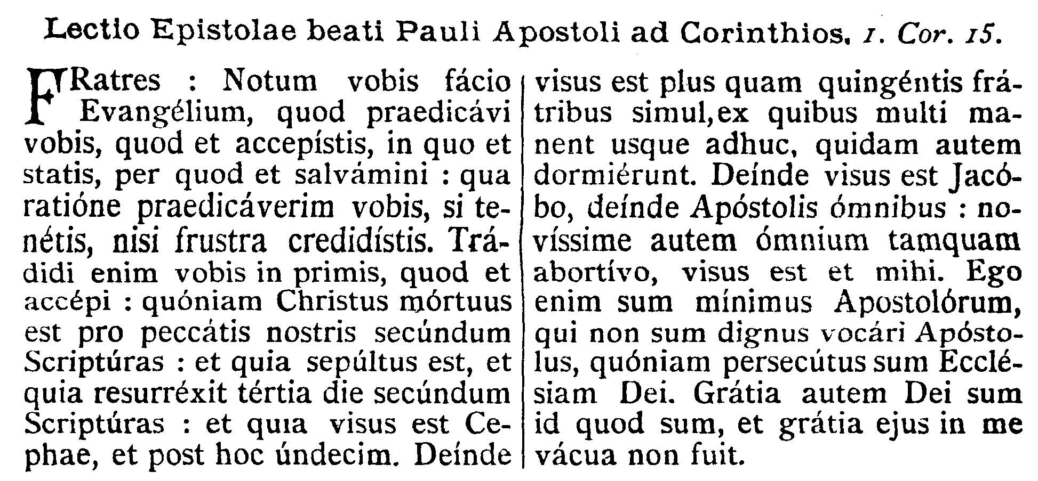
COLLECT.--O almighty and everlasting God, who in the abundance of Thy loving-kindness art wont to go beyond both the merits and prayers of Thy suppliant people, pour down upon us Thy mercy: that Thou mayest forgive us those things whereof our conscience is afraid, and grant us what our prayer does not dare to ask. Through our Lord Jesus Christ, Thy Son, who . . .

EPISTLE ¤ I Cor. 15. 1-10
Lesson from the first Epistle of Blessed Paul the Apostle to the Corinthians.
[The Apostle reminds the Christian of the miraculous transformation which has taken place in him through the grace of God.]
Brethren, I make known unto you the Gospel which I preached to you, which also you have received and wherein you stand, by which also you are saved, if you hold fast after what manner I preached unto you, unless you have believed in vain. For I delivered unto you first of all, which I also received, how that Christ died for our sins according to the Scriptures; and that He was buried, and that He rose again the third day according to the Scriptures; and that He was seen by Cephas, and after that by the eleven. Then was He seen by more than five hundred brethren at once; of whom many remain until this present, but some are fallen asleep. After that He was seen by James, then by all the Apostles. And last of all He was seen by me, as by one born out of due time. For I am the least of the Apostles, who am not worthy to be called an Apostle, because I persecuted the Church of God. But by the grace of God I am what I am; and His grace in me hath not been void.
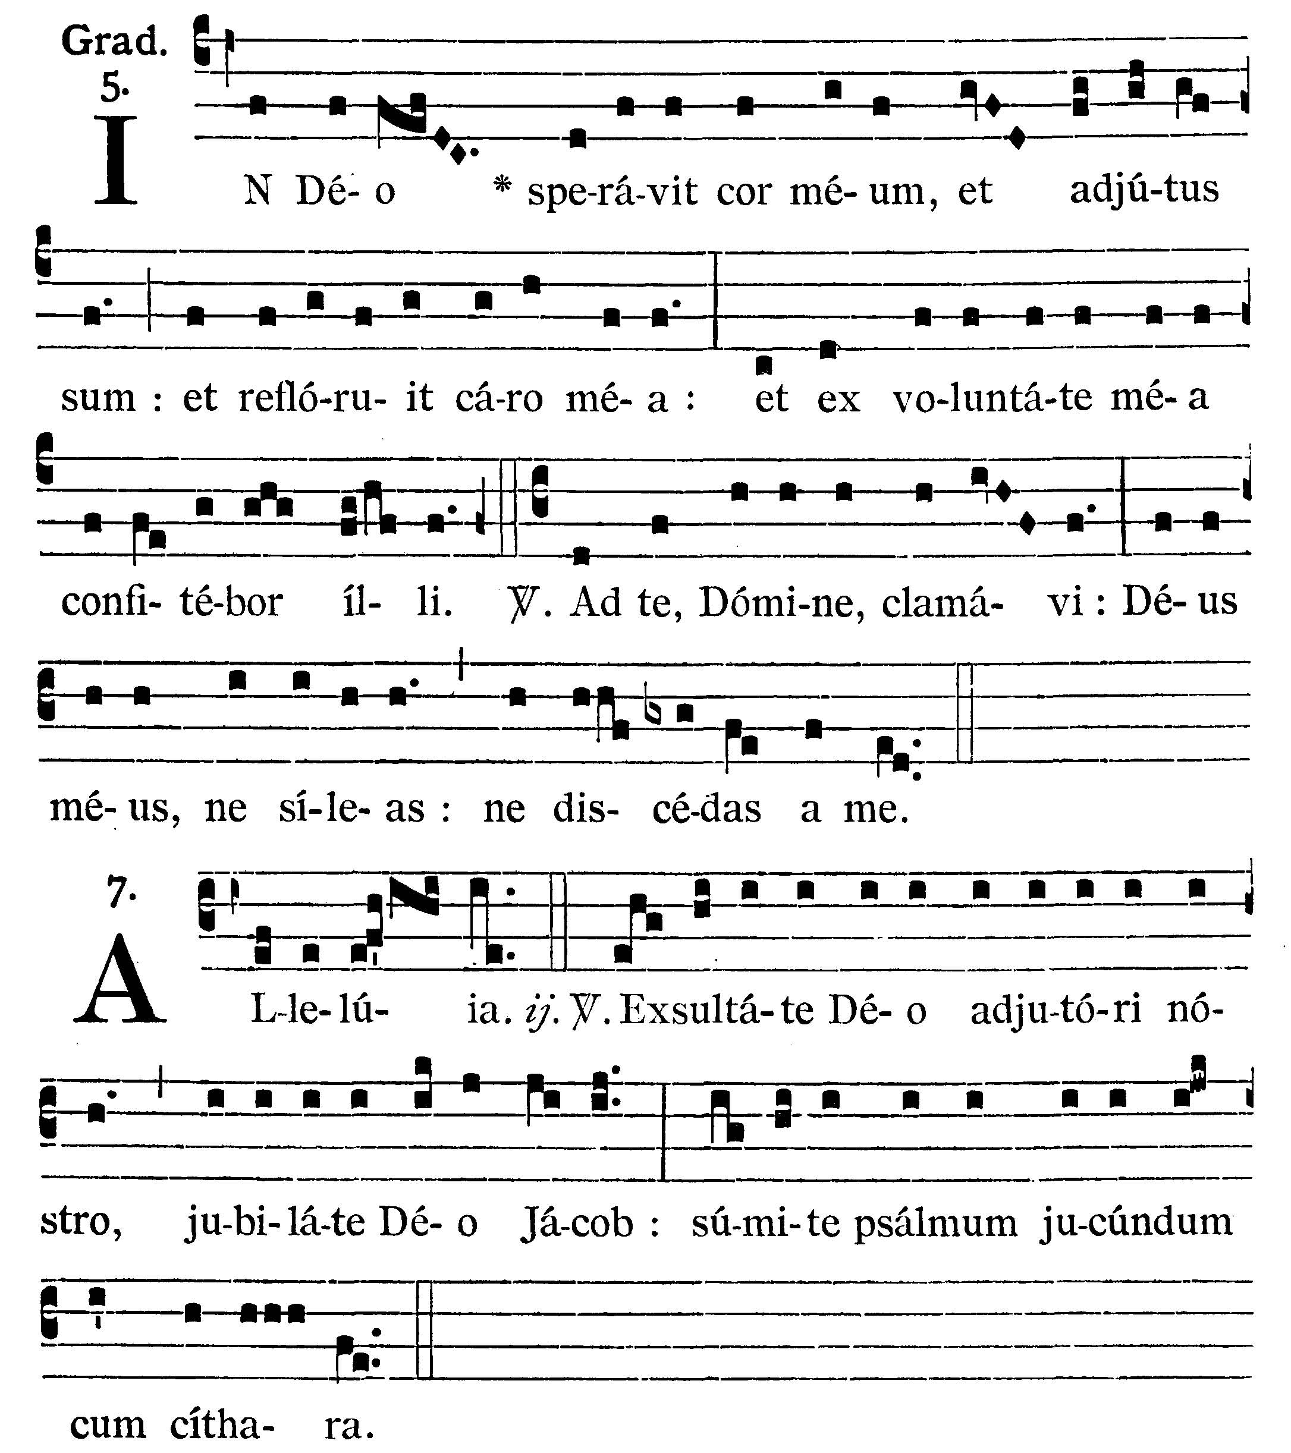
In God hath my heart confided, and I have been helped; and my flesh hath flourished again; and with my will I will give praise to Him. V.: Unto Thee have I cried, O Lord: O my God, be not Thou silent; depart not from me.
Alleluia, alleluia. V.(Ps. 80. 2, 3). Rejoice in God our helper; sing aloud to the God of Jacob; take a pleasant pslam with the harp. Alleluia.

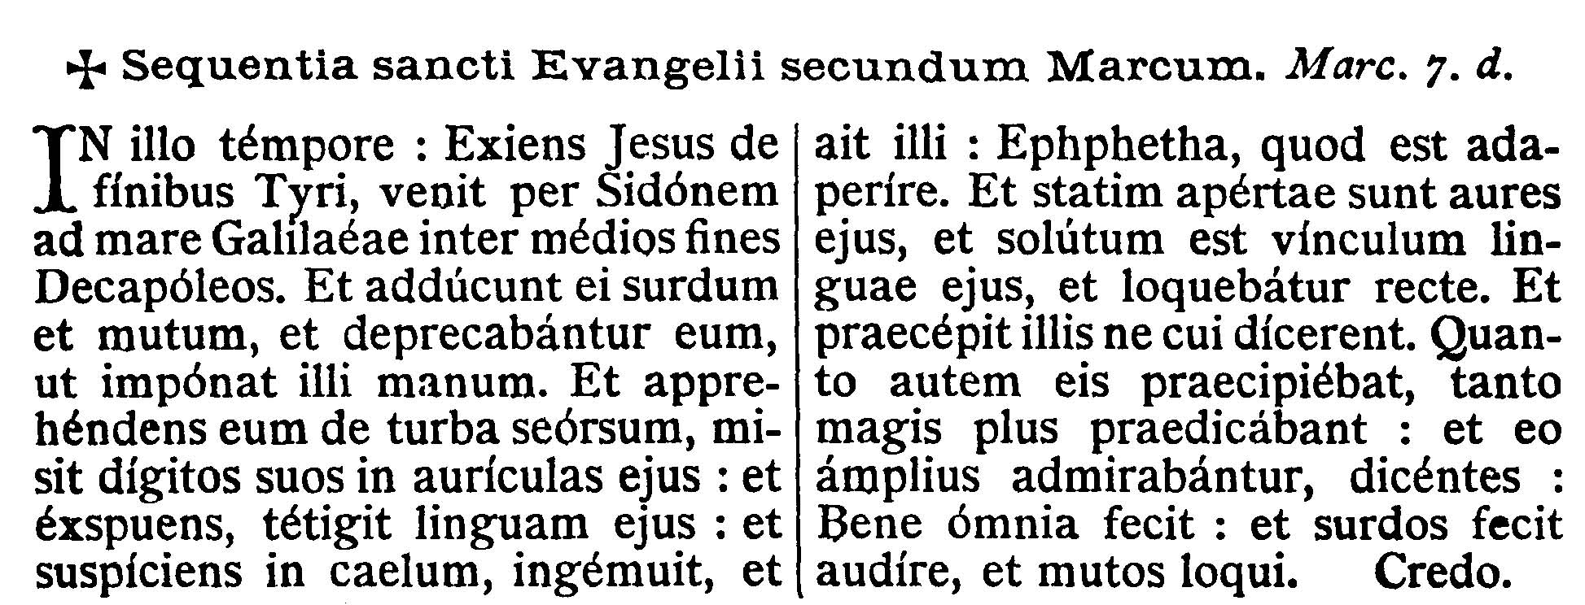
GOSPEL ¤ Mark 7. 31-37
† Continuation of the holy Gospel according to St. Mark.
[Jesus heals the deaf and dumb.]
At that time, Jesus going out to the coasts of Tyre, came by Sidon to the sea of Galilee, through the midst of the coasts of Decapolis. And they bring to Him one deaf and dumb, and they besought Him that He would lay His hand upon him. And taking him from the multitude apart, He put His fingers into his ears, and spitting, He touched his tongue; and looking up to heaven, He groaned and said to him: Ephpheta, that is, Be thou opened: and immediately his ears were opened, and the string of his tongue was loosed, and he spoke right. And He charged them that they should tell no man: but the more He charged them so much the more a great deal did they publish it; and so much the more did they wonder, saying: He hath done all things well; He hath made both the deaf to hear, and the dumb to speak.

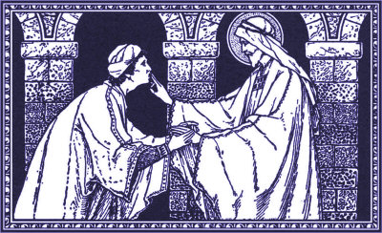

Priest: Dominus Vobiscum
All: Et Cum Spirtu tuo
Preist: Oremus:

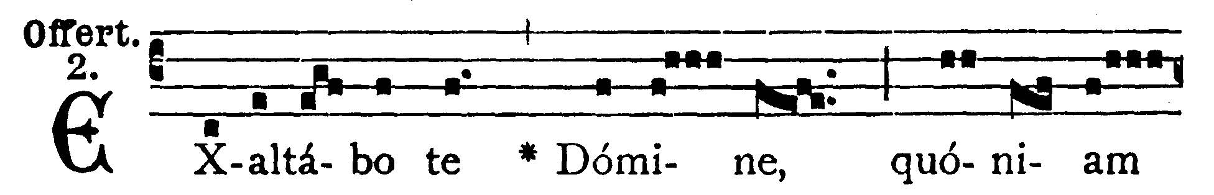
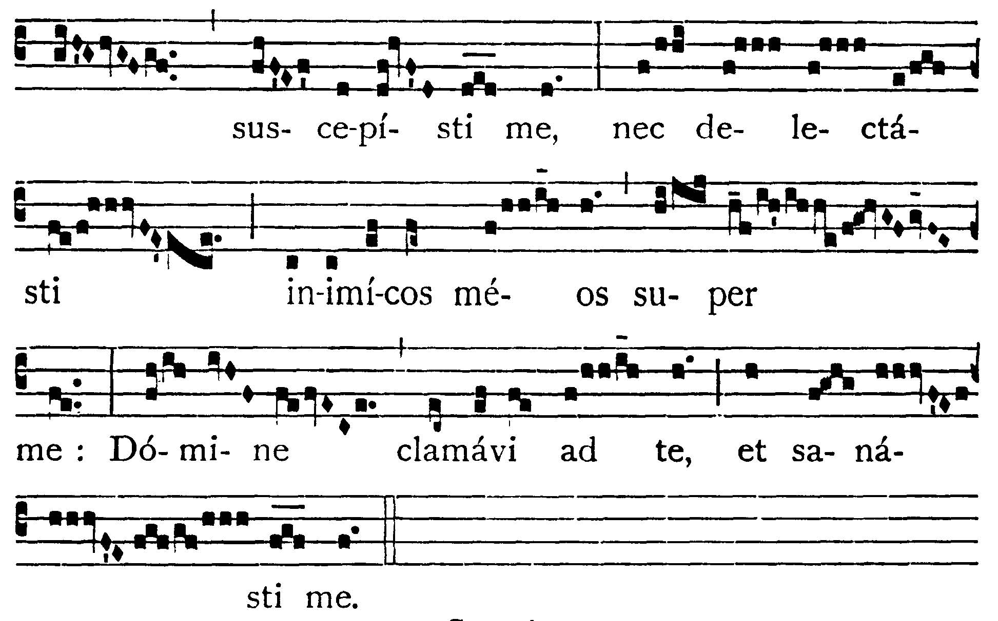

I will extol Thee, O Lord, for Thou hast upheld me; and hast not made my enemies to rejoice over me: O Lord, I have cried to Thee, and Thou hast healed me.

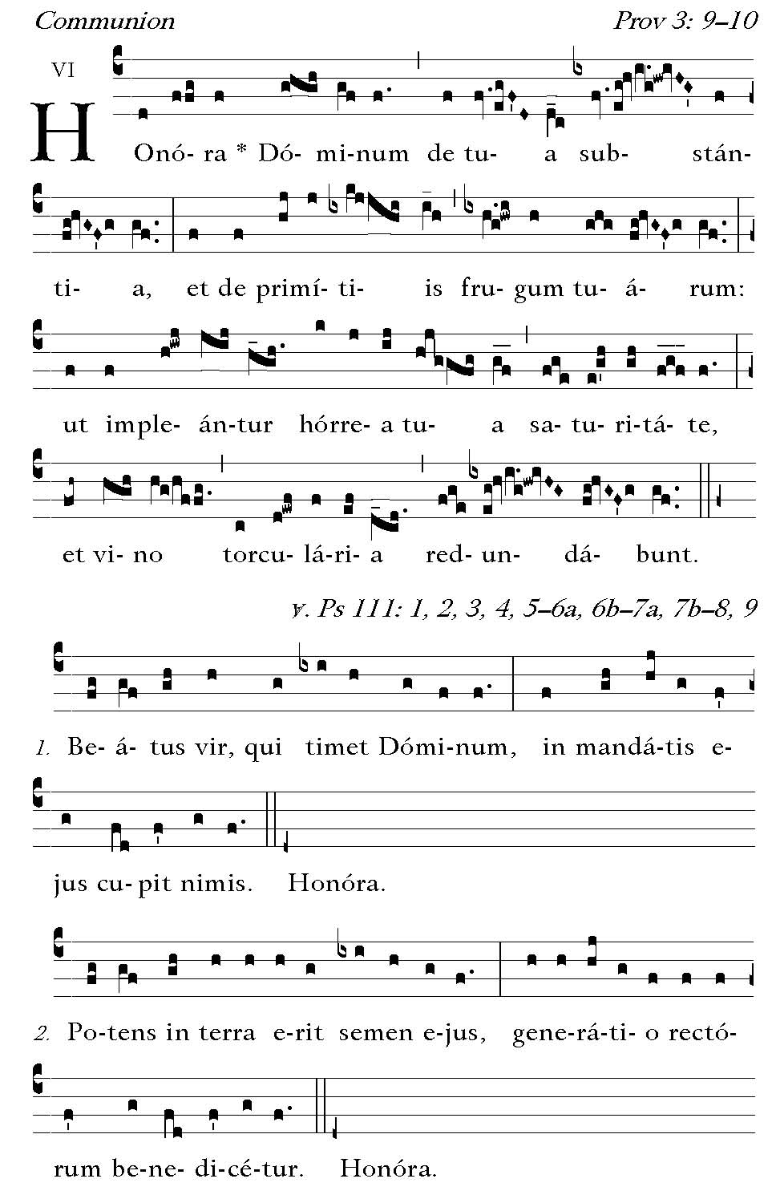
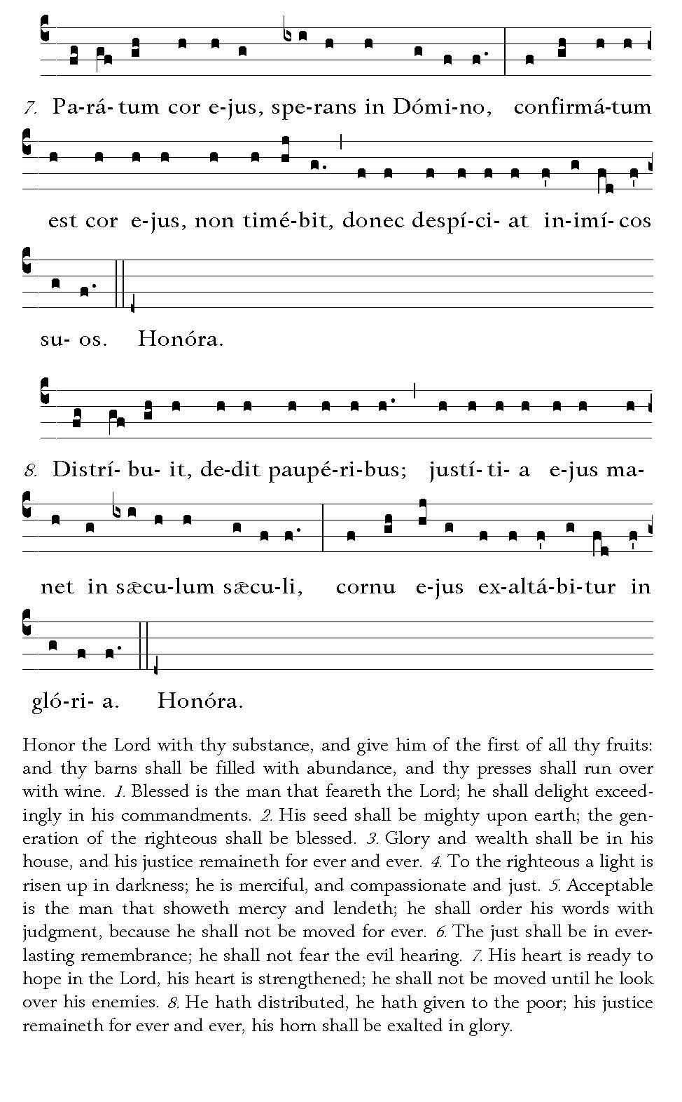



POSTCOMMUNION.--By the reception of Thy Sacrament, we beseech Thee, O Lord, may we find support for mind and body: so that, healed in both, we may glory in the fulness of the heavenly remedy. Through our Lord . . .

Ite Missa Est......Deo Gratias

