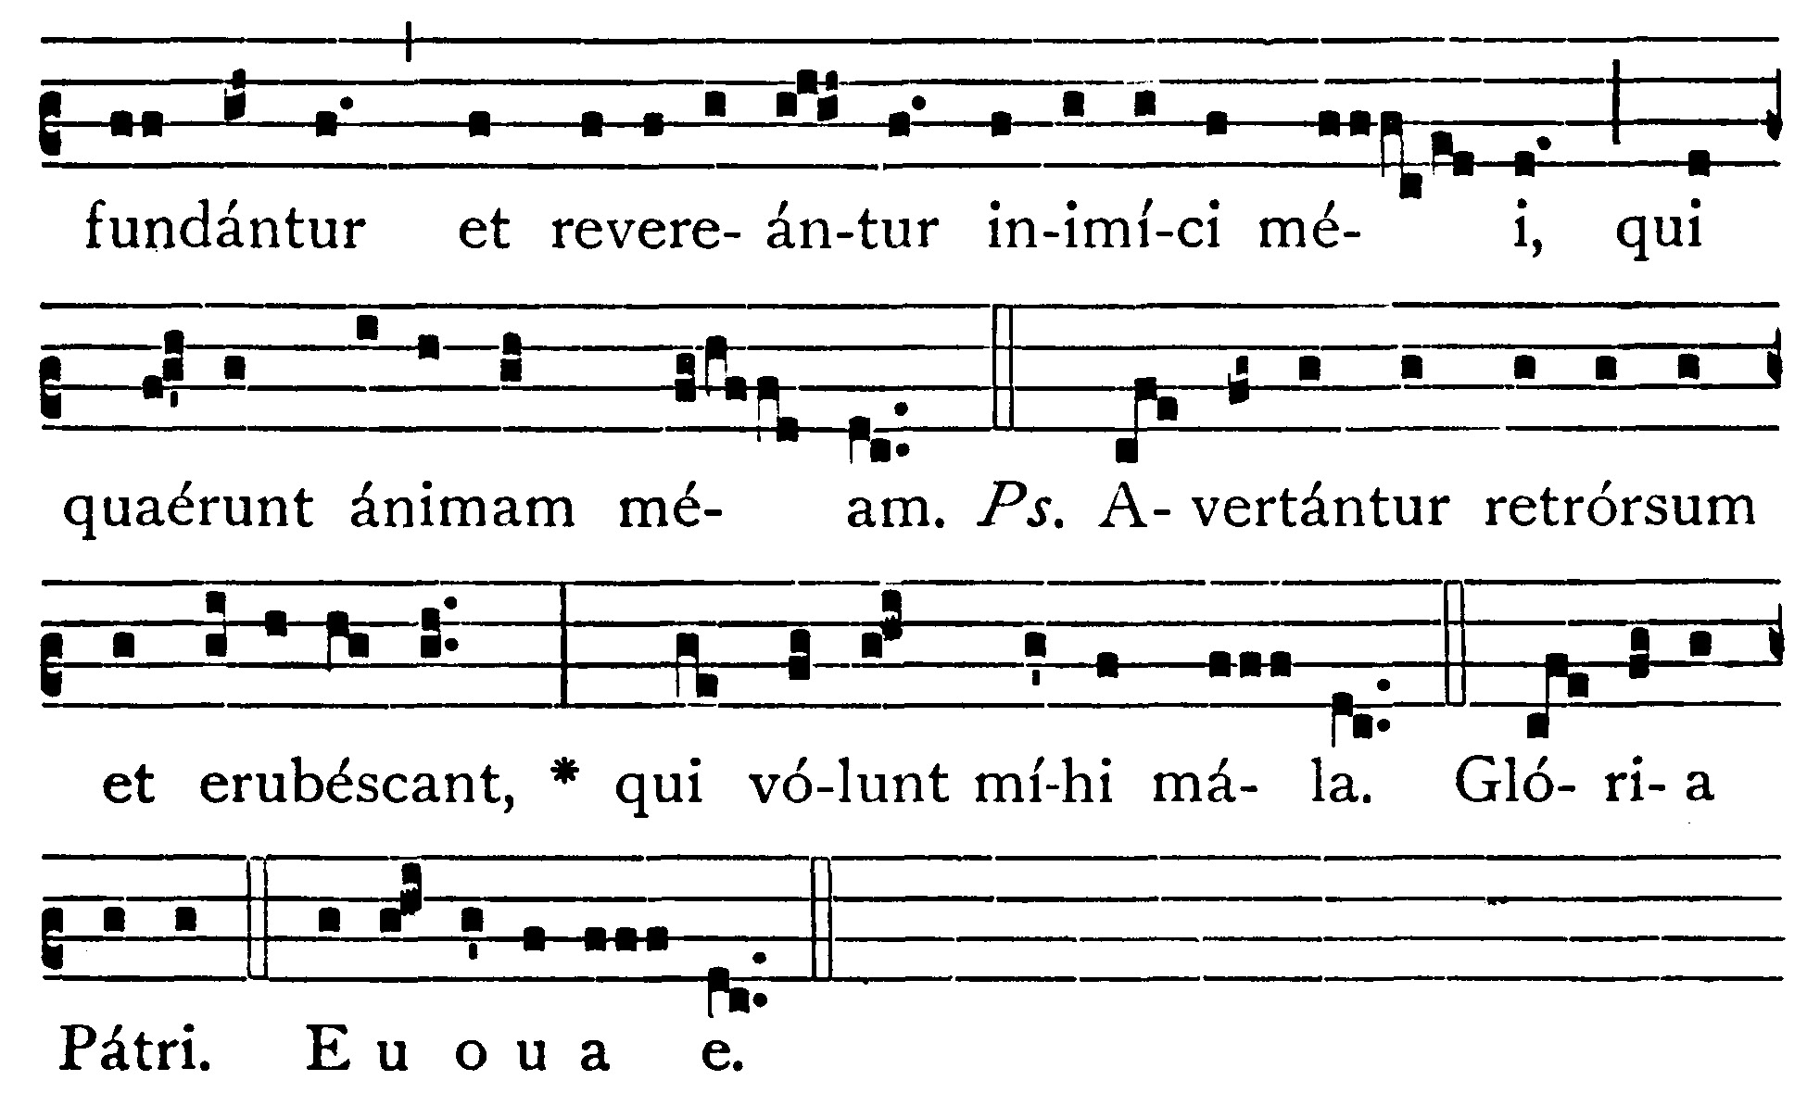
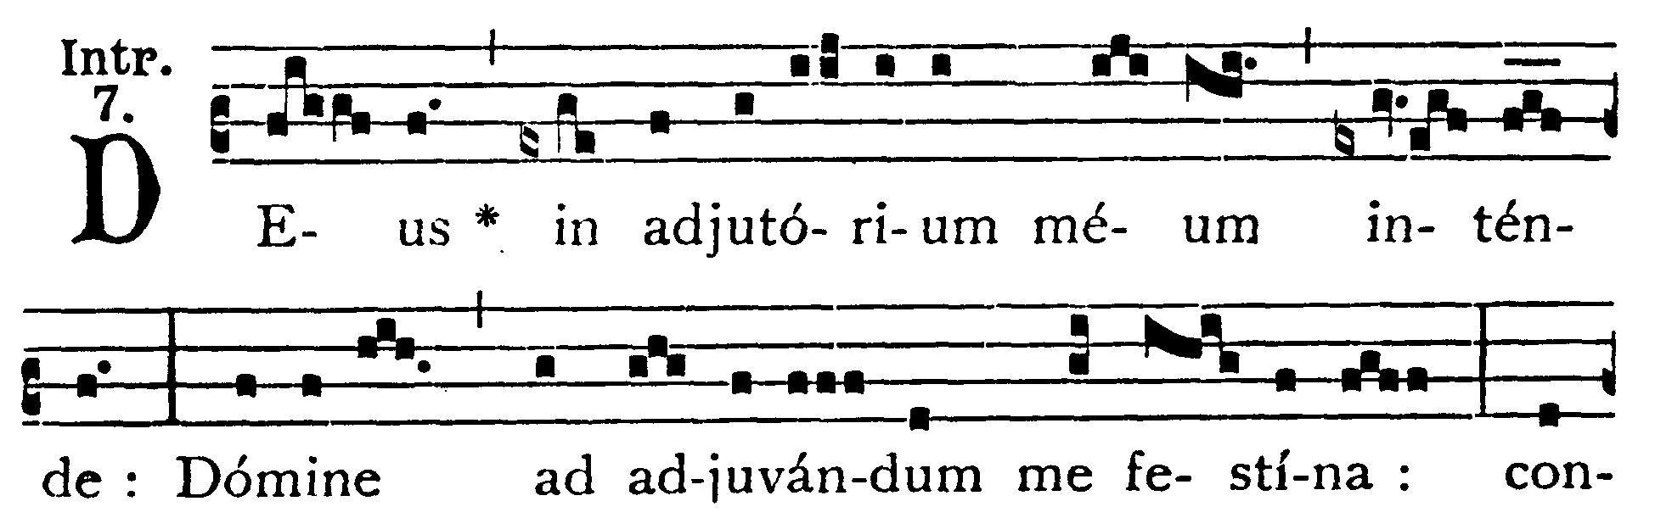
12th Sunday After Pentecost
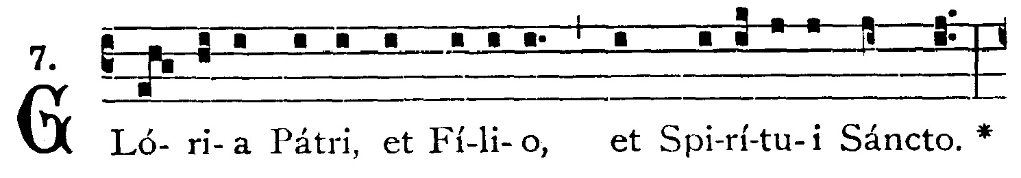
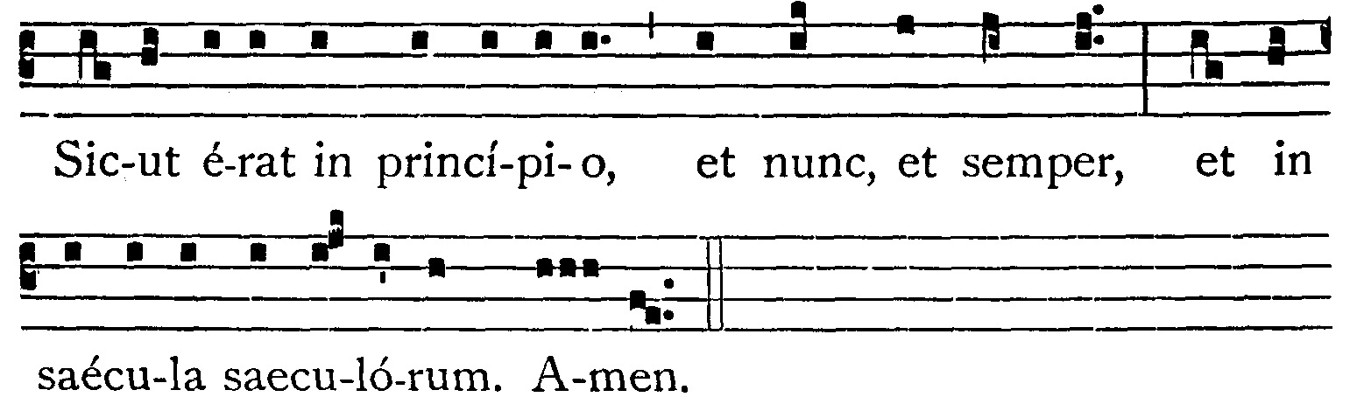

Incline unto my aid, O God: O Lord, make haste to help me: let my enemies be confounded and ashamed, who seek my soul. -- (Ps. 69. 4). Let them be turned backward and blush for shame, who desire evils to me. V.: Glory be to the Father . . . -- Incline unto my aid, O God . . .


Begin singing Gradual while Father reads the Epistle if only one priest
With Deacon and Sub-Deacon, wait until Epistle is sung first
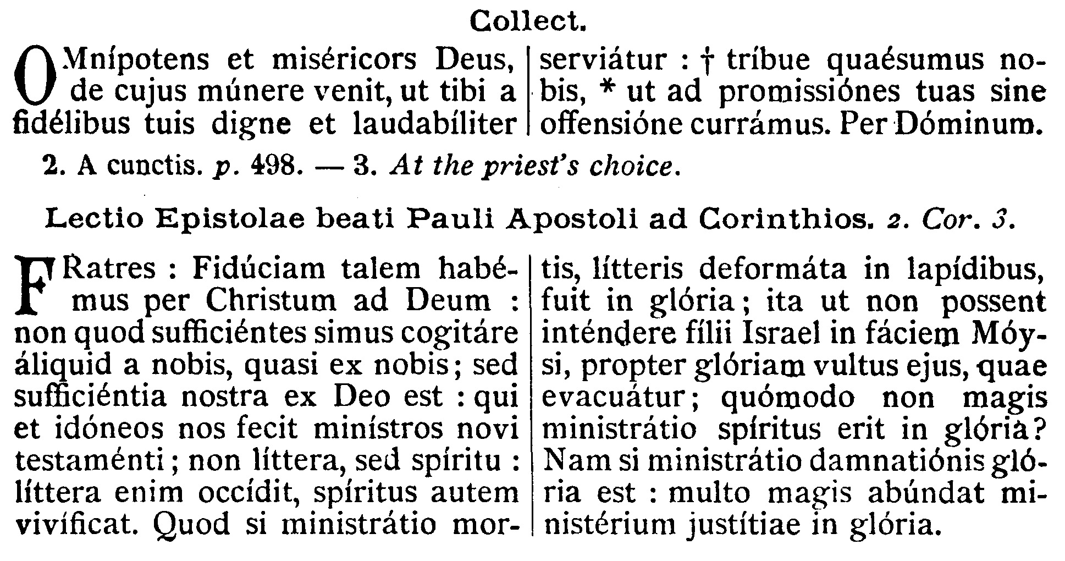
COLLECT.--O almighty and merciful God, of whose only gift it cometh that Thy faithful people do unto Thee worthy and laudable service: grant unto us, we beseech Thee, that we may run without stumbling towards the attainment of Thy promises. Through our Lord . . .

EPISTLE ¤ II Cor. 3. 1-9
Lesson from the second Epistle of Blessed Paul the Apostle to the Corinthians.
[The law of Our Lord Jesus Christ is the perfect development of the Law of Moses. Let us not follow a pharisaical interpretation of the law which reduces our religious duties to a few outward practices. "The letter killeth, the spirit quickeneth."]
Brethren, Such confidence we have through Christ towards God. Not that we are sufficient to think any thing of ourselves, as of ourselves: but our sufficiency is from God. Who also hath made us fit ministers of the new testament, not in the letter, but in the spirit: for the letter killeth, but the spirit quickeneth. Now if the ministration of death, engraven with letters upon stones, was glorious, so that the children of Israel could not steadfastly behold the face of Moses, for the glory of his countenance; which is made void: how shall not the ministration of the Spirit be rather in glory? For if the ministration of condemnation be glory, much more the ministration of justice aboundeth in glory.

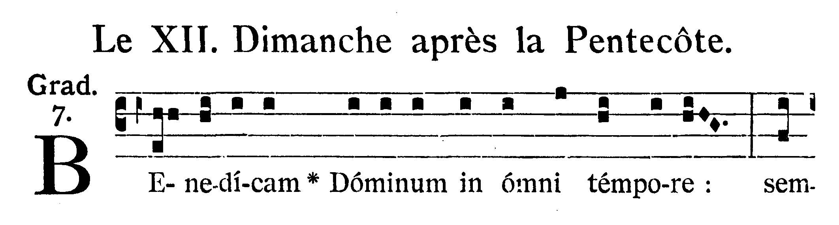
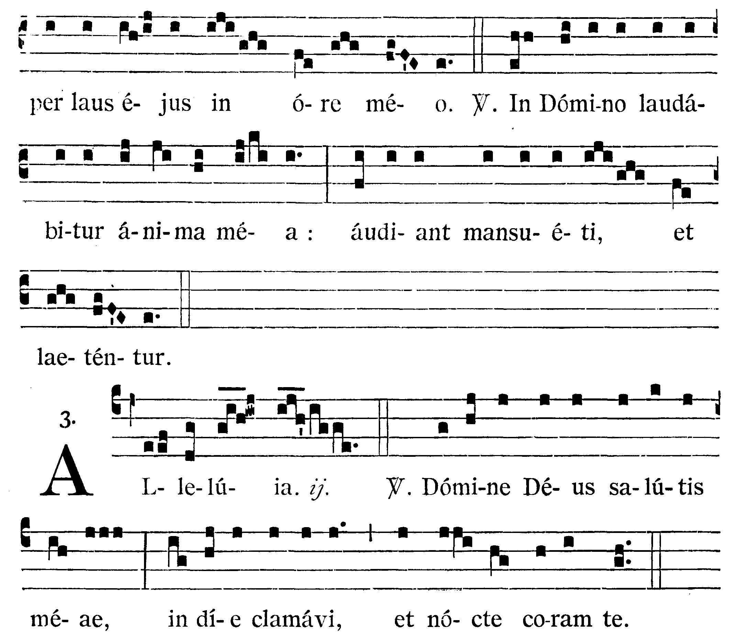
I will bless the Lord at all times: His praise shall ever be in my mouth. V.: In the Lord shall my soul be praised: let the meek hear, and rejoice.
Alleluia, alleluia. V.(Ps. 87. 2). O Lord, the God of my salvation, I have cried in the day, and in the night before Thee. Alleluia.

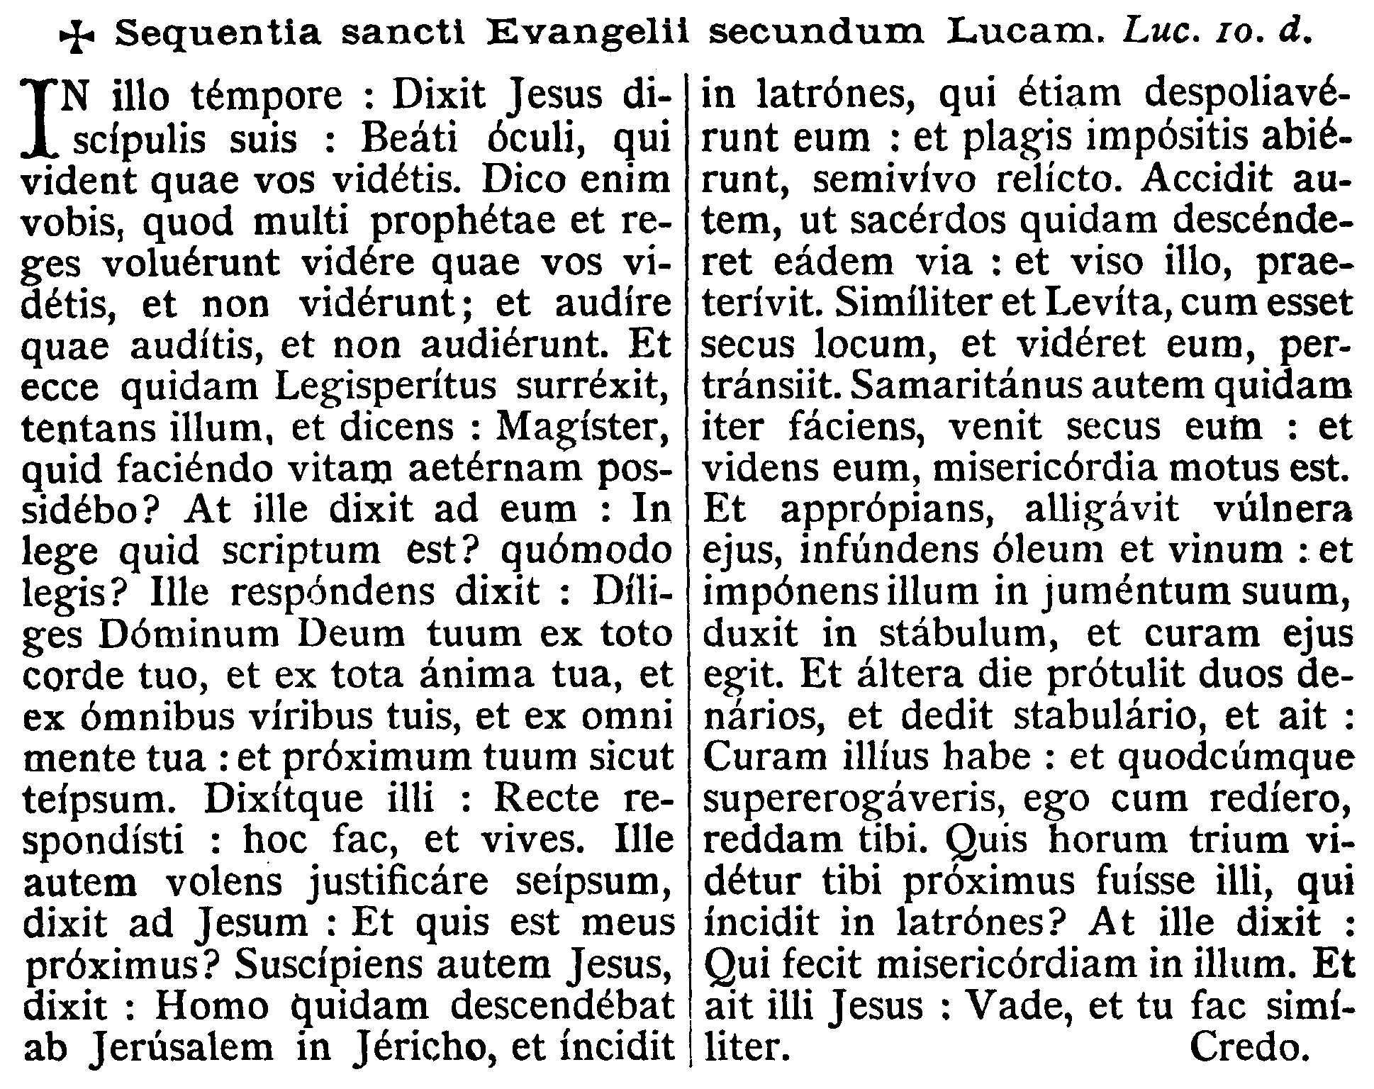
GOSPEL ¤ Luke 10. 23-37
† Continuation of the holy Gospel according to St. Luke.
[The parable of the good Samaritan shows us that our neighbor is every man, known or unknown, friend or enemy, to whom we are united by the bonds of Christian charity taught us by Jesus in healing our wounds.]
At that time, Jesus said to His disciples: Blessed are the eyes that see the things which you see. For I say to you, that many prophets and kings have desired to see the things that you see, and have not seen them; and to hear the things you hear, and have not heard them. And behold a certain lawyer stood up, tempting Him, and saying: Master, what must I do to possess eternal life? But He said to them: What is written in the law? how readest thou? He answering, said: "Thou shalt love the Lord thy God with thy whole heart, and with thy whole soul, and with all thy strength, and with all thy mind; and thy neighbor as thyself." And He said to him: Thou hast answered rightly: this do, and thou shalt live. But he, willing to justify himself, said to Jesus: And who is my neighbor? And Jesus answering, said: A certain man went down from Jerusalem to Jericho, and fell among robbers, who also stripped him, and having wounded him, went away, leaving him half dead. And it chanced that a certain priest went down the same way, and seeing him, passed by. In like manner also a Levite, when he was near the place and saw him, passed by. But a certain Samaritan being on his journey, came near him, and seeing him, was moved with compassion, and going up to him, bound up his wounds, pouring in oil and wine; and setting him upon his own beast, brought him to an inn, and took care of him. And the next day he took out two pence, and gave to the host, and said: Take care of him, and whatsoever thou shalt spend over and above, I, at my return, will repay thee. Which of these three, in thine opinion, was neighbor to him that fell among robbers? But he said: He that showed mercy to him. And Jesus said to him: Go and do thou in like manner.

Priest: Dominus Vobiscum
All: Et Cum Spirtu tuo
Preist: Oremus:

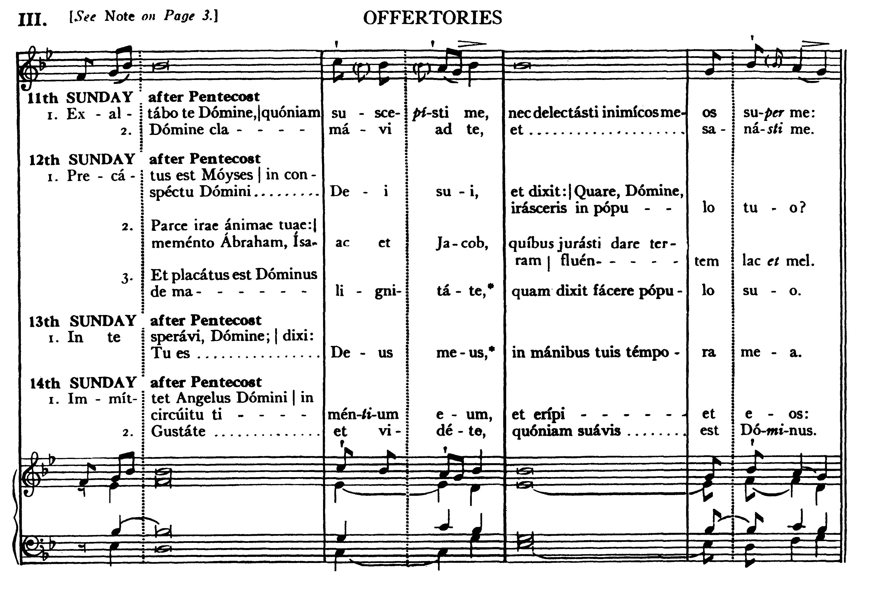
Moses prayed in the sight of the Lord his God, and said: Why, O Lord, is Thine indignation enkindled against Thy people? Let the anger of Thy mind cease; remember Abraham, Isaac, and Jacob, to whom Thou didst swear to give a land flowing with milk and honey. And the Lord was appeased from doing the evil which He had spoken of doing against His people.

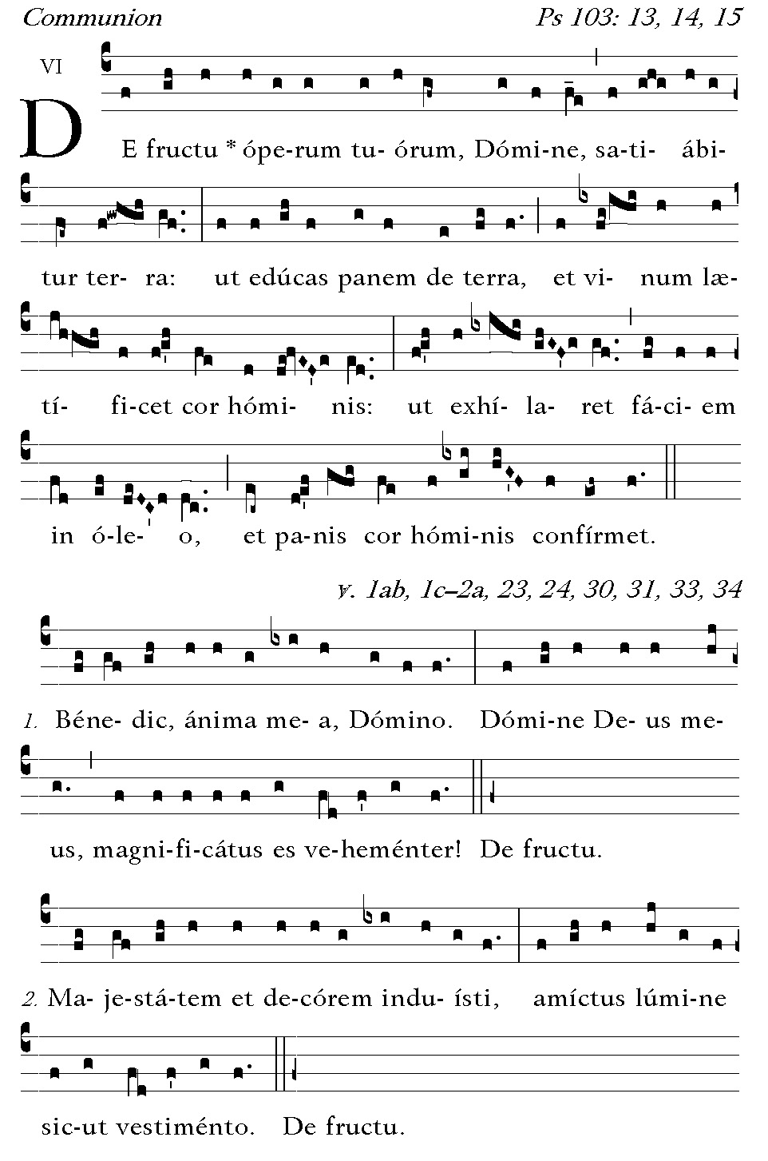
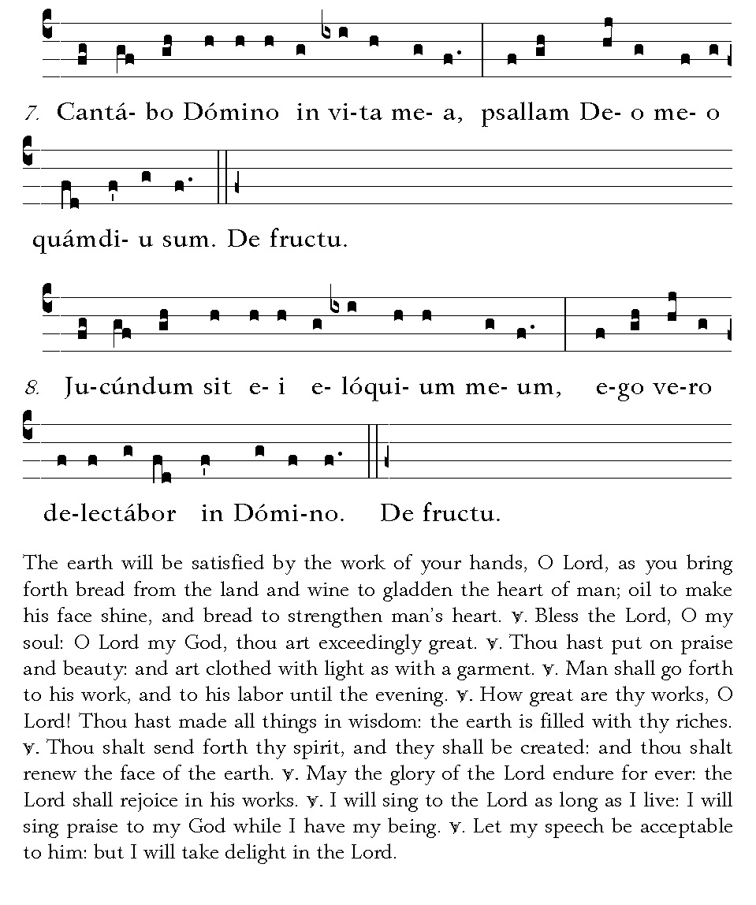


POSTCOMMUNION.--May the holy reception of this Mystery, we beseech Thee, O Lord, quicken us: and may it win for us both pardon and protection. Through our Lord Jesus Christ, Thy Son, who liveth and reigneth with Thee in the unity of the Holy Ghost . . .
Deo Gratias

