16th Sunday After Pentecost
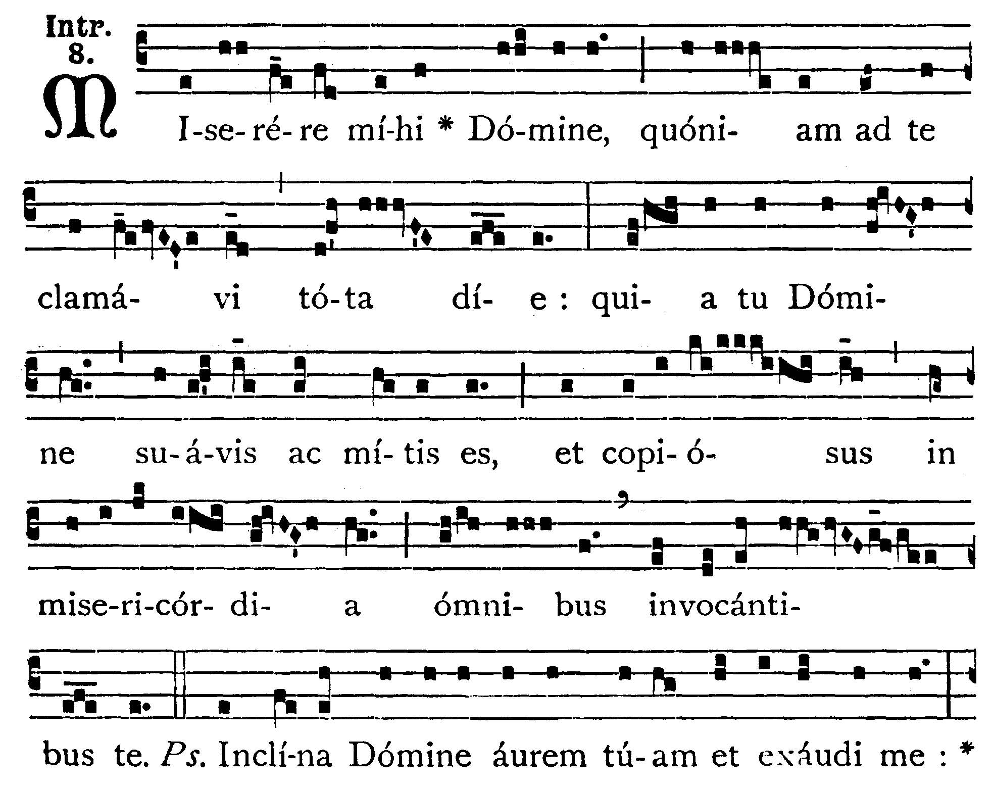
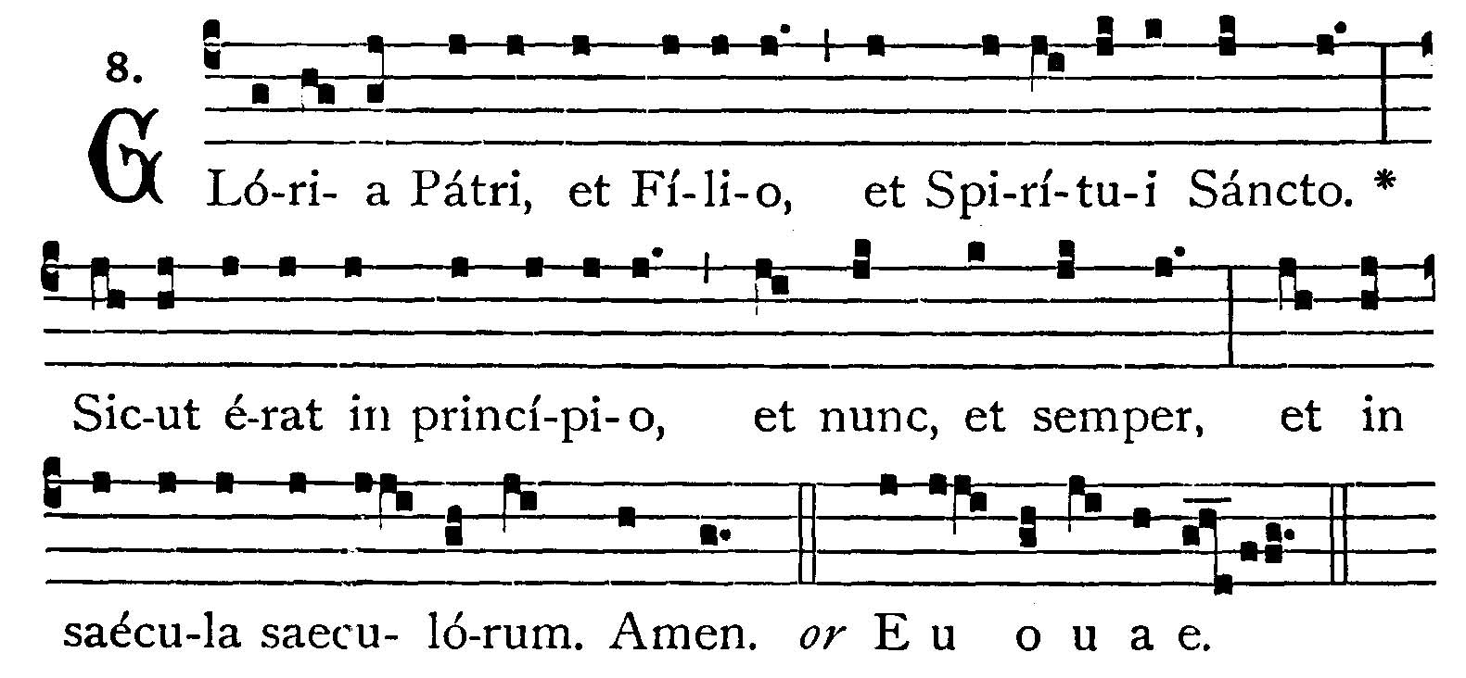
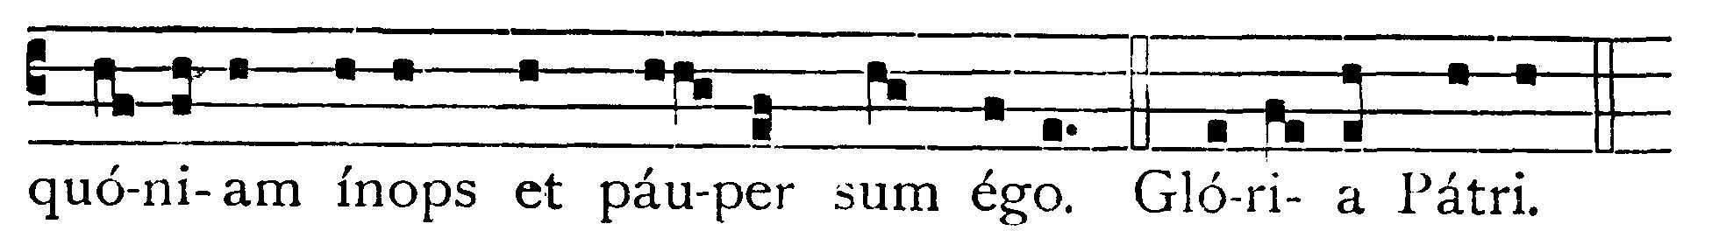

Have mercy on me, O Lord, for I have cried to Thee all the day; for Thou, O Lord, art sweet and mild, and plenteous in mercy to all that call upon Thee. -- (Ps. 85. 1). Bow down Thine ear to me, O Lord, and hear me; for I am needy and poor. V.: Glory be to the Father . . . -- Have mercy on me, O Lord, for I have cried . . .


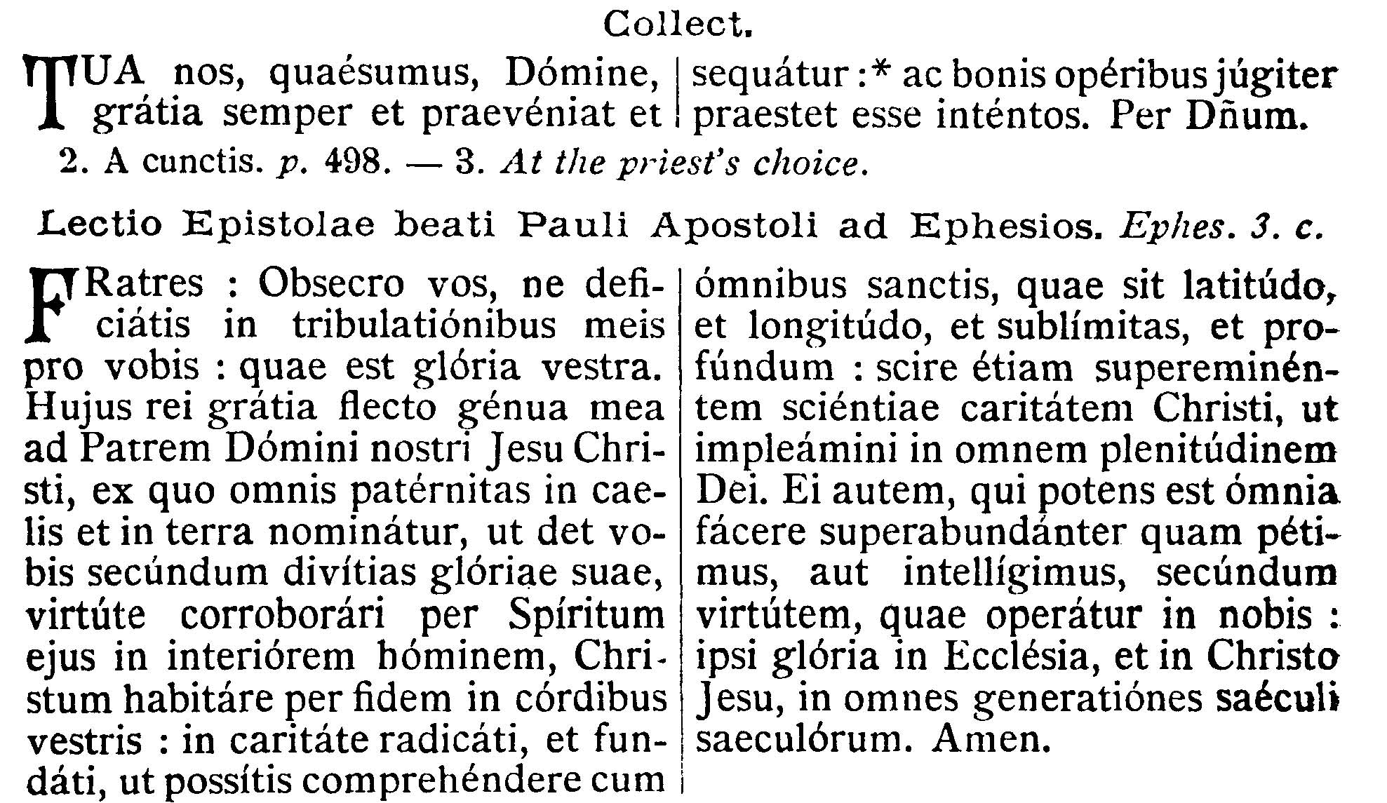
COLLECT.--May Thy grace, we beseech Thee, O Lord, ever go before us and follow us: and make us continually to be intent upon good works. Through our Lord . . .

EPISTLE ¤ Ephesians 3. 13-21
Lesson from the Epistle of Blessed Paul the Apostle to the Ephesians.
[That Christ our Lord may dwell by faith in our hearts; that to Him be glory and to the Father and the Holy Ghost, in the Church unto all generations, is the theme of the Epistle.]
Brethren, I pray you not to faint at my tribulations for you, which are your glory. For this cause I bow my knees to the Father of Our Lord Jesus Christ, of whom all paternity in heaven and earth is named, that He would grant you, according to the riches of His glory, to be strengthened with the Holy Spirit with might unto the inward man. That Christ may dwell by faith in your hearts; that being rooted and founded in charity, you may be able to comprehend with all the saints, what is the breadth and length, and height, and depth. To know also the charity of Christ, which surpasseth all knowledge; that you may be filled unto all the fulness of God. Now to Him who is able to do all things more abundantly than we desire or understand, according to the power that worketh in us: to Him be glory in the Church, and in Christ Jesus, unto all generations, world without end. Amen.

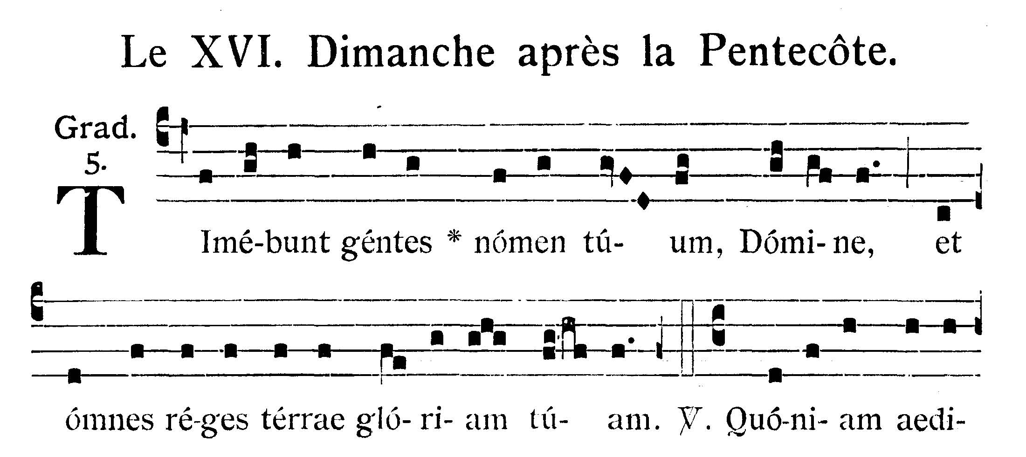
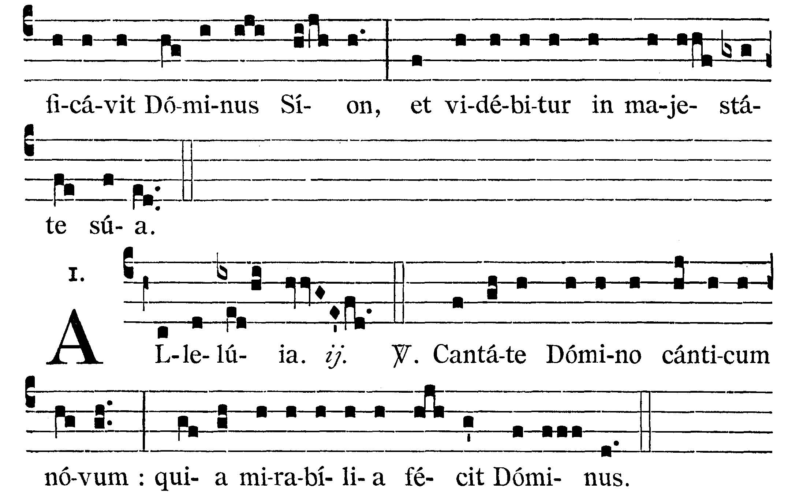

The Gentiles shall fear Thy Name, O Lord, and all the kings of the earth Thy glory. V.: For the Lord hath built up Sion, and He shall be seen in His majesty.
Alleluia, alleluia. V.(Ps. 97. 1). Sing ye to the Lord a new canticle, because the Lord hath done wonderful things. Alleluia.


GOSPEL ¤ Luke 14. 1-11
† Continuation of the holy Gospel according to St. Luke.
[Jesus heals a man with the dropsy. Short parable showing that God exalts whosoever humbles himself.]
At that time, when Jesus went into the house of one of the chief of the Pharisees on the sabbath day to eat bread, they watched Him. And behold, there was a certain man before Him that had the dropsy: and Jesus answering, spoke to the lawyers and Pharisees, saying: Is it lawful to heal on the sabbath day? But they held their peace: but He taking him, healed him, and sent him away. And answering them, He said: Which of you whall have an ass or an ox fall into a pit, and will not immediately draw him out on the sabbath day? And they could not answer Him these things. And He spoke a parable also to them that were invited, marking how they chose the first seats at the table, saying to them: When thou art invited to a wedding, sit not down in the first place, lest perhaps one more honorable than thou be invited by him; and he that invited thee and him, come and say to thee: Give this man place: and then thou begin with shame to take the lowest place. But when thou art invited, go, sit down in the lowest place: that when he who invited thee cometh, he may say to thee: Friend, go up higher. Then shalt thou have glory before them that sit at table with thee: because every one that exalteth himself shall be humbled; and he that humbled himself shall be exalted.

Priest: Dominus Vobiscum
All: Et Cum Spirtu tuo
Preist: Oremus:

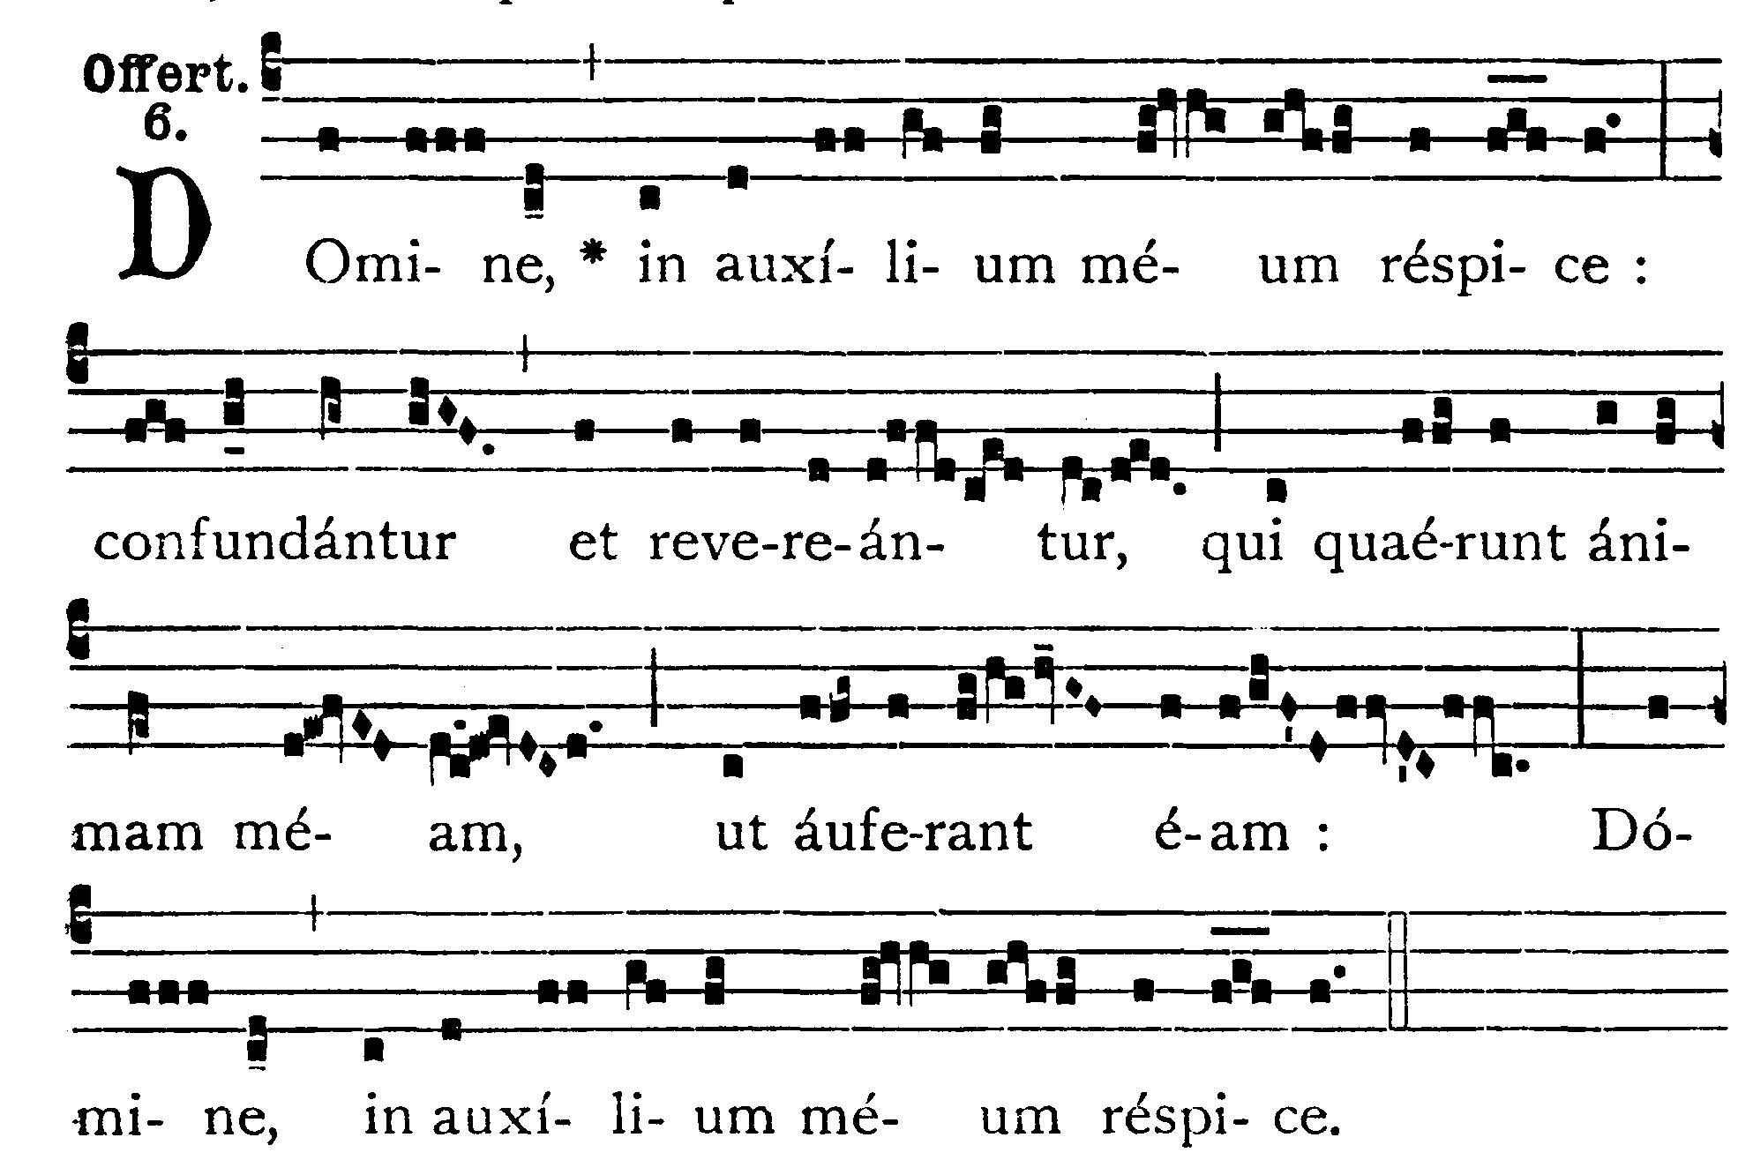
Look down, O Lord, to help me; let them be confounded and ashamed that seek after my soul to take it away; look down, O Lord, to help me.

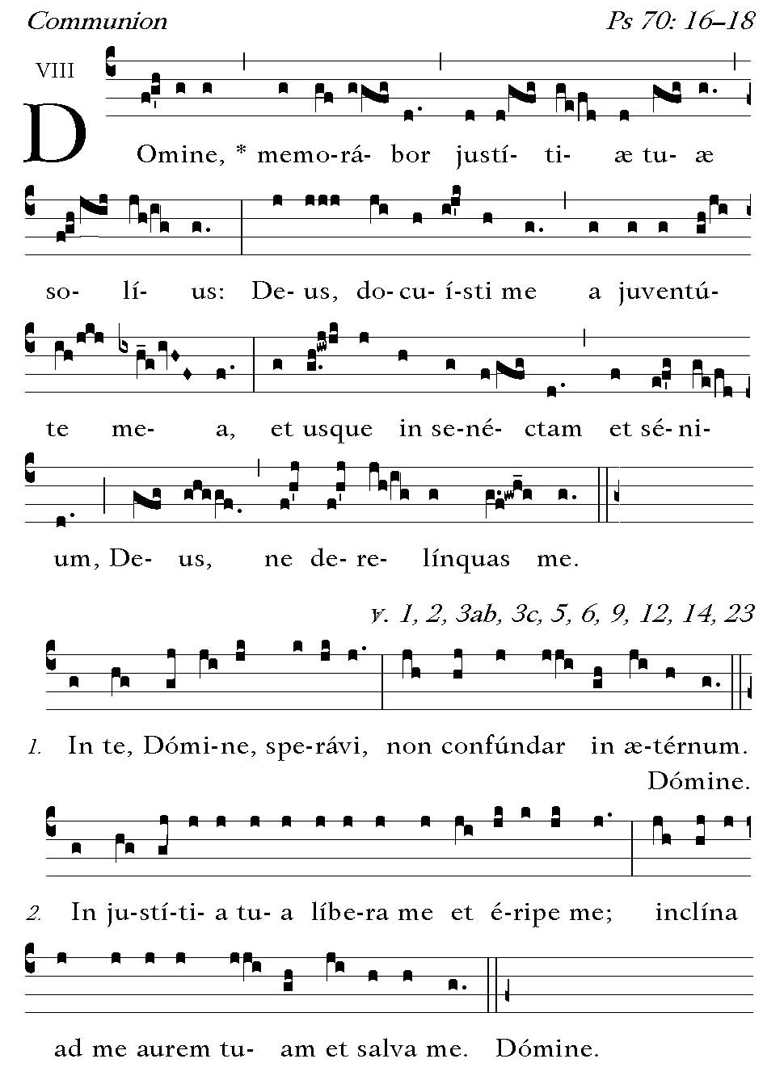
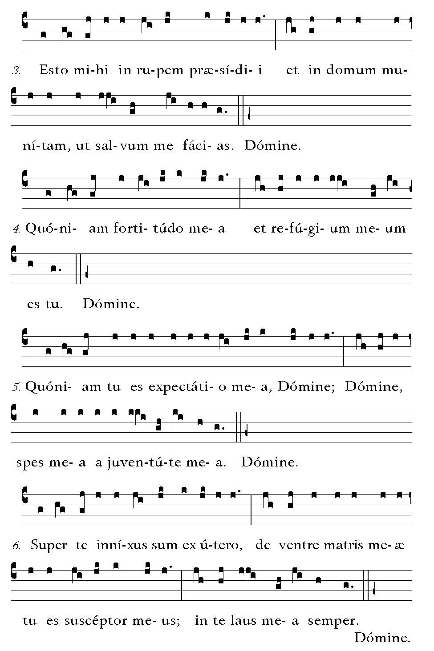

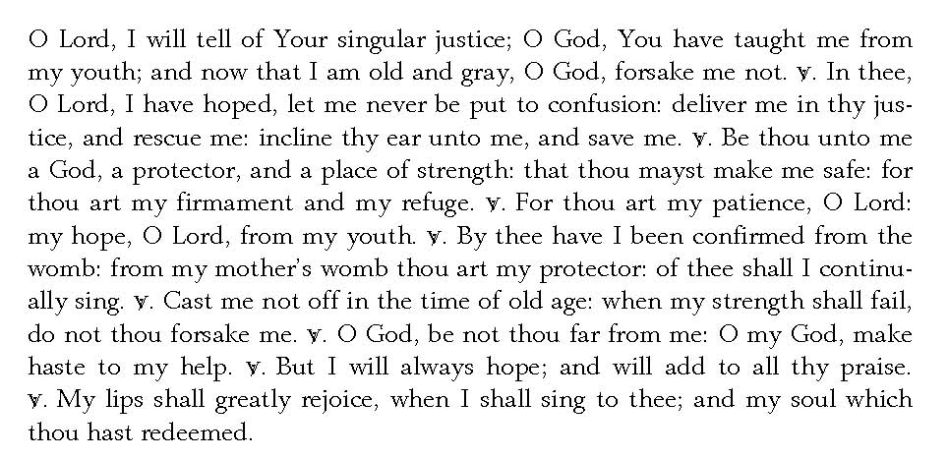

Post Communion

Deo Gratias

