1st Sunday of Advent
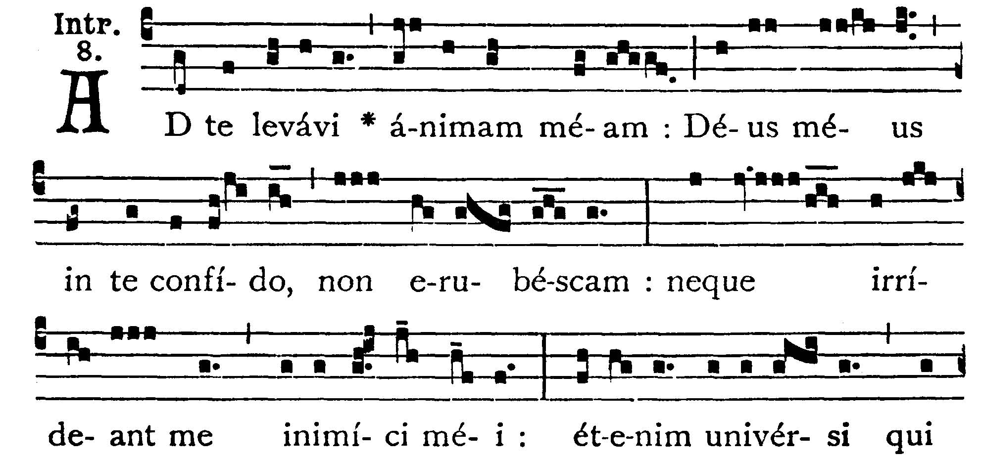
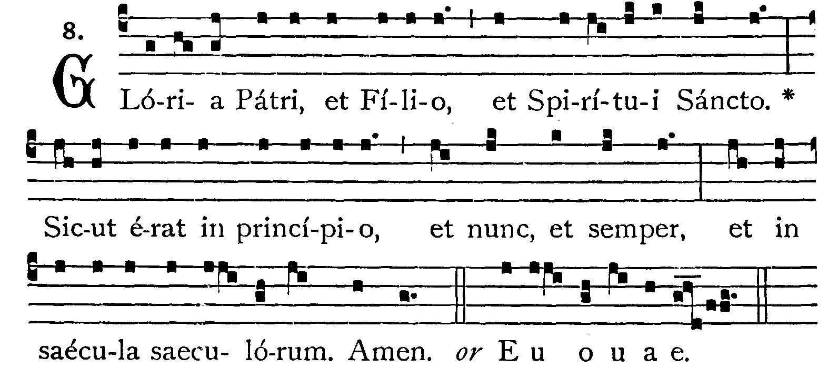
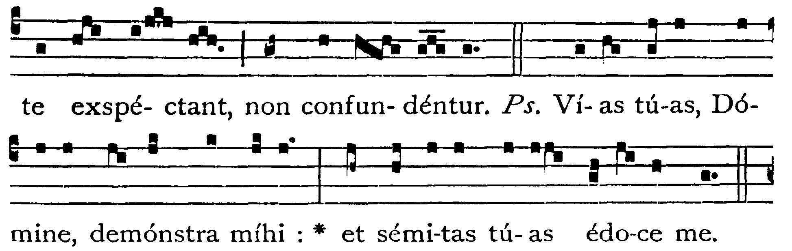
To Thee have I lifted up my soul: in Thee, O my God, I put my trust, let me not be ashamed: neither let my enemies laugh at me: for none of them that wait on Thee shall be confounded. -- (Ps. 24. 4). Show, O Lord, Thy ways to me: and teach me Thy paths. V.: Glory to the Father . . . -- He shall cry to me . . .


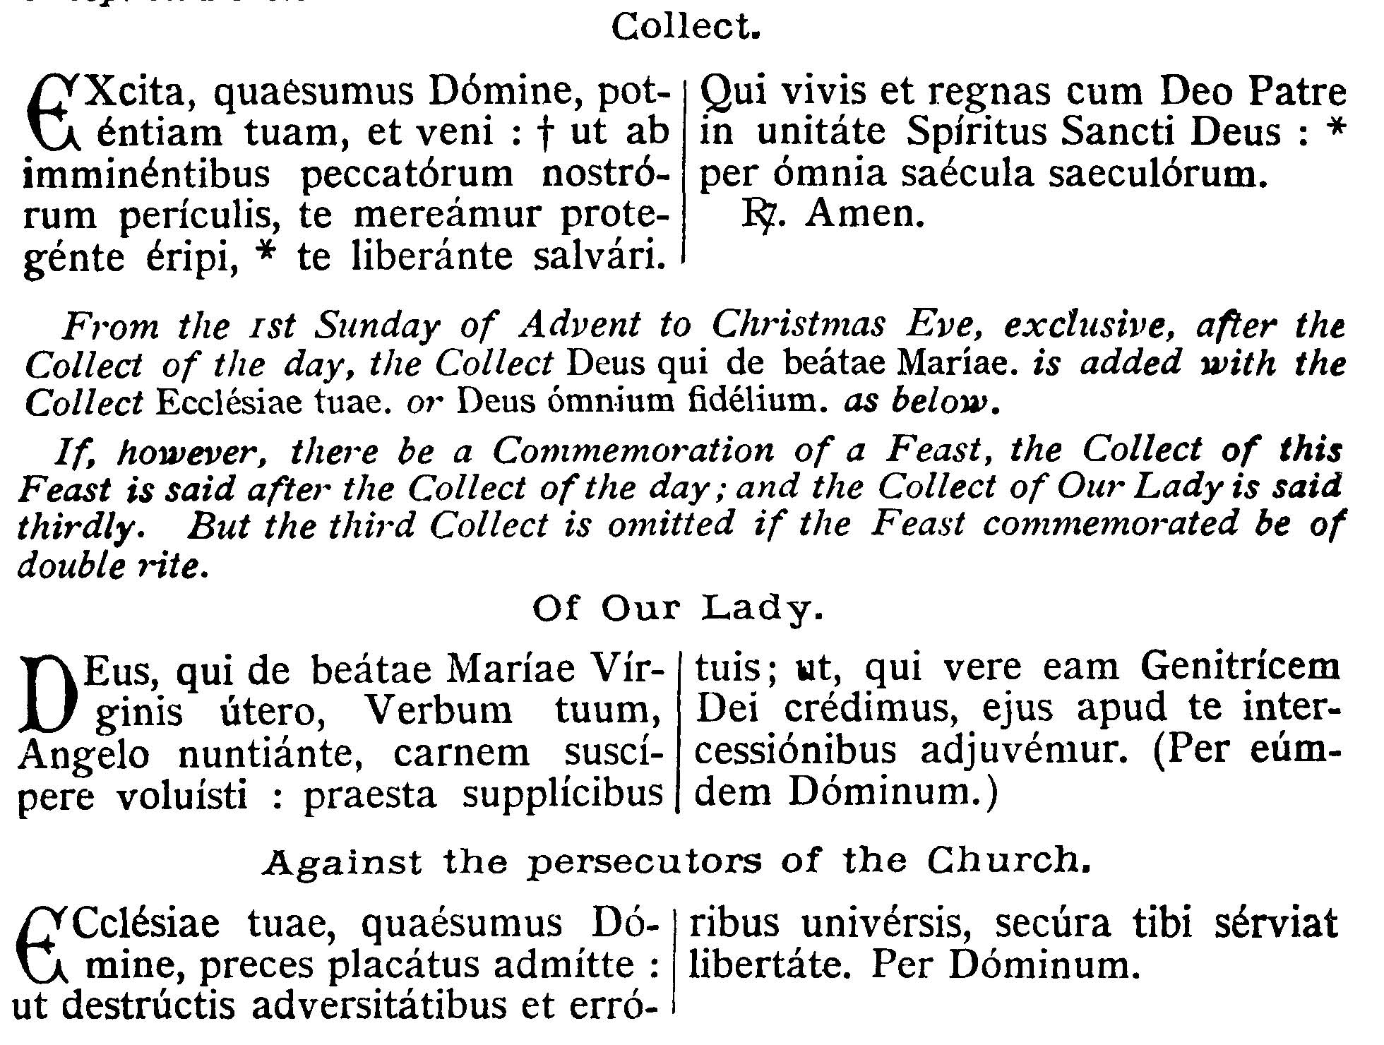
COLLECT - Stir up Thy power, we beseech Thee, O Lord, and come: that from the threatening dangers of our sins we may deserve to be rescued by Thy protection, and to be saved by Thy deliverance. Who livest and reignest, with God the Father, in the unity of the Holy Ghost, world without end.

EPISTLE ¤ Rom. 13. 11-14
Lesson from the Epistle of Blessed Paul the Apostle to the Romans.
Lectio Epistolae beati Pauli Apostoli ad Romanos.
[It is now the hour for us to rise from sleep . . . Let us therefore cast off the works of darkness . . . and walk honestly.]
Fratres: Scientes, quia hora est iam nos de somno surgere. Nunc enim propior est nostra salus, quam cum credidimus. Nox praecessit, dies autem appropinquavit. Abiiciamus ergo opera tenebrarum, et induamur arma lucis. Sicut in die honeste ambulemus: non in comessationibus, et ebrietatibus, non in cubilibus, et impudicitiis, non in contentione, et aemulatione, sed induimini Dominum Iesum Christum.
Brethren, knowing that is is now the hour for us to rise from sleep. For now our salvation is nearer than when we believed. The night is past and the day is at hand. Let us therefore cast off the works of darkness, and put on the armor of light. Let us walk honestly, as in the day: not in rioting and drunkenness, not in chambering and impurities, not in contention and envy: but put ye on the Lord Jesus Christ.

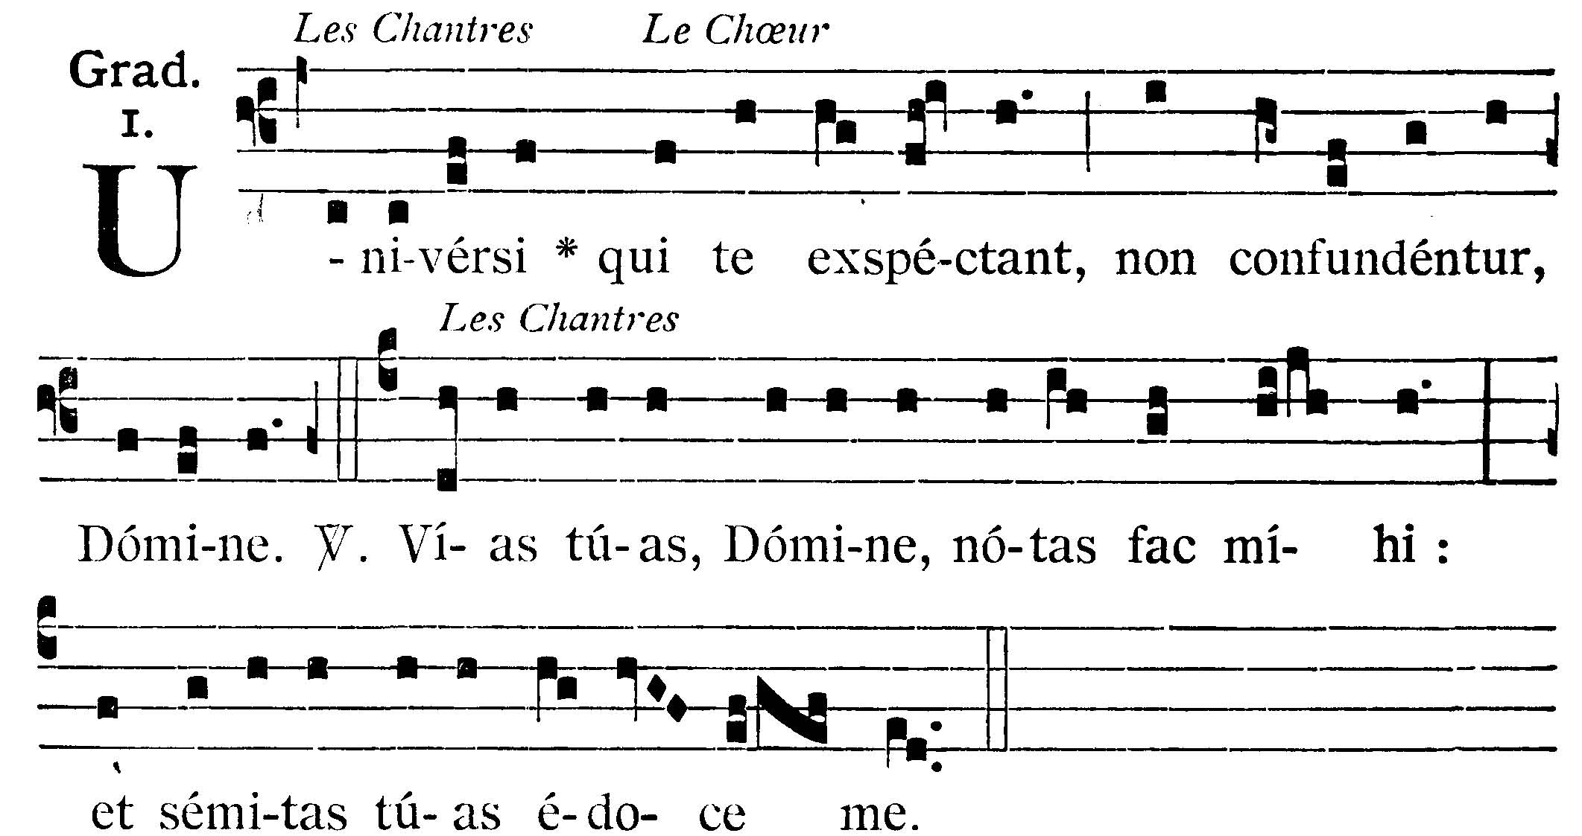
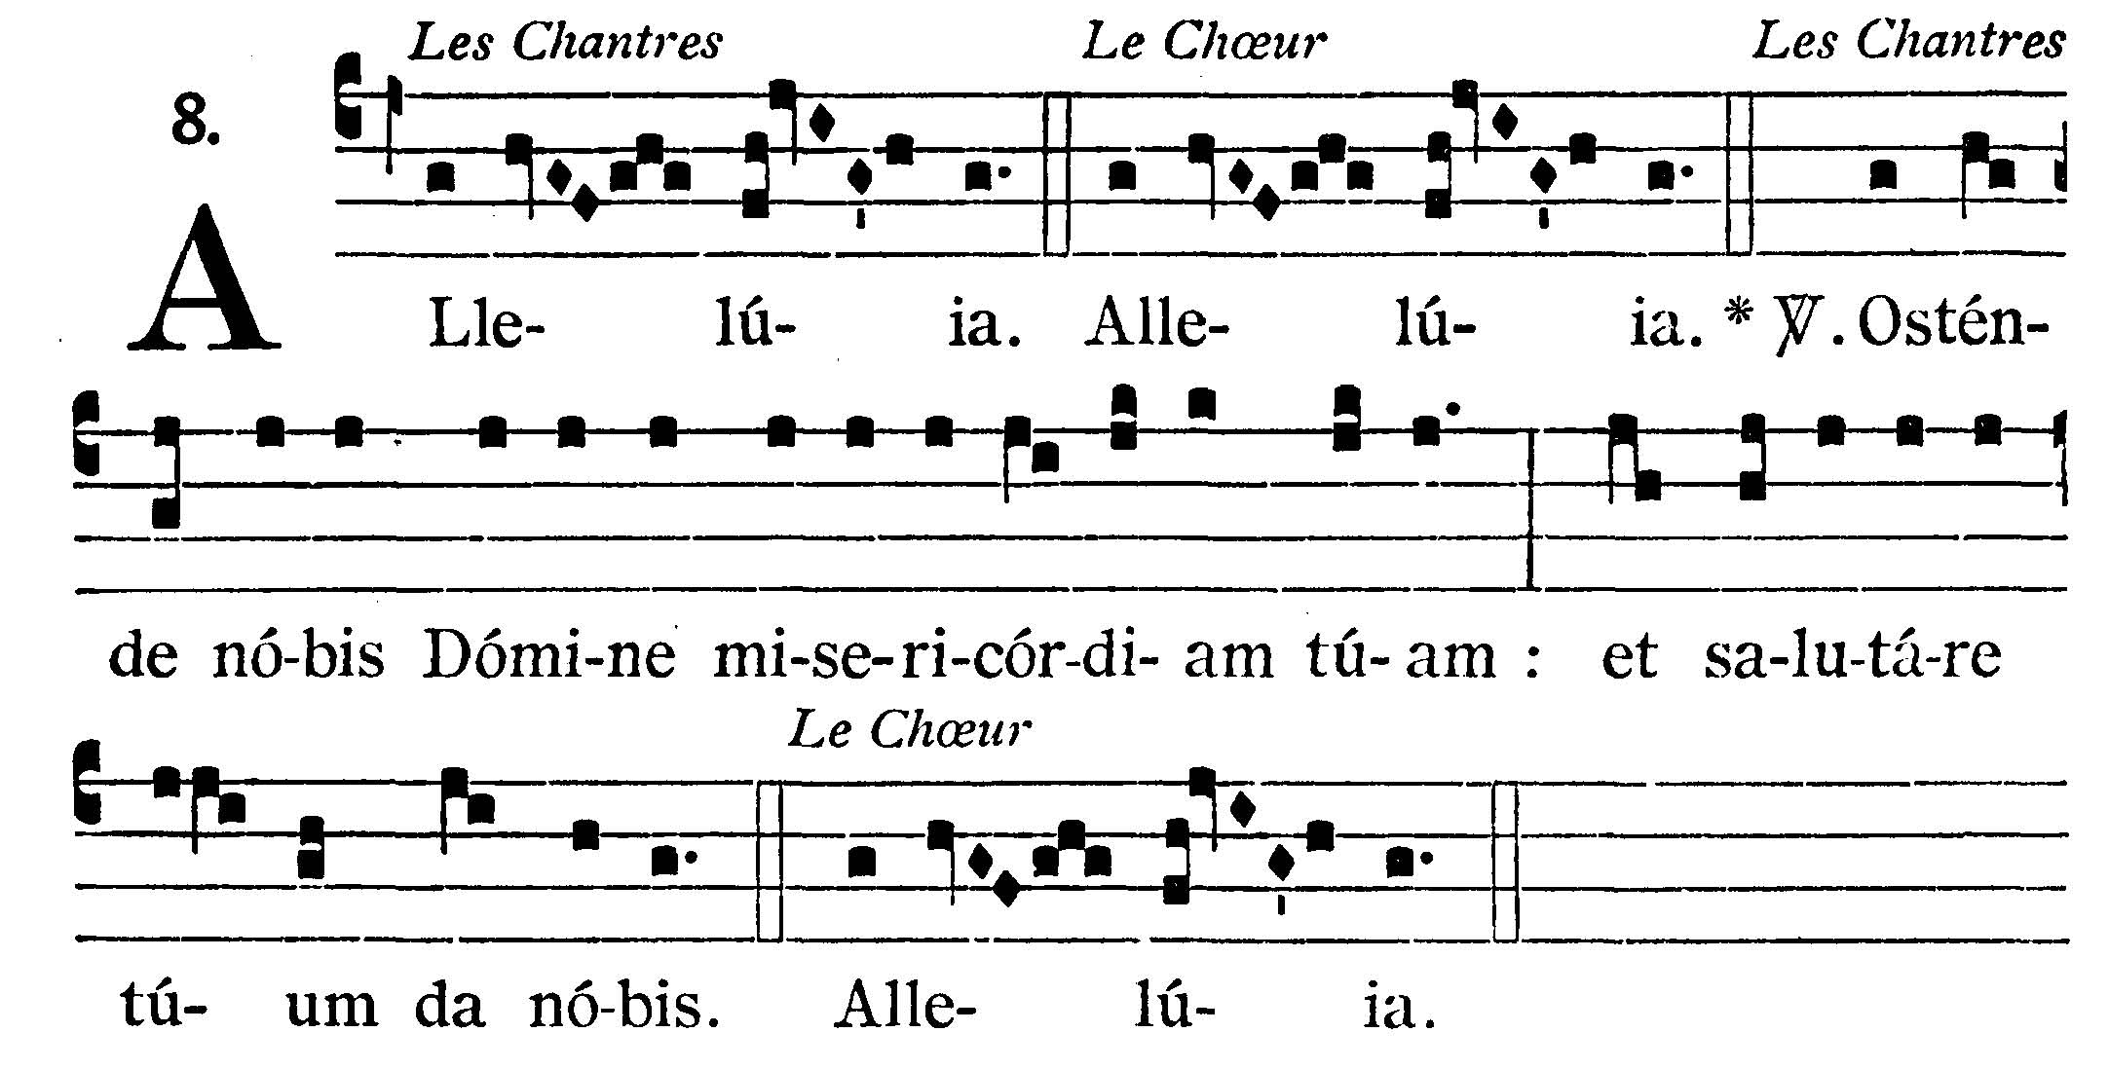
GRADUAL
All they that wait on Thee shall not be confounded, O Lord. V.: Show, O Lord, Thy ways to me: and teach me Thy paths.
Alleluia, alleluia. V.: (Ps. 84. 8) Show us, O Lord, Thy mercy; and grant us Thy salvation.



GOSPEL ¤ Luke 21. 25-33.
† Continuation of the holy Gospel according to St. Luke.
† Sequentia sancti Evangelii secundum Lucam
[We learn in this Gospel of the second coming of Christ: to render to each one according to his works.]
In illo tempore: Dixit Iesus discipulis suis: Erunt signa in sole, et luna, et stellis, et in terrispressura gentium prae confusione sonitus maris, et fluctuum: arescentibus hominibus prae timore et exspectatione, quae supervenient universo orbi: nam virtutes caelorum movebuntur. Et tunc videbunt Filium hominis venientem in nube cum potestate magna, et maiestate. His autem fieri incipientibus, respicite, et levate capita vestra: quoniam appropinquat redemptio vestra. Et dixit illis similitudinem:Videte ficulneam, et omnes arbores: cum producunt iam ex se fructum, scitis quoniam prope est regnum Dei. Amen dico vobis, quia nonpraeteribit generatio haec, donec omnia fiant. Caelum et terra transibunt: verba autem mea non transibunt.

At that time Jesus said to His disciples: There shall be signs in the sun, and in the moon, and in the stars; and upon the earth distress of nations, by reason of the confusion of the roaring of the sea and of the waves: men withering away for fear and expectations of what shall come upon the whole world. For the powers of heaven shall be moved. And then they shall see the Son of Man coming in a cloud with great power and majesty. But when these things begin to come to pass, look up and lift up your heads, because your redemption is at hand. And He spoke to them a similitude: See the fig tree and all the trees: when they now shoot forth their fruit, you know that summer is nigh. So you also, when you shall see these things come to pass, know that the kingdom of God is at hand. Amen, I say to you, this generation shall not pass away till all things be fulfilled. Heaven and earth shall pass away: but My words shall not pass away.

Priest: Dominus Vobiscum
All: Et Cum Spirtu tuo
Preist: Oremus:

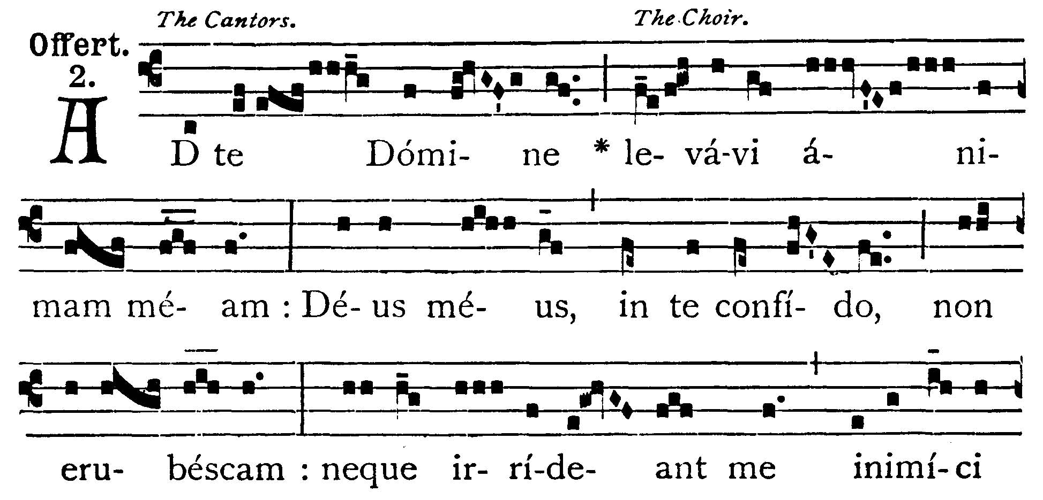
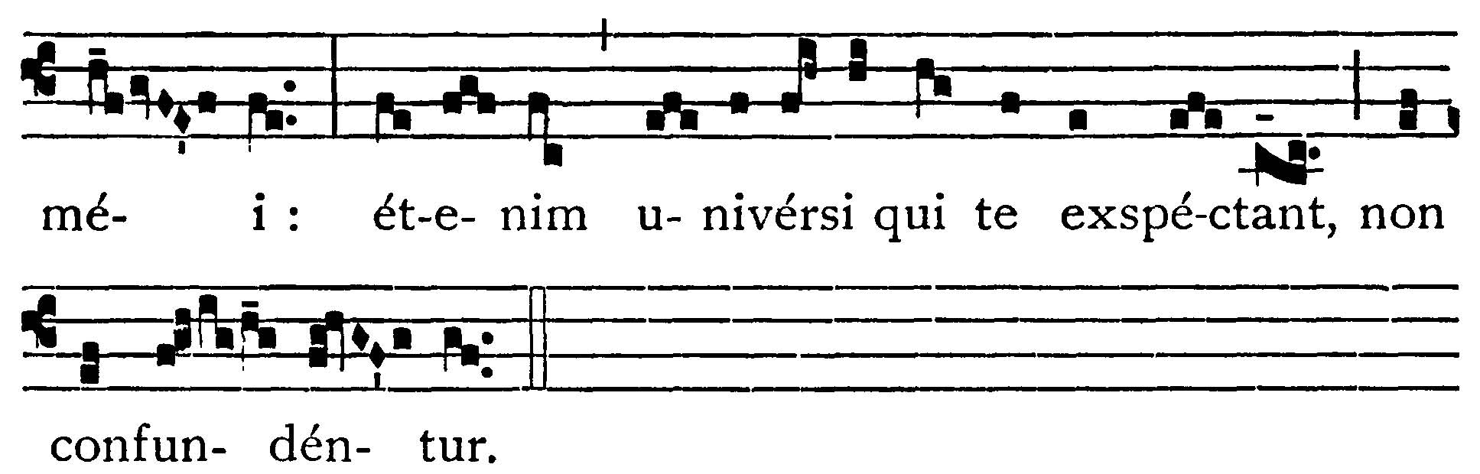
OFFERTORY
To Thee have I lifted up my soul: in Thee, O my God, I put my trust, let me not be ashamed: neither let my enemies laugh at me: for none of them that wait on Thee shall be confounded.

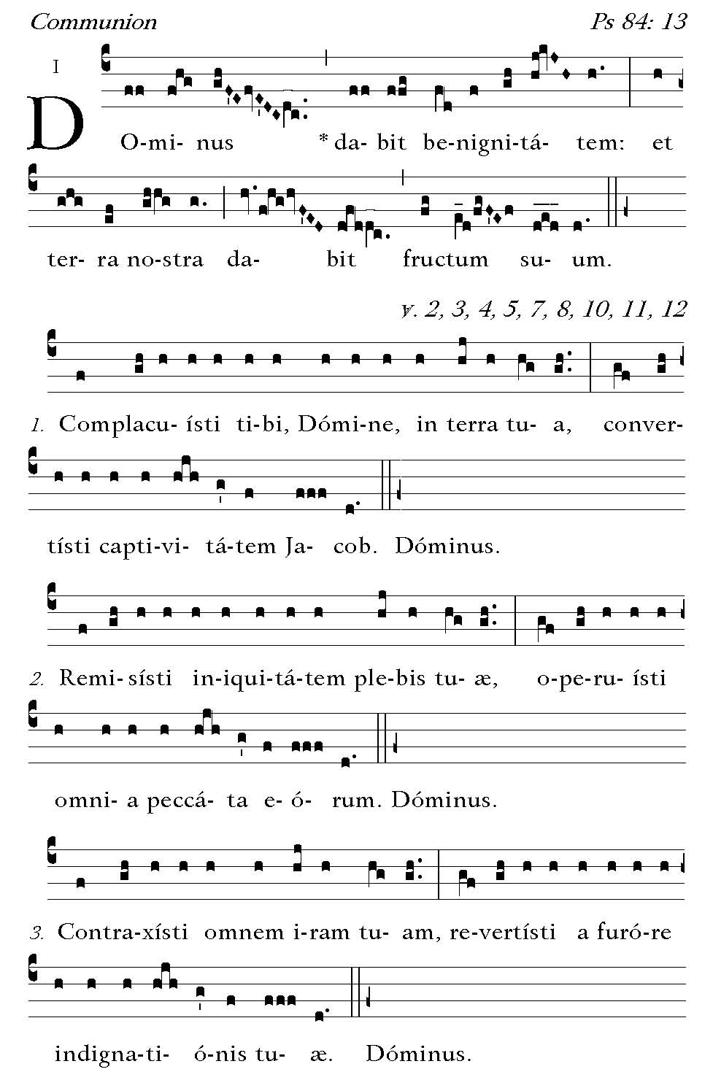
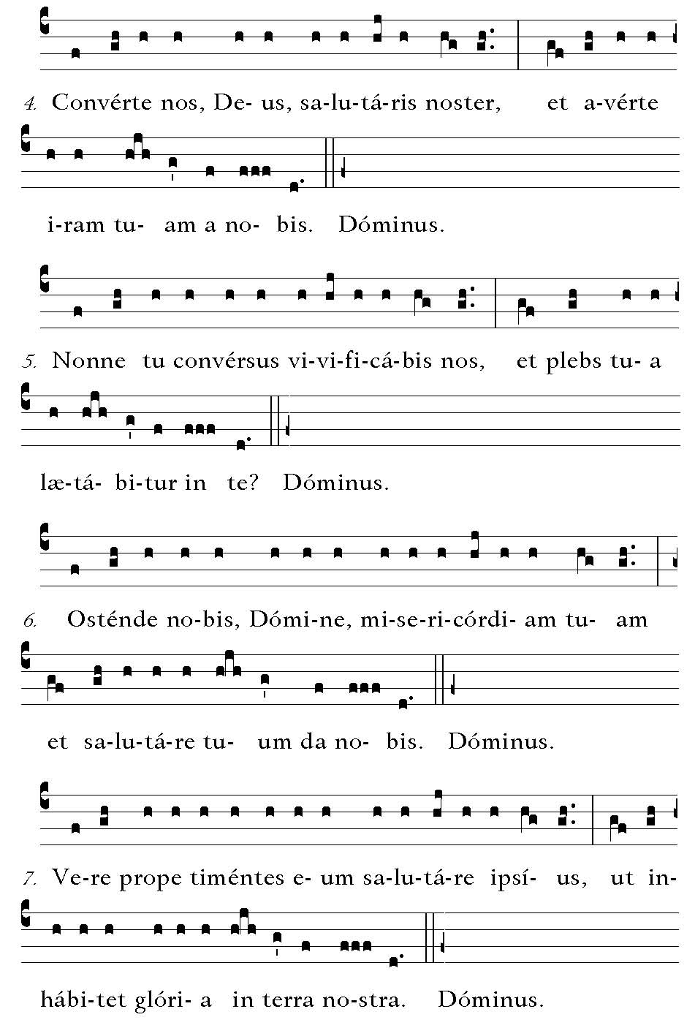
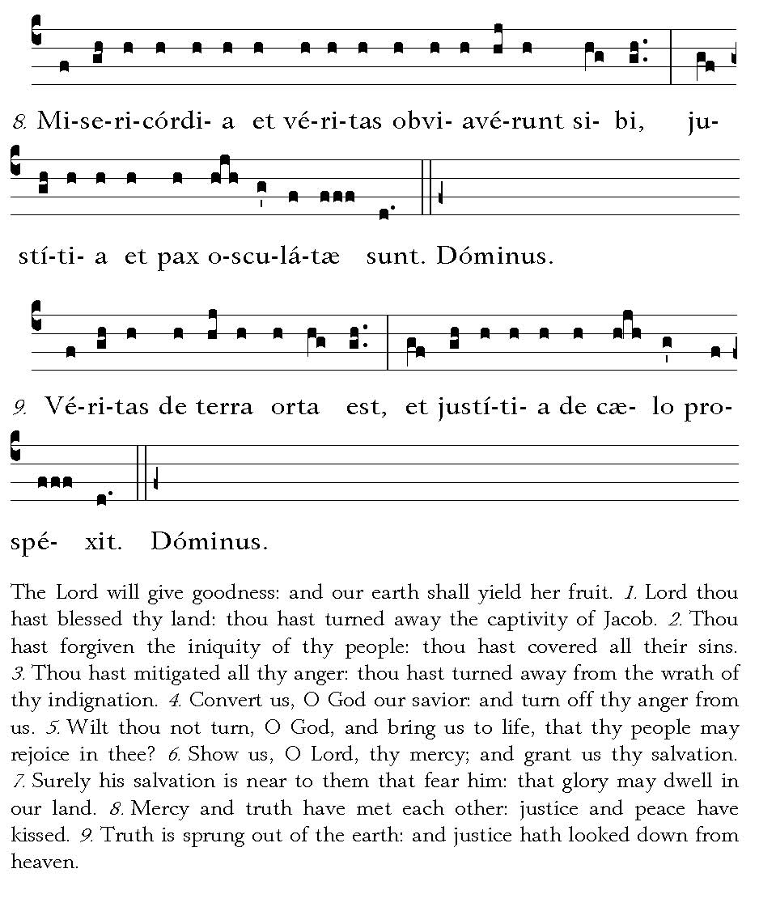

Post Communion
Deo Gratias

