20th Sunday After Pentecost
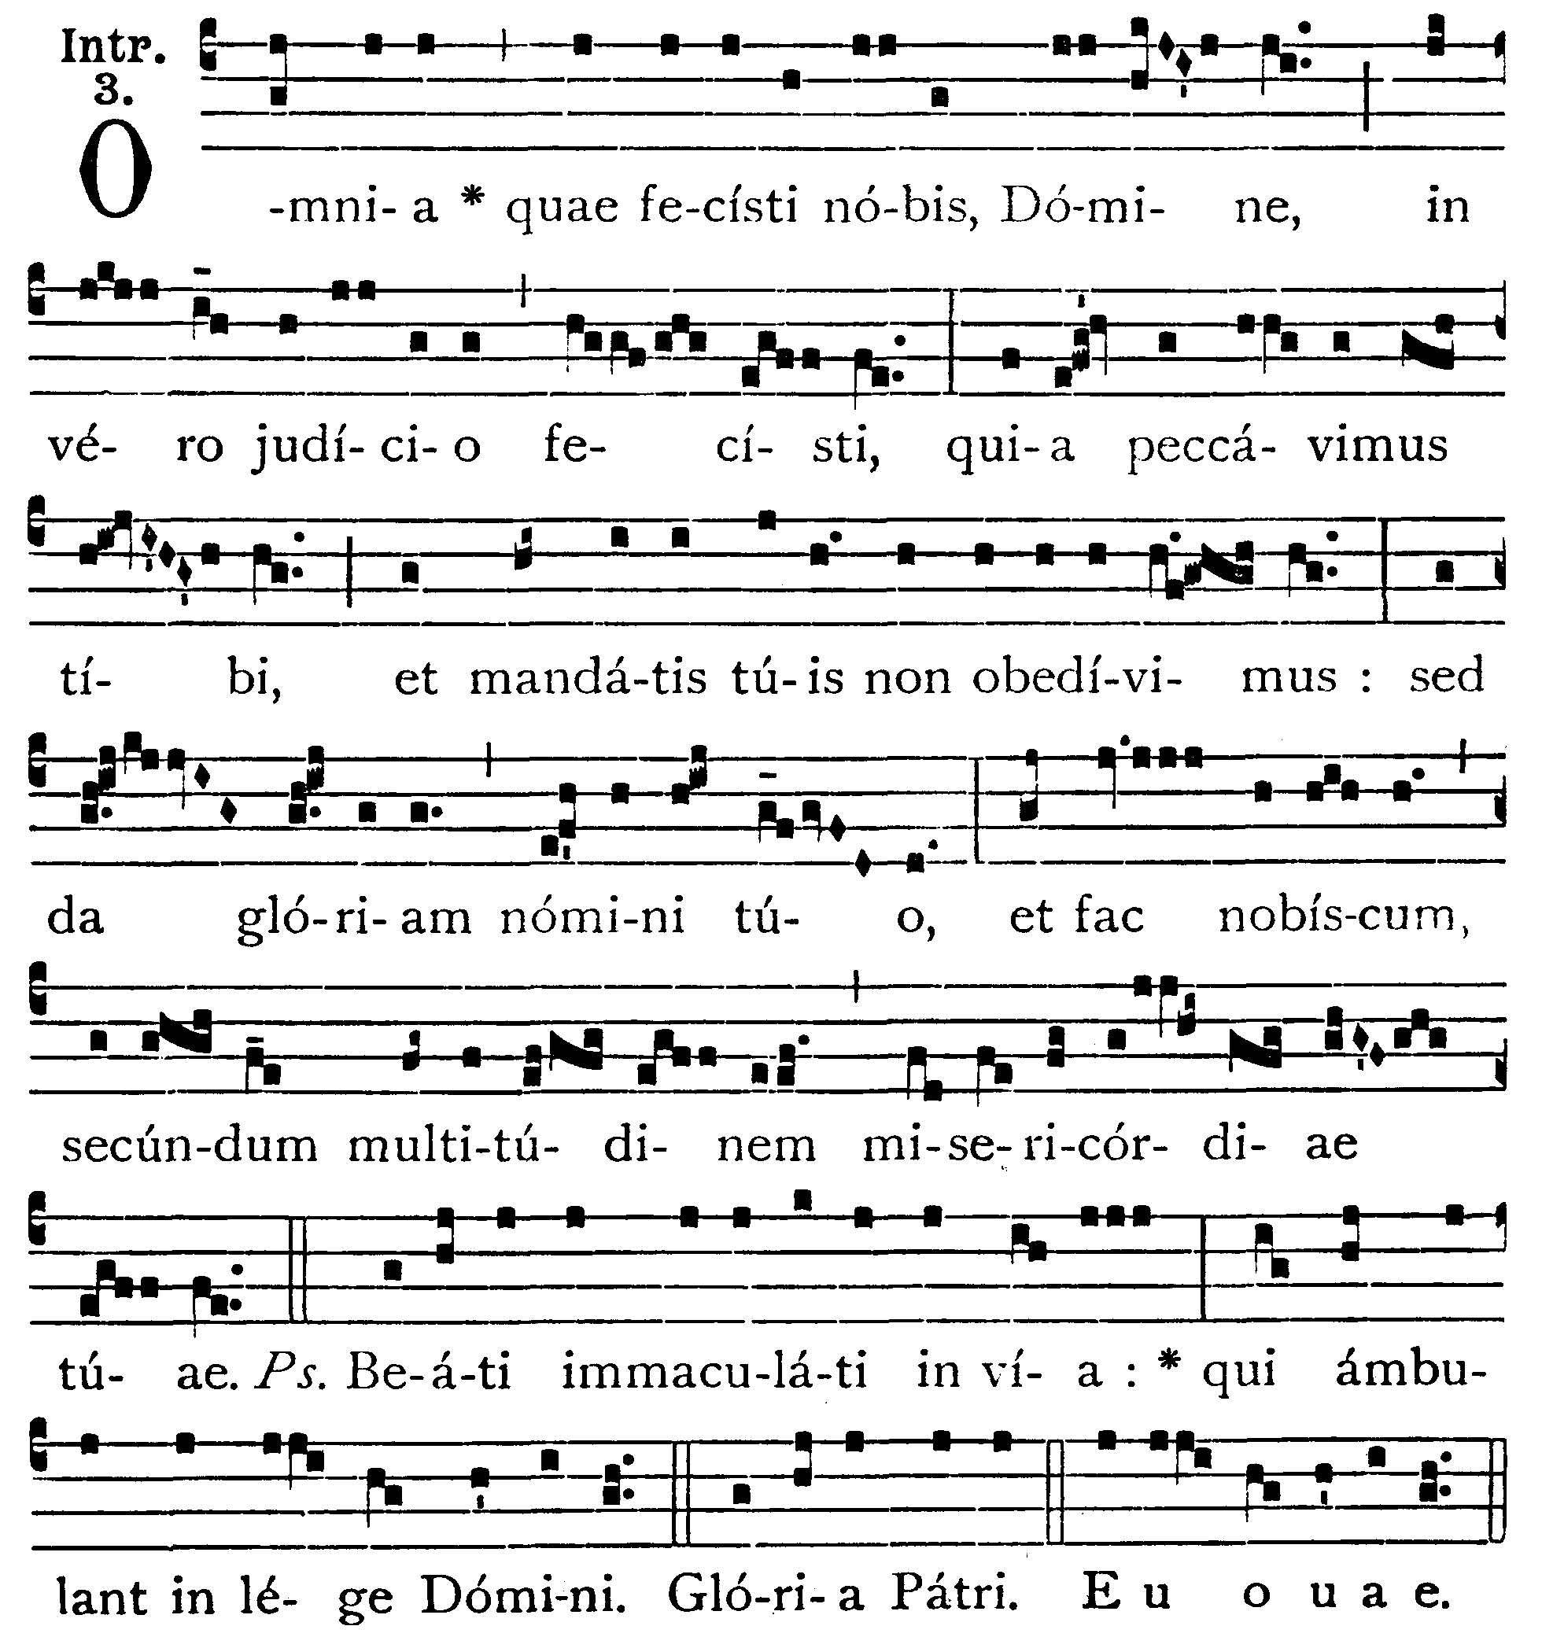
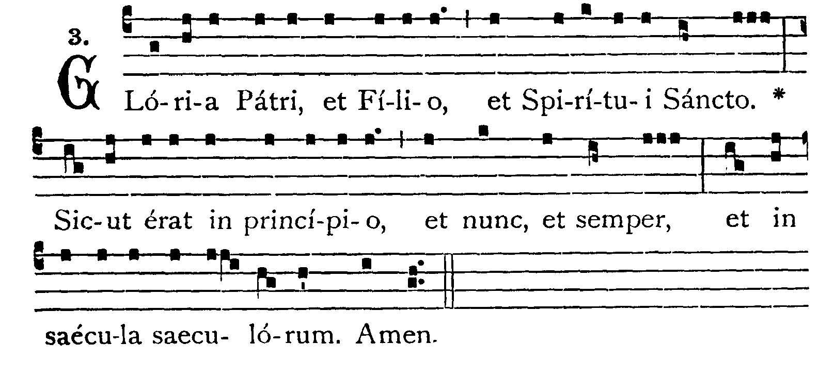
All that Thou hast done to us, O Lord, Thou hast done in true judgment: because we have sinned against Thee, and we have not obeyed Thy commandments: but give glory to Thy Name, and deal with us according to the multitude of Thy mercy. -- (Ps. 118. 1). Blessed are the undefiled in the way; who walk in the law of the Lord. V.: Glory be to the Father . . . -- All that Thou hast done . . .


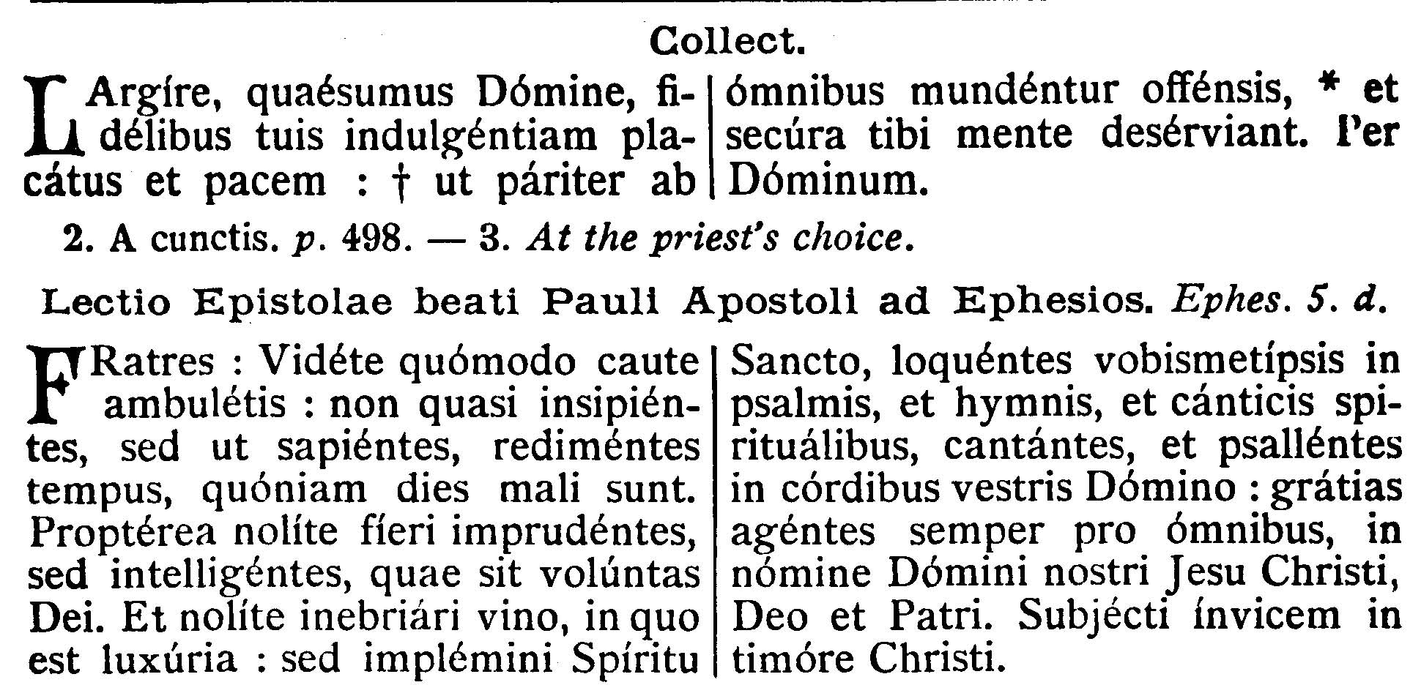

COLLECT.--In Thy mercy, we beseech Thee, O Lord, grant to Thy faithful people pardon and peace, that they may be cleansed from all their sins and also serve Thee with a quiet mind. Through our Lord Jesus Christ, Thy Son, who liveth and reigneth with Thee . . .

EPISTLE ¤ Eph. 5. 15-21
Lesson from the Epistle of Blessed Paul the Apostle to the Ephesians.
[Filled with the Holy Ghost, let us give thanks always for all things in the Name of Our Lord Jesus Christ, to God, being subject to one another in the fear of Christ.]
Brethren, See how you walk circumspectly, not as unwise, but as wise; redeeming the time, because the days are evil. Wherefore, become not unwise, but understanding what is the will of God. And be not drunk with wine, wherein is luxury; but be ye filled with the Holy Spirit, speaking to yourselves in psalms and hymns, and spiritual canticles, singing and making melody in your hearts to the Lord: giving thanks always for all things, in the Name of Our Lord Jesus Christ, to God and the Father; being subject one to another in the fear of Christ.

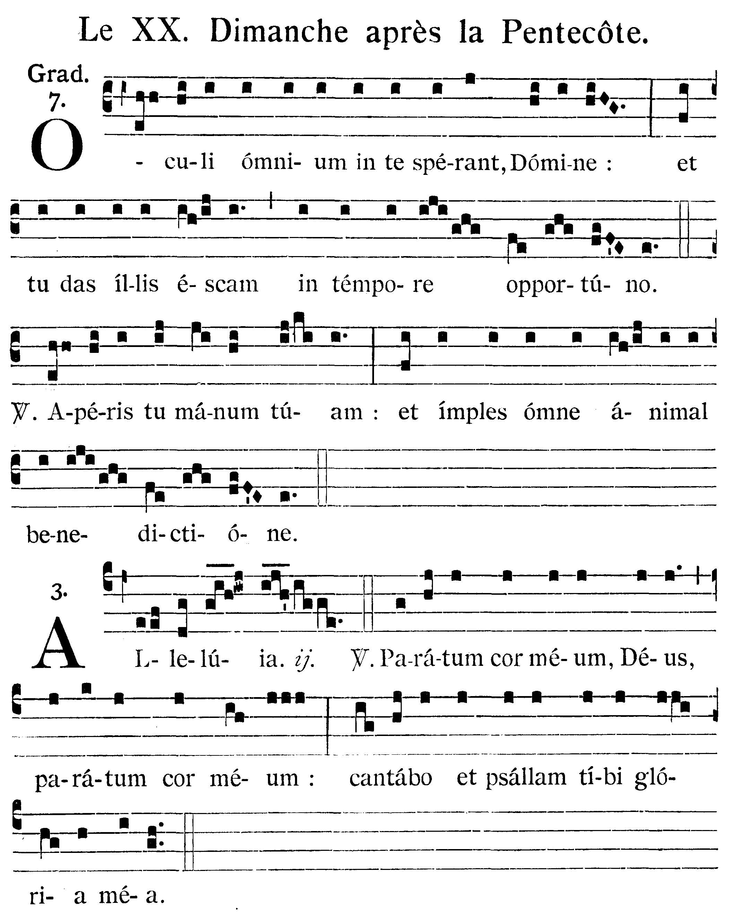
The eyes of all hope in Thee, O Lord; and Thou givest them meat in due season. V.: Thou openest Thy hand, and fillest every living creature with Thy blessing.
Alleluia, alleluia. V.(Ps. 107. 2). My heart is ready, O God, my heart is ready: I will sing, and will give praise to Thee, my glory. Alleluia.


GOSPEL ¤ Matthew 4. 46-53
† Continuation of the holy Gospel according to St. Matthew.
[Healing of the ruler's son at Capharnaum. The reward of faith in Our Lord.]
At that time, there was a certain ruler whose son was sick at Capharnaum. He having heard that Jesus was come from Judaea into Galilee, went to Him, and prayed Him to come down, and heal his son; for he was at the point of death. Jesus therefore said to him: Unless you see signs and wonders, you believe not. The ruler saith to Him: Lord, come down before my son die. Jesus saith to him: Go thy way, thy son liveth. The man believed the word which Jesus said to him, and went his way. And as he was going down, his servants met him, and they brought word, saying that his son lived. He asked therefore of them the hour wherein he grew better. And they said to him: Yesterday at the seventh hour the fever left him. The father therefore knew that it was at the same hour that Jesus said to him: Thy son liveth; and himself believed, and his whole house.

Priest: Dominus Vobiscum
All: Et Cum Spirtu tuo
Preist: Oremus:

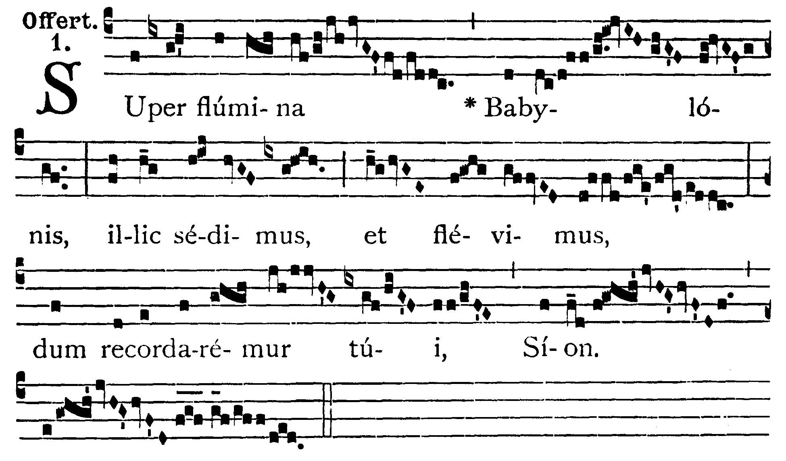

Upon the rivers of Babylon there we say and wept; when we remembered thee, O Sion.

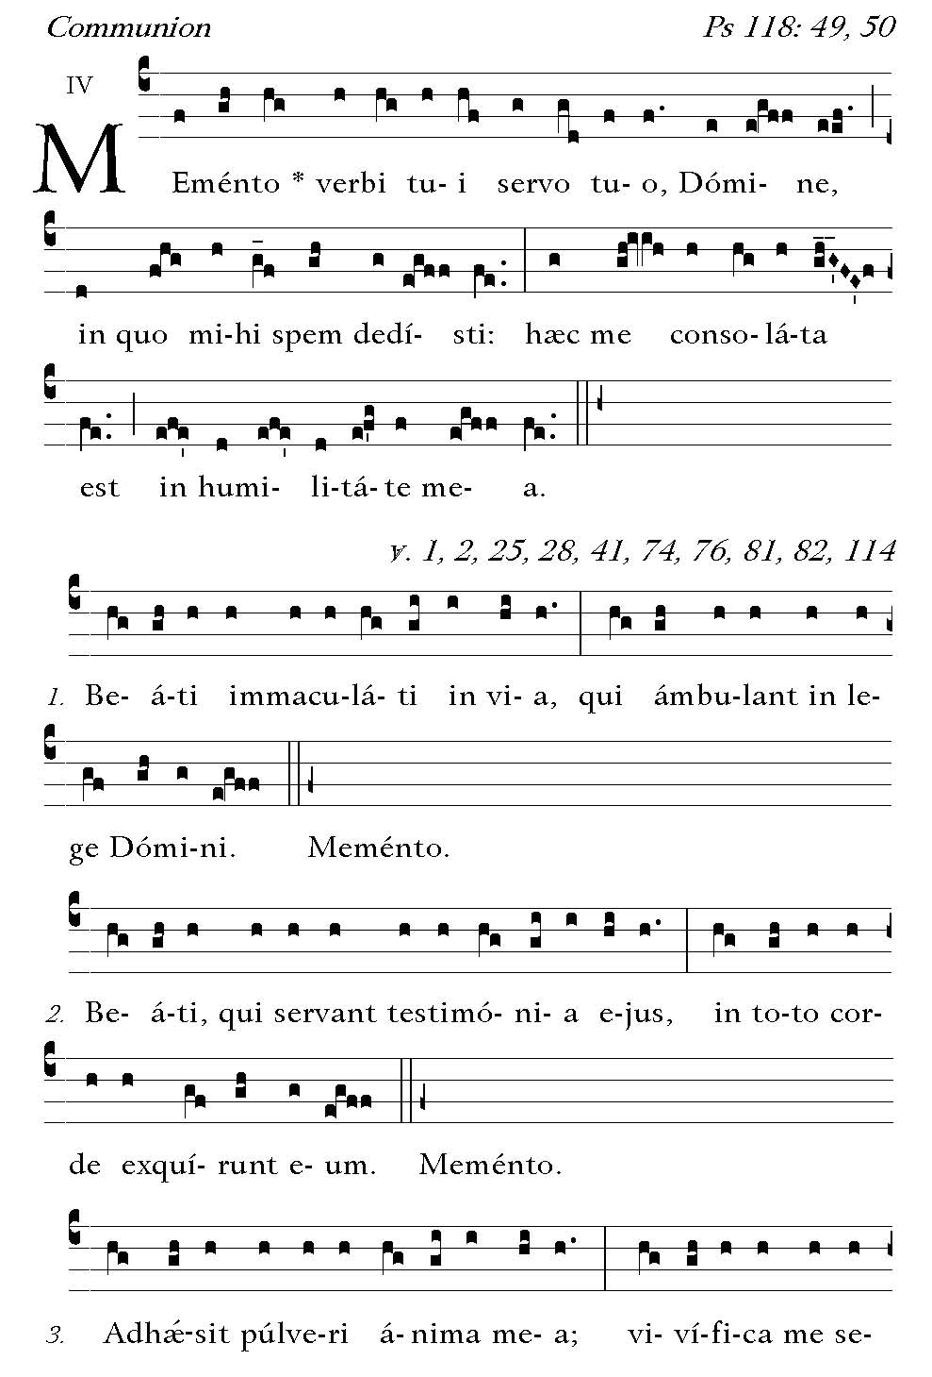
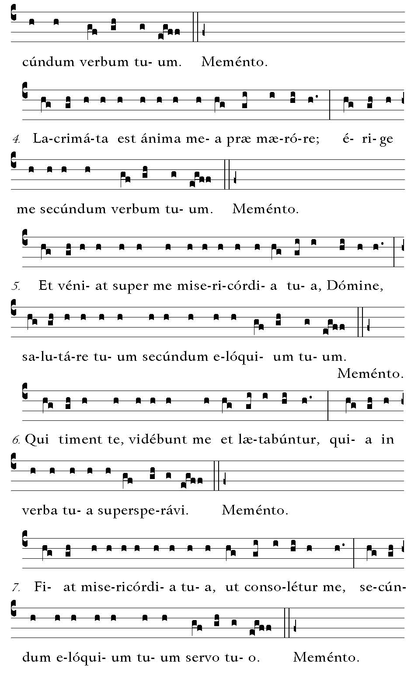
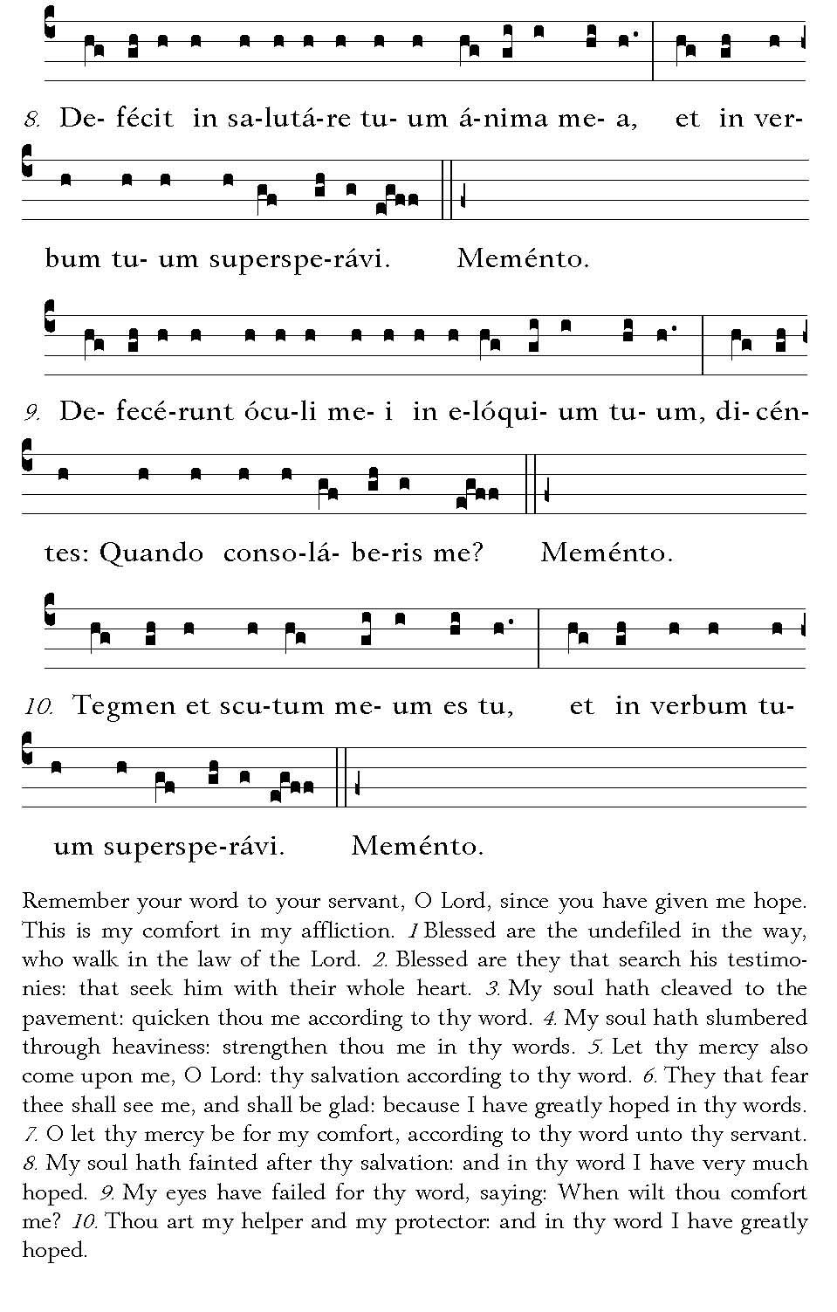

Post Communion
Deo Gratias

