22nd Sunday After Pentecost
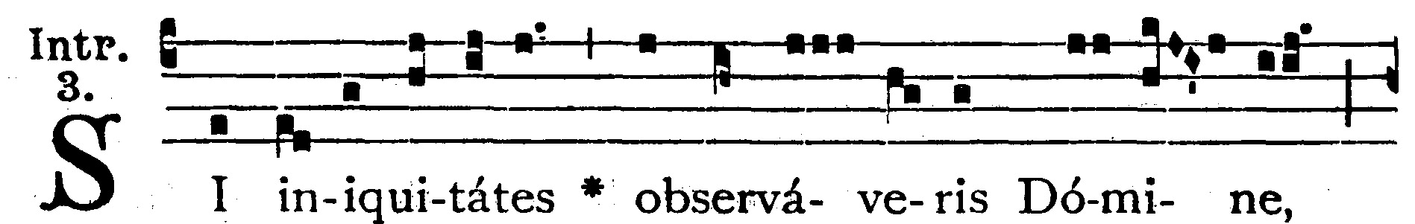
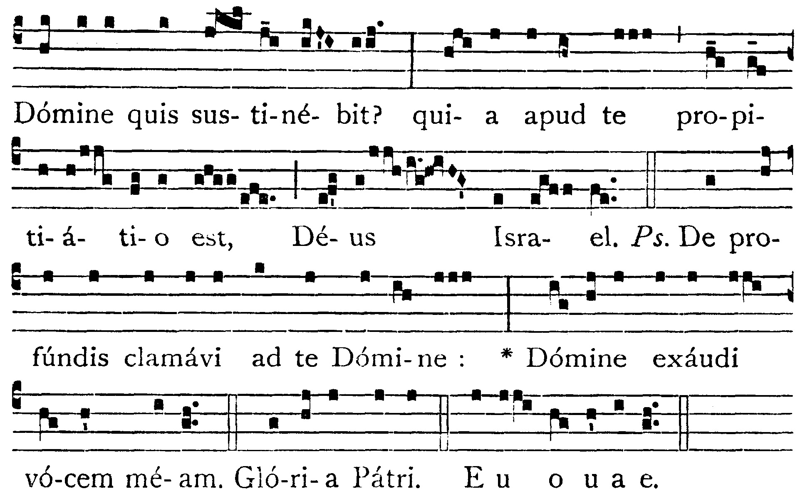
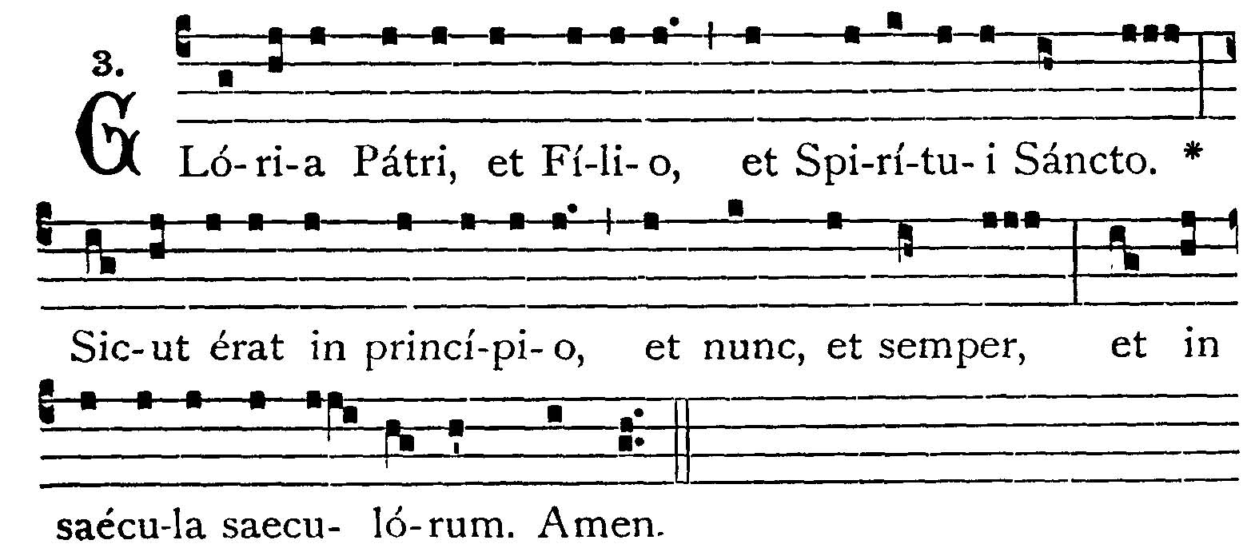
If Thou shalt observe iniquities, O Lord, Lord, who shall endure it? for with Thee is propitiation, O God of Israel. -- (Ps. 129. 1). From the depths I have cried to Thee, O Lord: Lord, hear my voice. V.: Glory to the Father . . . If Thou shalt observe iniquities, O Lord . . .


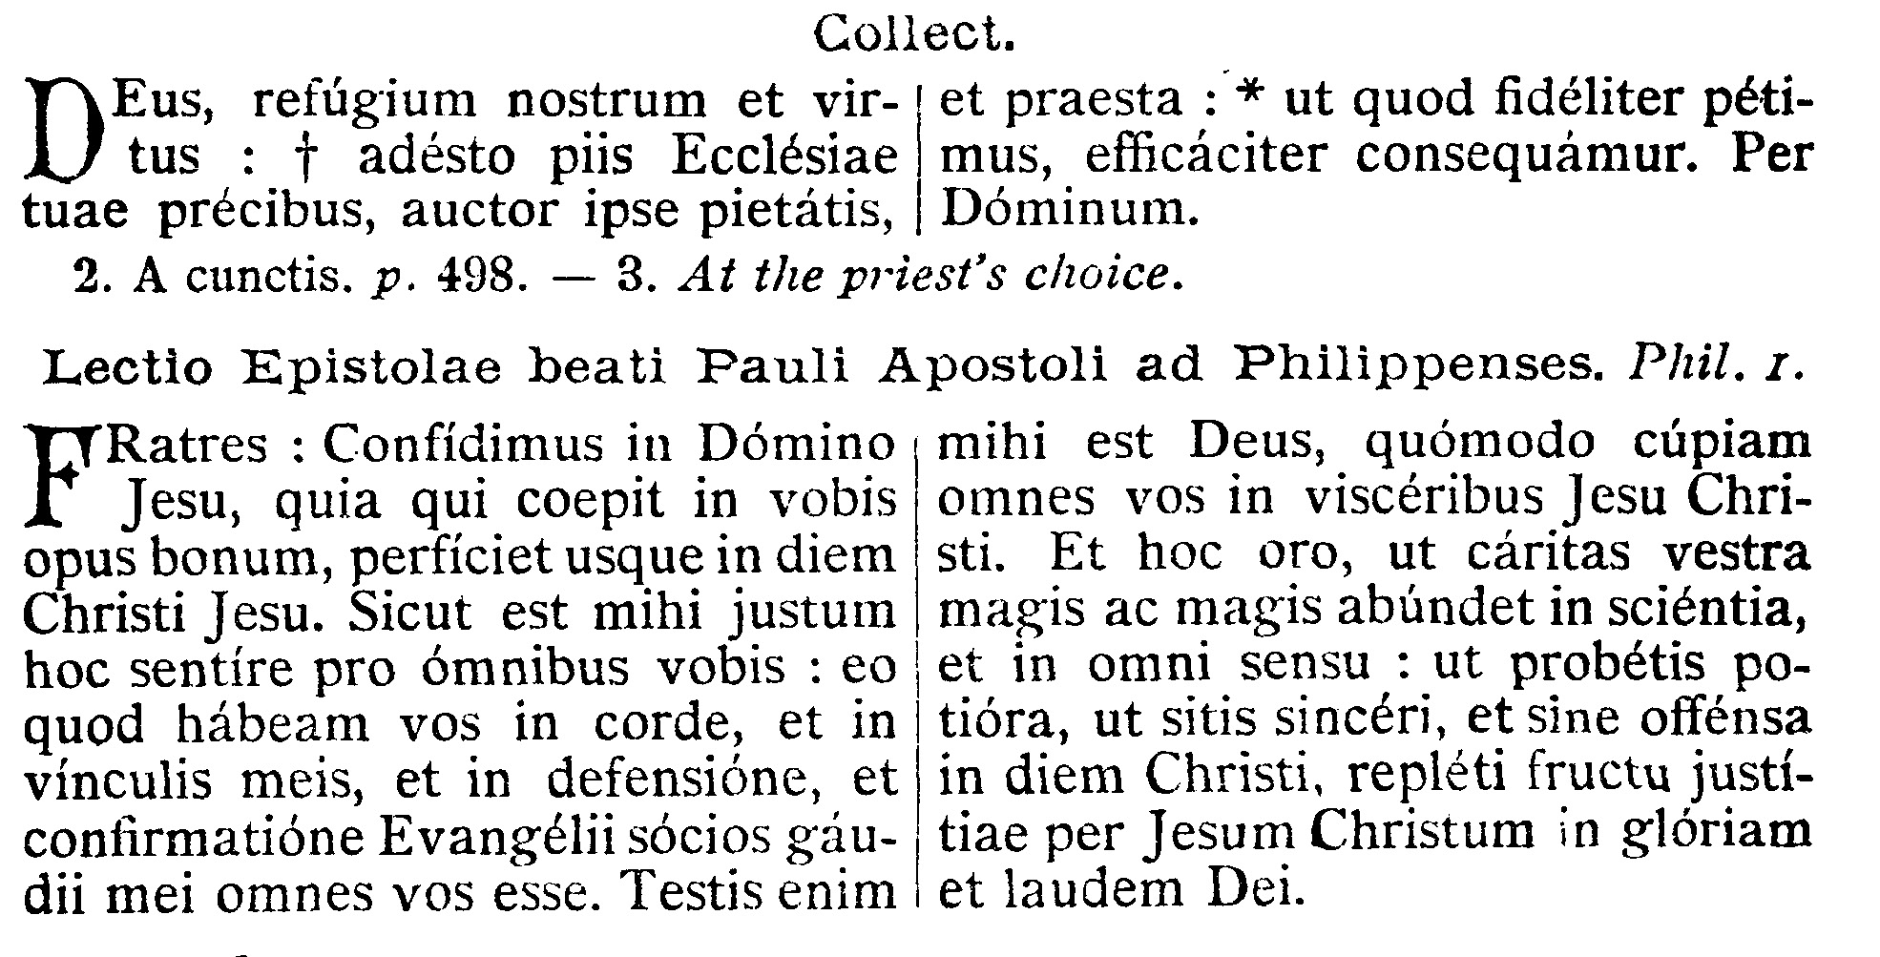

COLLECT.--O God, our refuge and our strength, who art the Author of all godliness, be ready to hear the devout prayers of the Church, and grant that what we ask faithfully we may obtain effectually. Thorugh our Lord Jesus Christ, Thy Son, who liveth and reigneth with Thee in the unity of the Holy Ghost . . .

EPISTLE ¤ Philippians 1. 6-11
Lesson from the Epistle of Blessed Paul the Apostle to the Philippians.
[Let us be sincere and without offense unto the day of Christ; "filled with the fruit of justice through Jesus Christ."]
Brethren, We are confident in the Lord Jesus, that He who hath begun a good work in you, will perfect it unto the day of Christ Jesus. As it is meet for me to think this for you all, for that I have you in my heart, and that in my bands, and in the defense and confirmation of the Gospel, you are all partakers of my joy. For God is my witness, how I long after you all in the bowels of Jesus Christ. And this I pray, that your charity may more and more abound in knowledge and in all understanding; that you may approve the better things; that you may be sincere and without offense unto the day of Christ: filled with the fruit of justice, through Jesus Christ unto the glory and praise of God.

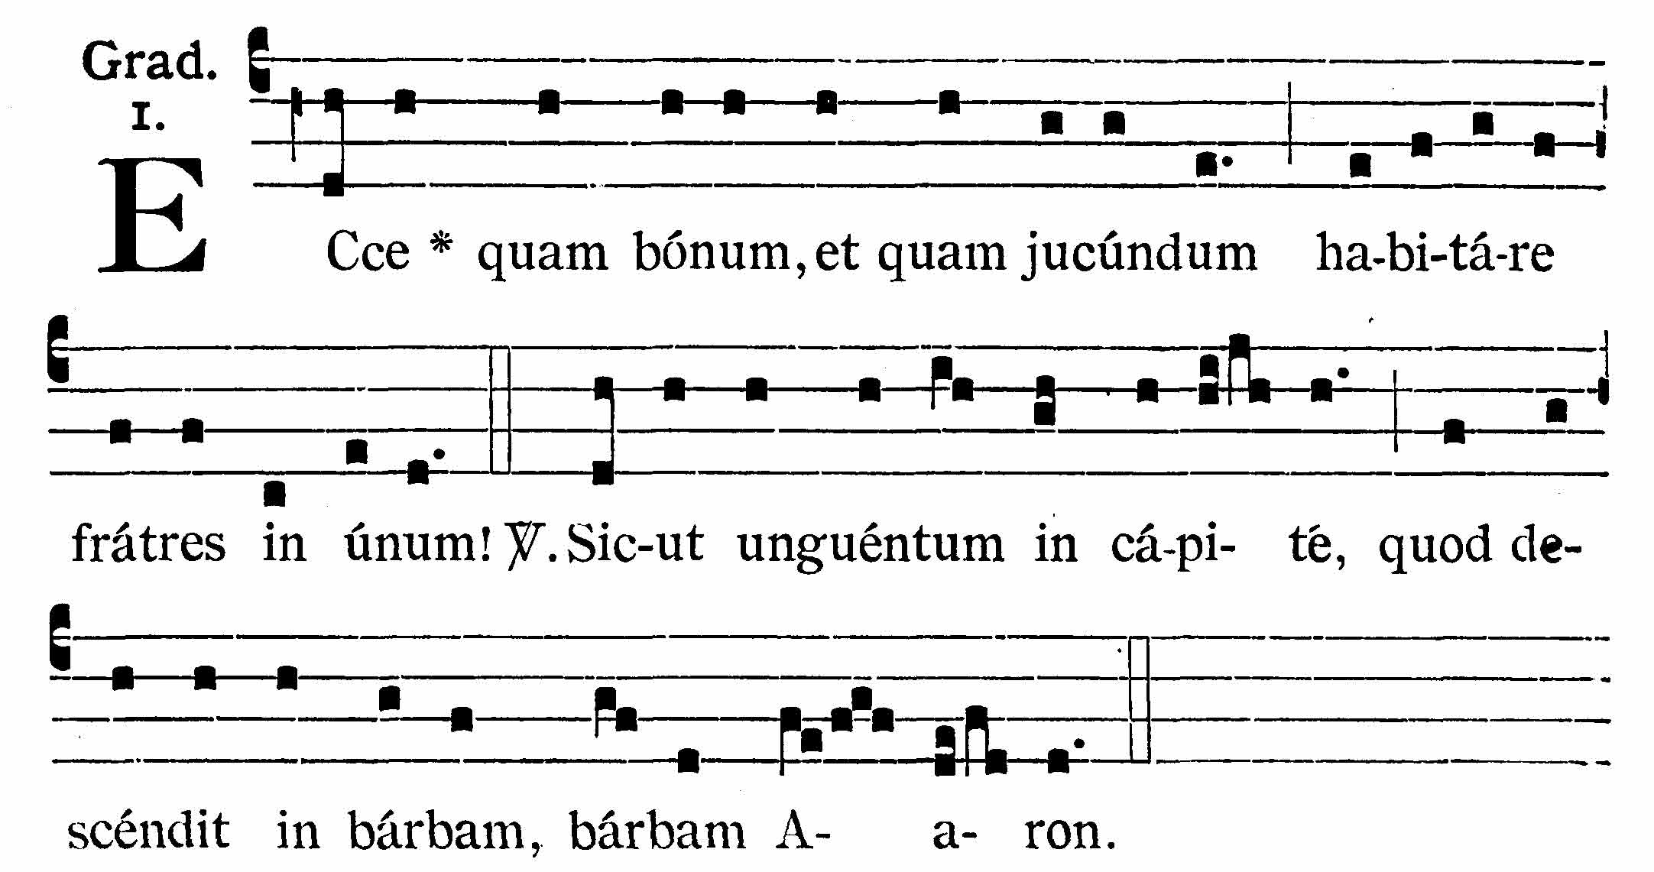
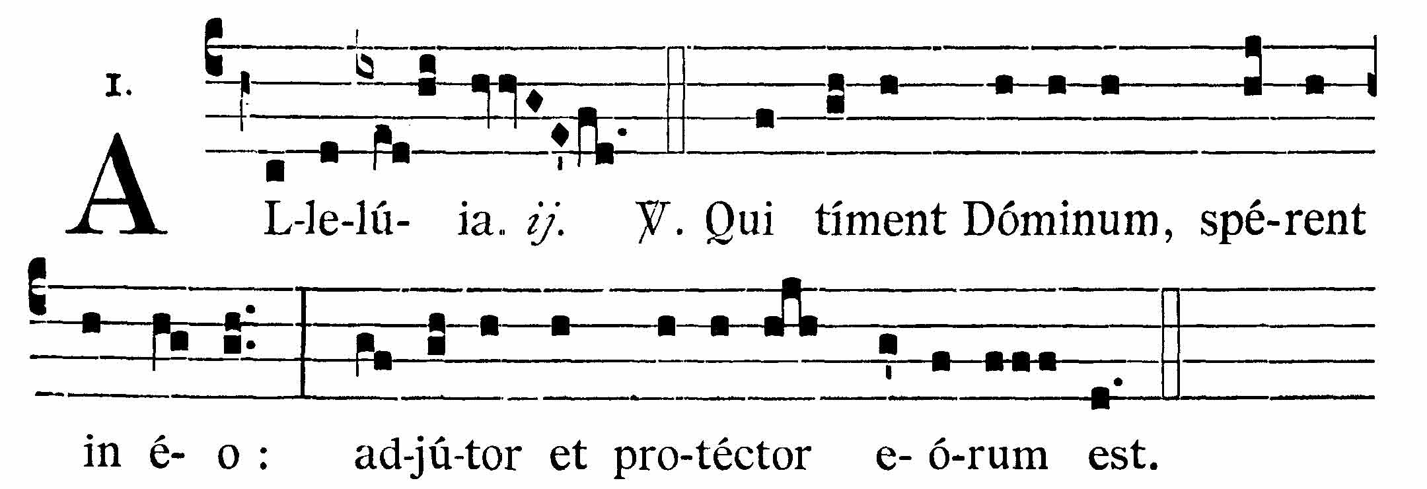
Behold how good and how pleasant it is for brethren to dwell together in unity. V.: It is like the precious ointment on the head, that ran down upon the beard, the beard of Aaron.
Alleluia, alleluia. V. (Ps. 113. 11). They that fear the Lord, let them hope in Him; He is their helper and protector. Alleluia.



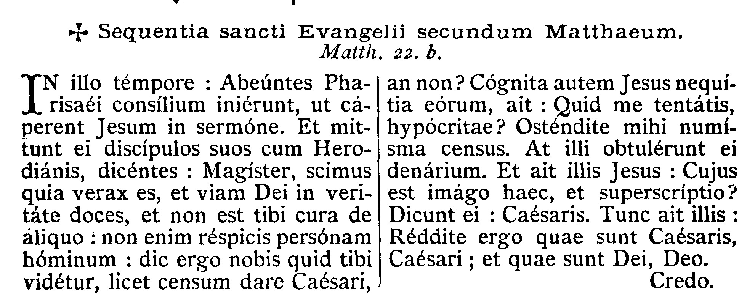
GOSPEL ¤ Matt. 22. 15-21
† Continuation of the holy Gospel according to St. Matthew.
[Jesus confounds the Pharisees, His enemies, who more than ever are compassing His ruin. His reply is full of divine wisdom.]
At that time, the Pharisees went and consulted among themselves, how to ensnare Jesus in His speech. And they sent to Him their disciples, with the Herodians, saying: Master, we know that Thou art a true speaker, and teachest the way of God in truth, neither carest Thou for any man, for Thou dost not regard the person of men. Tell us therefore, what dost Thou think? Is it lawful to give tribute to Caesar, or not? But Jesus knowing their wickedness, said: Why do you tempt Me, ye hypocrites? Show me the coin of the tribute. And they offered Him a penny. And Jesus saith to them: Whose image and superscription is this? They say to Him: Caesar's. The He saith to them: Render therefore to Caesar the things that are Caesar's, and to God the things that are God's.

Priest: Dominus Vobiscum
All: Et Cum Spirtu tuo
Preist: Oremus:

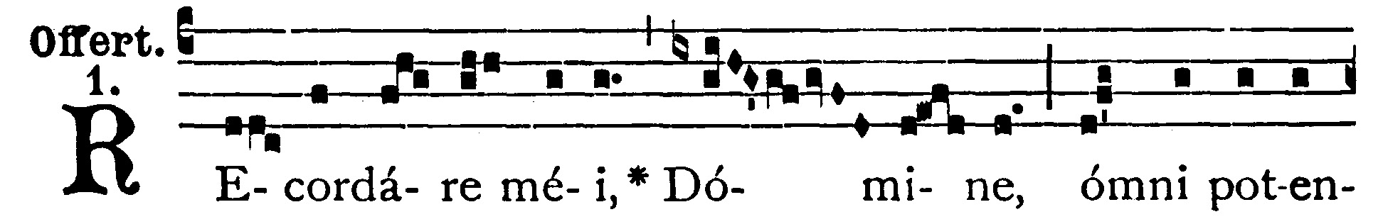
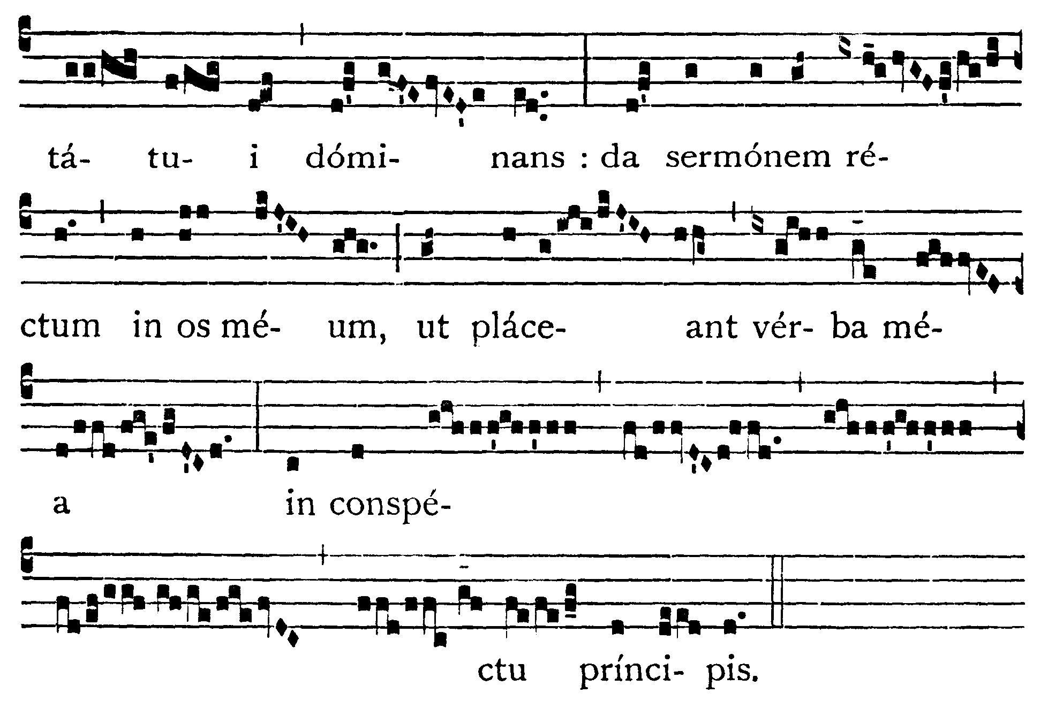
Remember me, O Lord, Thou who rulest above all power; and give a well-ordered speech in my mouth, that my words may be pleasing in the sight of the prince.

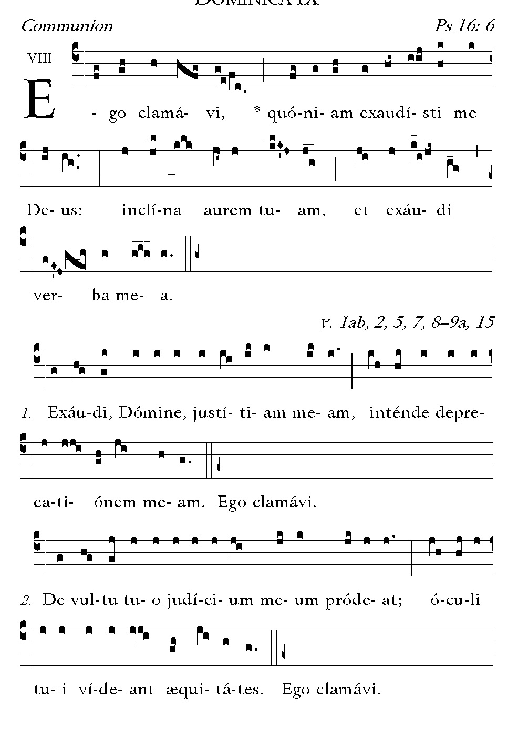
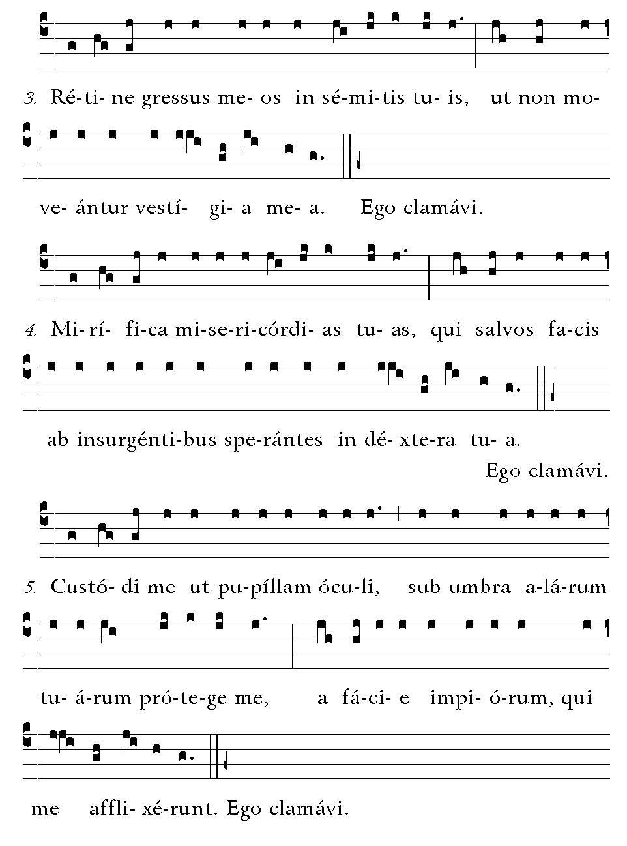
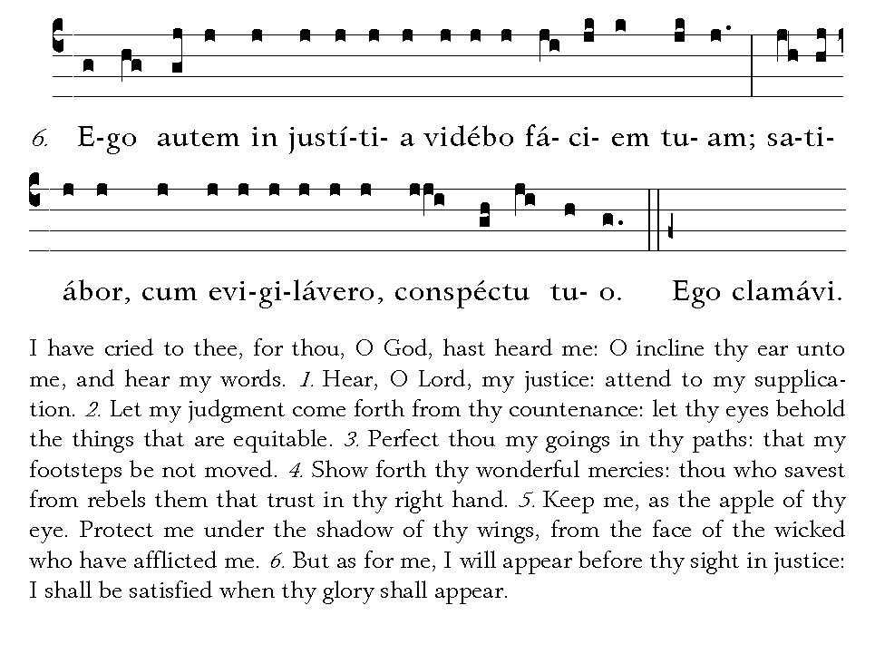

Post Communion
Deo Gratias

