23rd Sunday After Pentecost
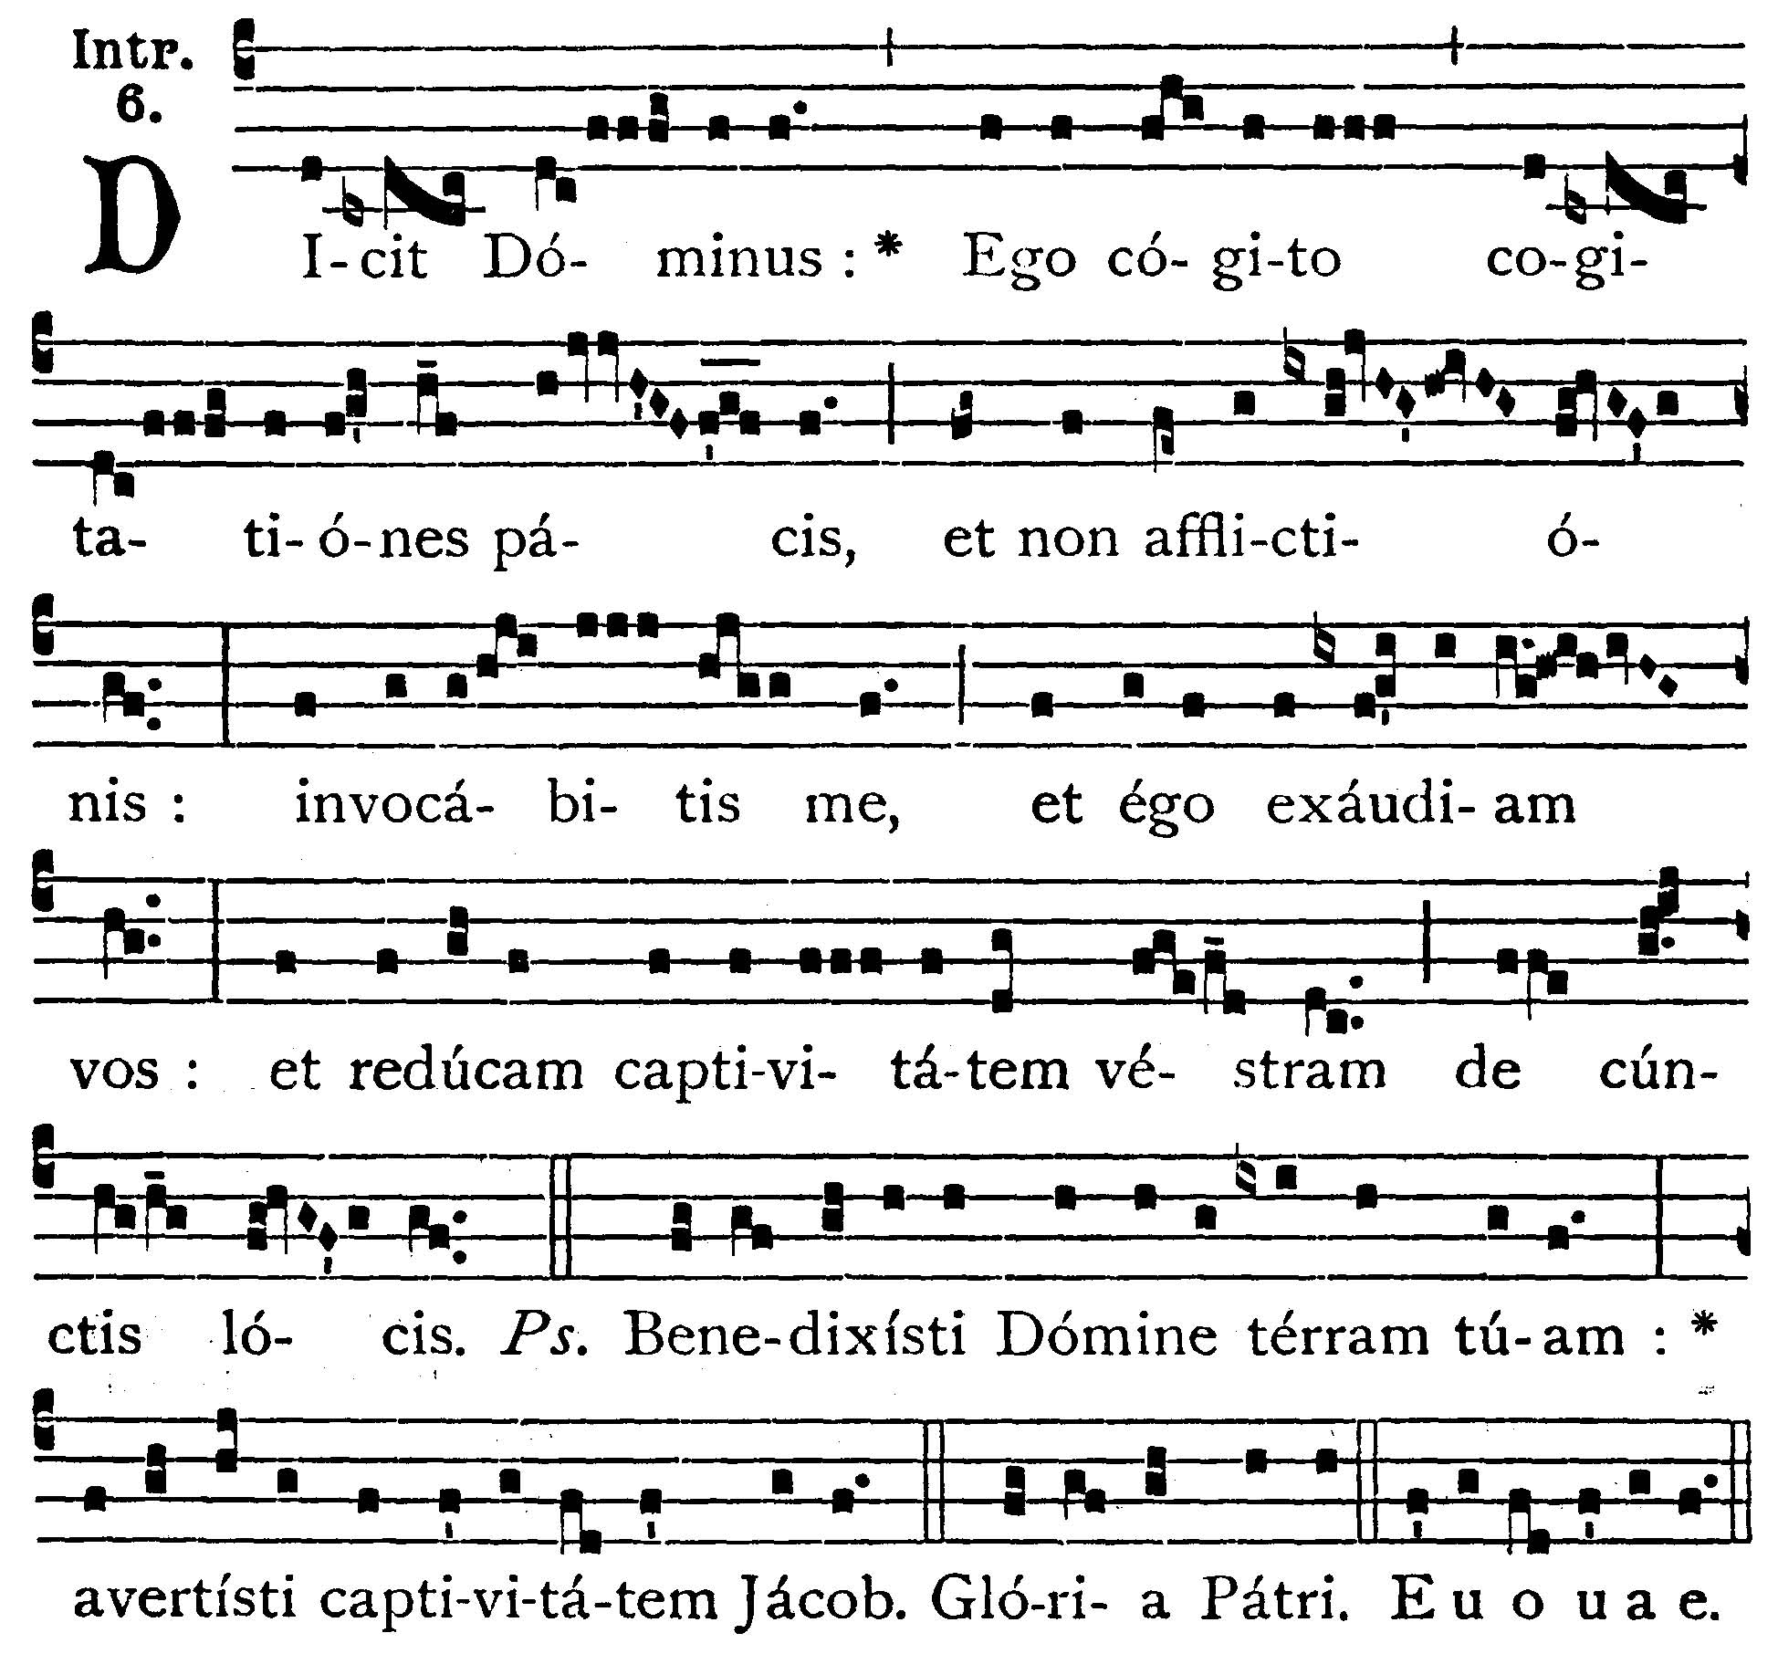
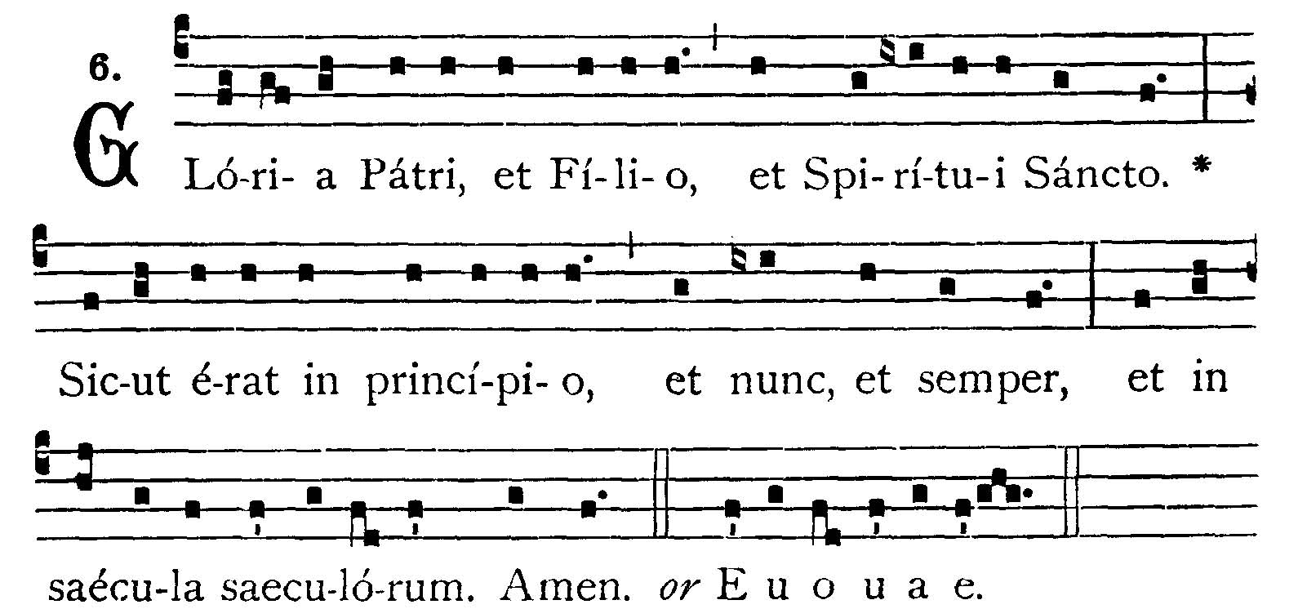
The Lord saith: I think thoughts of peace, and not of affliction: you shall call upon Me, and I will hear you; and I will bring back your captivity from all places. -- (Ps. 84. 2). Lord, Thou hast blessd Thy land: Thou hast turned away the captivity of Jacob. V.: Glory be to the Father, to the Son, and to the Holy Ghost. As it was in the beginning, is now, and ever shall be, world without end, amen. -- The Lord saith: I think thoughts of peace , and not of affliction: you shall call upon Me, and I will hear you; and I will bring back your captivity from all places.



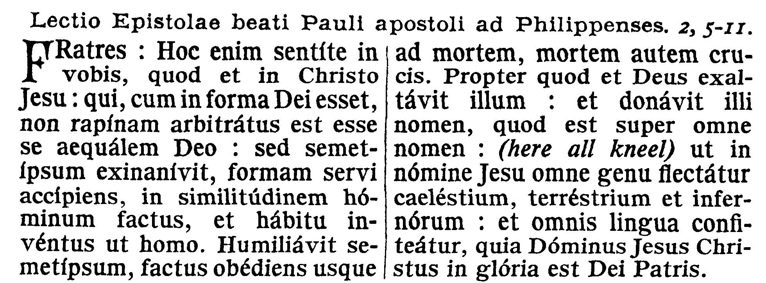
Collect
O Lord, we beseech Thee, absolve Thy people from their offenses, that through Thy bountiful goodness, we may be freed from the bonds of those sins, which by our frailty we have committed. Through our Lord Jesus Christ, Thy Son, who liveth and reigneth in the unity of the Holy Ghost, God, world without end.

EPISTLE ¤ Philippians 3. 17-21; 4. 1-3
Lesson from the Epistle of Blessed Paul the Apostle to the Philippians.
Lectio Epistolae beati Pauli Apostoli ad Philippenses.
[Destruction is the end of those who are enemies of the Cross.]
Brethren, Be followers of me, and observe them who walk so as you have our model. For many walk, of whom I have told you often (and now tell you weeping), that they are enemies of the Cross of Christ; whose end is destruction, whose God is their belly, and whose glory is in their shame; who mind earthly things. But our conversation is in heaven, from whence also we lookd for the Savior, our Lord Jesus Christ, who will reform the body of our lowness, made like to the body of His glory, according to the operation whereby also He is able to subdue all things unto Himself. Therefore, my brethren, dearly beloved, and most desired, my joy and my crown: so stand fast in the Lord, my dearly beloved. I beg of Evodia, and I beseech Syntyche to be of one mind in the Lord: and I entreat thee also, my sincere companion, help those women who have labored with me in the Gospel, with Clement and the rest of my fellow-laborers, whose names are in the book of life.
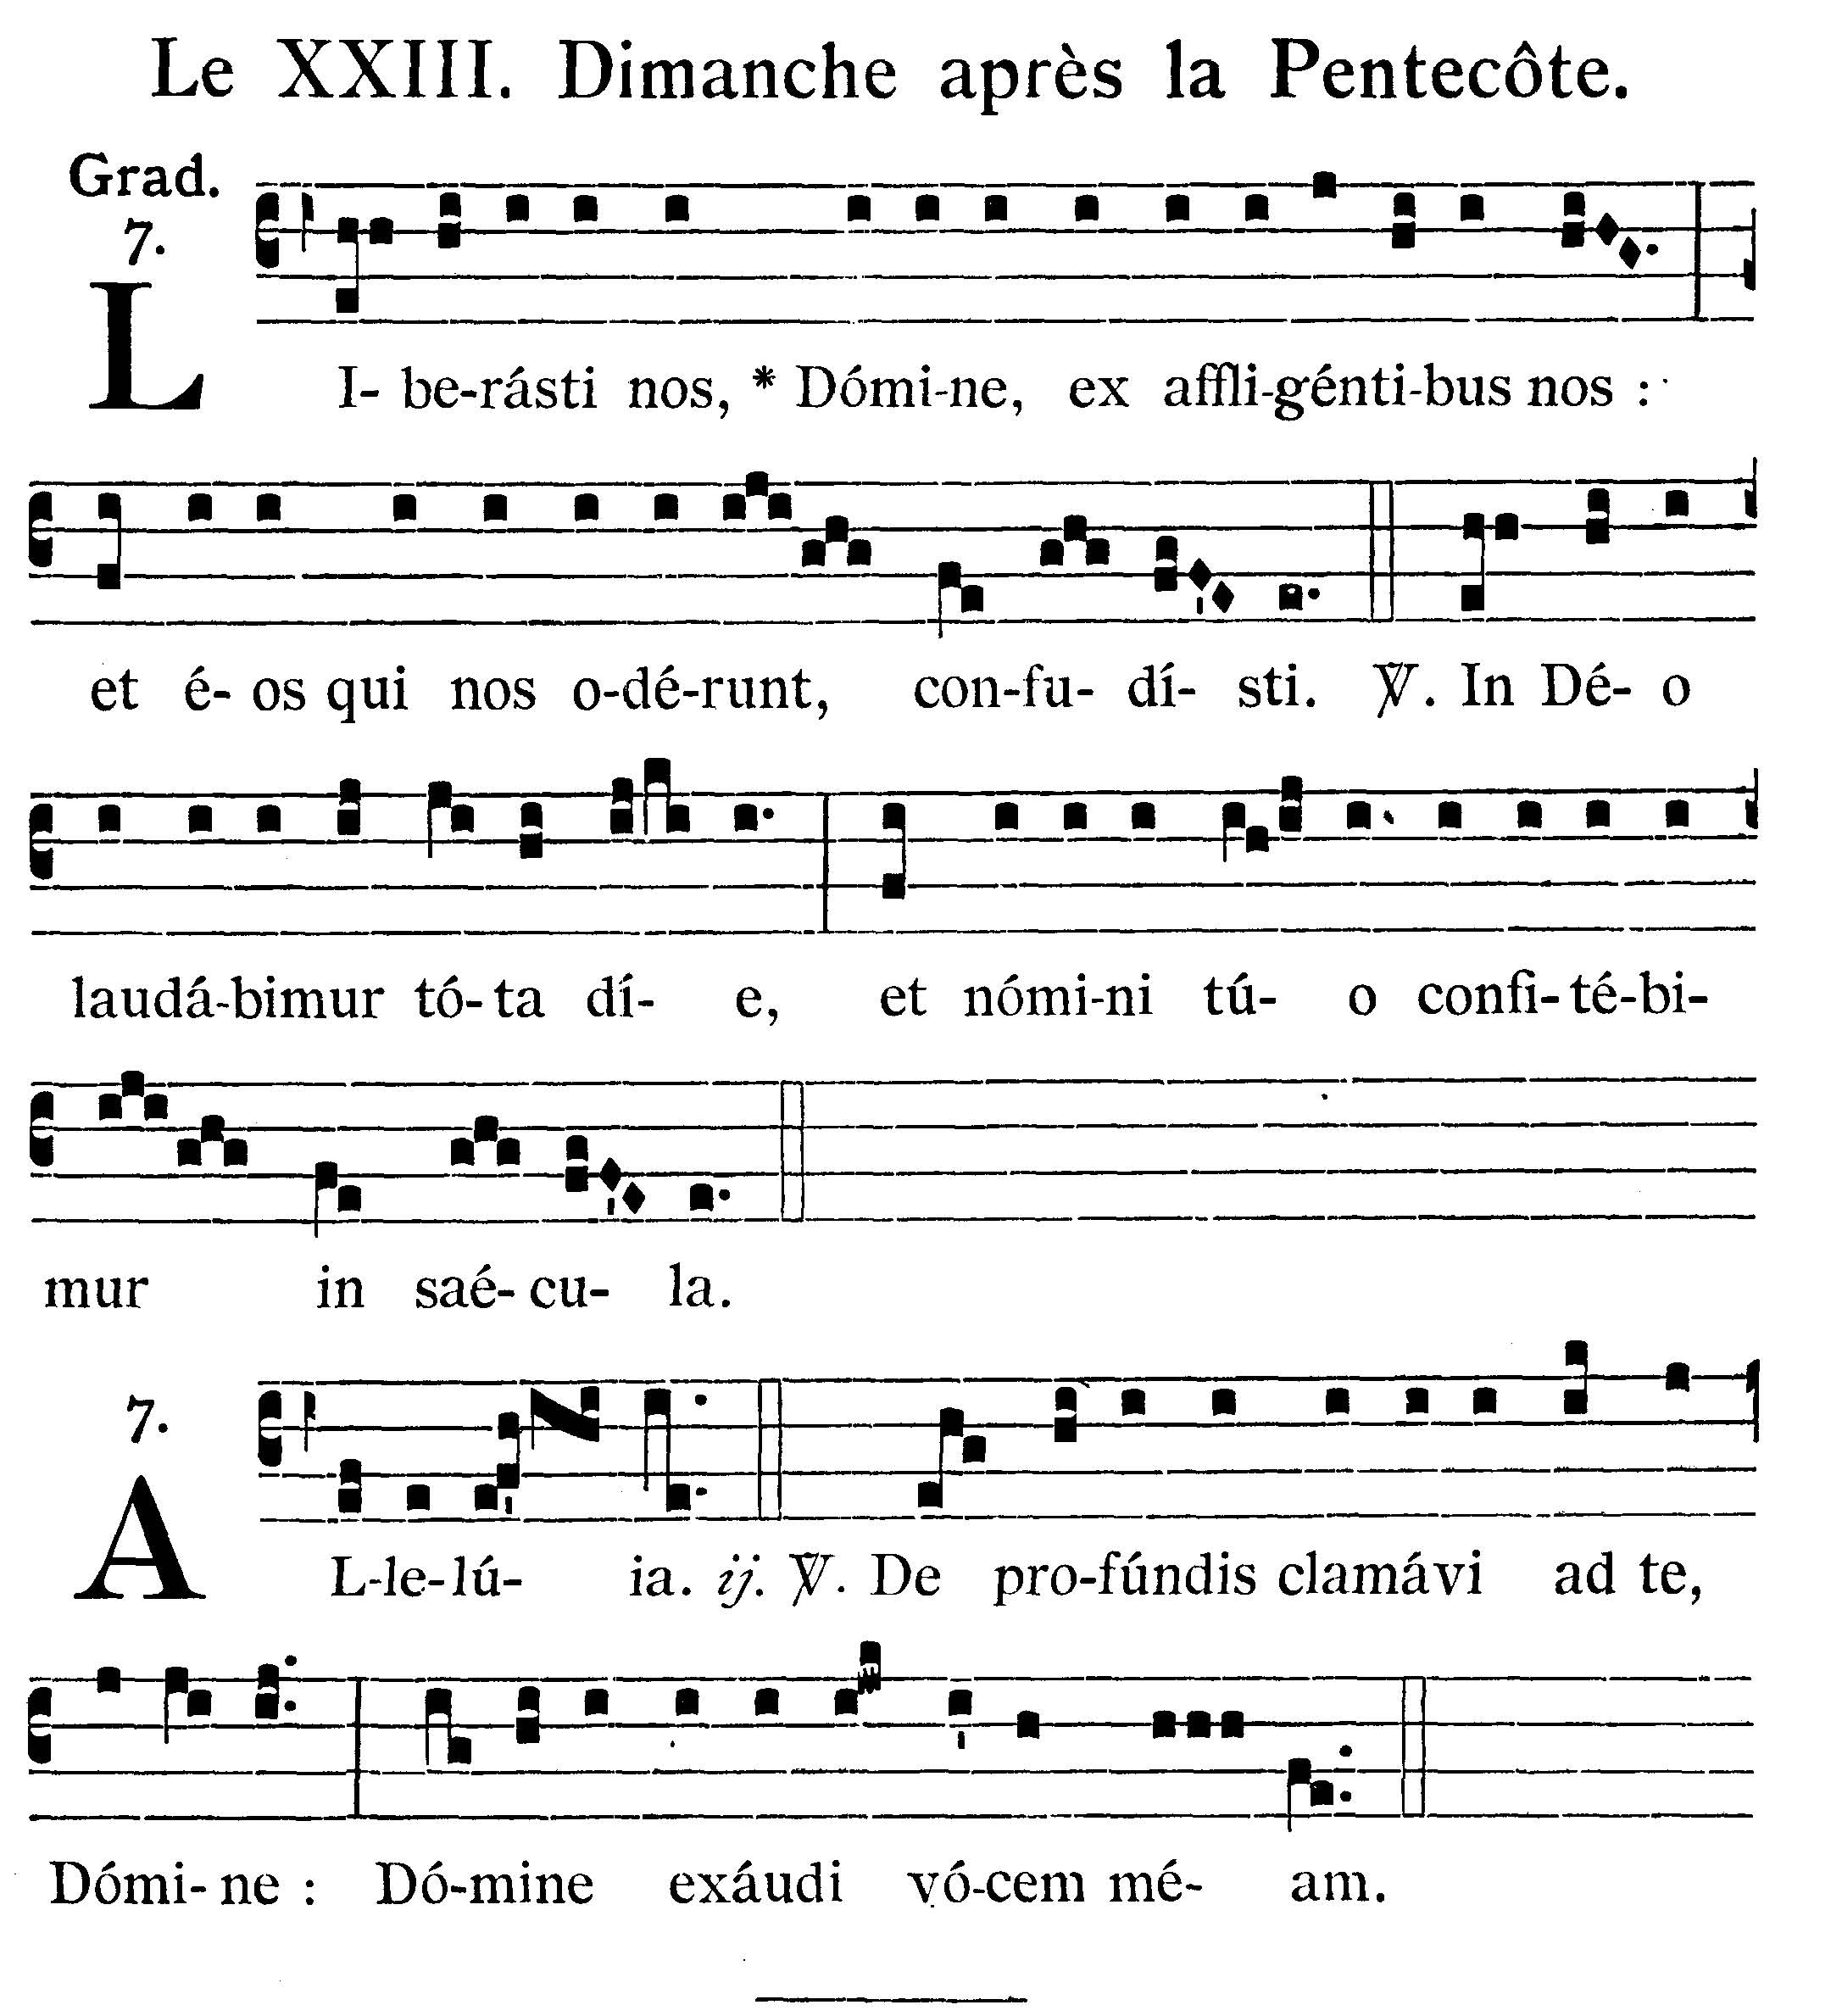
Thou hast delivered us, O Lord, from them that afflict us: and hast put them to shame that hate us. V.: In God we will glory all the day: and in Thy Name we will give praise for ever.
Alleluia, alleluia. V. (Ps. 129. 1, 2). From the depths I have cried to Thee, O Lord: Lord, hear my prayer. Alleluia.



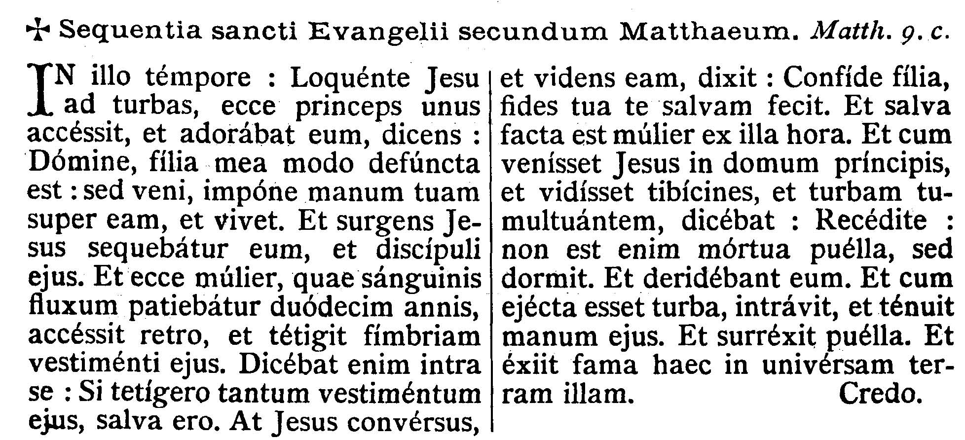
GOSPEL ¤ Matt. 9. 18-26
† Continuation of the holy Gospel according to St. Matthew.
† Sequentia sancti Evangelii secundum Matthaeum.
[Healing of a woman troubled with an issue of blood, and resurrection of the ruler's daughter.]
At that time, as Jesus was speaking to the multitudes, behold a certain ruler came up, and adored Him, saying: Lord, my daughter is even now dead; but come lay Thy hand upon her, and she shall live. And Jesus, rising up, followed him, and with His disciples. And behold a woman, who was troubled with an issue of blood twelve years, came behind Him, and touched the hem of His garment. For she said within herself: If I shall touch only His garment, I shall be healed. But Jesus turning and seeing her, said: Be of good heart, daughter, thy faith hath made thee whole. And the woman was made whole from that hour. And when Jesus was come into the house of the ruler, and saw the minstrels and the multitude making a tumult, He said: GIve place; for the girl is not dead, but sleepeth. And they laughed Him to scorn. And when the multitude was put forth, He went in and took her by the hand. And the maid arose. And the fame thereof went abroad into all that country.

Priest: Dominus Vobiscum
All: Et Cum Spirtu tuo
Preist: Oremus:

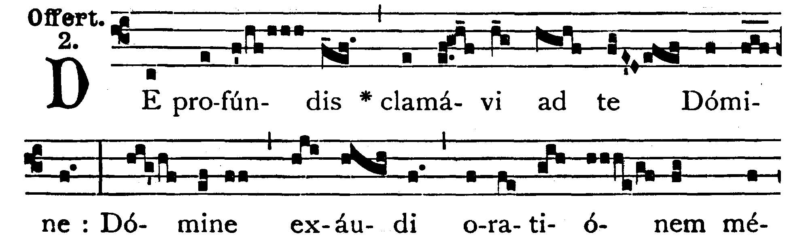
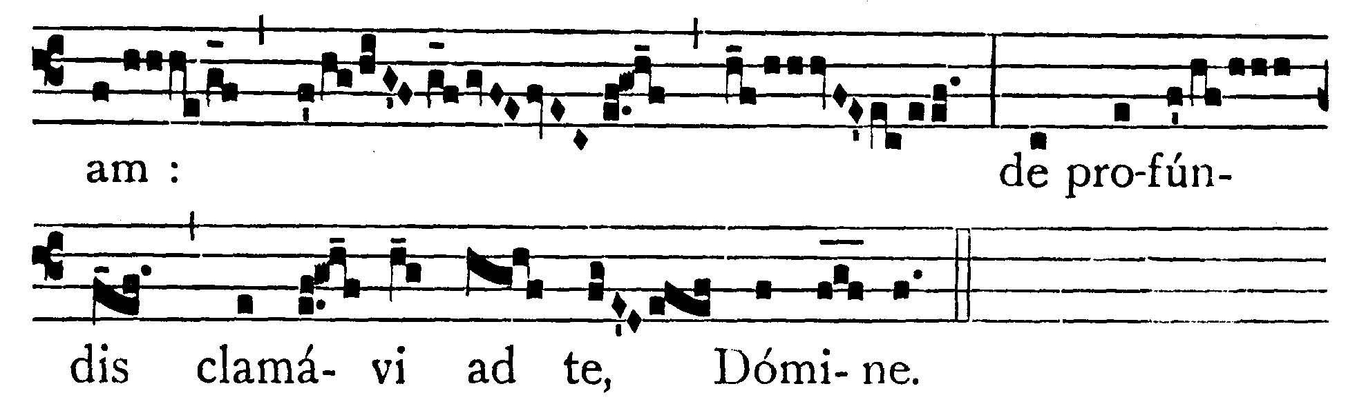
From the depths I have cried out to Thee, O Lord; Lord, hear my prayer: from the depths I have cried out to Thee, O Lord.

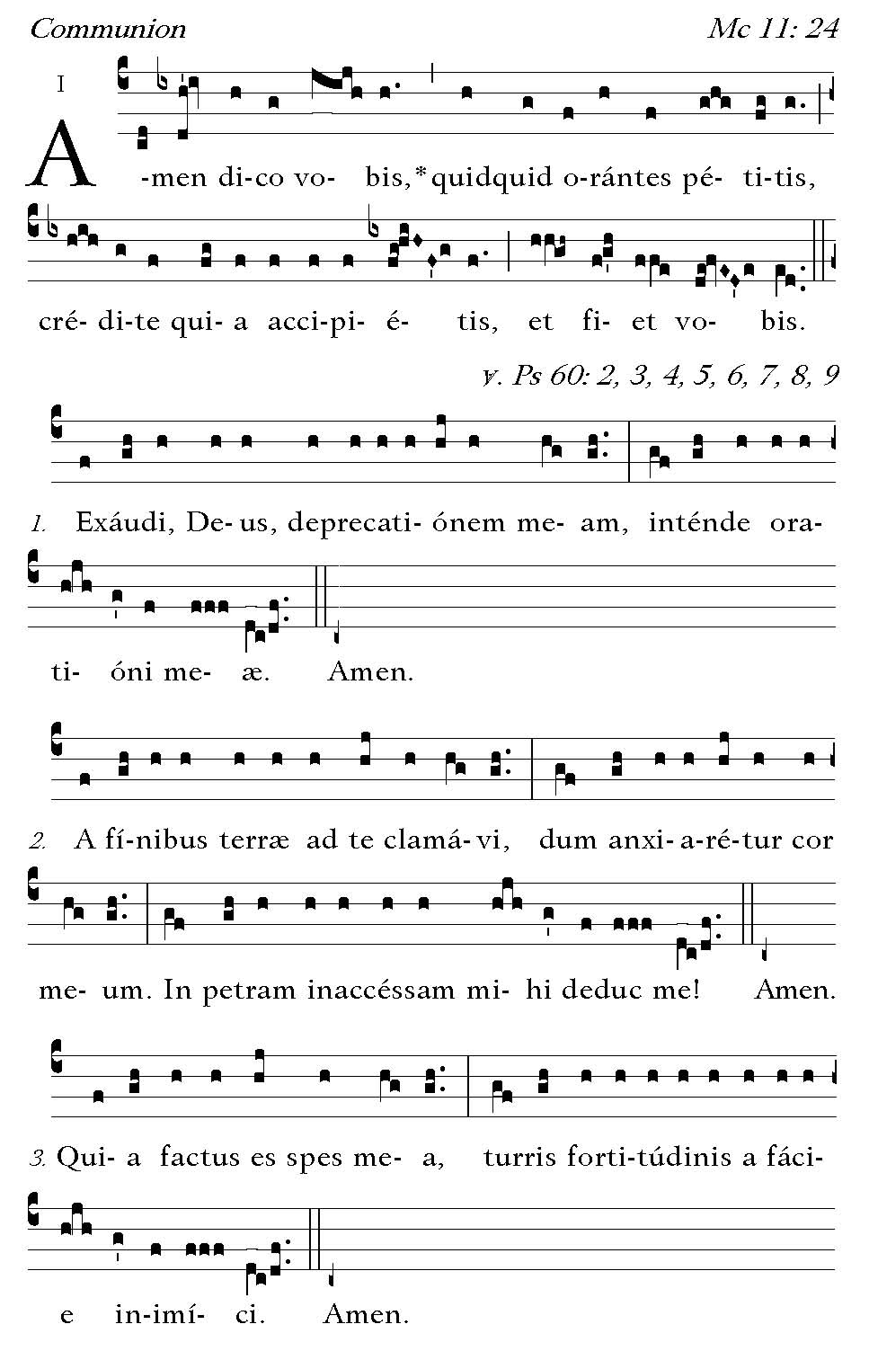
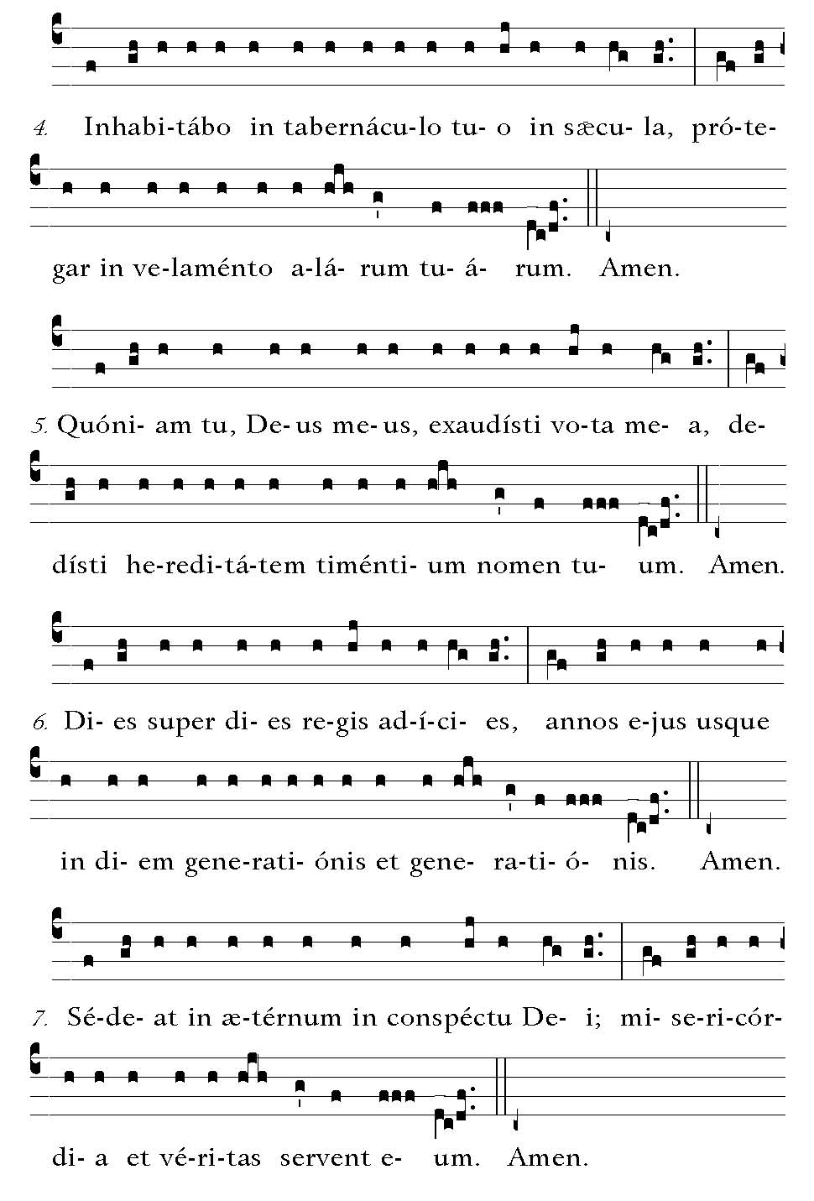
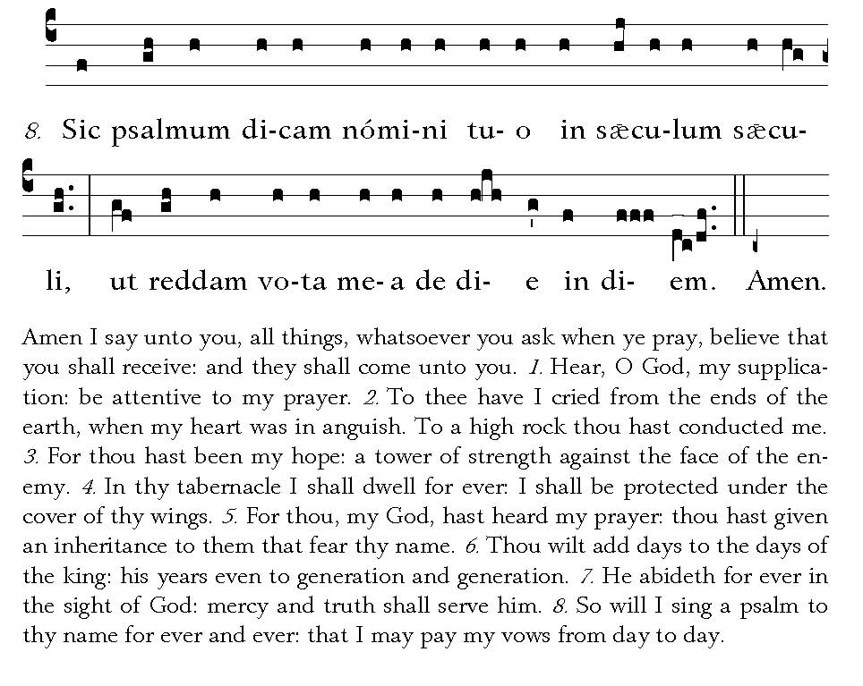

POSTCOMMUNION
Quaesumus, omnipotens Deus: ut quos divina tribuis participatione gaudere, humanis non sinas subiacere perculis. Per Dominum nostrum, Iesum Christum, filium tuum, qui tecum vivit et regnat in unitate Spiritus Sancti, Deus, per omnia saecula saeculorum.

We beseech Thee, O almighty God: that Thou suffer us not to yield to human dangers whom Thou dost grant to rejoice in this sharing in divine Gifts. Through our Lord Jesus Christ, Thy Son, who liveth and reigneth with Thee in the unity of the Holy Ghost, God, world without end.

Deo Gratias

