2nd Sunday of Advent
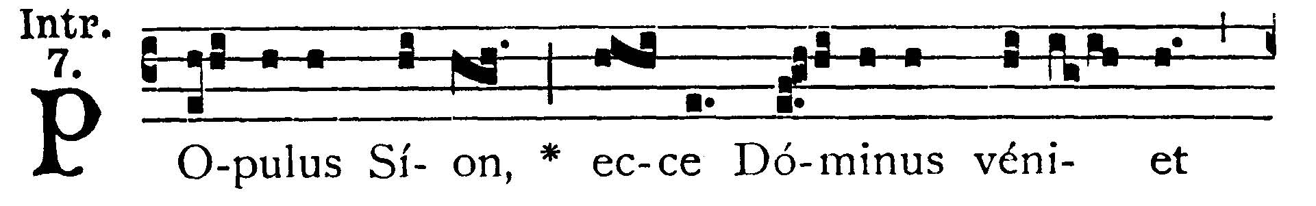
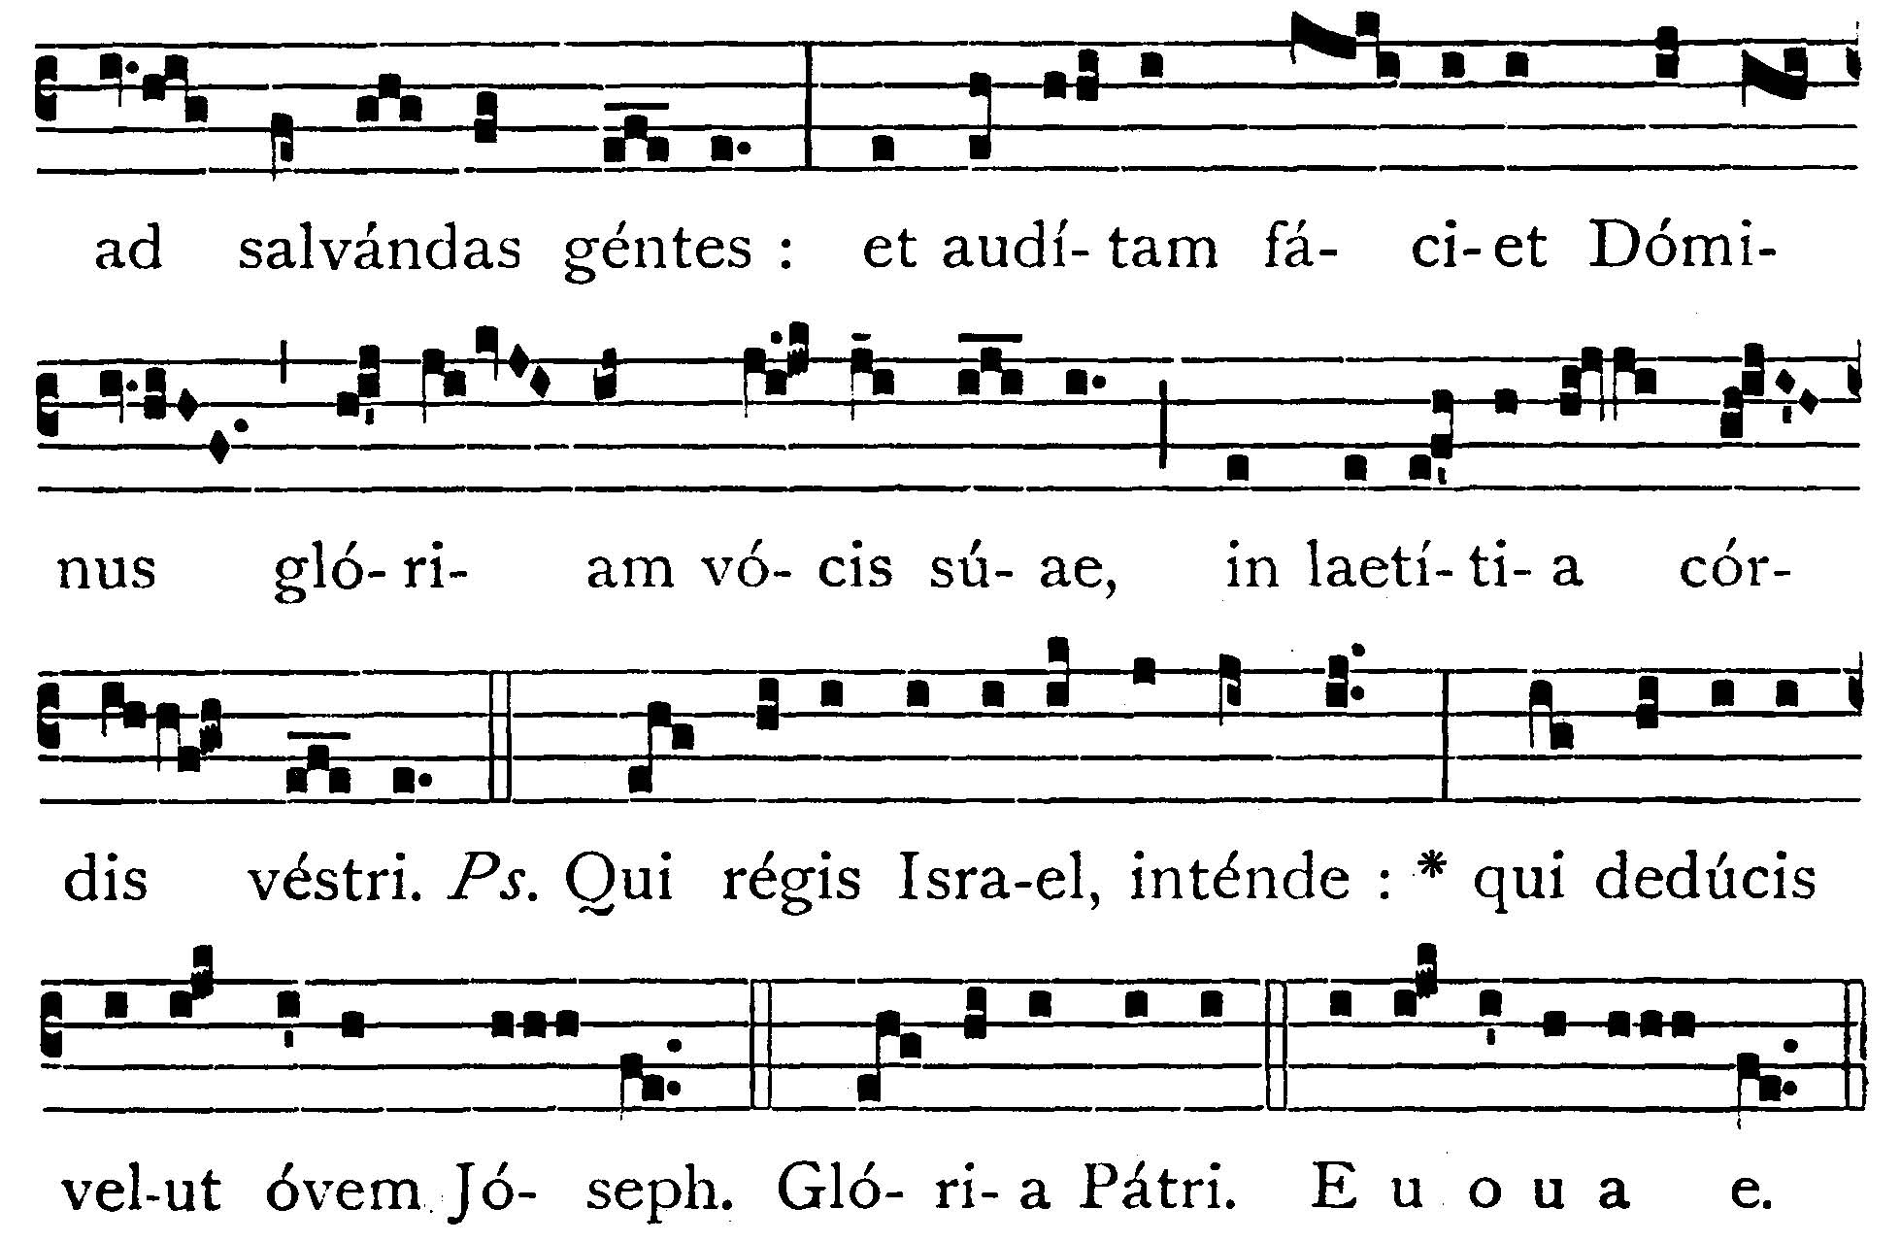
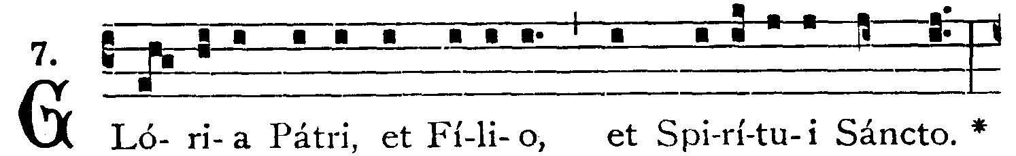
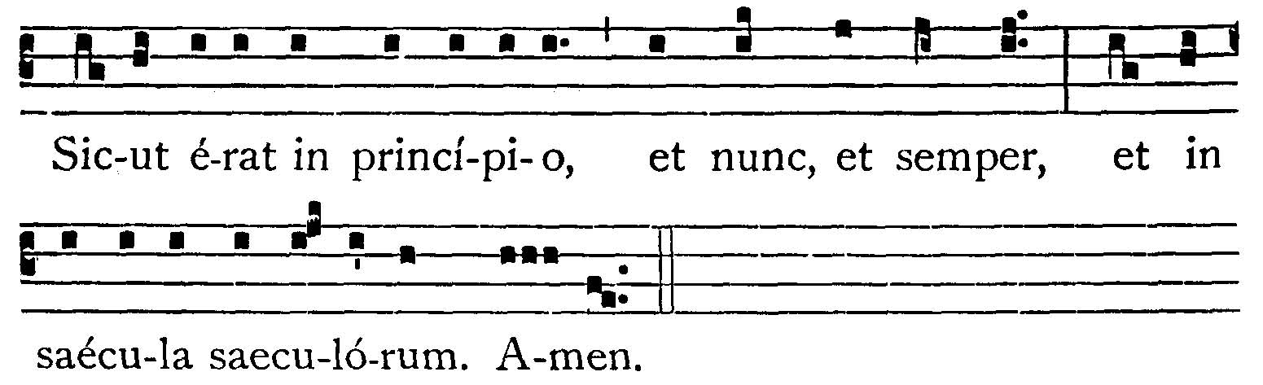
People of Sion, behold the Lord shall come to save the nations: and the Lord shall make the glory of His voice to be heard, in the joy of your heart. -- (Ps. 79. 2). Give ear, O Thou that rulest Israel: Thou that leadest Joseph like a sheep. V.: Glory to the Father . . . -- People of Sion . . .



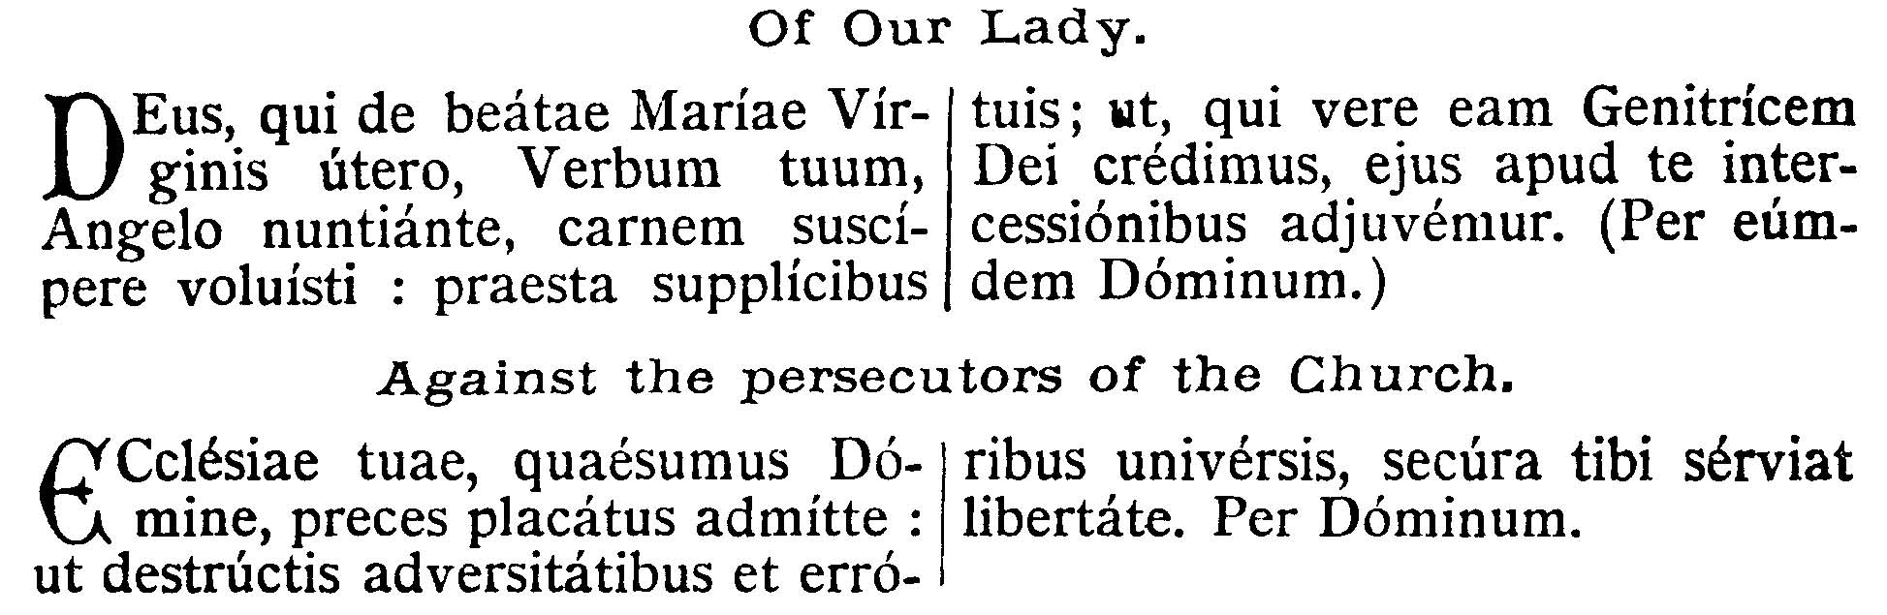
COLLECT - Stir up our hearts, O Lord, to prepare the way of Thine only-begotten Son: that through His coming we may attain to serve Thee with purified minds. Who liveth and reigneth, with God the Father, in the unity of the Holy Ghost, God . . .
EPISTLE ¤ Rom. 15. 4-13
Lesson from the Epistle of Blessed Paul the Apostle to the Romans.
Lectio Epistolae beati Pauli Apostoli ad Romanos.
["A root of Jesse shall rise up" for the salvation of the Hebrews and Gentiles.]
Fratres: Quaecumque scripta sunt, ad nostram doctrinam scripta sunt: ut per patientiam, et consolationem Scripturarum, spem habeamus. Deus autem patientiae, et solatii, det vobis idipsum sapere in alterutrum secundum Iesum Christum: ut unanimes, uno ore honorificetis Deum et Patrem Domini nostri Iesu Christi. Propter quod suscipite invicem, sicut et Christus suscepit vos in honorem Dei. Dico enim Christum Iesum ministrum fuisse circumcisionis propter veritatem Dei, ad confirmandas promissiones patrum: gentes autem super misericordia honorare Deum, sicut scriptum est: Propterea confitebor tibi in gentibus, Domine, et nomini tui cantabo, cum plebe eius. Et iterum: Laudate omnes gentes Dominum: et magnificate eum omnes populi. Et rursus Isaias ait: Erit radix Iesse, et qui exsurget regere gentes, in eum gentes sperabunt. Deus autem spei credendo: ut abundetis in spe, et virtute Spiritus Sancti.

Brethren, What things soever were written, were written for our learning: that, through patience and the comfort of the Scriptures, we might have hope. Now the God of patience and of comfort grant you to be of one mind and with one mouth you may glorify the God and Father of our Lord Jesus Christ. Wherefore receive one another, as Christ also hath received you unto the honor of God. For I say that Christ Jesus was minister of the circumcision for the truth of God, to confirm the promises made unto the fathers: but that the Gentiles are to glorify God for His mercy, as it is written: Therefore will I confess to Thee, O Lord, among the Gentiles, and will sing to Thy Name. And again He saith: Rejoice, ye Gentiles, with His people. And again: Praise the Lord, all ye Gentiles, and magnify Him, all ye people. And again, Isaias saith: There shall be a root of Jesse; and He that shall rise up to rule the Gentiles, in Him the Gentiles shall hope. Now the God of hope fill you with all joy and peace in believing: that you may abound in hope, and in the power of the Holy Ghost.
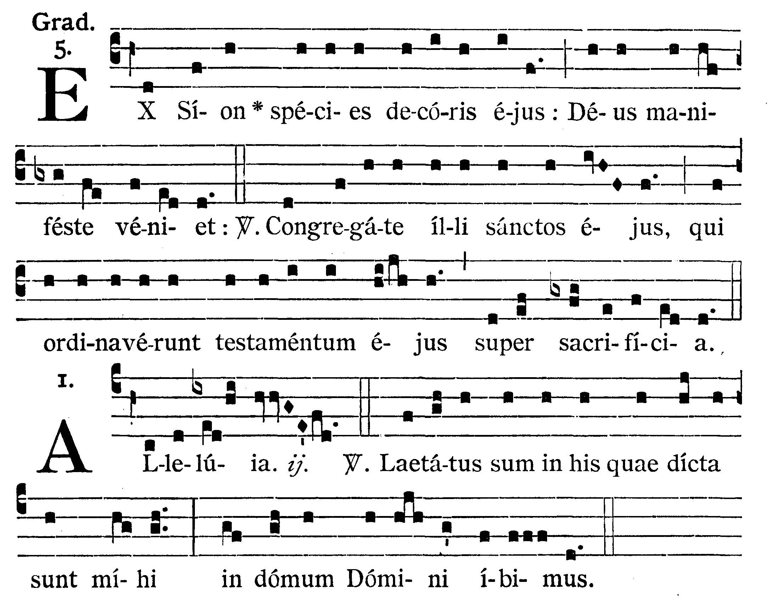
GRADUAL
Out of Sion, the loveliness of His beauty: God shall come manifestly. V.: Gather ye together His Saints to Him, who have set His covenant before sacrifices.
Alleluia, alleluia. V.: (Ps. 121. 1) I rejoiced at the things that were said to me: We shall go unto the house of the Lord. Alleluia.



GOSPEL ¤ Matthew 11. 2-10
† Continuation of the holy Gospel according to St. Matthew.
† Sequentia sancti Evangelii secundum Matthaeum.
[John the Baptist, sent "to prepare the way for the Messias," puts the question to Jesus: "Art Thou He that art to come?" Reply of Jesus to the Precursor.]

In illo tempore: Cum audisset Ioannes in vinculis opera Christi, mittens duos de discipulis suis, ait illi: Tu es, qui venturus es, an alium expectamus? Et respondens Iesus ait illis: Euntes renuntiate Ioanni, quae audistis, et vidistis. Caeci vident, claudi ambulant, leprosi mundantur, surdi audiunt, mortui resurgunt, pauperes evangelizantur: et beatus est, qui non fuerit scandalizatus in me. Illis autem abeuntibus, coepit Iesus dicere ad turbas de Ioanne: Quid existis in desertum videre? arundinem vento agitatam? Sed quid existis videre? hominem mollibus vestitum? Ecce qui mollibus vestiuntur, in domibus regum sunt. Sed quid existis videre? prophetam? Etiam dico vobis, et plus quam prophetam. Hic est enim de quo scriptum est: Ecce ego mitto Angelum meum ante faciem tuam, qui praeparabit viam tuam ante te.

At that time, when John had heard in prison the works of Christ, sending two of his disciples, he said to Him: Art thou He that art to come, or look we for another? And Jesus, making answer, said to them: Go and relate to John what you have heard and seen. The blind see, the lame walk, the lepers are cleansed, the deaf hear, the dead rise again, the poor have the gospel preached to them: and blessed is he that shall not be scandalized in Me. And when they went their way, Jesus began to say to the multitudes concerning John: What went you out into the desert to see? A reed shaken with the wind? But what went you out to see? A man clothed in soft garments? Behold they that are clothed in soft garments are in the houses of kings. But what went you out to see? A prophet? Yea I tell you, and more than a prophet. For this is he of whom it is written: Behold, I send my Angel before Thy face, who shall prepare Thy way before Thee.

Priest: Dominus Vobiscum
All: Et Cum Spirtu tuo
Preist: Oremus:

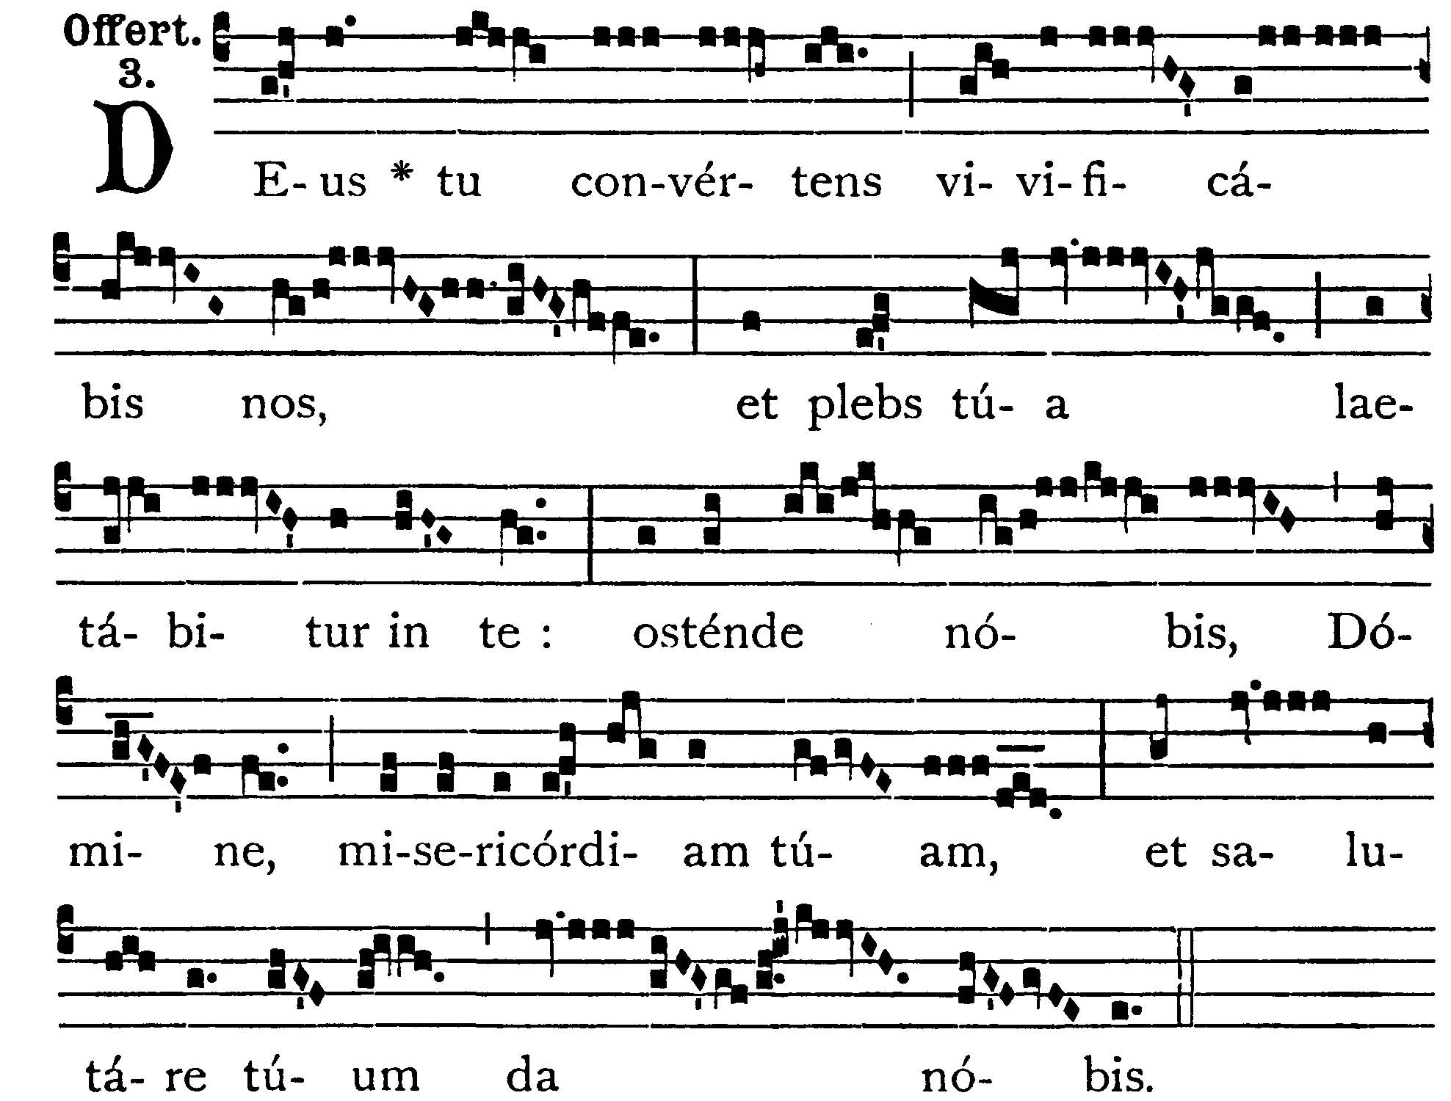

OFFERTORY
Thou wilt turn, O God, and bring us to life, and Thy people shall rejoice in Thee: show us, O Lord, Thy mercy, and grant us Thy salvation.

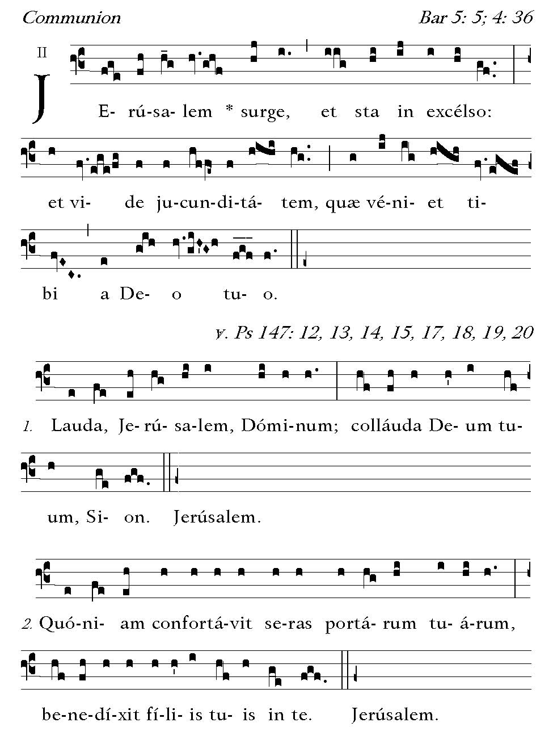
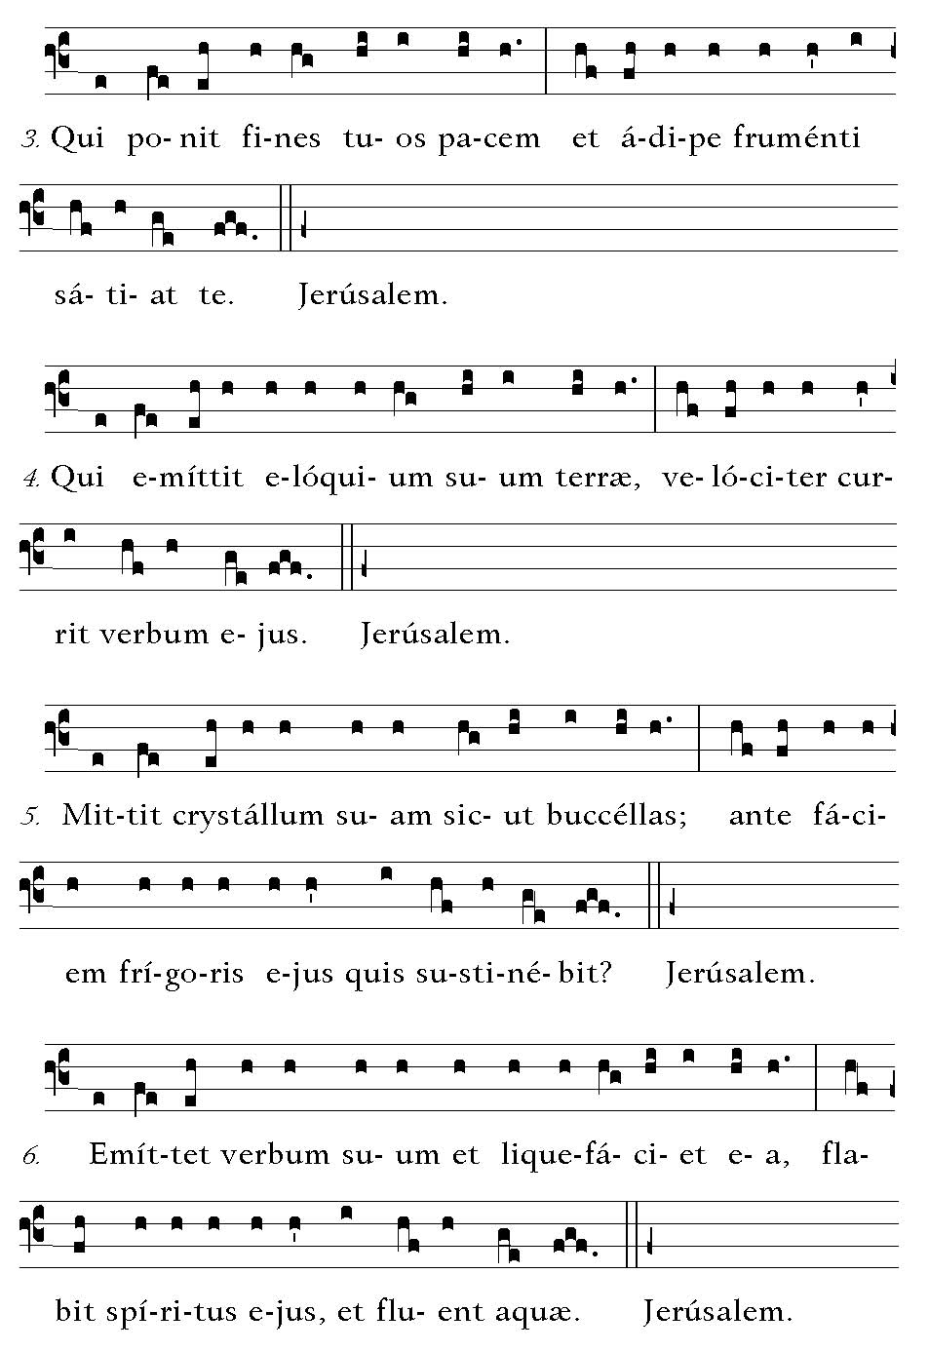
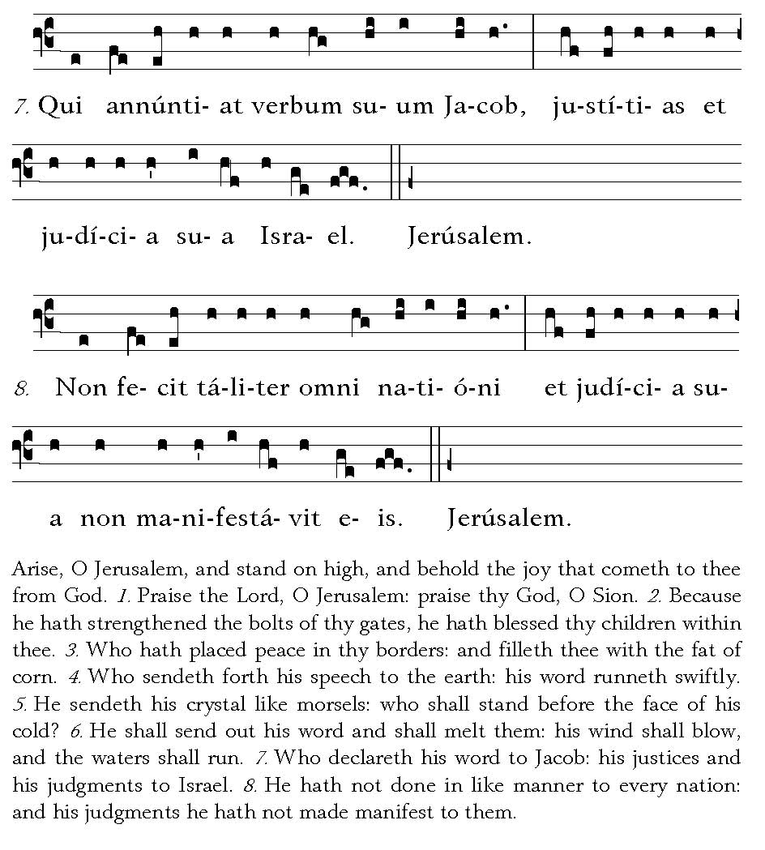

Post Communion
Deo Gratias

