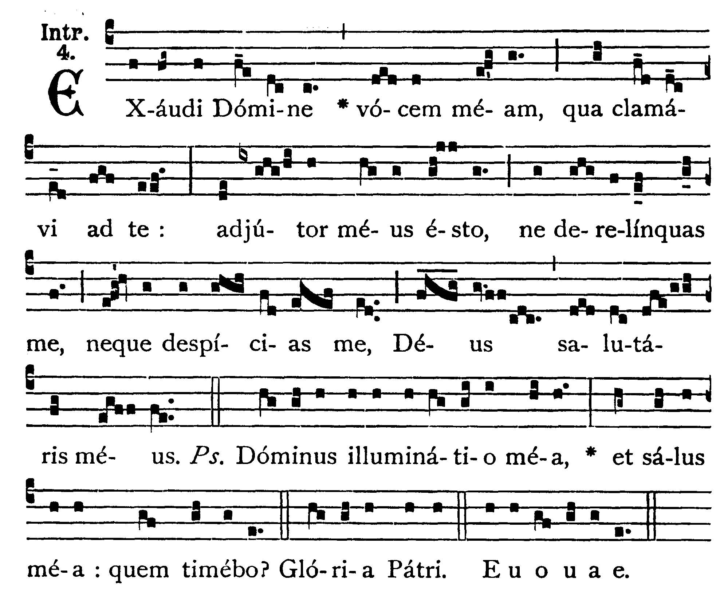
5th Sunday After Pentecost
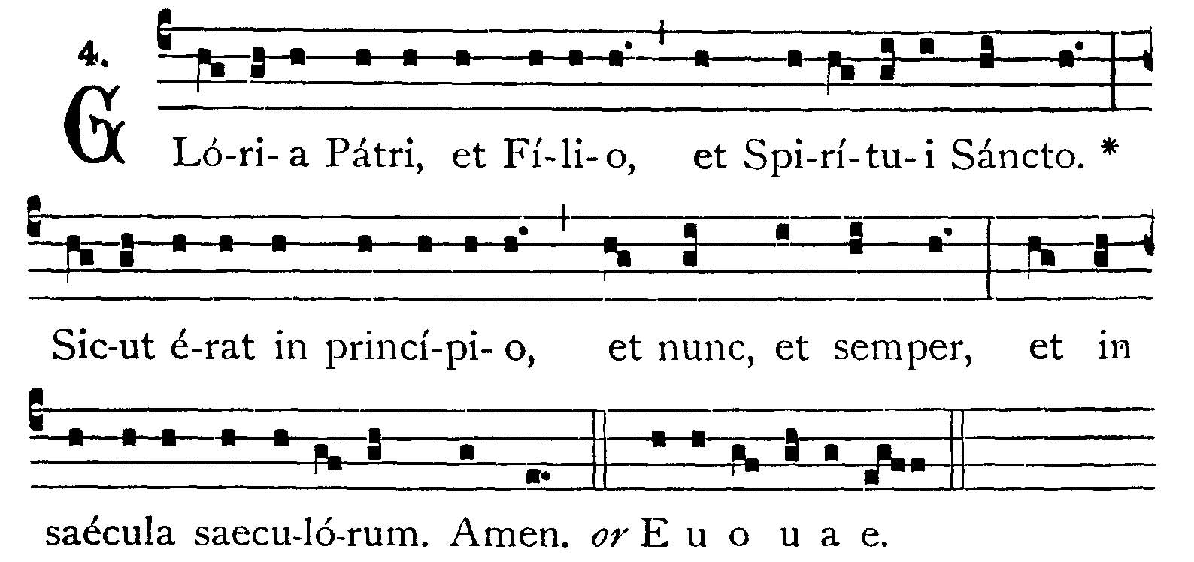
INTROIT
Psalms 26: 7-9
Hear, O Lord, my voice with which I have cried to Thee: be Thou my helper, forsake me not, nor do Thou despise me, O God, my Savior. -- (Ps. 26. 1). The Lord is my light, and my salvation, whom shall I fear? V.: Glory to the Father -- Hear, O Lord, my voice . . .
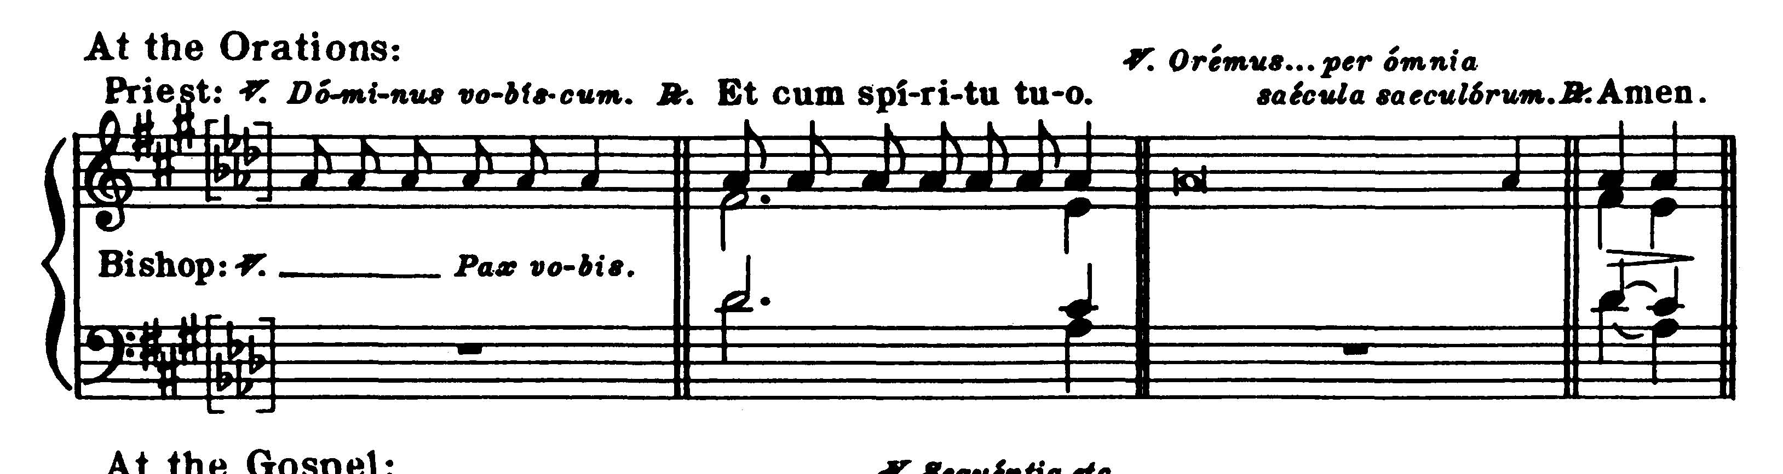
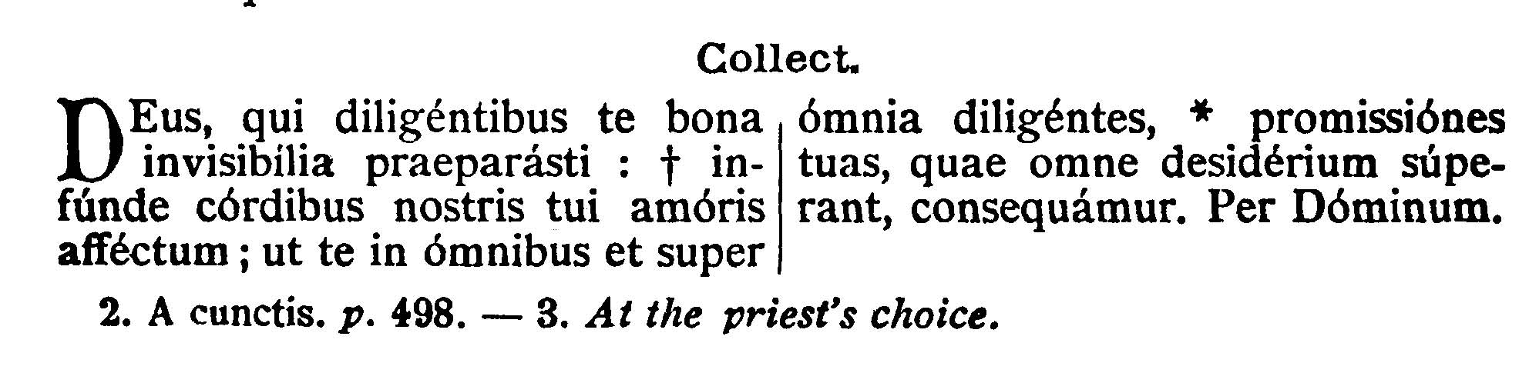

COLLECT - O God, who hast prepared for them that love Thee such good things as pass understanding: pour into our hearts such love towards Thee, that we, loving Thee in all things, and above all things, may obtain Thy promises which exceed all that we can desire. Through our Lord Jesus Christ, Thy Son, who liveth and reigneth with Thee in the unity of the Holy Ghost . . .
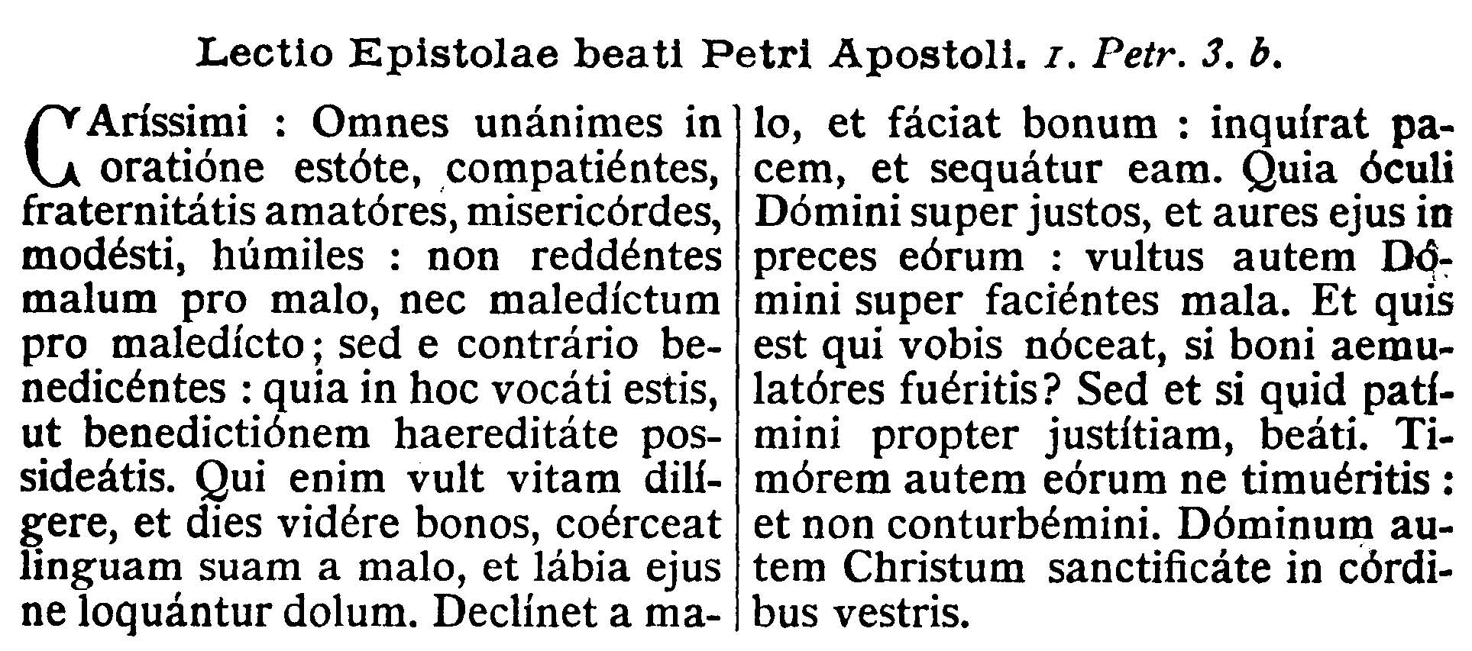
EPISTLE
1 Peter 3: 8-15
Dearly beloved, Be ye all of one mind, having compassion one of another, being lovers of the brotherhood, merciful, modest, humble; not rendering evil for evil, nor railing for railing, but contrariwise, blessing: for unto this you are called, that you may inherit a blessing. For he that will love life, and see good days, let him refrain his tongue from evil, and his lips that they speak no guile. Let him decline from evil and do good; let him seek after peace, and pursue it: because the eyes of the Lord are upon the just, and His ears unto their prayers, but the countenance of the Lord against them that do evil things. And who is he that can hurt you, if you be zealous of good? But if also you suffer anything for justice' sake, blessed are ye. And be not afraid of their fear, and be not troubled: but sanctify the Lord Christ in your hearts.
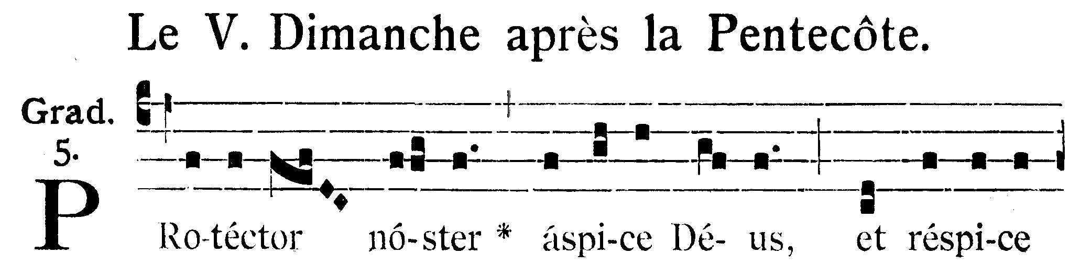
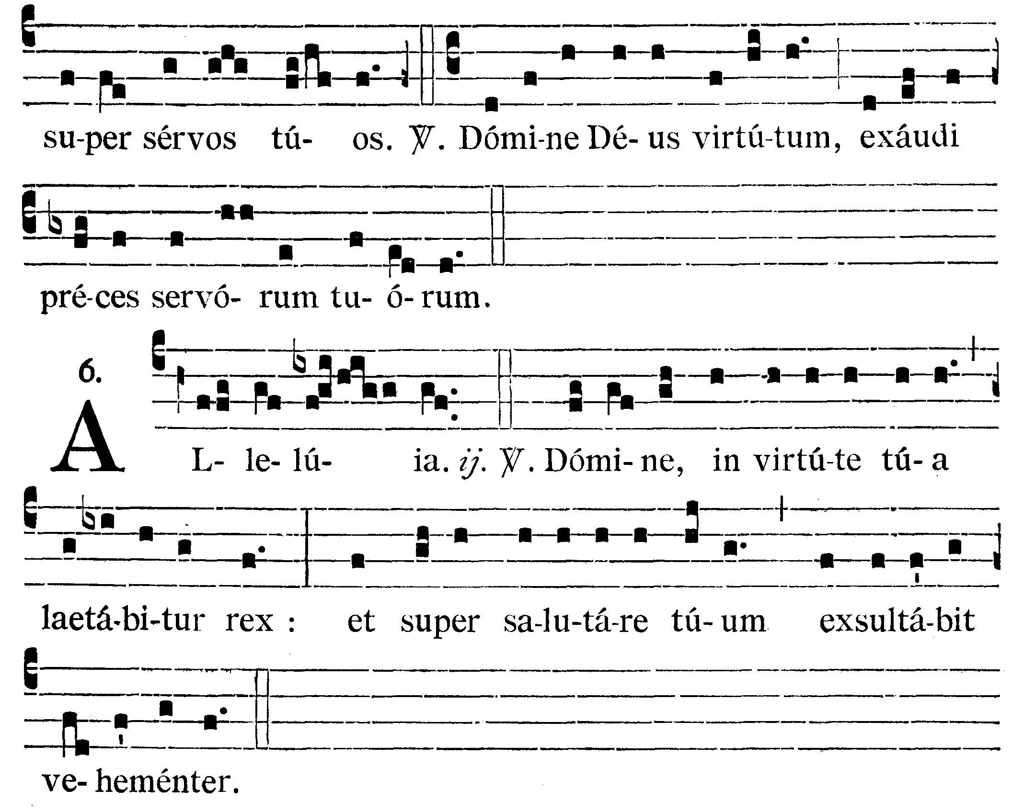
GRADUAL
Psalms 86: 10, 9
Behold, O God our protector, and look upon Thy servants. V.: O Lord God of hosts, give ear to the prayers of Thy Servants.
Alleluia, alleluia. V.(Ps. 20. 1). In Thy strength, O Lord, the king shall joy; and in Thy salvation he shall rejoice exceedingly. Alleluia.


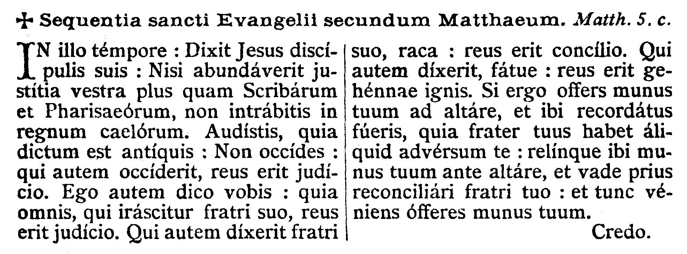
GOSPEL
Matthew 5: 20-24
At that time Jesus said to His disciples: Except your justice abound more than that of the Scribes and Pharisees, you shall not enter into the kingdom of heaven. You have heard that it was said to them of old: Thou shalt not kill; and whosoever shall kill, shall be in danger of the judgment. But I say to you, that whosoever is angry with his brother, shall be in danger of the judgment; and whosoever shall say to his brother: Raca, shall be in danger of the council; and whosoever shall say: Thou fool, shall be in danger of hell fire. If therefore thou offer thy gift at the altar, and there thou remember that thy brother hath anything against thee, leave there thy offering before the altar, and go first to be reconciled to thy brother; and then coming thou shalt offer thy gift.
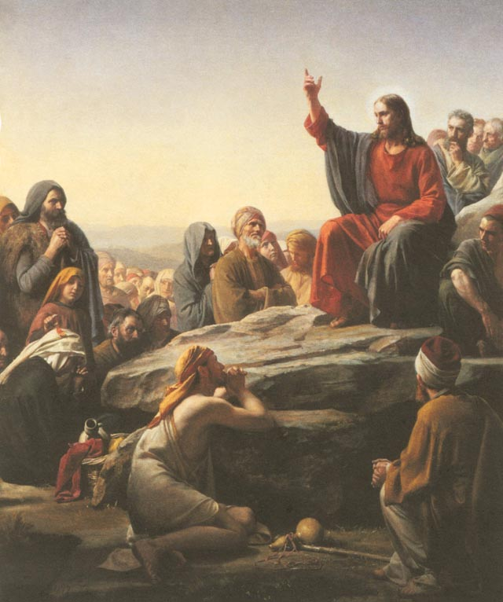
Dominus Vobiscum
Et Cum Spirtu tuo
Oremus:

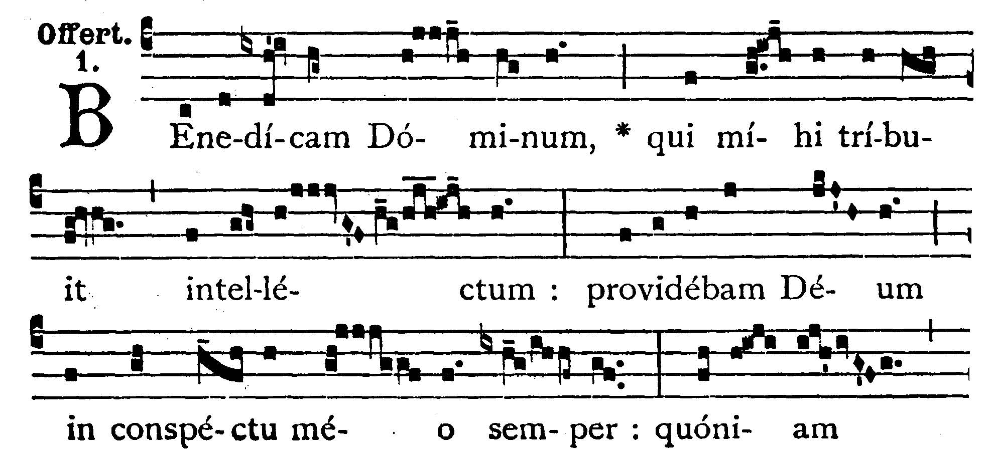
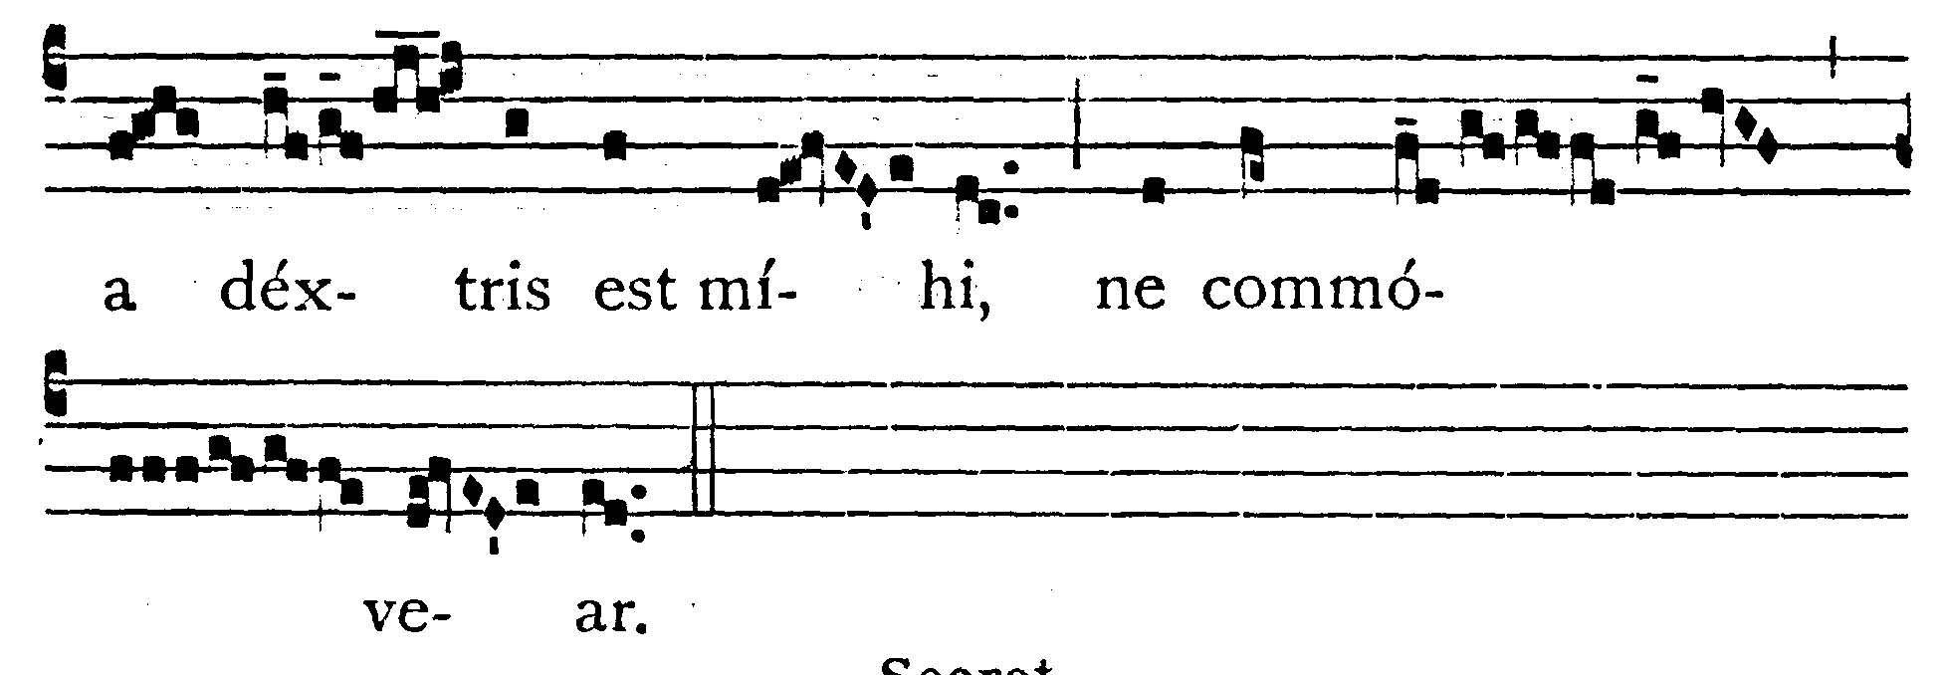
OFFERTORY
Psalms 15: 7, 8
I will bless the Lord, who hath given me understanding: I set God always in my sight; for He is at my right hand, that I be not moved.

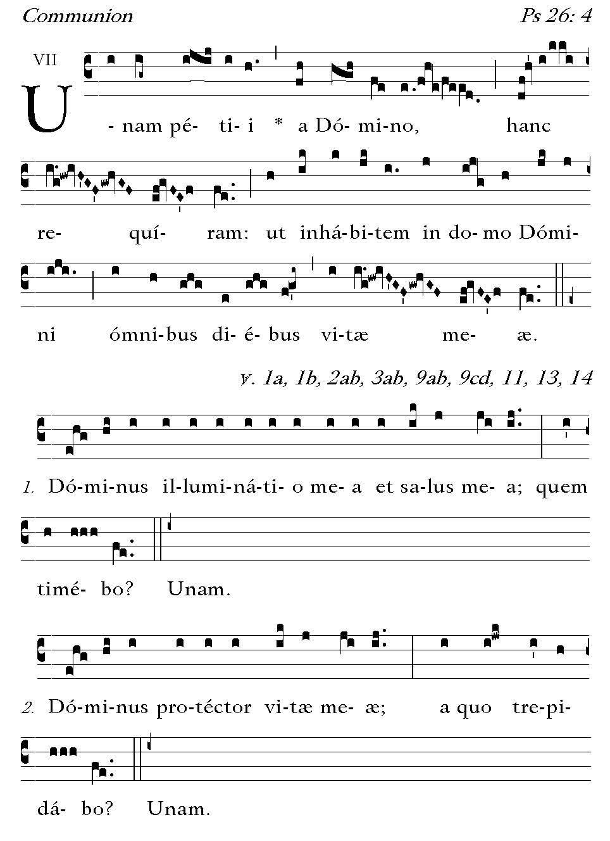

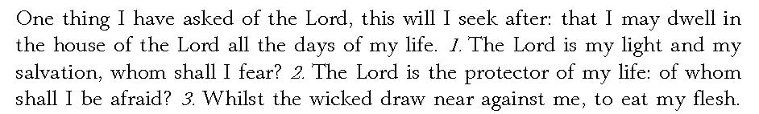



POST COMMUNION - Grant, O Lord, we beseech Thee, that we whom Thou hast fed with the heavenly Gift, may be cleansed from our hidden sins and delivered from the snares of our enemies. Through our Lord Jesus Christ, Thy Son, who liveth and reigneth . . .

Deo Gratias

