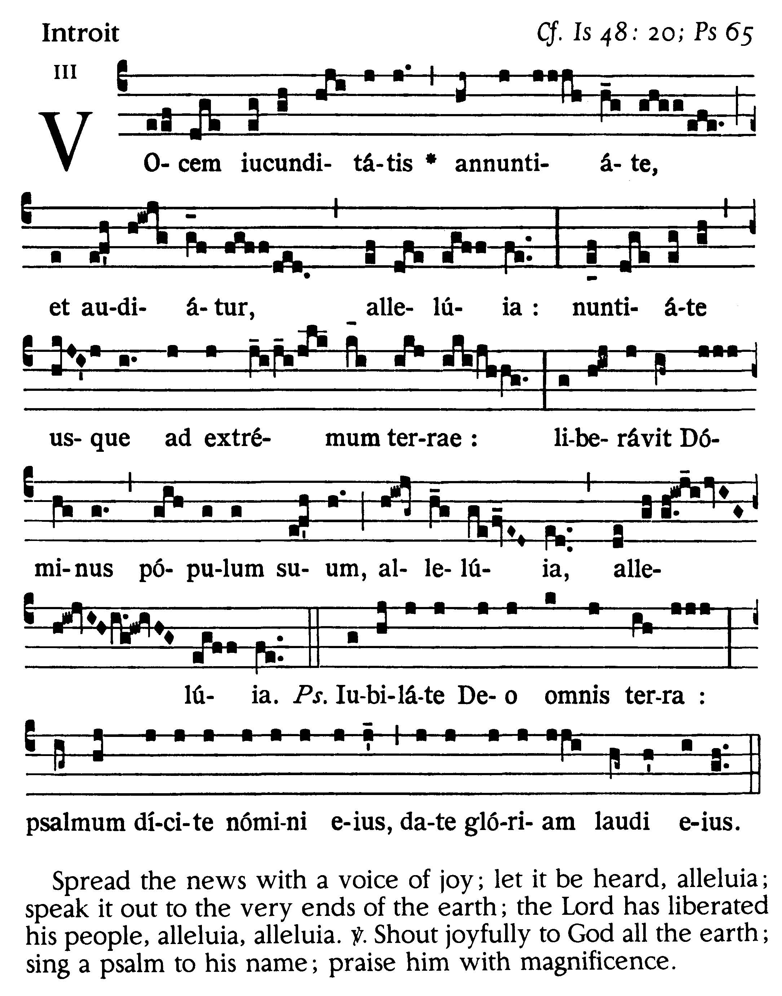
5th Sunday After Easter
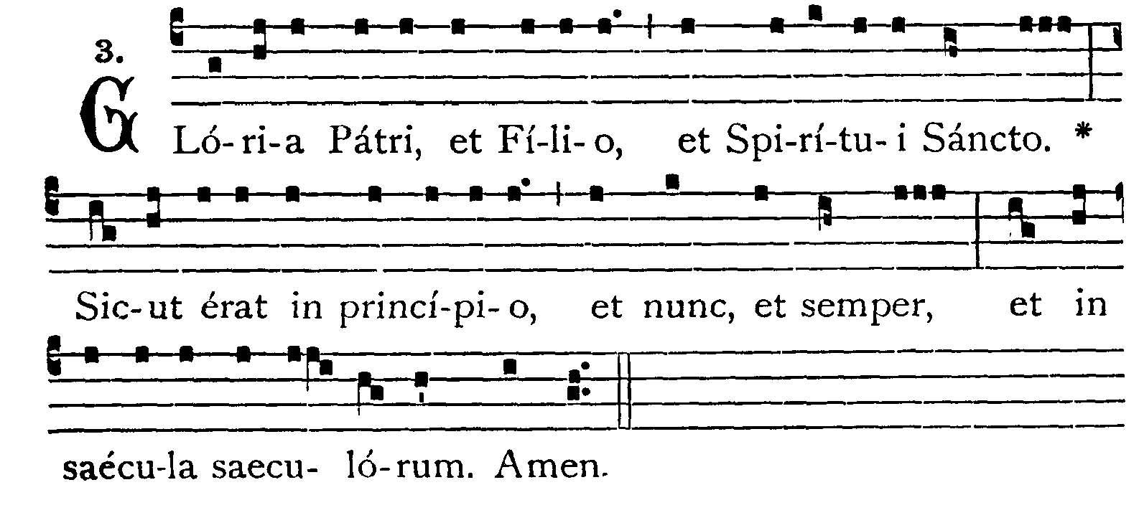
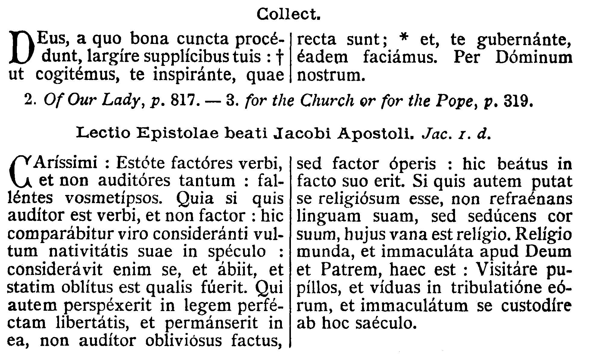
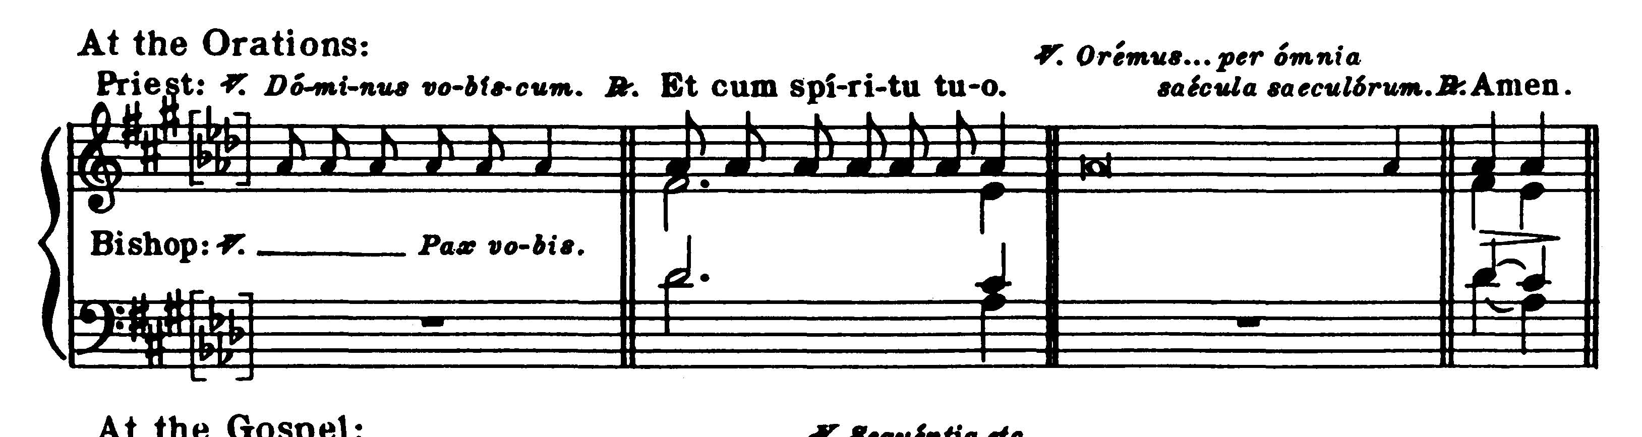
COLLECT
O God, from whom all good things do come, grant unto us, Thy suppliant people, that by Thine inspiration, we may think what is right, and under Thy guidance perform the same. Through our Lord Jesus Christ, Thy Son, who liveth and reigneth . . .

EPISTLE
James 1: 22-27
Dearly beloved, Be ye doers of the word and not hearers only, deceiving your own selves. For if a man be a hearer of the word and not a doer, he shall be compared to a man beholding his own countenance in a glass: for he beheld himself and went his way, and presently forgot what manner of man he was. But he that hath looked into the perfect law of liberty and hath continued therein, not becoming a forgetful hearer but a doer of the work: this man shall be blessed in his deed. And if any man think himself to be religious, not bridling his tongue but deceiving his own heart, this man's religion is in vain. Religion clean and undefiled before God and Father is this: To visit the fatherless and widows in their tribulation, and to keep one's self unspotted from this world.

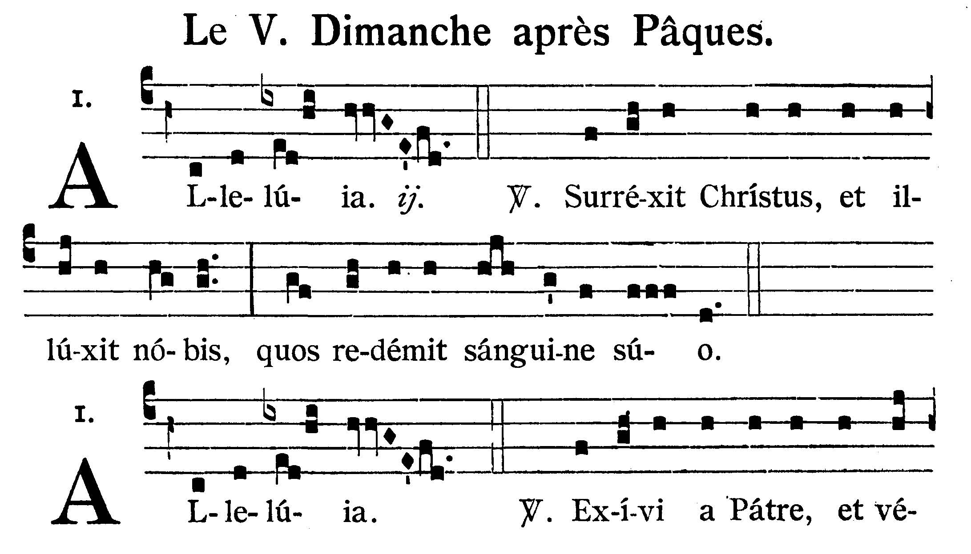
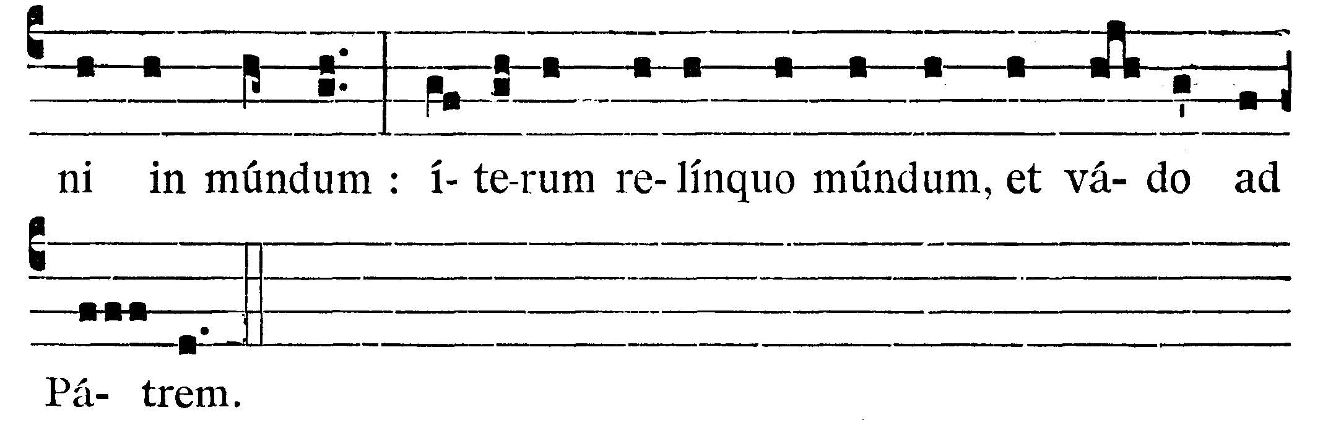
Alleluia, alleluia. V.: Christ is risen, and hath shone upon us, whom He redeemed with His blood. Alleluia. V.: (John. 16. 28). I came forth from the Father, and am come into the world: again I leave the world and go back to the Father. Alleluia.


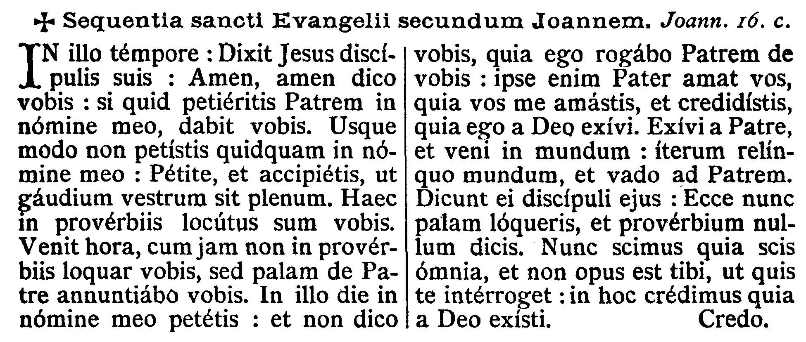

GOSPEL
John 16: 23-30

On that day you will not question me about anything. Amen, amen, I say to you, whatever you ask the Father in my name he will give you. Until now you have not asked anything in my name; ask and you will receive, so that your joy may be complete. "I have told you this in figures of speech. The hour is coming when I will no longer speak to you in figures but I will tell you clearly about the Father. On that day you will ask in my name, and I do not tell you that I will ask the Father for you. For the Father himself loves you, because you have loved me and have come to believe that I came from God. I came from the Father and have come into the world. Now I am leaving the world and going back to the Father." His disciples said, "Now you are talking plainly, and not in any figure of speech. Now we realize that you know everything and that you do not need to have anyone question you. Because of this we believe that you came from God."
Dominus Vobiscum
Et Cum Spirtu tuo
Oremus:
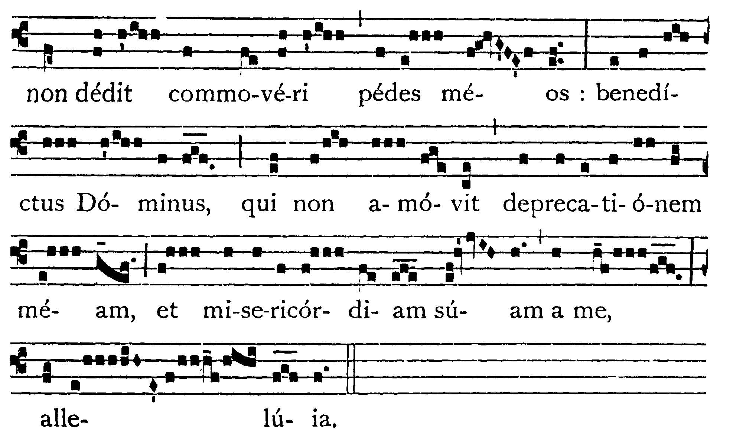
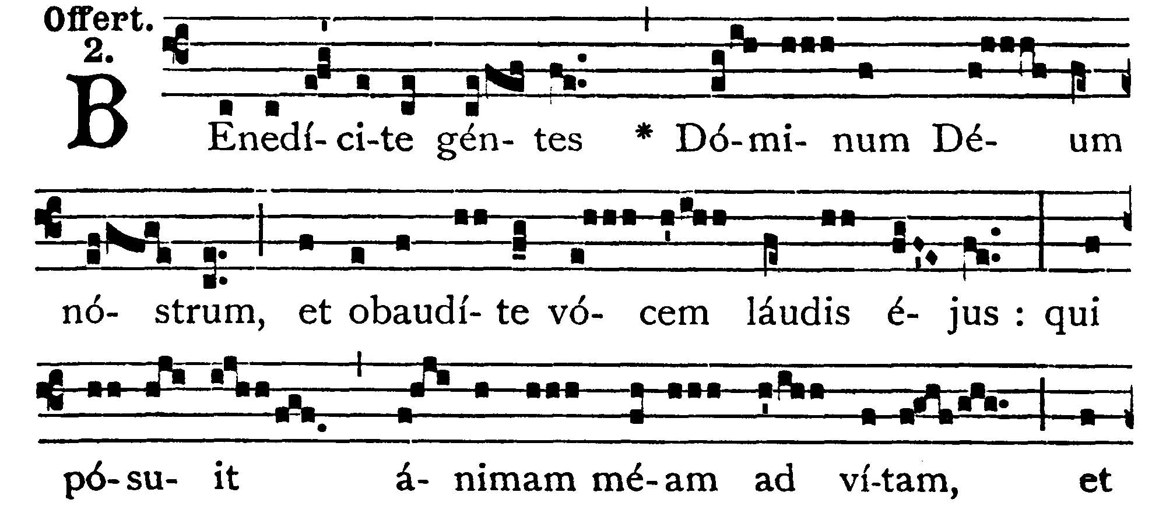
O nations, bless the Lord our God, let the voice of his praises resound; he has restored my soul to life and he has not suffered my feet to stumble; blessed be the Lord who has neither rejected my prayer nor turned his mercy away from me, alleluia.
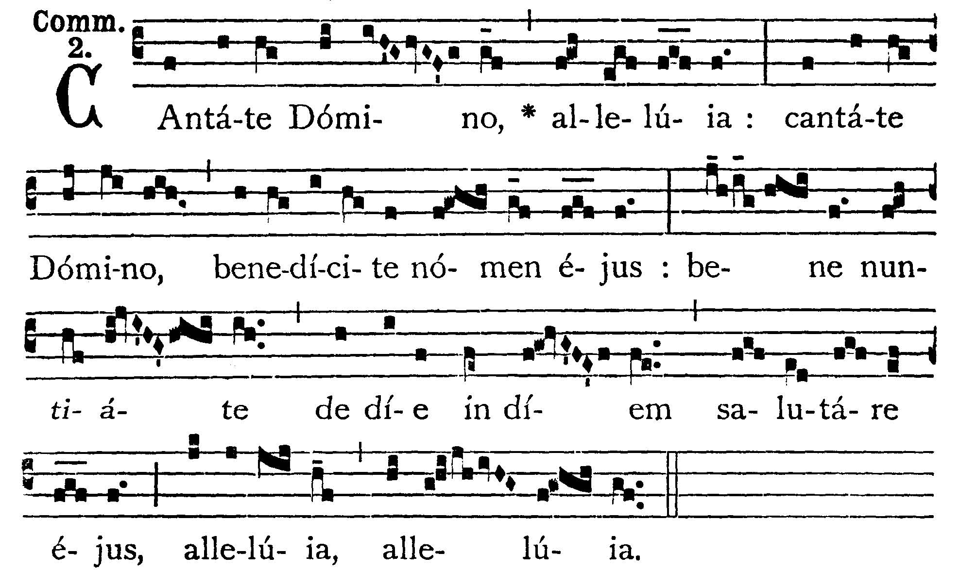

COMMUNION
John 16:8
Sing unto the Lord, alleluia; sing unto the Lord, and bless His name; show forth His salvation from day to day, alleluia, alleluia.

POST COMMUNION - Grant to us, O Lord, that filled with strength from this heavenly table, we may both desire what is right, and obtain that which we desire. Through our Lord Jesus Christ, Thy Son, who liveth . . .

Deo Gratias

