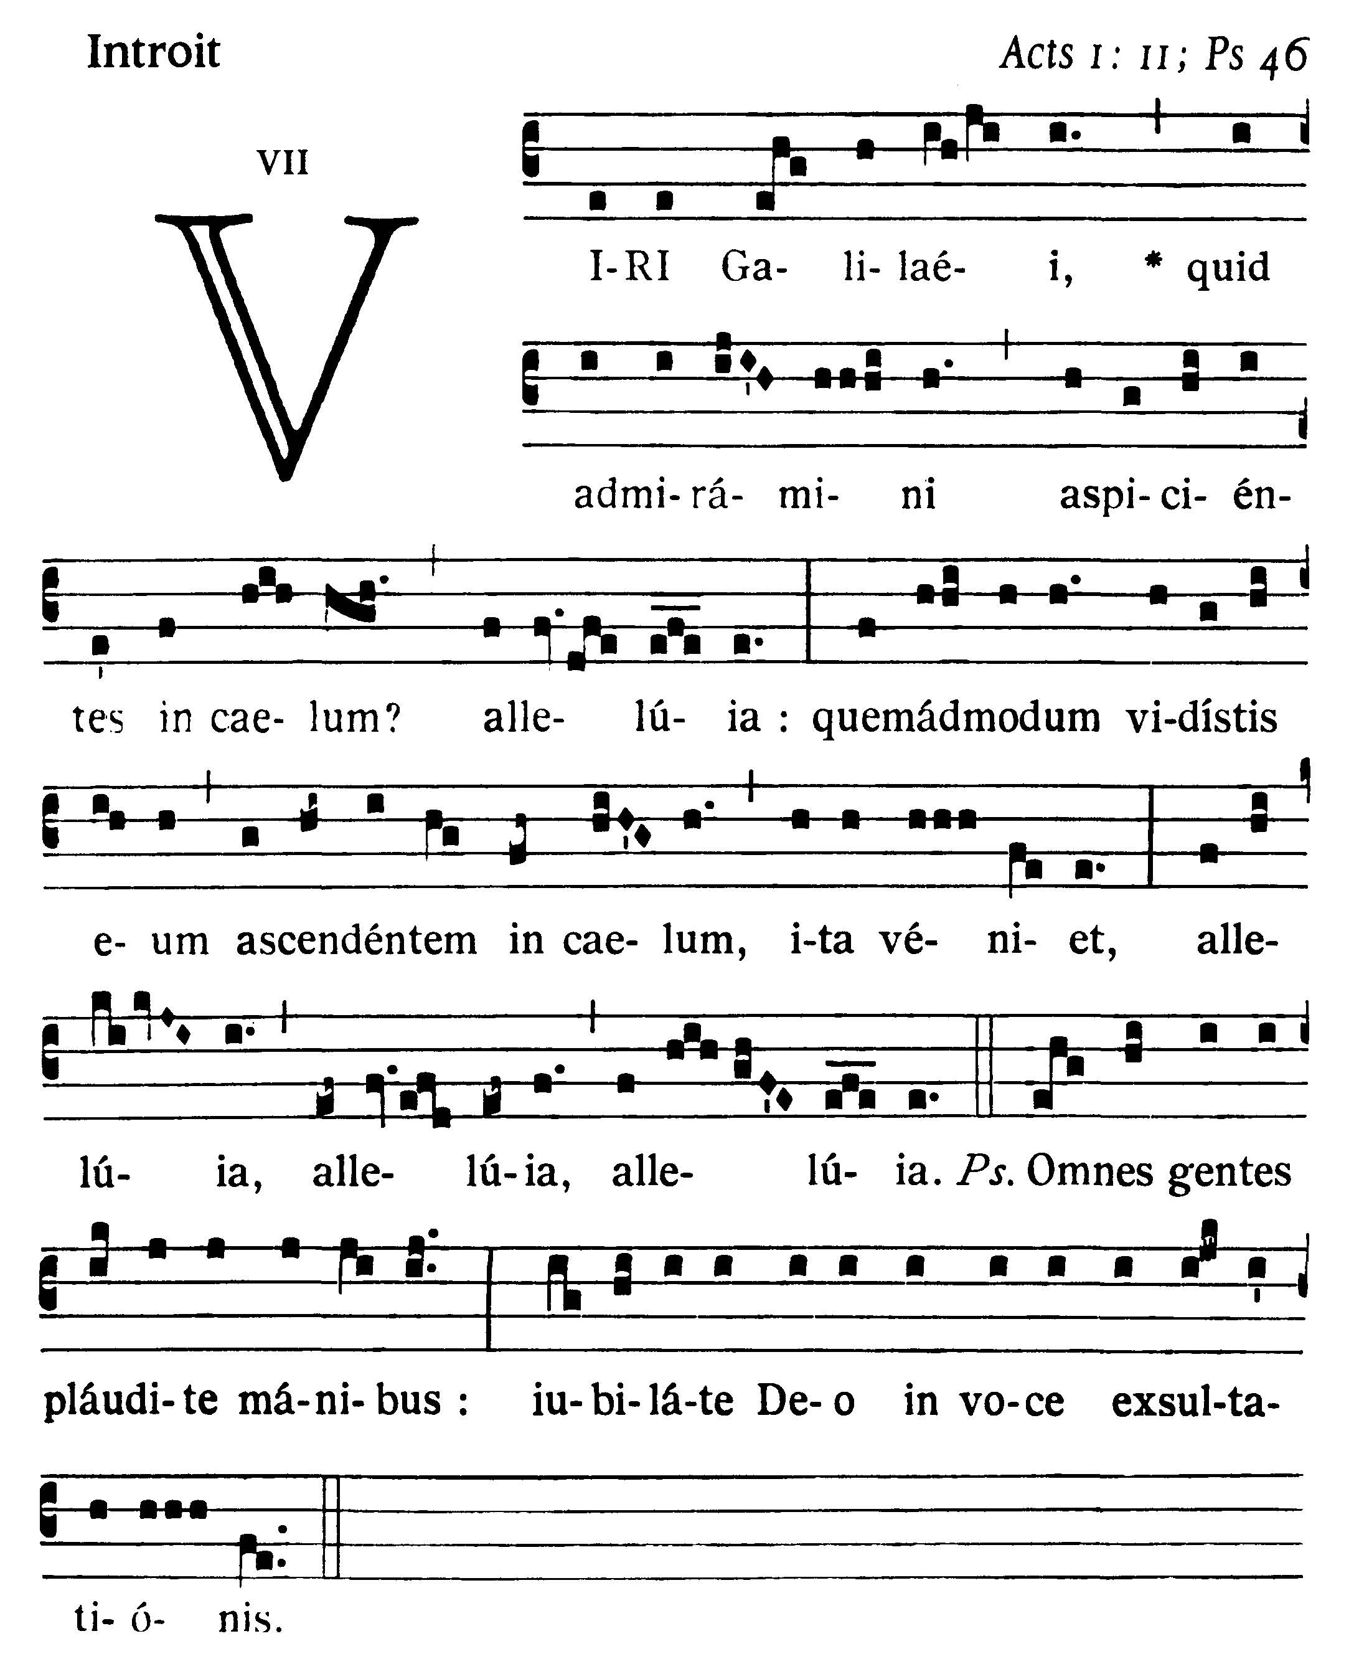
Ascension
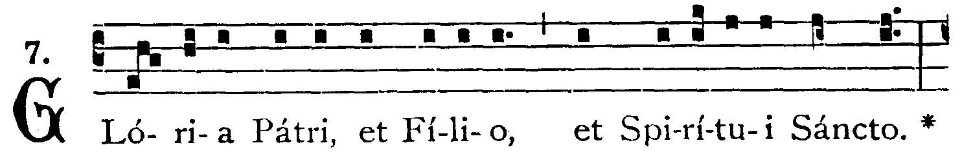
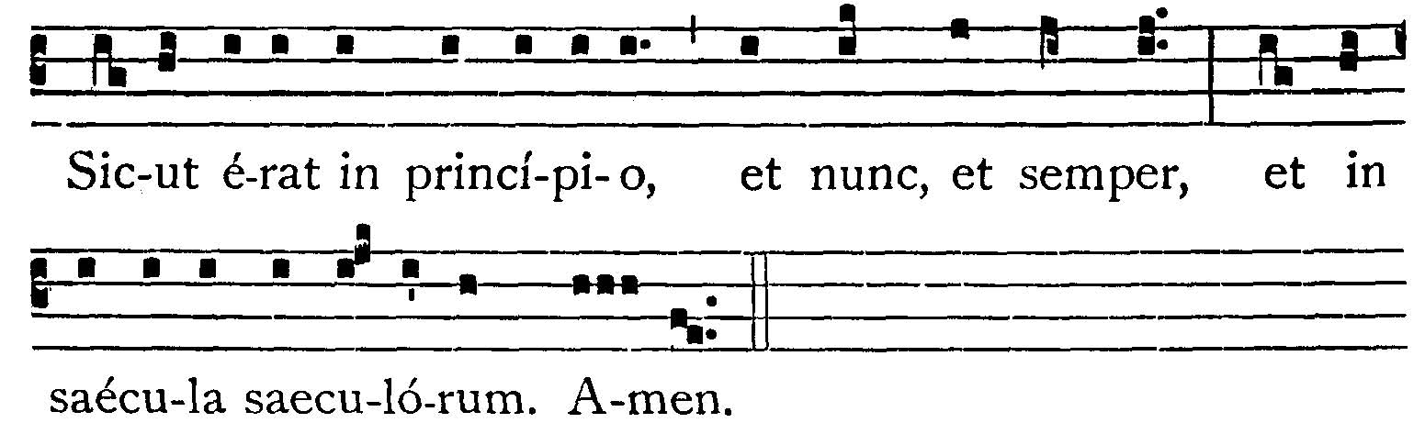
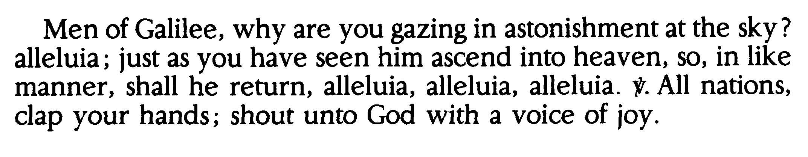
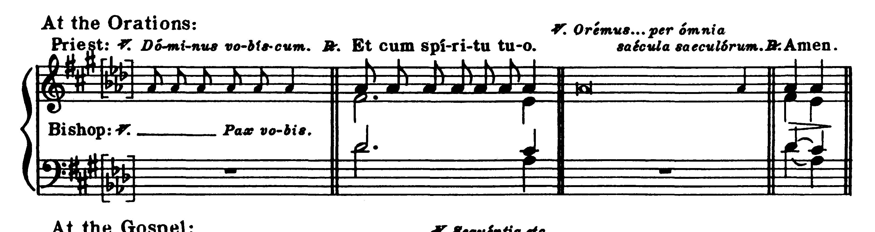

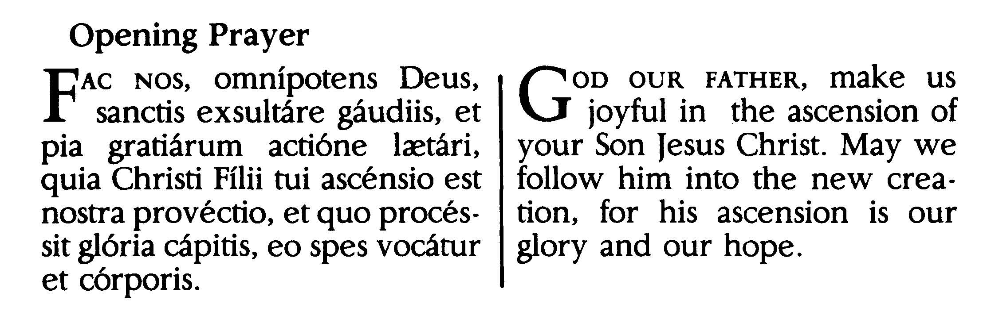
EPISTLE
Acts 1: 1-11
The former treatise I made, O Theophilus, of all things which Jesus began to do and to teach, until the day on which, giving commandments by the Holy Ghost to the Apostles whom He had chosen, He was taken up: to whom also He showed Himself alive after His Passion by many proofs, for forty days appearing to them and speaking of the Kingom of God. And eating together with them, He commanded them that they should not depart from Jerusalem, but should wait for the promise of the Father, which you have heard (saith He) by My mouth; for John indeed baptized with water, but you shall be baptized with the Holy Ghost not many days hence. They therefore who were come together asked Him, saying: Lord, wilt Thou at this time restore again the kingdom of Israel? But He said to them: It is not for you to know the times or moments which the Father hath put in His own power: but you shall receive the power of the Holy Ghost coming upon you, and you shall be witnesses unto Me in Jerusalem, and in all Judea and Samaria, and even to the uttermost part of the earth. And when He had said these things, while they looked on, He was raised up: and a cloud received Him out of their sight. And while they were beholding Him going up to heaven, behold two men stood by them in white garments, who also said: Ye men of Galilee, why stand you looking up to heaven? This Jesus, who is taken up from you into heaven, shall so come as you have seen Him going into heaven.

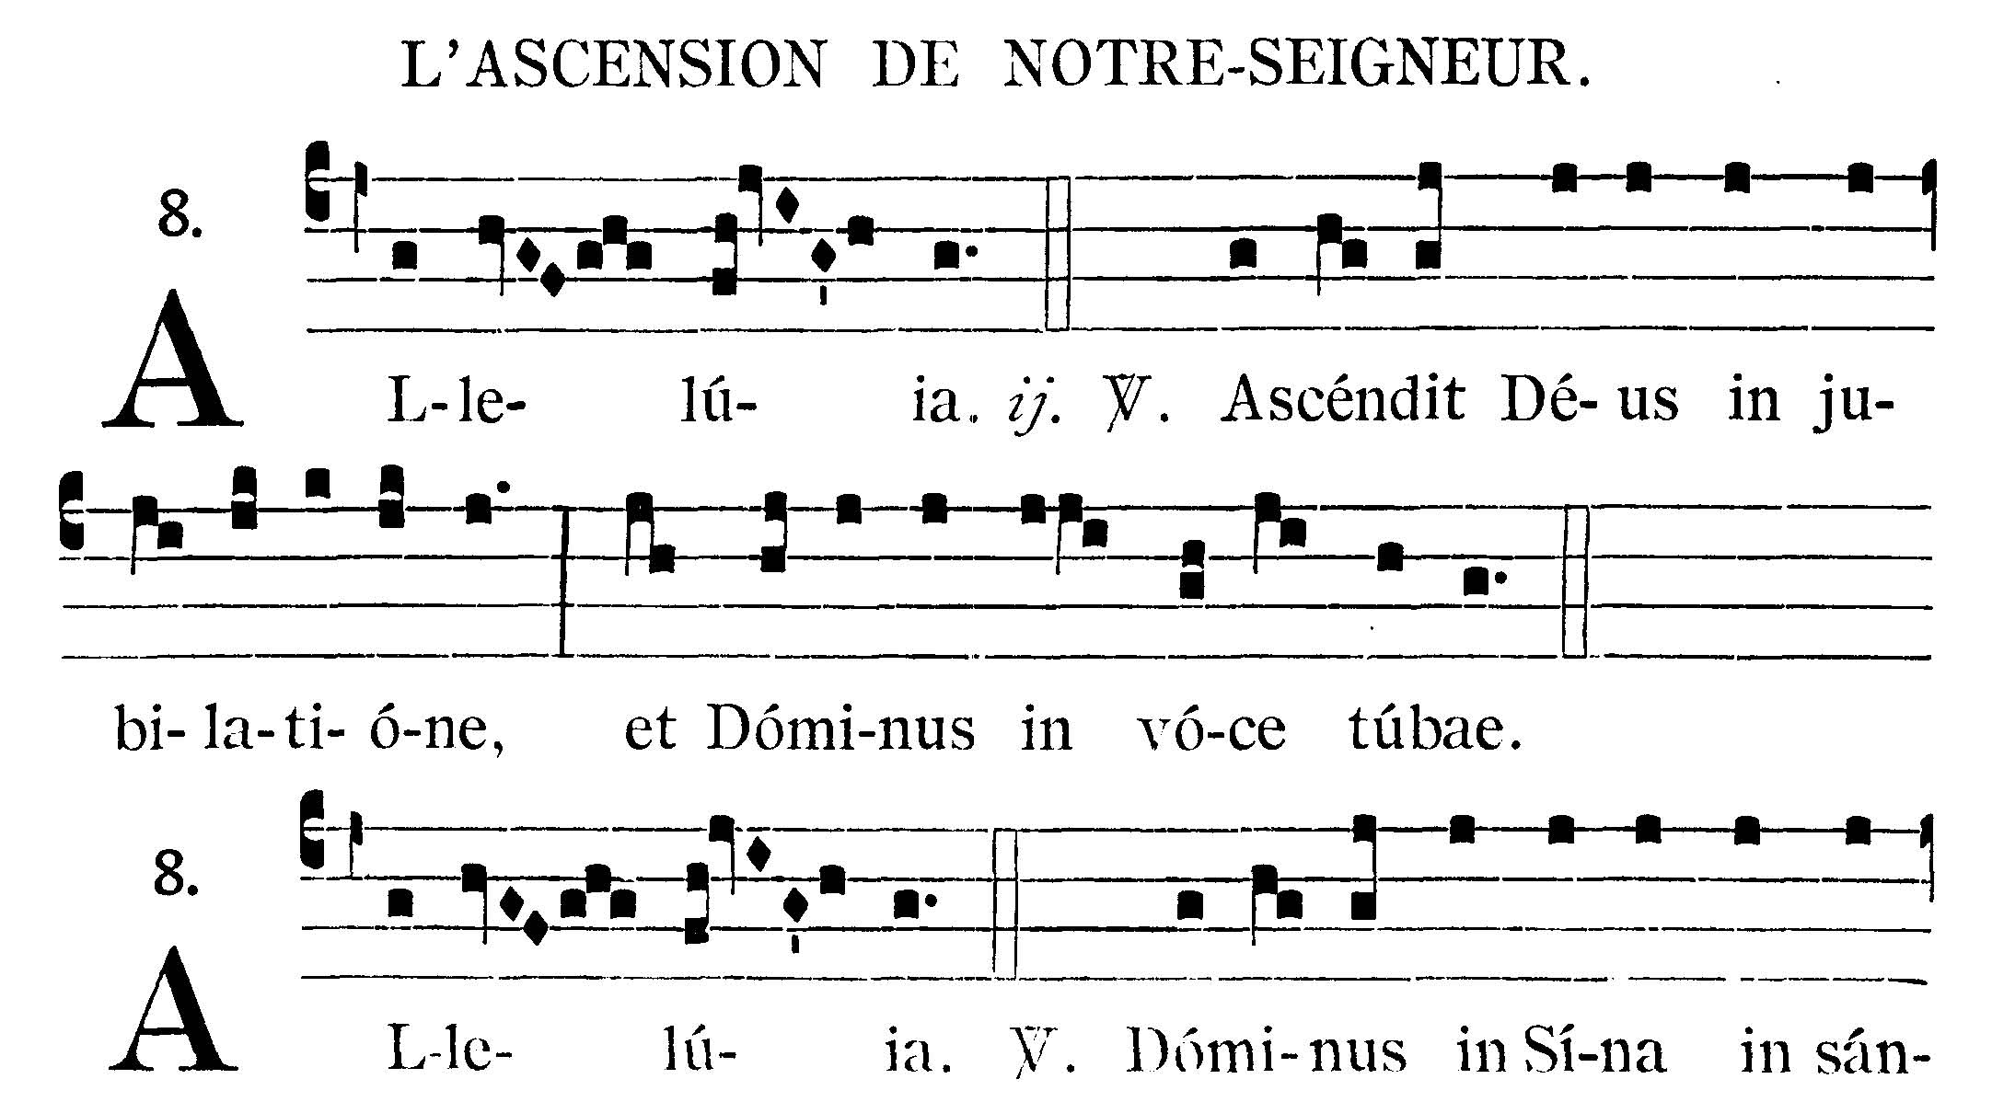
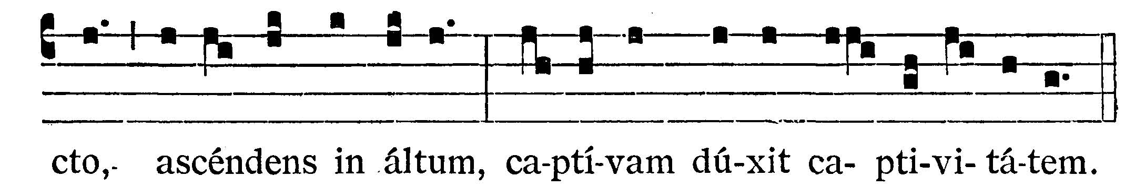

GRADUAL
Psalms 46: 6
Alleluia, alleluia. V.: God is ascended with a shout, and the Lord with the sound of a trumpet. Alleluia. V.: (Ps. 67. 18). The Lord is in Sinai, in the holy place; ascending on high He hath led captivity captive.



GOSPEL
Mark 16: 14-20
At that time Jesus appeared to the eleven as they were at table: and He upbraided them with their incredulity and hardness of heart, because they did not believe them who had seen Him after He was risen again. And He said to them: Go ye into the whole world and preach the Gospel to every creature. He that believeth and is baptized shall be saved: but he that beleiveth not shall be condemned. And these signs shall follow them that believe: In My Name they shall cast out devils; they shall speak with new tongues; they shall take up serpents; and if they shall drink any deadly thing, it shall not hurt them; they shall lay their hands upon the sick, and they shall recover. And the Lord Jesus, after He had spoken unto them, was taken up into heaven and sitteth on the right hand of God. But they going forth preached everywhere, the Lord working withal, and confirming the word with signs that followed.
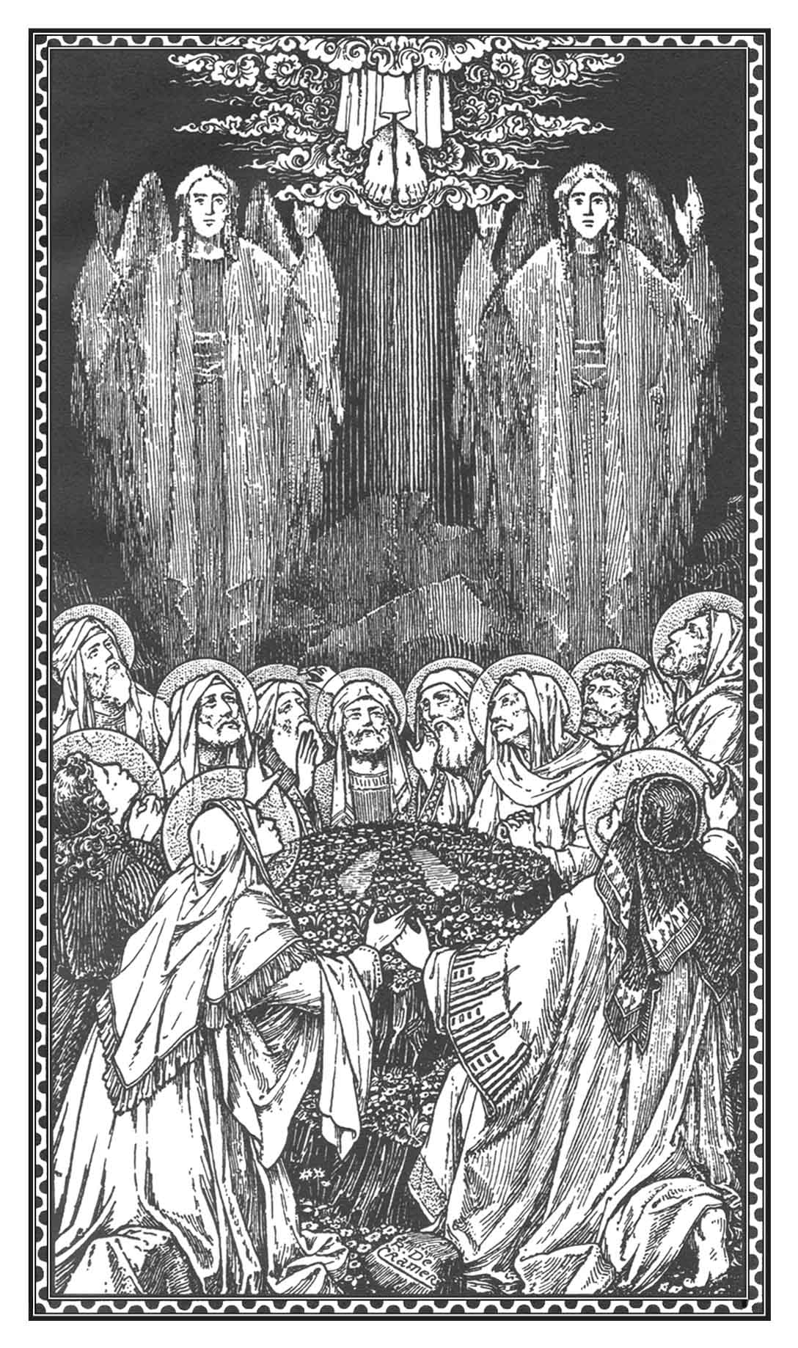
Dominus Vobiscum
Et Cum Spirtu tuo
Oremus:
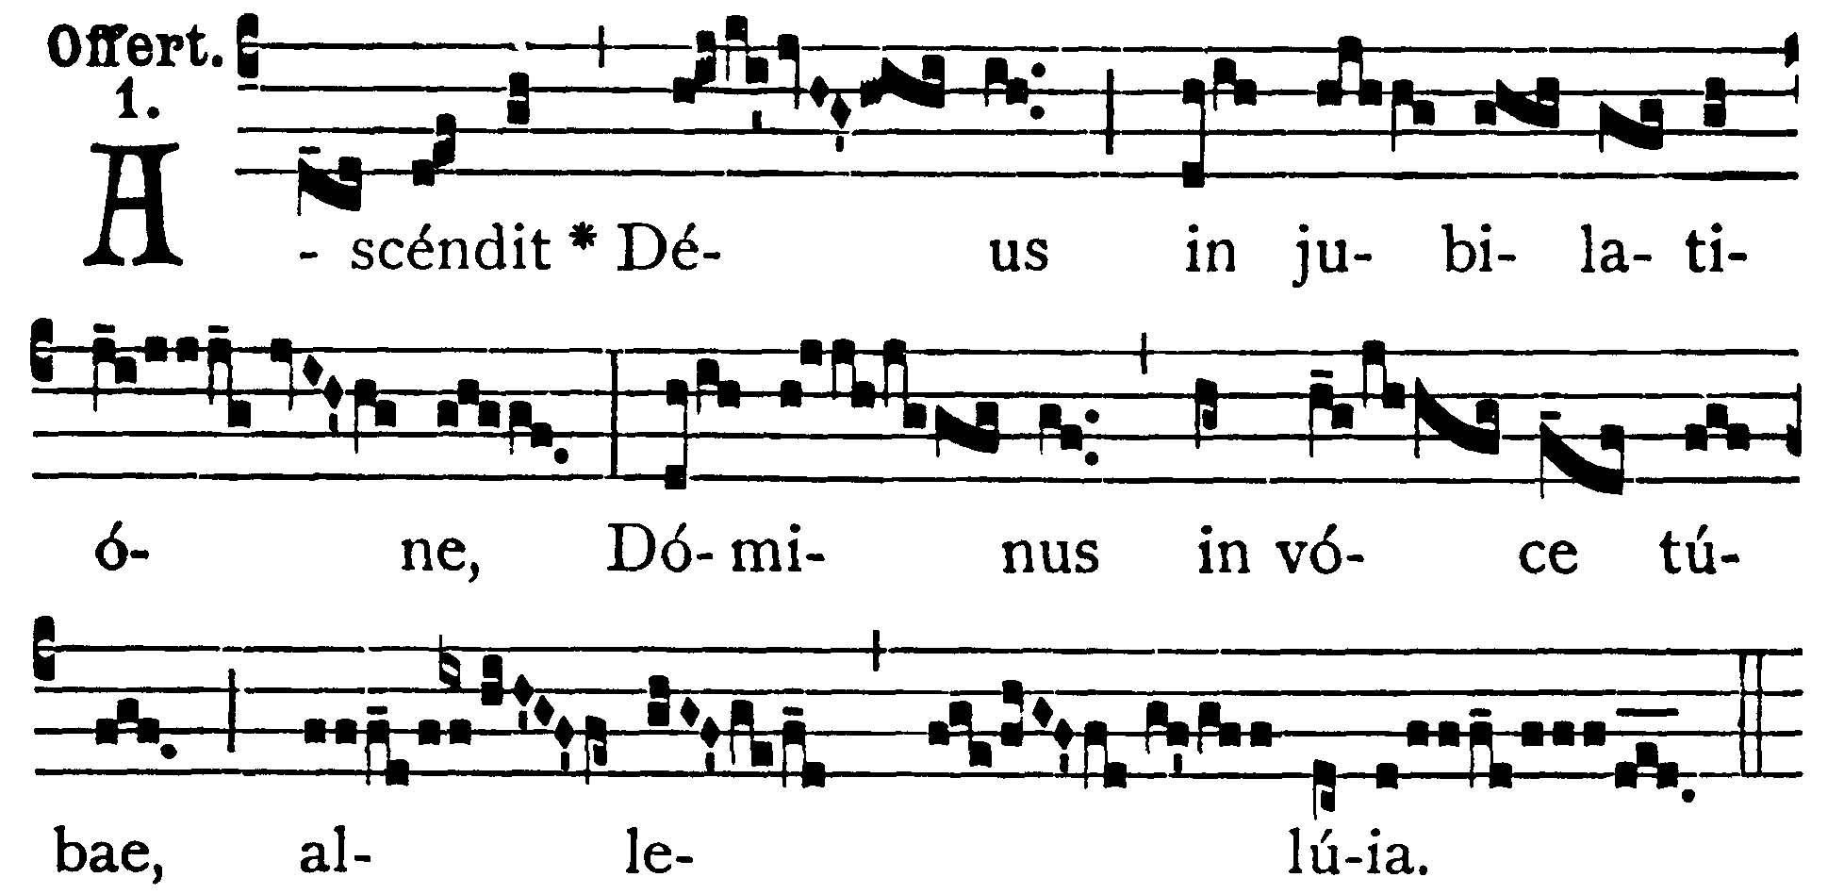
OFFERTORY
Psalms 46: 6
God is ascended with a shout, and the Lord with the sound of a trumpet, alleluia.

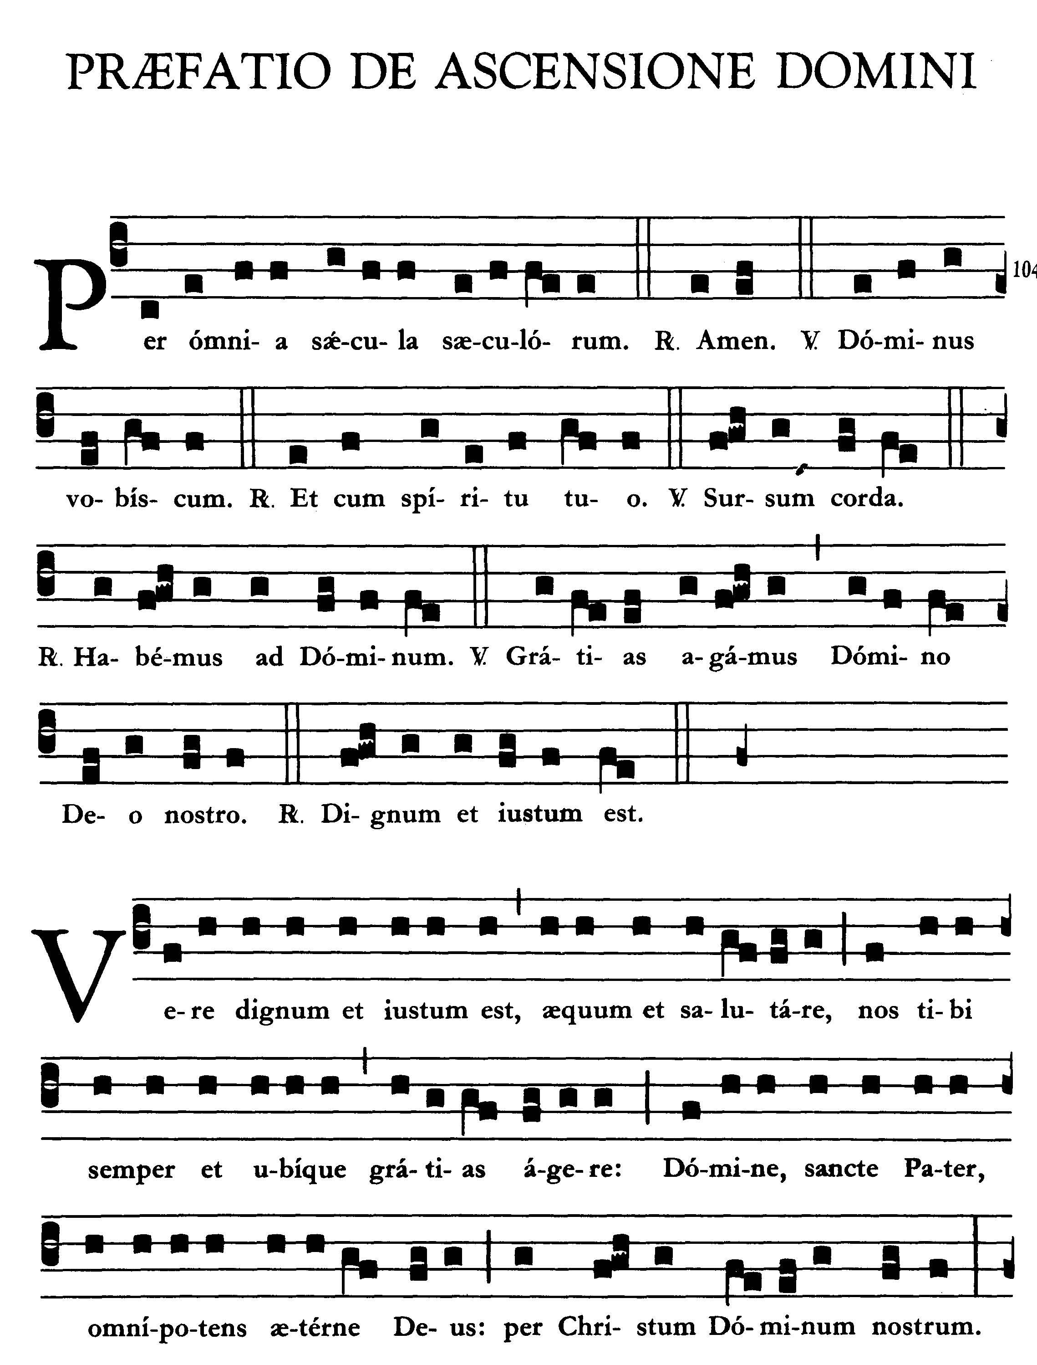
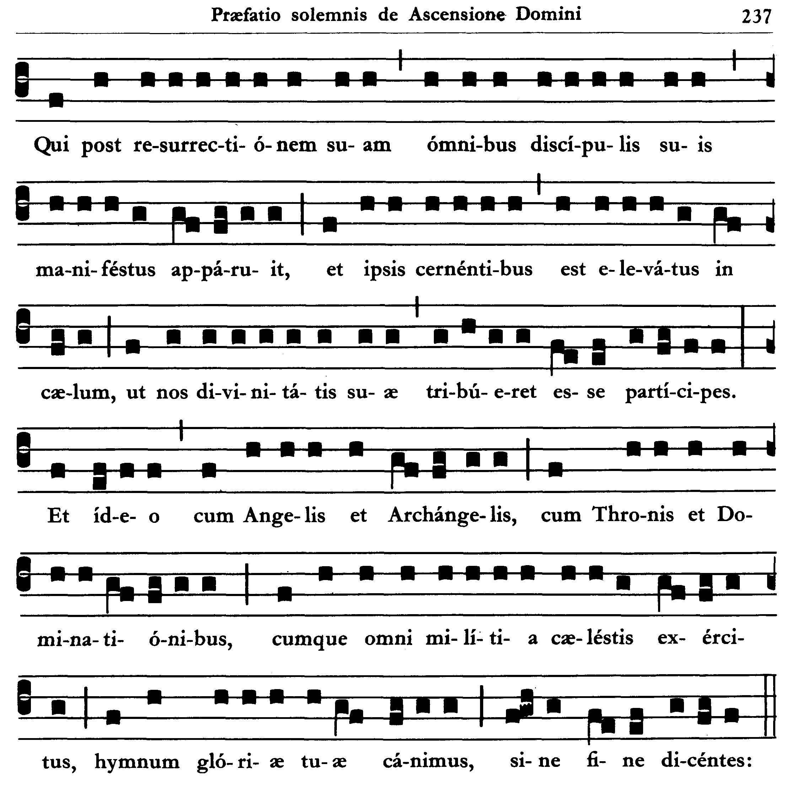
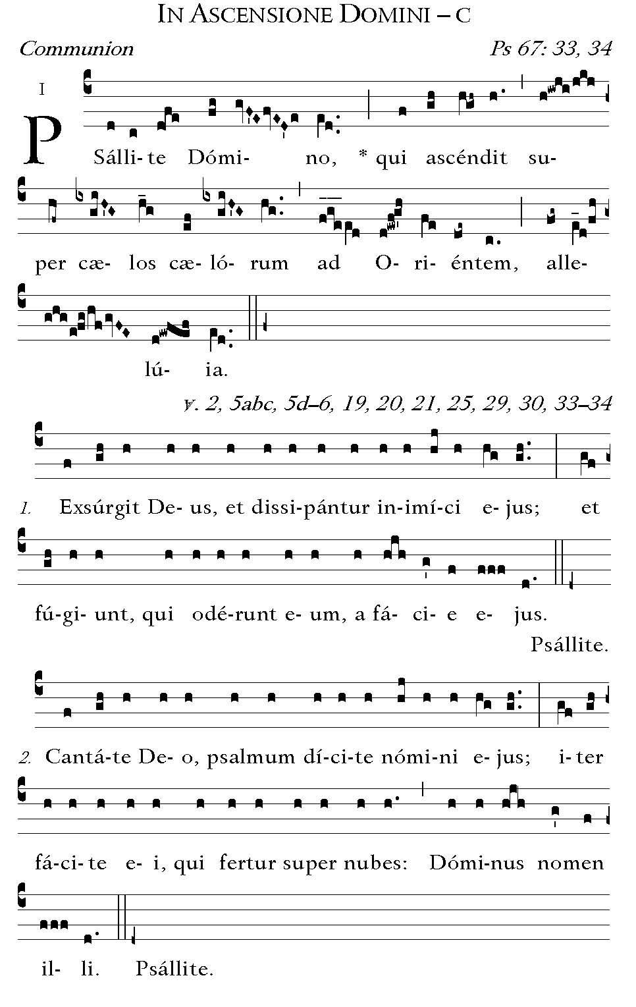
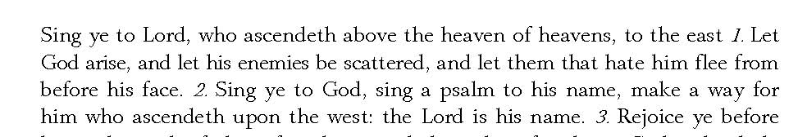



POST COMMUNION - Grant to us, we beseech Thee, almighty and merciful God, that we may obtain the invisible effects of that which we have shared by communion in visible Mysteries. Through our Lord Jesus Christ, Thy Son, who liveth and reigneth with Thee in the unity of the Holy Ghost . . .

Deo Gratias

