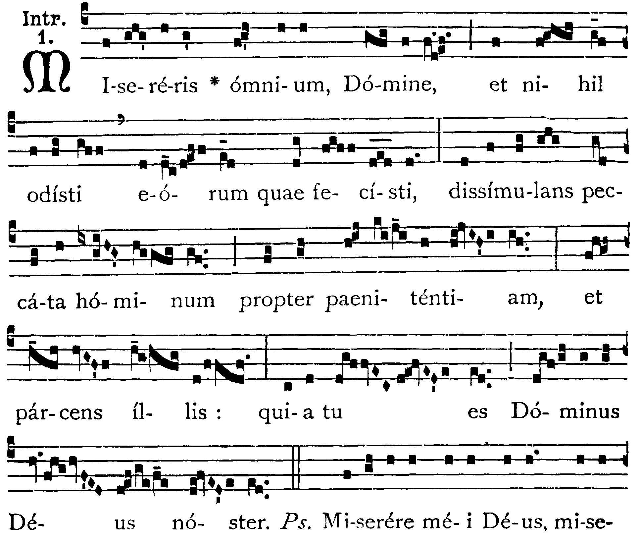
Ash Wednesday
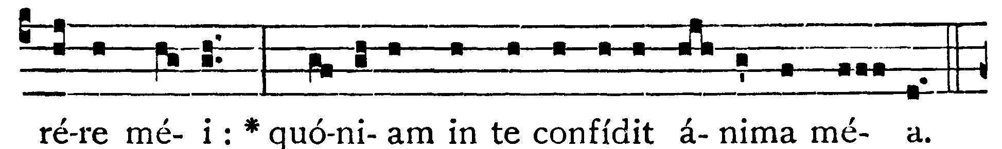
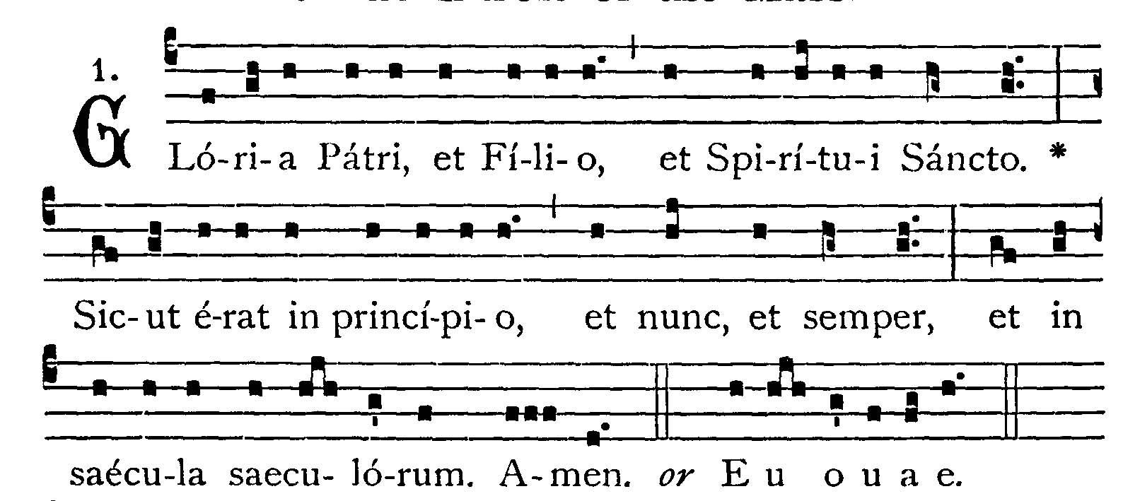
Thou hast mercy upon all, O Lord, and hatest none of the things which Thou hast made, overlooking the sins of men for the sake of repentance, and sparing them: because Thou art the Lord our God. -- (Ps. 56. 2). Have mery on me, O God, have mercy on me: for my soul trusteth in Thee. V.: Glory be to the Father . . . -- Thou hast mercy upon all, O Lord . . .
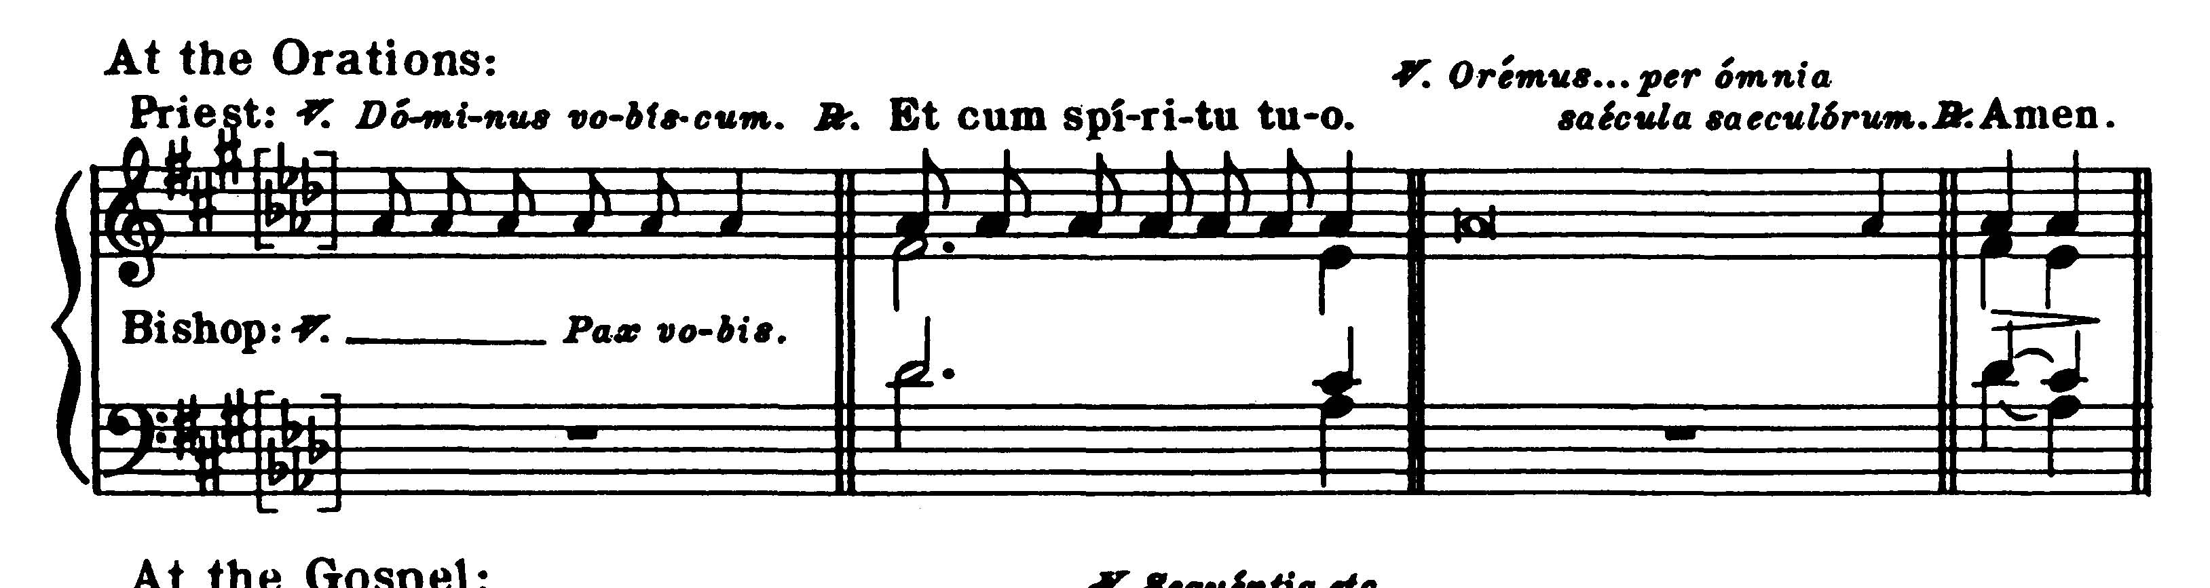

COLLECT
Praesta Domine fidelibus tuis: ut ieiuniorum veneranda solemnia, et congrua pietate suscipiant, et secura devotione percurrant. Per Dominum . . .

Grant, O Lord, to Thy faithful people, that they may undertake with fitting piety the venerable solemnities of fasting, and complete them with steadfast devotion. Through our Lord Jesus Christ, Thy Son, who liveth and reigneth with Thee in the unity of the Holy Ghost . . .

EPISTLE ¤ Joel 2. 12-19
Lesson from the Prophet Joel.
Lectio Ioelis Prophetae.
[Almighty God is rich in mercy and clemency to those who are converted to Him in fasting, in weeping and in mourning.]
Haec dicit Dominus: Convertimini ad me in toto corde vestro, in ieiunio, et in fletu, et in planctu. Et scindite corda vestra, et non vestimenta vestra, et convertimini ad Dominum Deum vestrum: quia benignus et misericors est, patiens, et multae misericordiae, et praestabilis super malitia. Quis scit, si convertatur, et ignoscat, et relinquat post se benedictionem, sacrificiam, et libamen Domino Deo vestro? Canite tuba in Sion, sanctificate ieiunium, vocate coetum, congregate populum, sanctificate Ecclesiam, coadunate senes, congregate parvulos, et sugentes ubera: egrediatur sponsus de cubili suo, et sponsa de thalamo suo. Inter vestibulum et altare plorabunt sacerdotes ministri Domini, et dicent: Parce, Domine, parce populo tuo: et ne des haereditatem tuam in opprobrium, ut dominentur eis nationes. Quare dicunt in populis: Ubi est Deus eorum? Zelatus est Dominus terram suam, et pepercit populo suo. Et respondit Dominus, et dixit populo suo: Ecce ego mittam vobis frumentum, et vinum, et oleum, et replebimini eis: et non dabo vos ultra opprobrium in gentibus: dicit Dominus omnipotens.

Thus saith the Lord: Be converted to Me with all your heart, in fasting and in weeping and in mourning. And rend your heats and not your garments, and turn to the Lord your God: for He is gracious and merciful, patient and rich in mercy, and ready to repent of the evil. Who knoweth but He will return and forgive and leave a blessing behind Him, sacrifice and libation to the Lord your God? Blow the trumpet in Sion, sanctify a fast, call a solemn assembly, gather together the people, sanctify the Church, assemble the ancients, gather together the little ones and them that suck at the breasts: let the bridegroom go forth from his bed and the bride out of her bride chamber. Between the porch and the altar the priests, the Lord's ministers, shall weep and shall say: Spare, O Lord, spare Thy people; and give not Thine inheritance to reproach, that the heathen should rule over them. Why should they say among the nations: Where is their God? The Lord hath been zealous for His land, and hath spared His people. And the Lord answered and said to His people: behold I will send you corn and wine and oil, and you shall be filled with them: and I will no more make you a reproach among the nations: saith the Lord almighty.
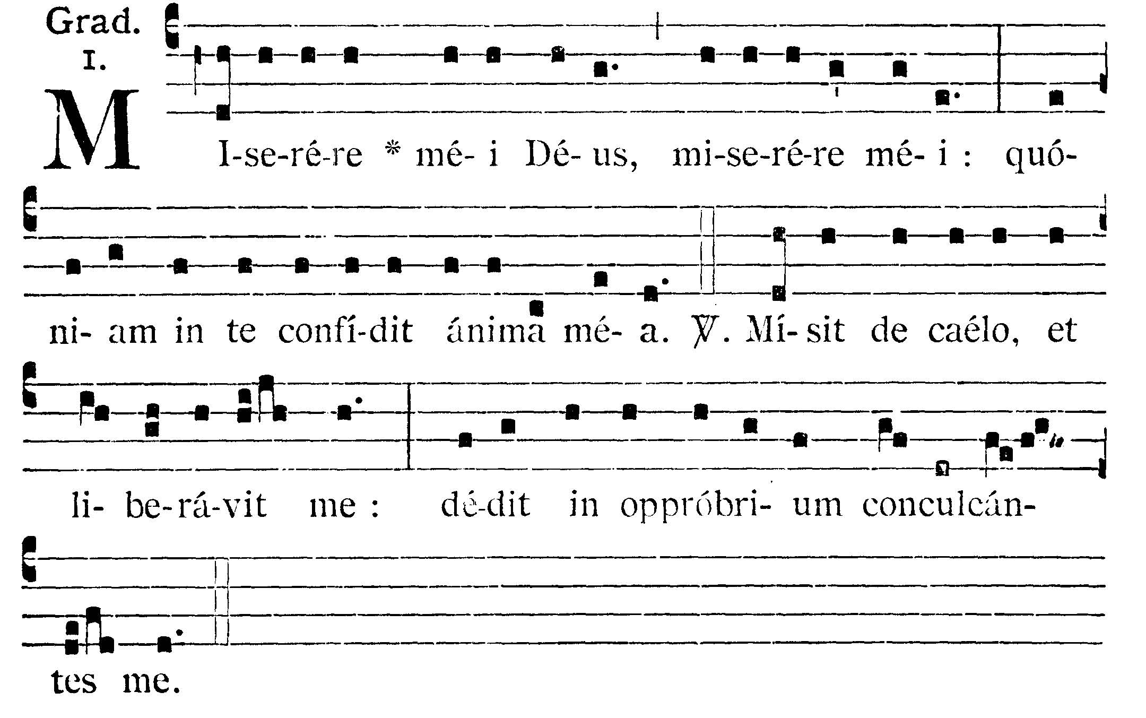
Have mercy on me, O Lord, have mercy on me: for my soul trusteth in Thee. V.: He hath sent from heaven and delivered me: He hath made them a reproach that trod upon me.

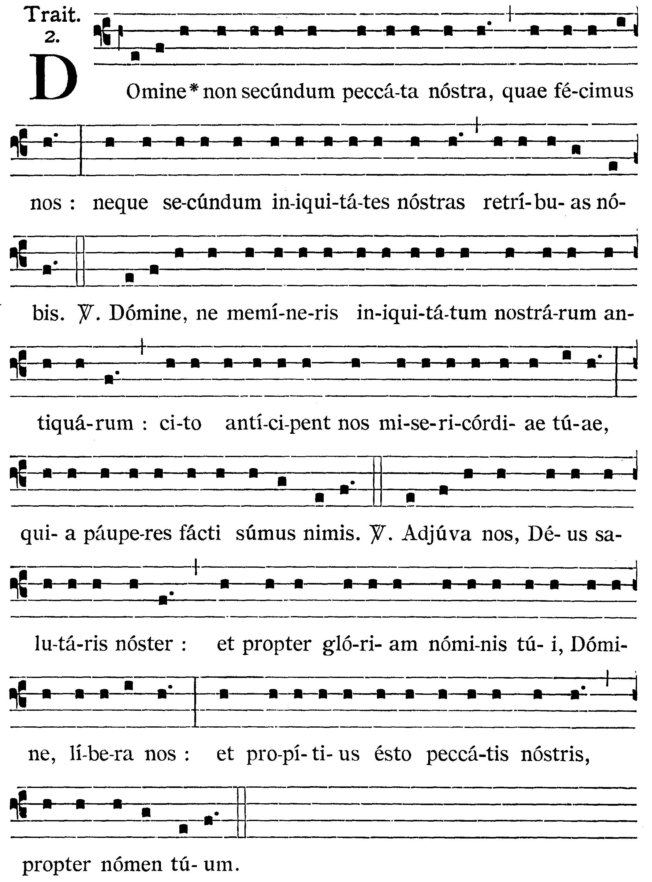
O Lord, repay us not according to the sins we have committed, nor according to our iniquities. V.: (Ps. 78. 8, 9) O Lord, remember not our former iniquities, let Thy mercies speedily prevent us: for we are become exceeding poor. [Here kneel.] V.: Help us, O God, our Savior: and for the glory of Thy Name, O Lord, deliver us: and forgive us our sins for Thy Name's sake1


GOSPEL ¤ Matth. 6. 16-21
† Continuation of the holy Gospel according to St. Matthew.
† Sequentia sancti Evangelii secundum Matthaeum.
[It is not our garments that we shuld rend as a sign of sorrow, as the Pharisees did, but rather our hearts, for it is not to men that we should appear to fast, but to our Father, who sees into the secret place of our souls, and who will repay us.]

In illo tempore: Dixit Iesus discipulis suis: Cum ieiunatis, nolite fieri sicut hypocritae, tristes. Exterminant enim facies suas, ut appareant hominibus ieiunantes. Amen dico vobis, quia receperunt mercedem suam. Tu autem, cum ieiunas, unge caput tuum, et faciem tuam lava, ne videaris hominibus ieiunans, sed Patri tuo, qui est in abscondito: et Pater tuus, qui videt in abscondito, reddet tibi. Nolite thesaurizare vobis thesauros in erra: ubi aerugo, et tinea demolitur: et ubi fures effodiunt, et furantur. Thesaurizate autem vobis thesauros in caelo: ubi neque aurugo, neque tinea demolitur; et ubi fures non effodiunt, nec furantur. Ubi enim est thesaurus tuus, ibi est et cor tuum.

At that time Jesus said to His disciples: When you fast, be not as the hypocrites, sad. For they disfigure their face, that they may appear unto men to fast. Amen I say to you, they have received their reward. But thou, when thou fastest, anoint thy head and wash thy face, that thou appear not to men to fast, but to thy Father who is in secret: and thy Father who seeth in secret will repay Thee. Lay not up to yourselves treasures on earth: where the rust and moth consume, and where thieves break through and steal. But lay up to yourselves treasures in heaven: where neither the rust nor moth doth consume, and where thieves do not break through nor steal. For where thy treasure is, there is thy heart also.
Dominus Vobiscum
Et Cum Spirtu tuo
Oremus:

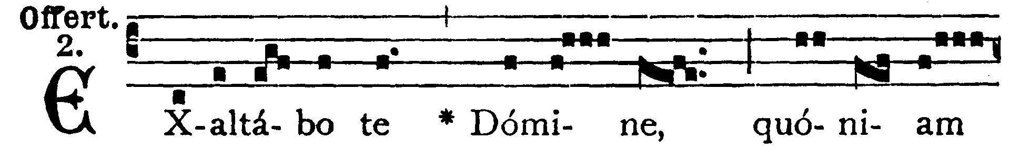
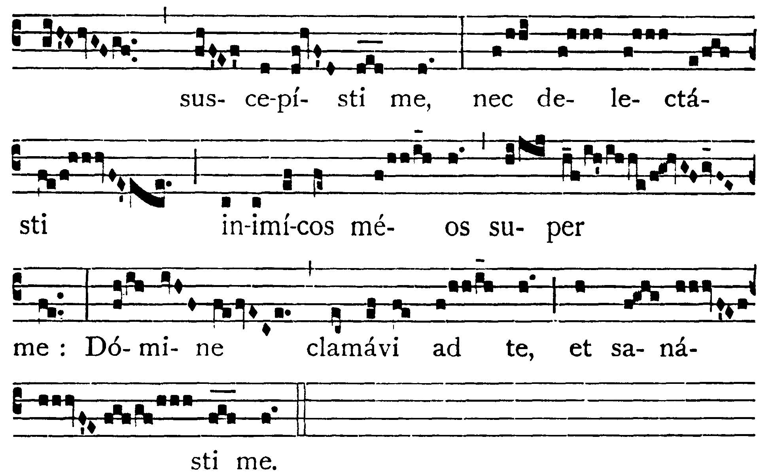
I will extol Thee, O Lord, for Thou hast upheld me, and hast not made my enemies to rejoice over me: O Lord, I have cried to Thee, and Thou hast healed me.

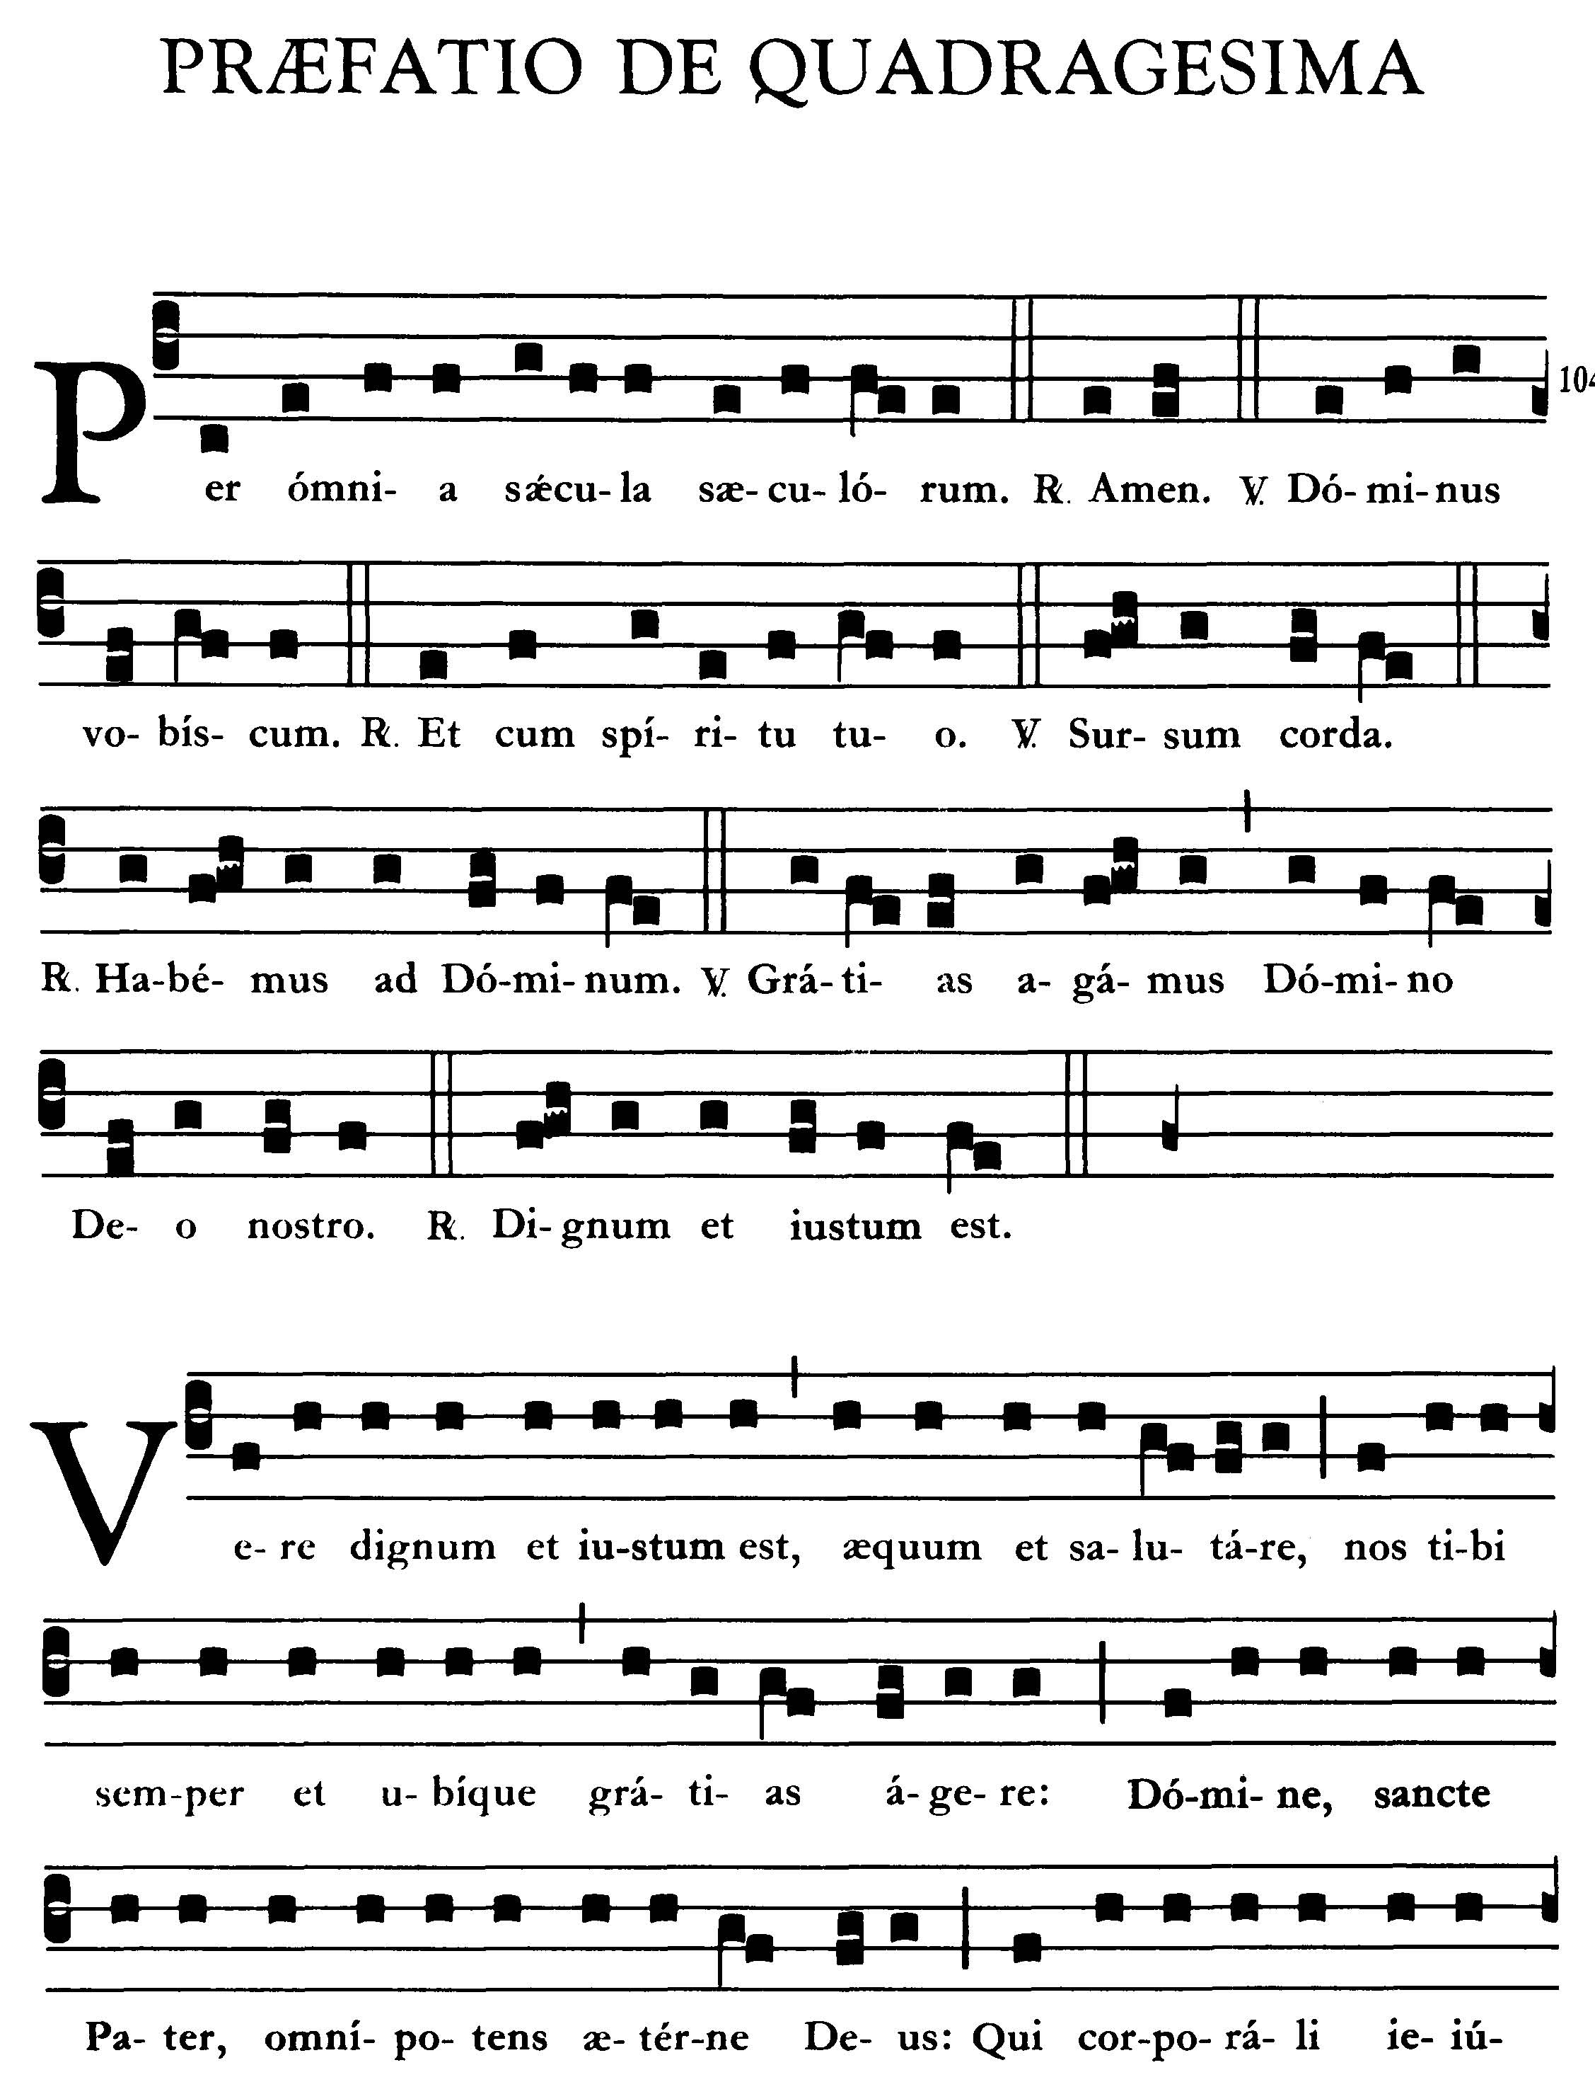
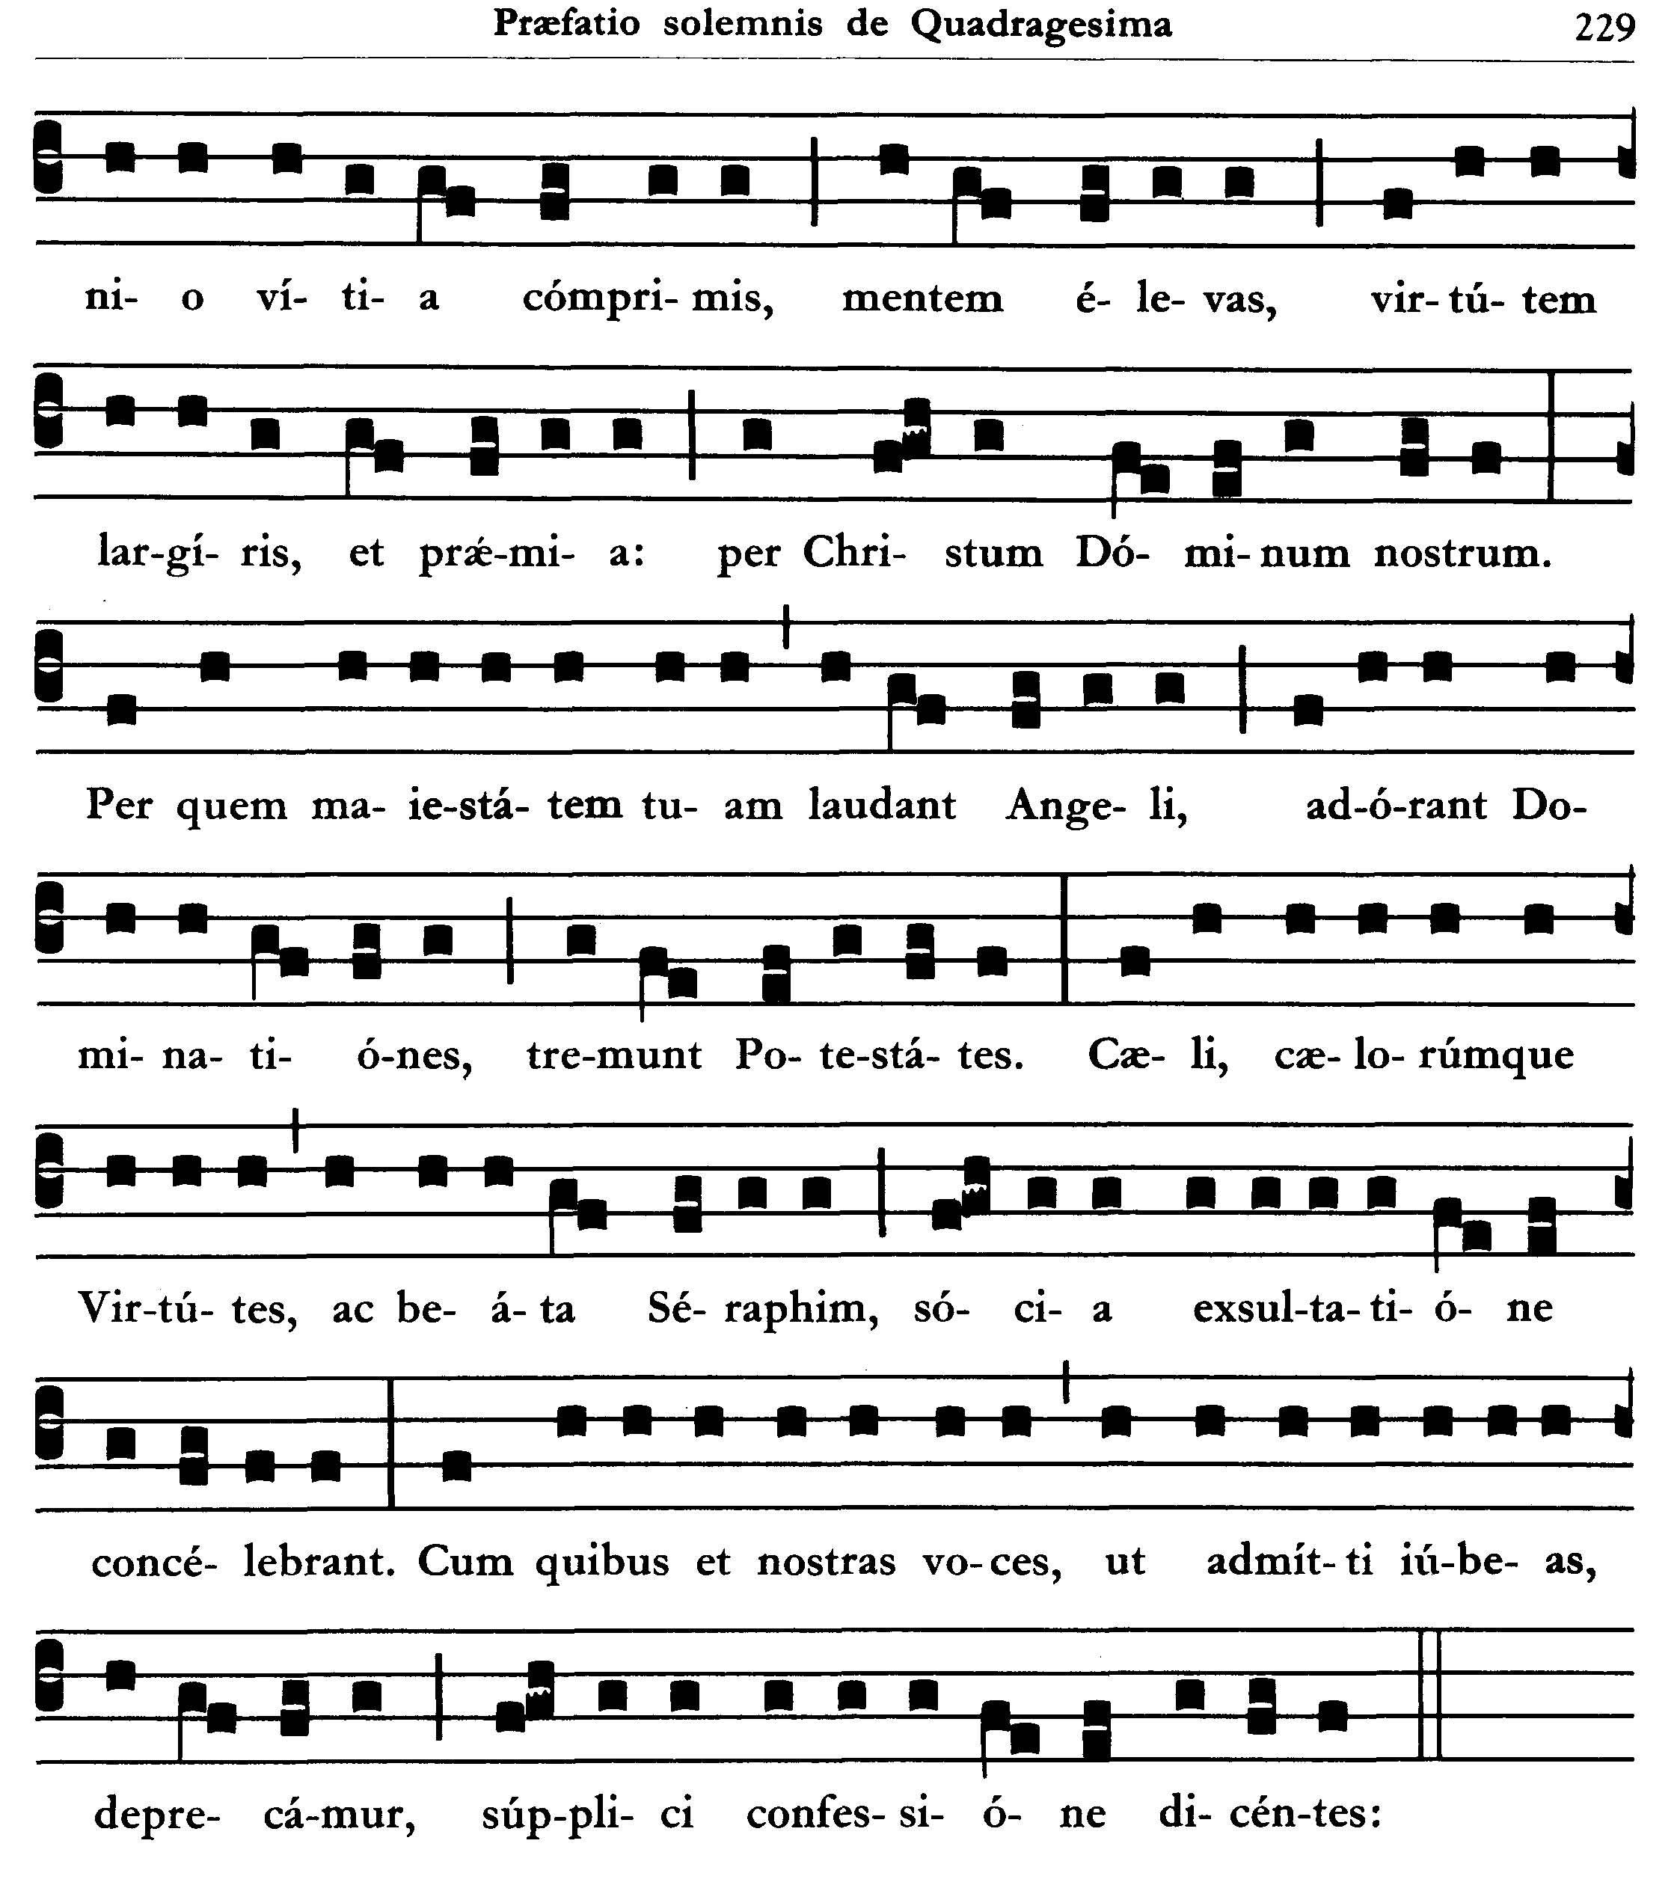
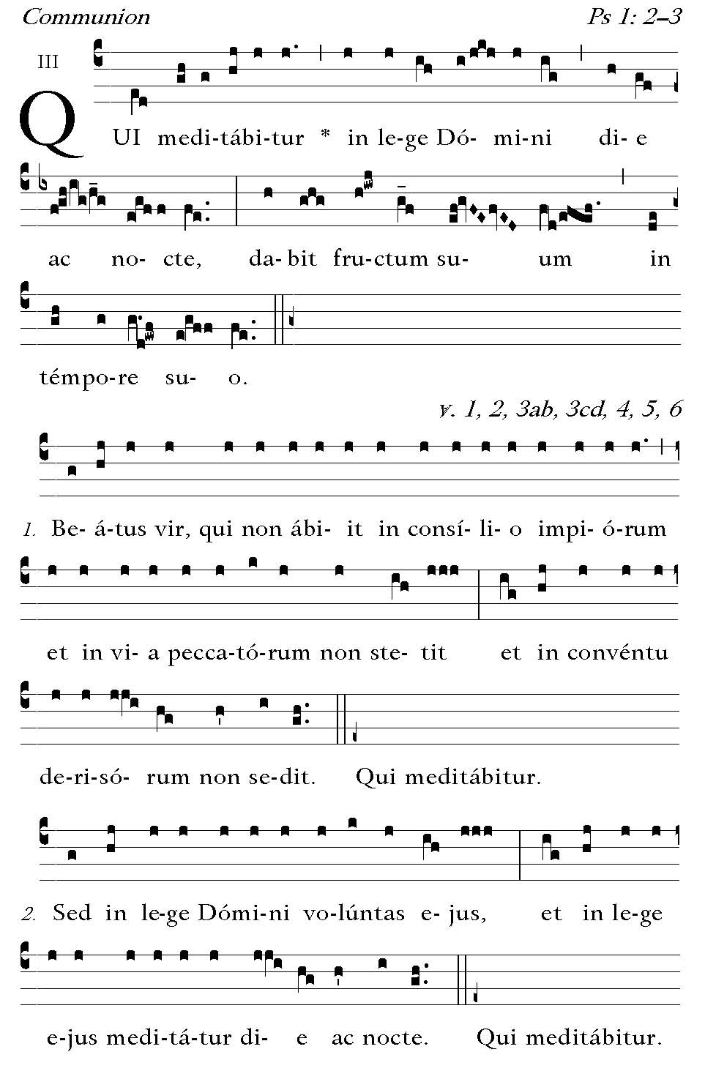
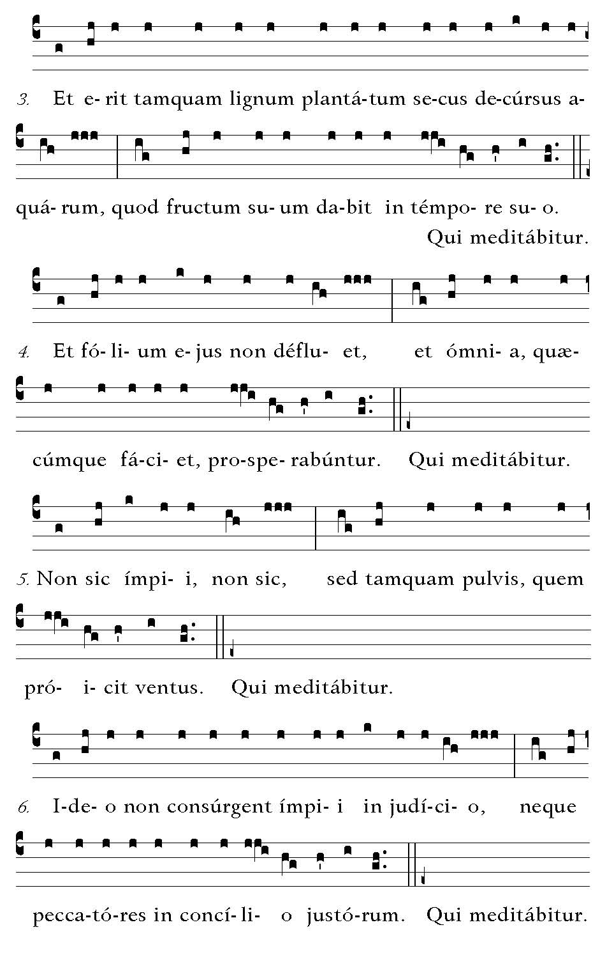

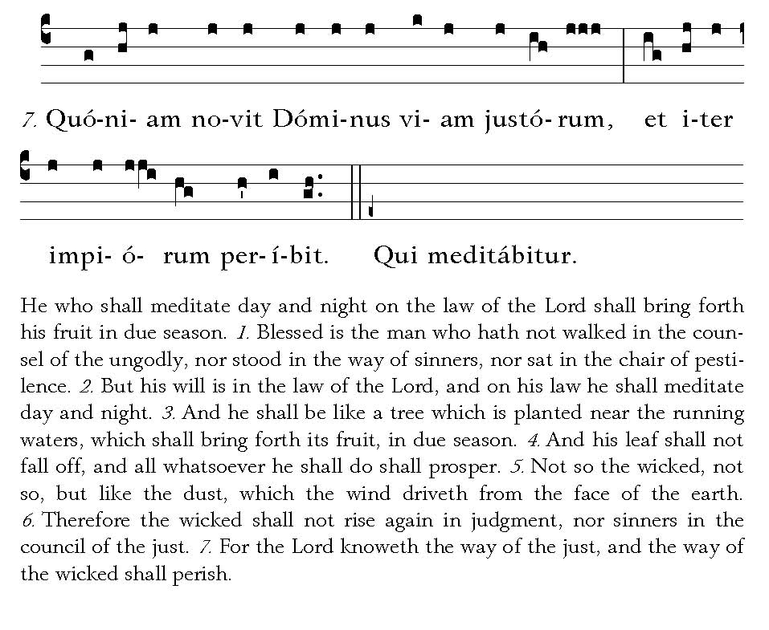


POSTCOMMUNION
Percepta nobis, Domine, praebeant sacramenta subsidium: ut tibi grata sint nostra ieiunia, et nobis proficiant ad medelam. Per Dominum . . .
May the Sacraments we have received afford us help, O Lord, that our fasts may be pleasing unto Thee, and profitable unto us for healing. Through our Lord Jesus Christ, Thy Son, who liveth . . .

PRAYER OVER THE PEOPLE
Oremus. Humiliate capita vestra Deo. -- Inclinantes se, Domine, maiestati tuae, propitiatus intende: ut qui divino munere sunt refecti, caelestibus semper nutriantur auxiliis. Per Dominum . . .

Let us pray. Bow down your heads before God. -- Look graciously, O Lord, upon us who bow down before Thy majesty: that we who have been refreshed by Thy divine Gift may ever be sustained by Thy heavenly aids. Through our Lord Jesus Christ, Thy Son . . .

