Corpus Christi
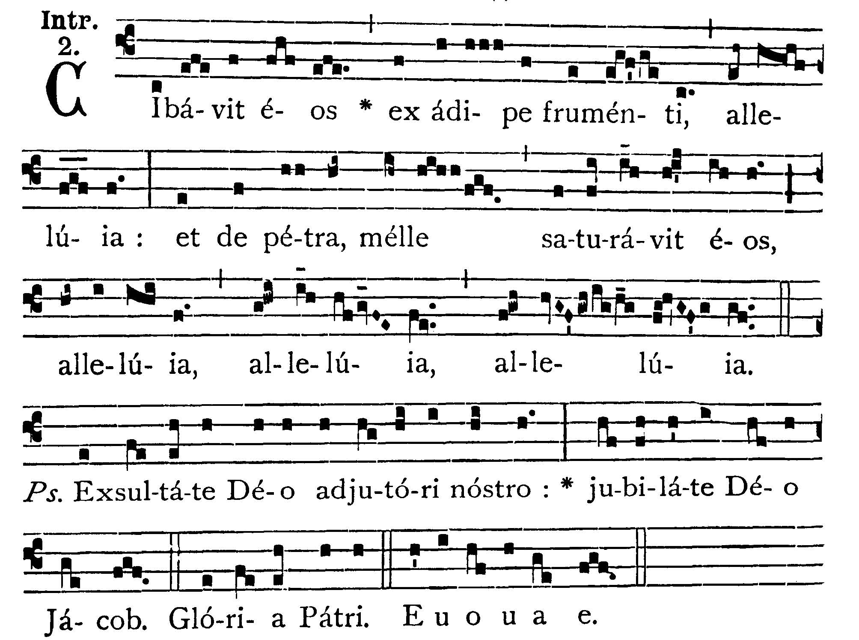
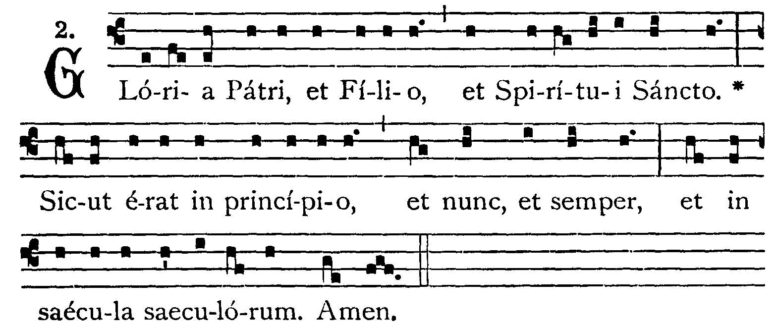
He fed them with the fat of wheat, alleluia; and filled them with honey out of the rock, alleluia, alleluia, alleluia. -- (Ps. 80. 2). Rejoice in God our helper; sing aloud to the God of Jacob. V.: Glory be to the Father . . . -- He fed them with the fat of wheat . . .
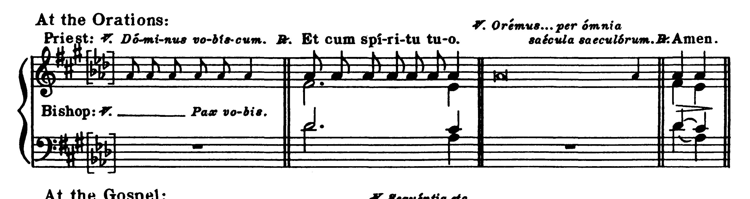
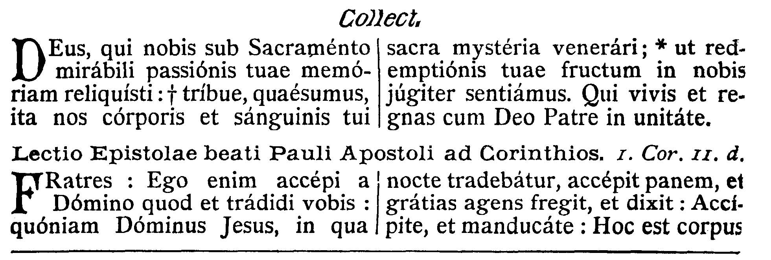
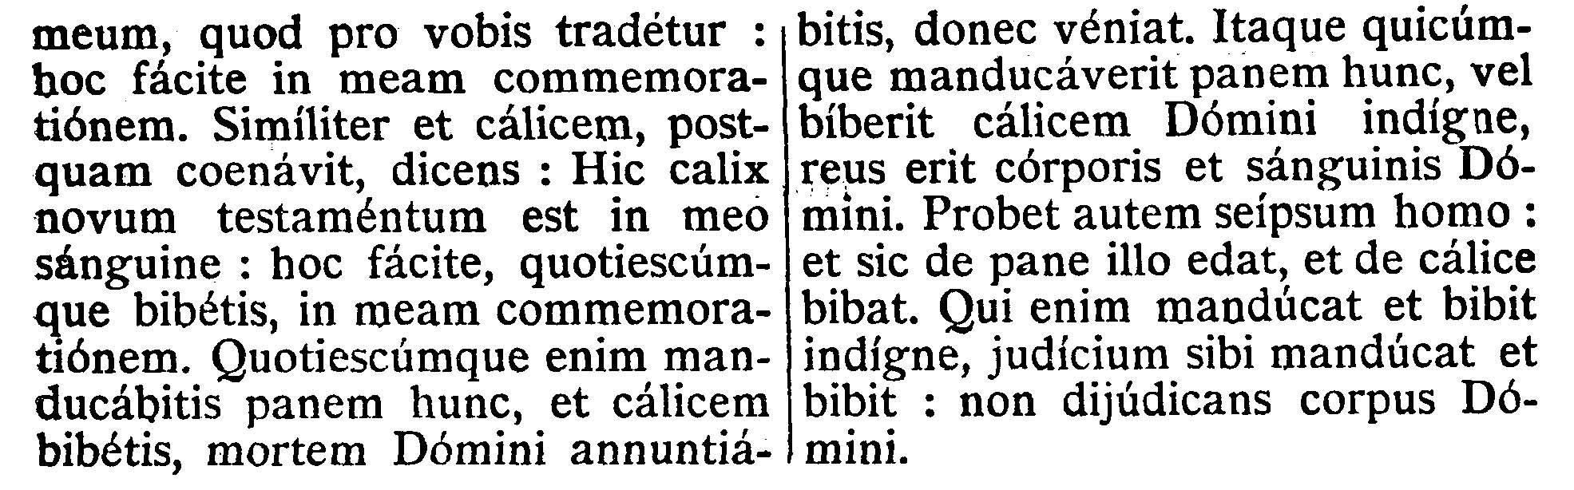
COLLECT.--O God, who in a wonderful Sacrament hast left unto us the memorial of Thy Passion; grant, we beseech Thee, that we may so venerate the sacred mysteries of Thy Body and Blood as to experience continually within ourselves the fruit of Thy Redemption. Who livest and reignest with God the Father, in the unity of the Holy Ghost, God, world without end.

EPISTLE ¤ I. Cor. 11. 23-29
Lesson from the first Epistle of Blessed Paul the Apostle to the Corinthians.
[The Blessed Sacrament remains the memorial of the Passion of Our Lord and shows forth the death of Jesus (Holy Mass).]
Brethren, I have received of the Lord, that which also I delivered to you, that the Lord Jesus, the same night in which He was betrayed, took bread, and giving thanks, broke, and said: Take ye and eat, this is My Body which shall be delivered for you; this do for the commemoration of Me. In like manner also the chalice, after He had supped, saying: This chalice is the new testament in My Blood; this do ye, as often as you shall drink, for the commemoration of Me. For as often as you shall eat this bread and drink this chalice, you shall show the death of the Lord until He come. Therefore whosoever shall eat this bread, or drink of the chalice of the Lord unworthily, shall be guilty of the Body and Blood of the Lord. But let a man prove himself; and so let him eat of that bread, and drink of the chalice. For he that eateth and drinketh unworthily, eateth and drinketh judgment to himself, not discerning the Body of the Lord.
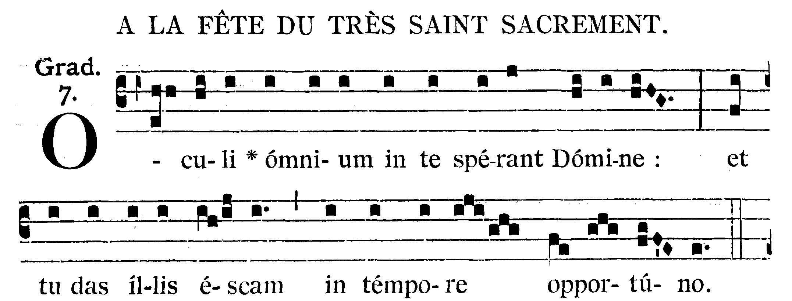
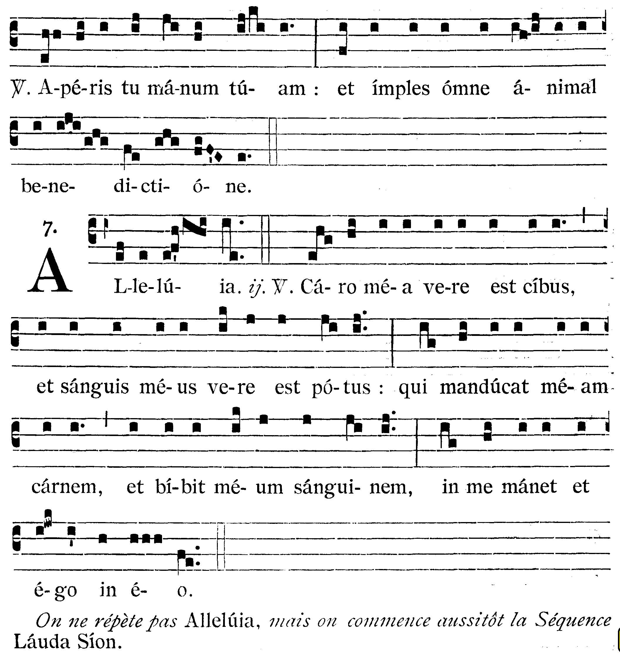
The eyes of all hope in Thee, O Lord, and Thou givest them meat in due season. V.: Thou openest Thy hand, and fillest every living creature with Thy blessing.
Alleluia, alleluia. V.(John 6. 56, 57). My Flesh is meat indeed and My Blood is drink indeed: he that eateth My Flesh and drinketh My Blood, abideth in Me, and I in Him. Alleluia.
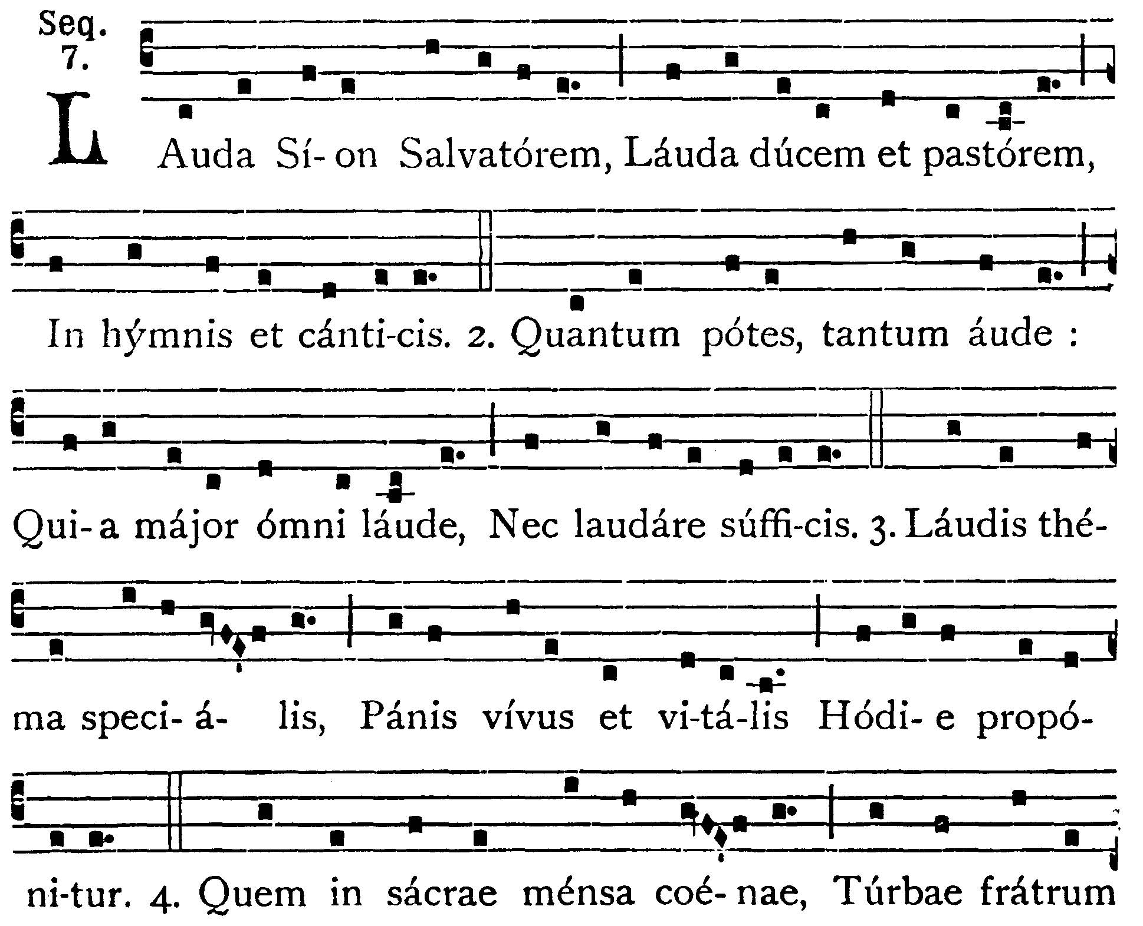
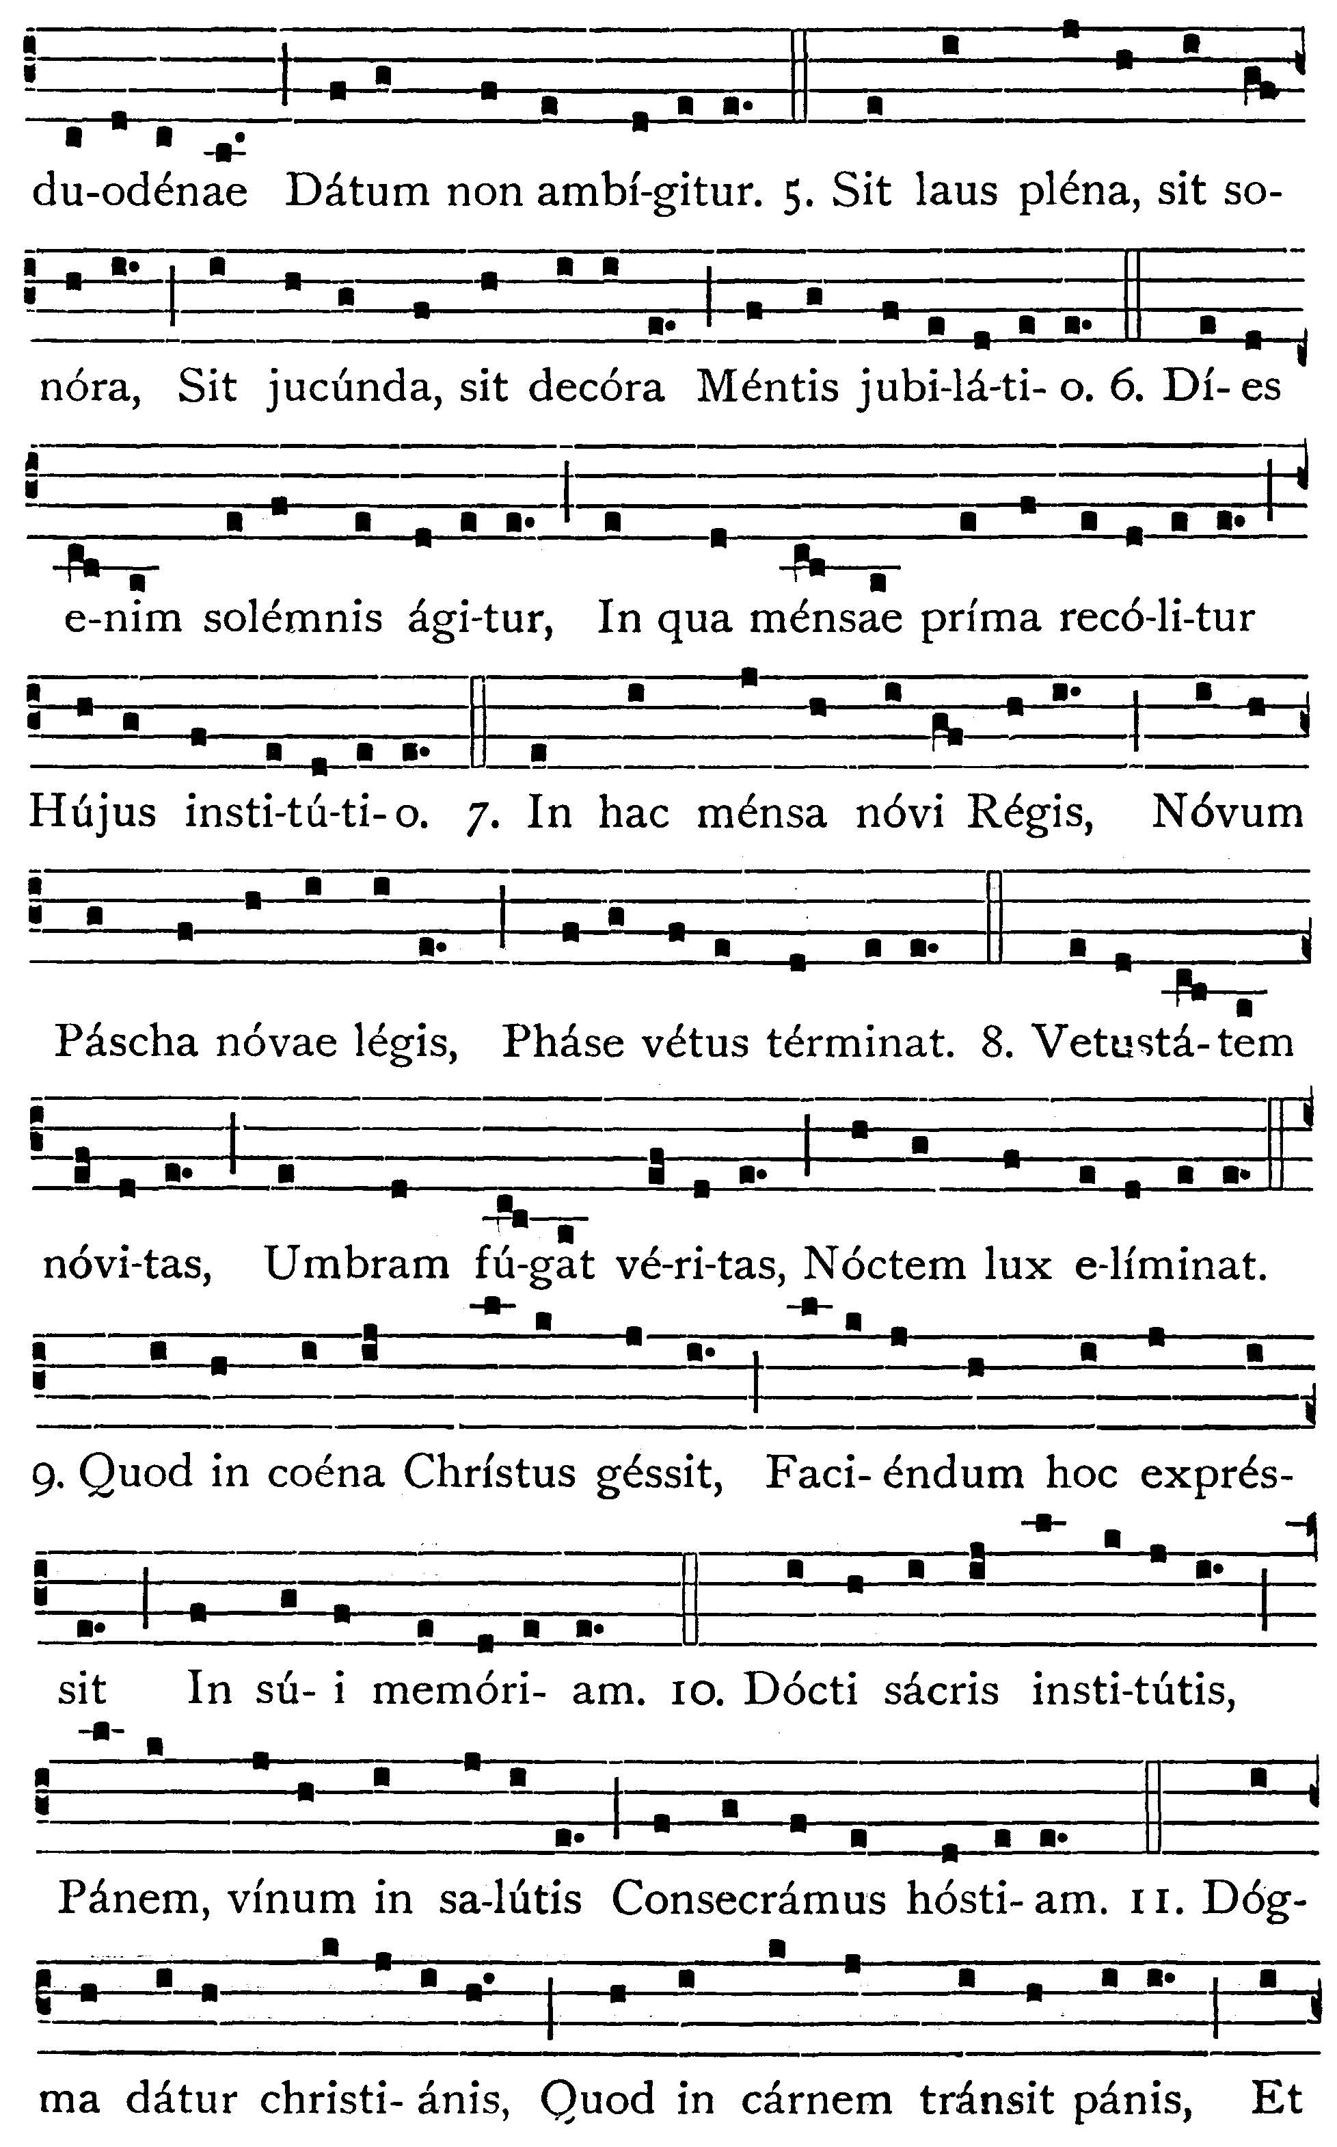
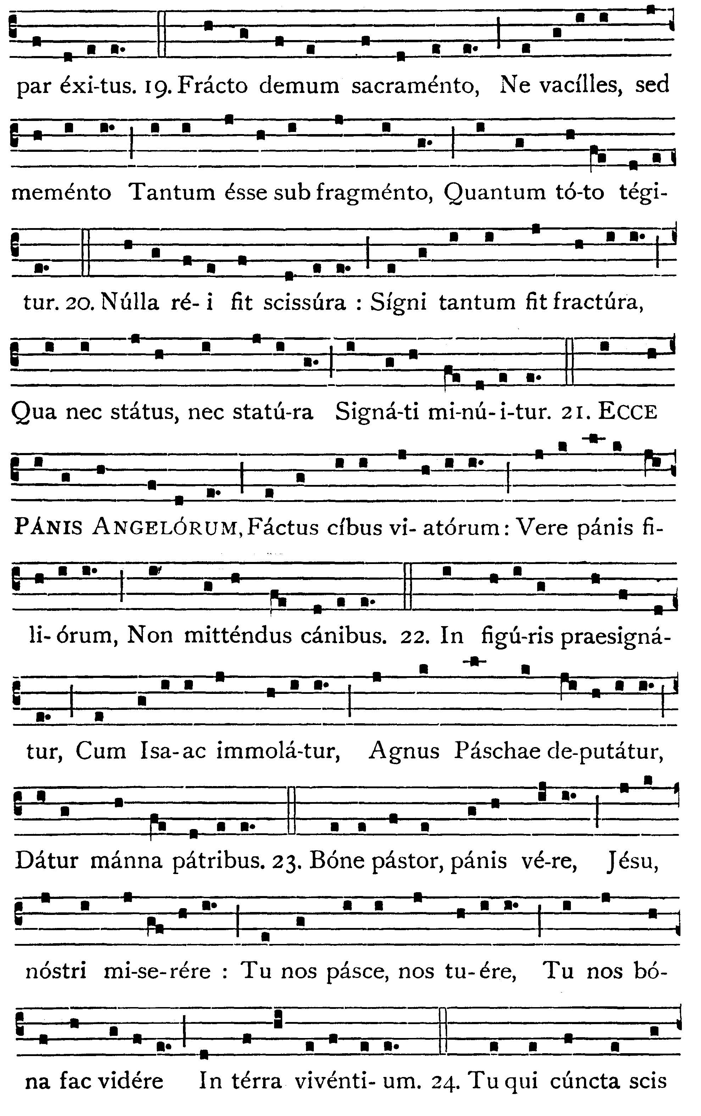
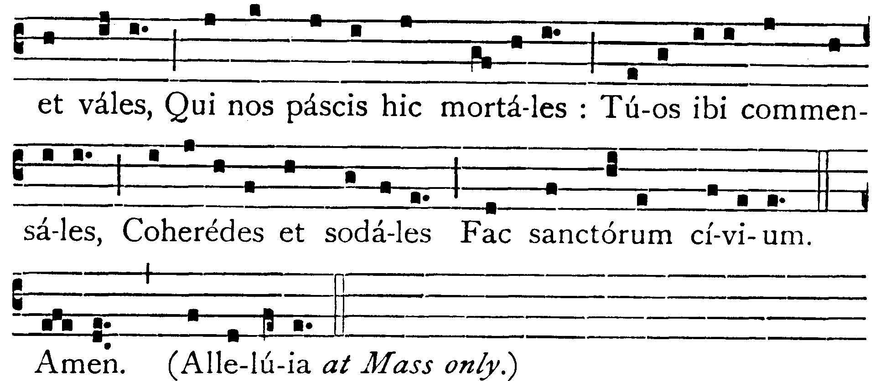

Lo! upon the altar lies,
Hidden deep from human eyes,
Bread of Angels from the skies,
Made the food of mortal man;

Children's meat to dogs denied,
In old types presignified:
In the manna heaven-supplied
In Isaac, and the Paschal lamb.

Shepherd of the sheep!
Thou Thy flock in safety keep,
Living Bread! Thy life supply:
Strengthen us, or else we die:
Fill us with celestial grace!

Thou, who feedest us below!
Source of all we have or know!
Grant that with Thy Saints above,
Sitting at the feast of love,
We may see Thee face to face.

Amen. Alleluia.

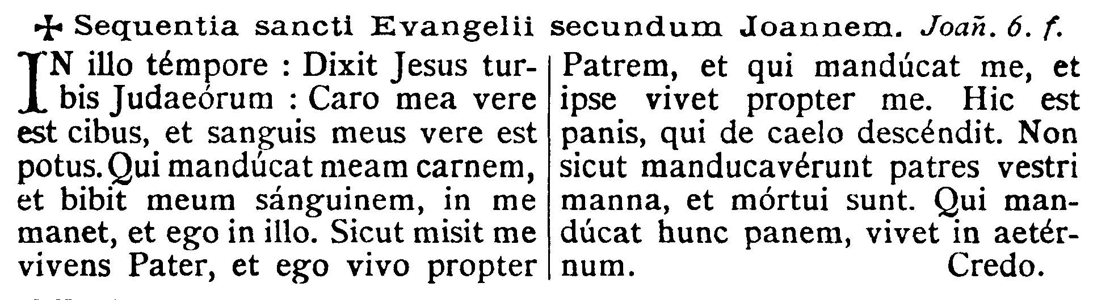
GOSPEL ¤ John 6. 56-59
† Continuation of the holy Gospel according to St. John.
[The Holy Eucharist is instituted in the form of food, so that we may receive in Holy Communion the Victim of the Cross.]
At that time Jesus said to the multitudes of the Jews: My Flesh is meat indeed, and My Blood is drink indeed. He that eateth My Flesh, and drinketh My Blood, abideth in Me, and I in him. As the living Father hath sent Me, and I live by the Father, so he that eateth Me, the same also shall live by Me. This is the bread that came down from heaven. Not as your fathers did eat manna and are dead. He that eateth this bread shall live for ever.
Dominus Vobiscum
Et Cum Spirtu tuo
Oremus:

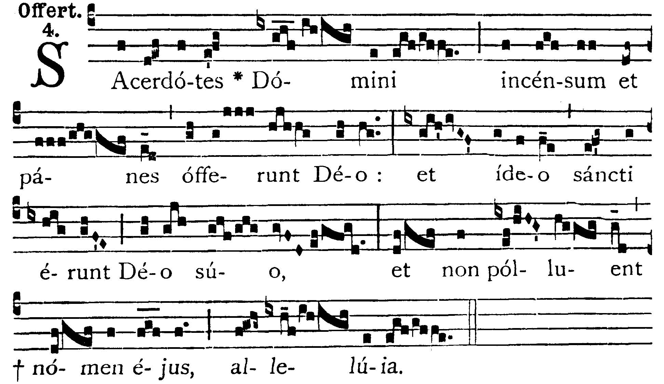

The priests of the Lord offer incense and loaves to God, and therefore they shall be holy to their God, and shall not defile His Name. Alleluia.

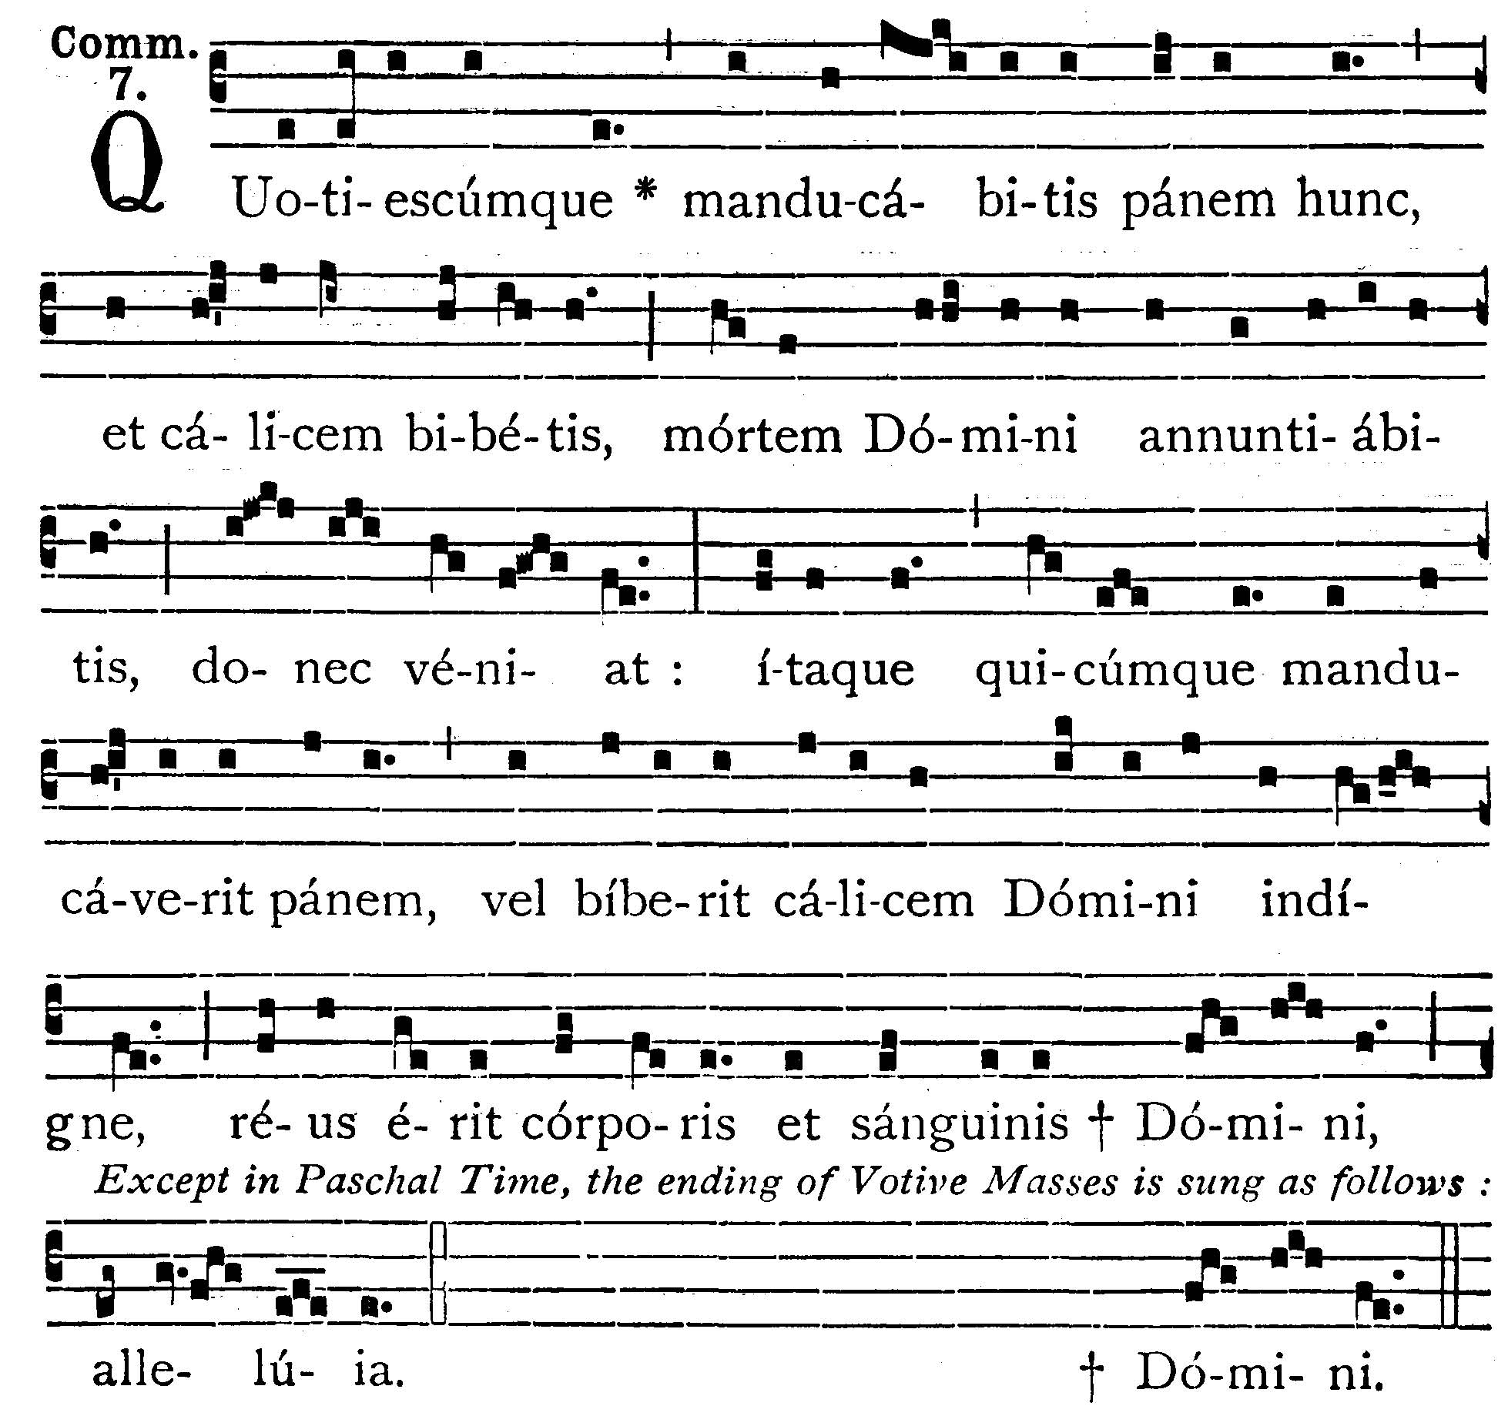
As often as you shall eat this Bread, and drink the Chalice, you shall show the death of the Lord, until He come: therefore whosoever shall eat this Bread or drink the Chalice of the Lord unworthily, shall be guilty of the Body and Blood of the Lord. Alleluia.
Post Communion

Deo Gratias

