Epiphany
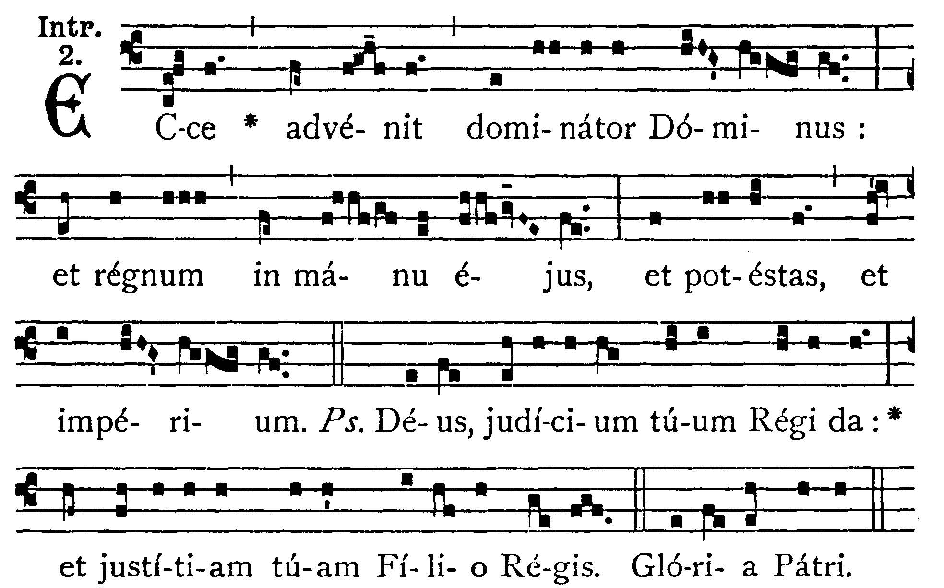
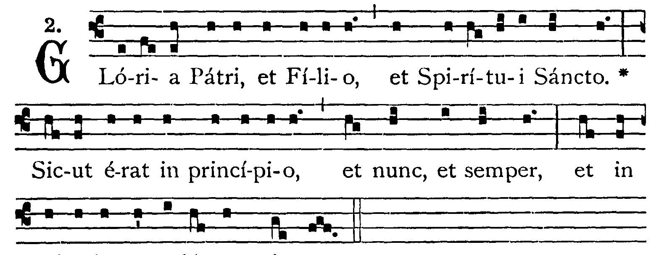

Behold the Lord the Ruler is come: and the Kingdom is in His Hand, and power, and dominion. -- (Ps.71. 2). Give to the king Thy judgment, O God: and to the king's Son Thy justice. V.: Glory be to the Father . . . -- Behold . . .


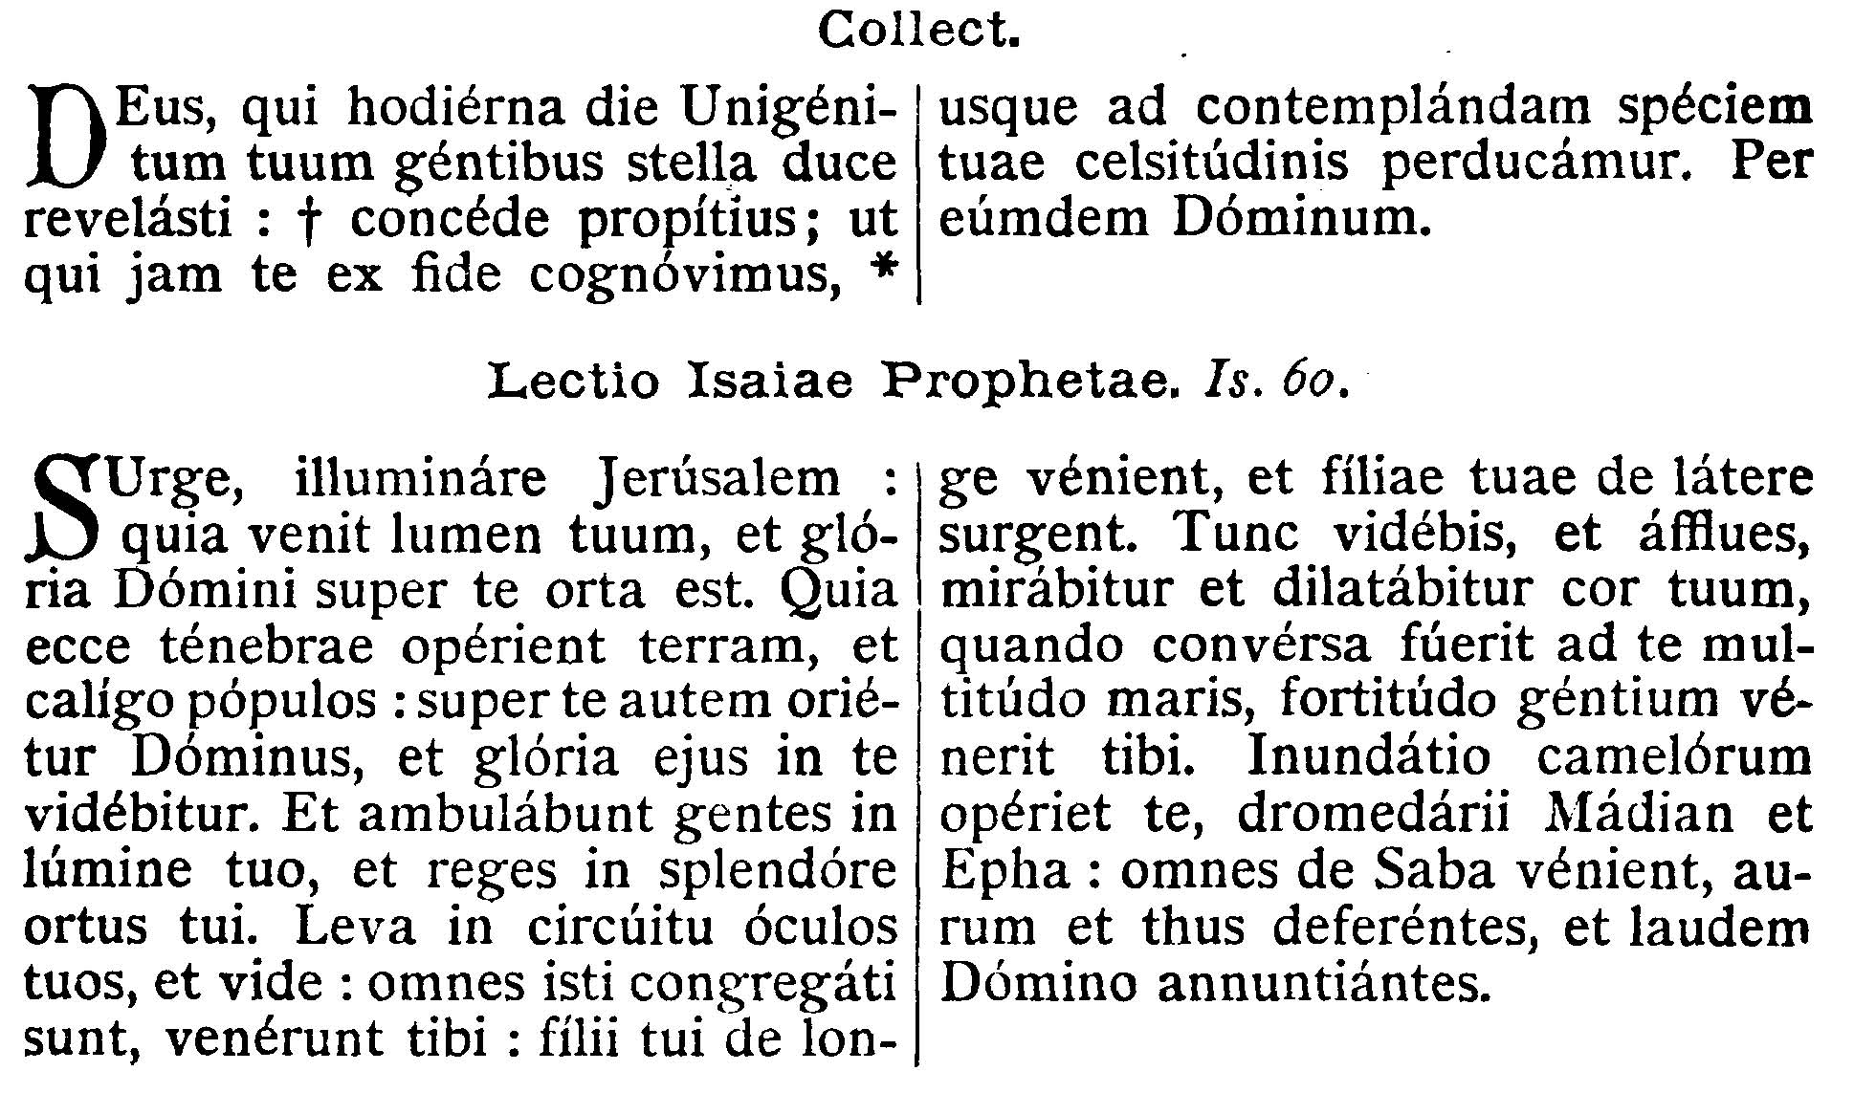
COLLECT.--O God, who on this day, didst manifest Thine only-begotten Son to the Gentiles by the guidance of a star: graciously grant, that we, who know Thee now by faith, may be led on even to contemplate the beauty of Thy Majesty. Through the same Jesus Christ, . . .

EPISTLE ¤ Isa. 60. 1-6
Lesson from Isaiah the Prophet.
[Isaias in a vision perceives the Church under the figure of Jerusalem where "the kings and the nations abound, the multitude who inhabit the borders of the sea and the strength of the Gentiles."]
Arise, be enlightened, O Jerusalem: for they light is come, and the glory of the Lord is risen upon thee. For behold darkness shall cover the earth, and a mist the people: but the Lord shall arise upon thee, and His glory shall be seen upon thee. And the Gentiles shall walk in thy light, and kings in the brightness of they rising. Lift up thy eyes round about and see: all these are gathered together: they are come to thee: thy sons shall come from afar, and thy daughters shall rise up at thy side. Then shalt Thou see and abound, and thy heart shall wonder and be enlarged, when the multitude of the sea shall be converted to thee, the strenth of the Gentiles shall come to thee. The multitude of camels shall cover thee, the dromedaries of Madian and Epha: all they from Saba shall come, bringing gold and frankincense and showing forth their praise to the Lord.
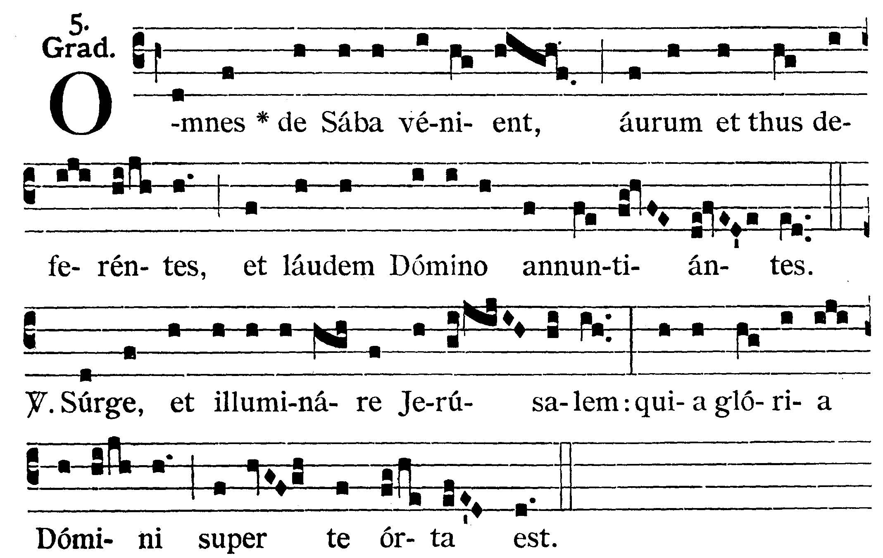
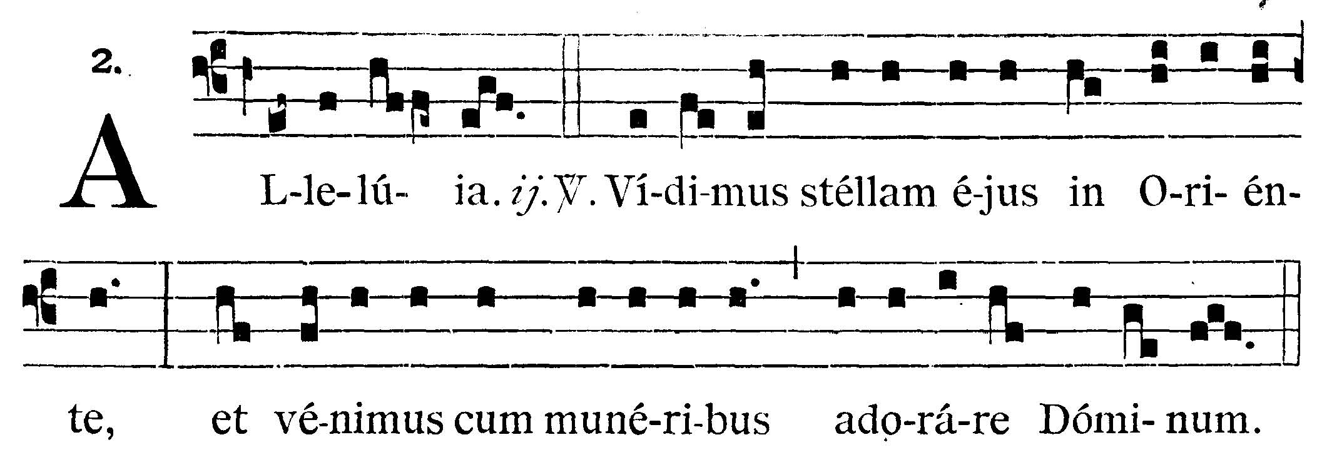
GRADUAL

All they from Saba shall come, bringing gold and frankincense and showing forth praise to the Lord. V.: Arise and be enlightened, O Jerusalem: for the glory of the Lord is risen upon thee.
Alleluia, alleluia. V.: We have seen His star in the East, and are come with gifts to adore the Lord. Alleluia



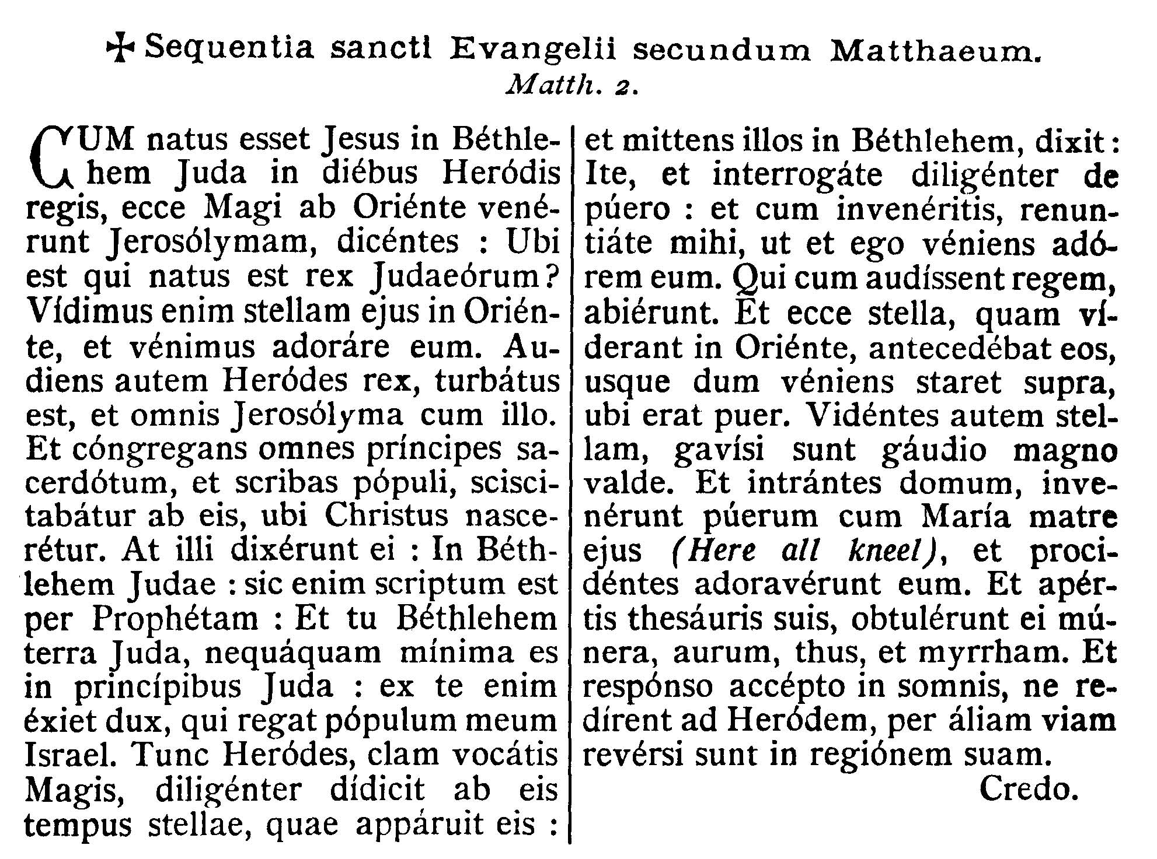
GOSPEL ¤ Matt. 2. 1-2.
† Continuation of the holy Gospel according to St. Matthew.
[Our Lord makes himself known to the Magi Kings by a star.]
When Jesus was born in Bethlehem of Juda in the days of king Herod, behold there came wise men from the East to Jerusalem, saying: Where is He that is born king of the Jews? For we have seen His star in the East, and are come to adore Him. And king Herod hearing this was troubled, and all Jerusalem with him. And assembling together all the chief priests and the scribes of the people, he inquired of them were Christ should be born. But they said to him: In Bethlehem of Juda. For so it is written by the Prophet. And thou Bethlehem, the land of Juda, are not the least among the princes of Juda: for out of thee shall come forth the Captain that shall rule My people Israel. Then Herod, privately calling the wise men, learned diligently of them the time of the star which appeared to them: and sending them into Bethlehem, said: Go and diligently inquire after the Child, and when you have found Him, bring me word again, that I also may come and adore Him. Who having heard the king went their way. And behold the star, which they had seen in the East, went before them until it came and stood over where the Child was. And seeing the star they rejoiced with exceeding great joy. And entering into the house, they found the Child with Mary His Mother, (here genuflect) and falling down they adored Him. And opening their treasures, they offered Him gifts, gold, frankincense, and myrrh. And having received an answer in sleep that they should not return to Herod, they went back another way into their country.

Priest: Dominus Vobiscum
All: Et Cum Spirtu tuo
Preist: Oremus:

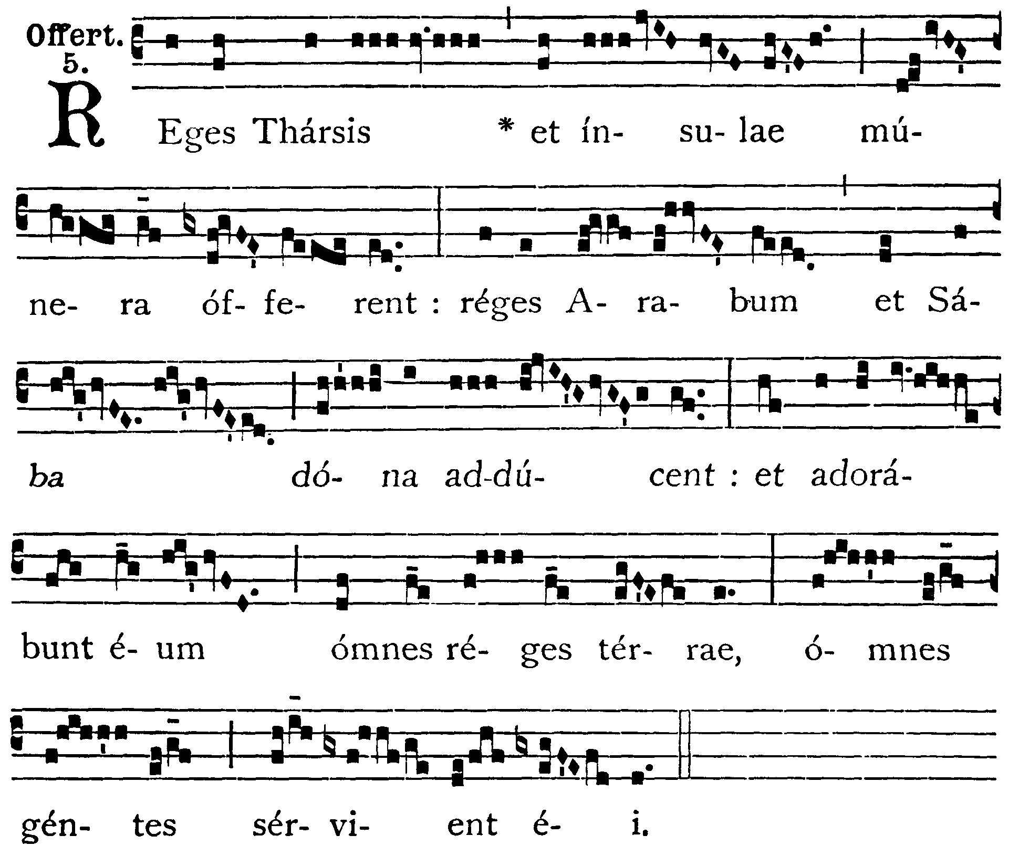

OFFERTORY
The kings of Tharsis and the islands shall offer presents: the kings of the Arabians and of Saba shall bring gifts: and all kings of the earth shall adore Him: all nations shall serve Him.

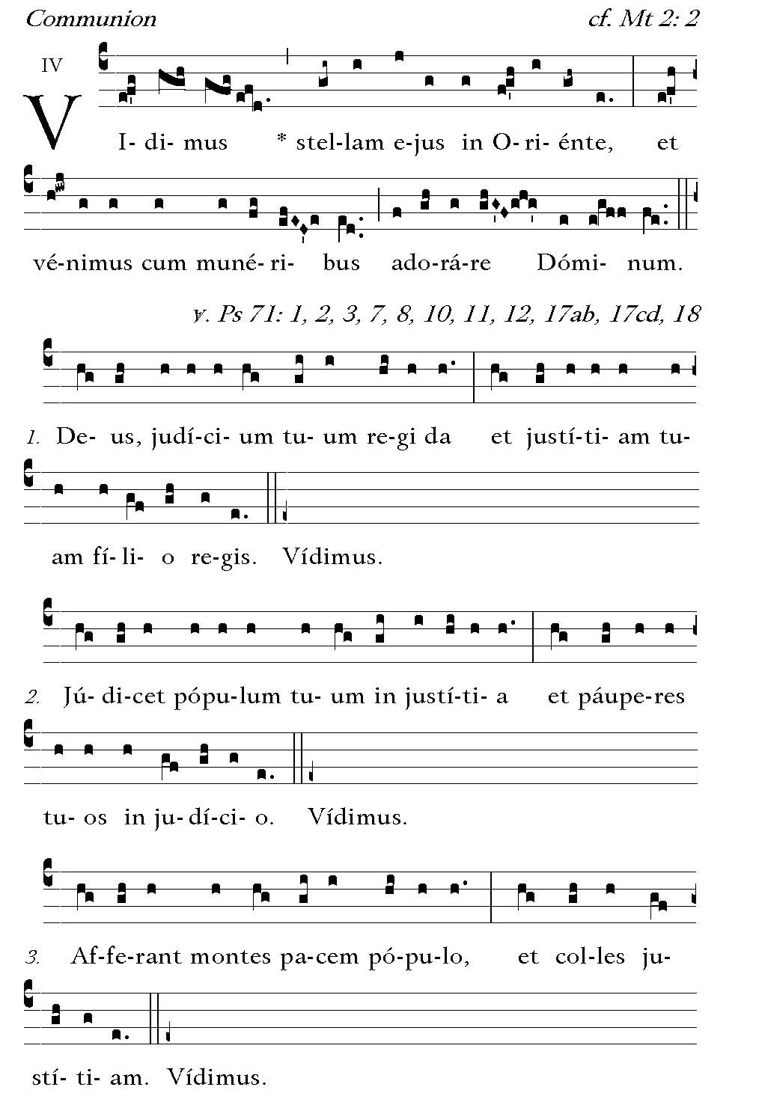
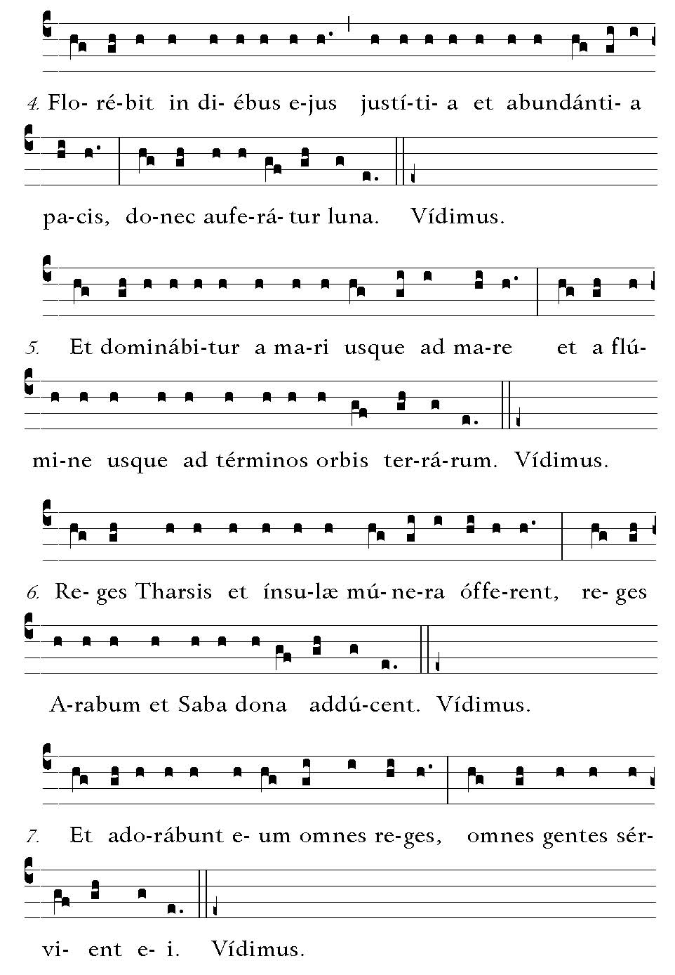
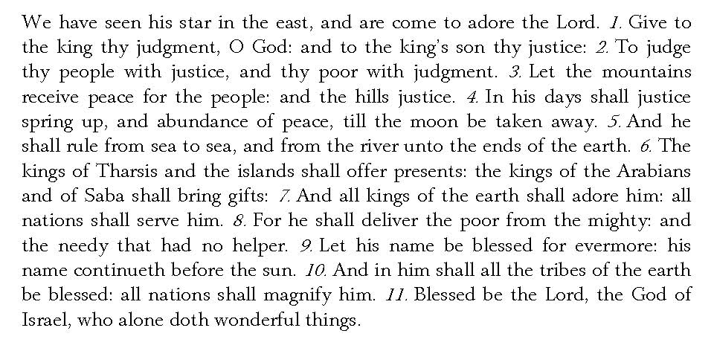

Post Communion
Deo Gratias

