Holy Family

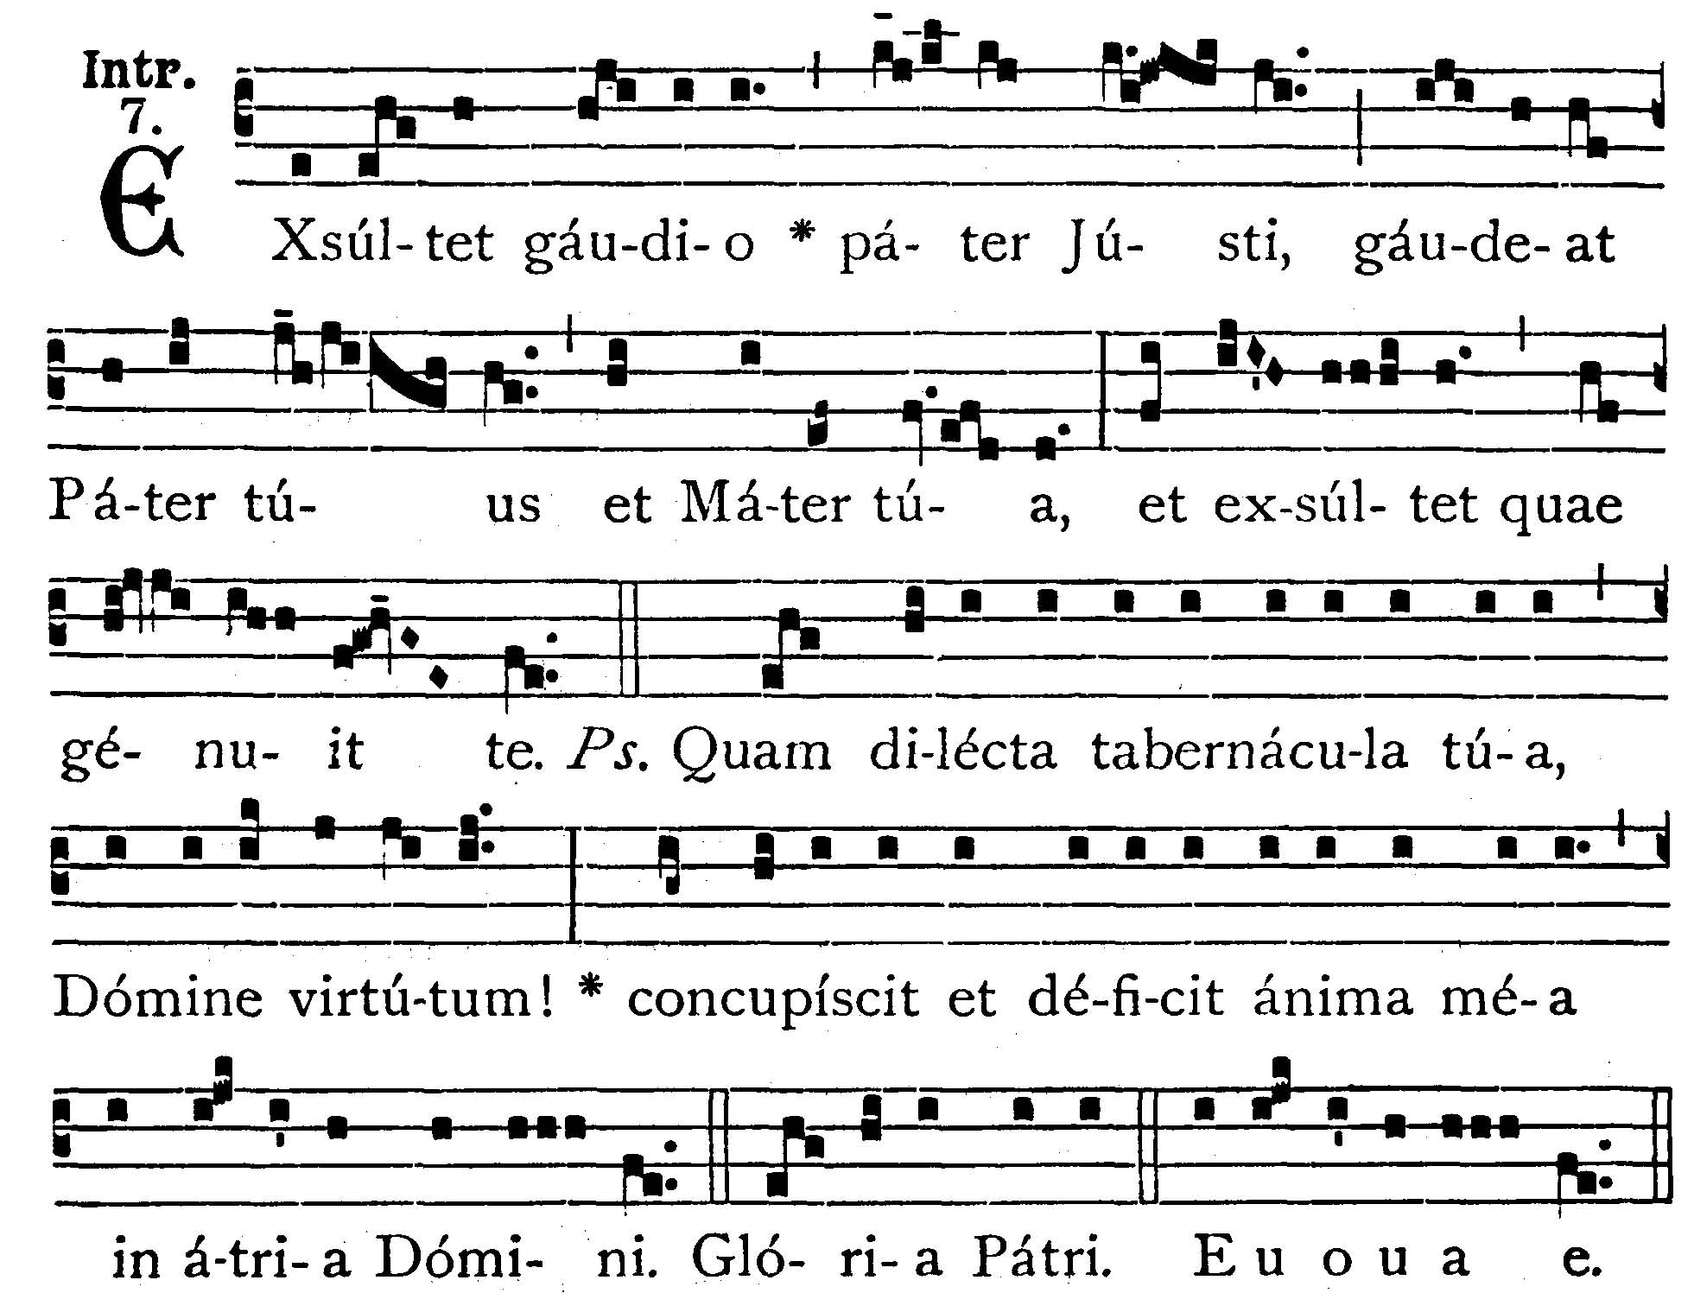
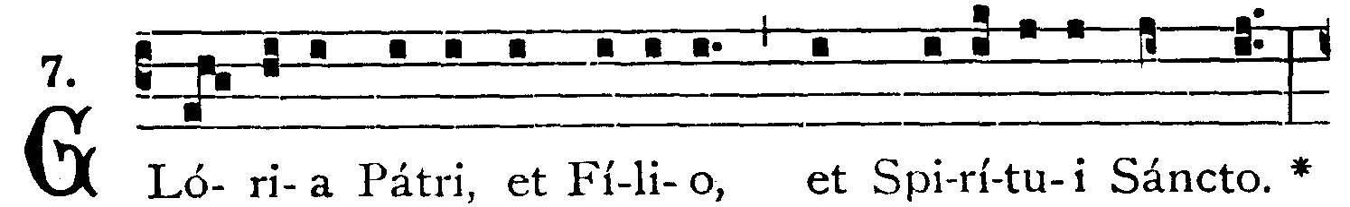
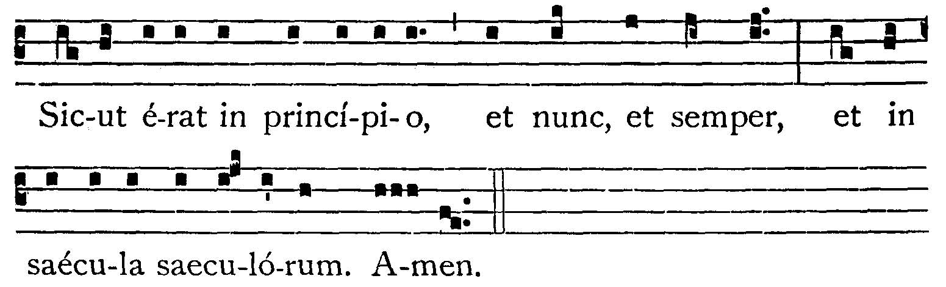
The father of the Just rejoiceth greatly, let Thy father and Thy mother be joyful, and let her rejoice who bore Thee. -- (Ps.88. 2, 3). How lovely are Thy tabernacles, O Lord of Hosts! my soul longeth and fainteth for the courts of the Lord. V.: Glory be to the Father . . . -- The father of the Just . . .


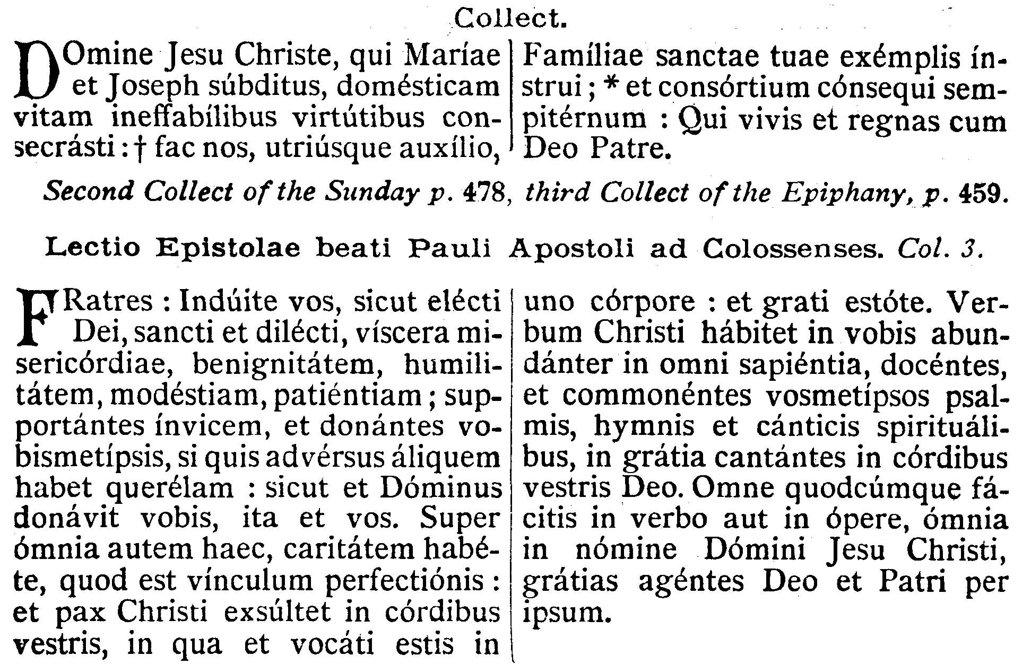
COLLECT.1--O Lord Jesus Christ, who, being subject to Mary and Joseph, didst sanctify home life with unspeakable virtues: grant, that, by the aid of both, we may be taught by the example of Thy Holy Family, and attain to eternal fellowship with it: Who livest and reignest, with God the Father, in the unity of the Holy Ghost, God . . . Commemoration of the Sunday
2nd COLLECT.--We beseech Thee, O Lord, hear of Thy heavenly goodness the prayers of Thy suppliant people: that they may both perceive what things they ought to do, and also may have power to fulfill the same. Through our Lord Jesus Christ, Thy Son, who liveth and reigneth with Thee in the unity of the Holy Ghost . . . Commemoration of the Epiphany
3rd COLLECT.--O God, who on this day, didst manifest Thine only-begotten Son to the Gentiles by the guidance of a star: graciously grant, that we, who know Thee now by faith, may be led on even to contemplate the beauty of Thy Majesty. Through the same Jesus Christ, . . .
EPISTLE ¤ Col. 3. 12-17
Lesson from the Epistle of blessed Paul the Apostle to the Colossians.
["All whatsoever you do in word or work, do all in the Name of the Lord Jesus Christ, giving thanks to God and the Father by Jesus Christ our Lord." . . . says St. Paul to the Colossians and to the Church.]
Brethren, Put ye on therefore, as the elect of God, holy and beloved, the bowels of mercy, benignity, humility, modesty, patience: bearing with one another and forgiving one another: even as the Lord hath forgiven you, so do you also. But above all these things have charity, which is the bond of perfection: and let the peace of Christ rejoice in your hearts, wherein also you are called in one body: and be ye thankful. Let the word of Christ dwell in you abundantly, in all wisdom, teaching and admonishing one another in psalms, hymns and spiritual canticles, singing in grace in your hearts to God. All whatsoever you do in word or in work, do all in the Name of the Lord Jesus Christ, giving thanks to God and the Father by Jesus Christ our Lord.
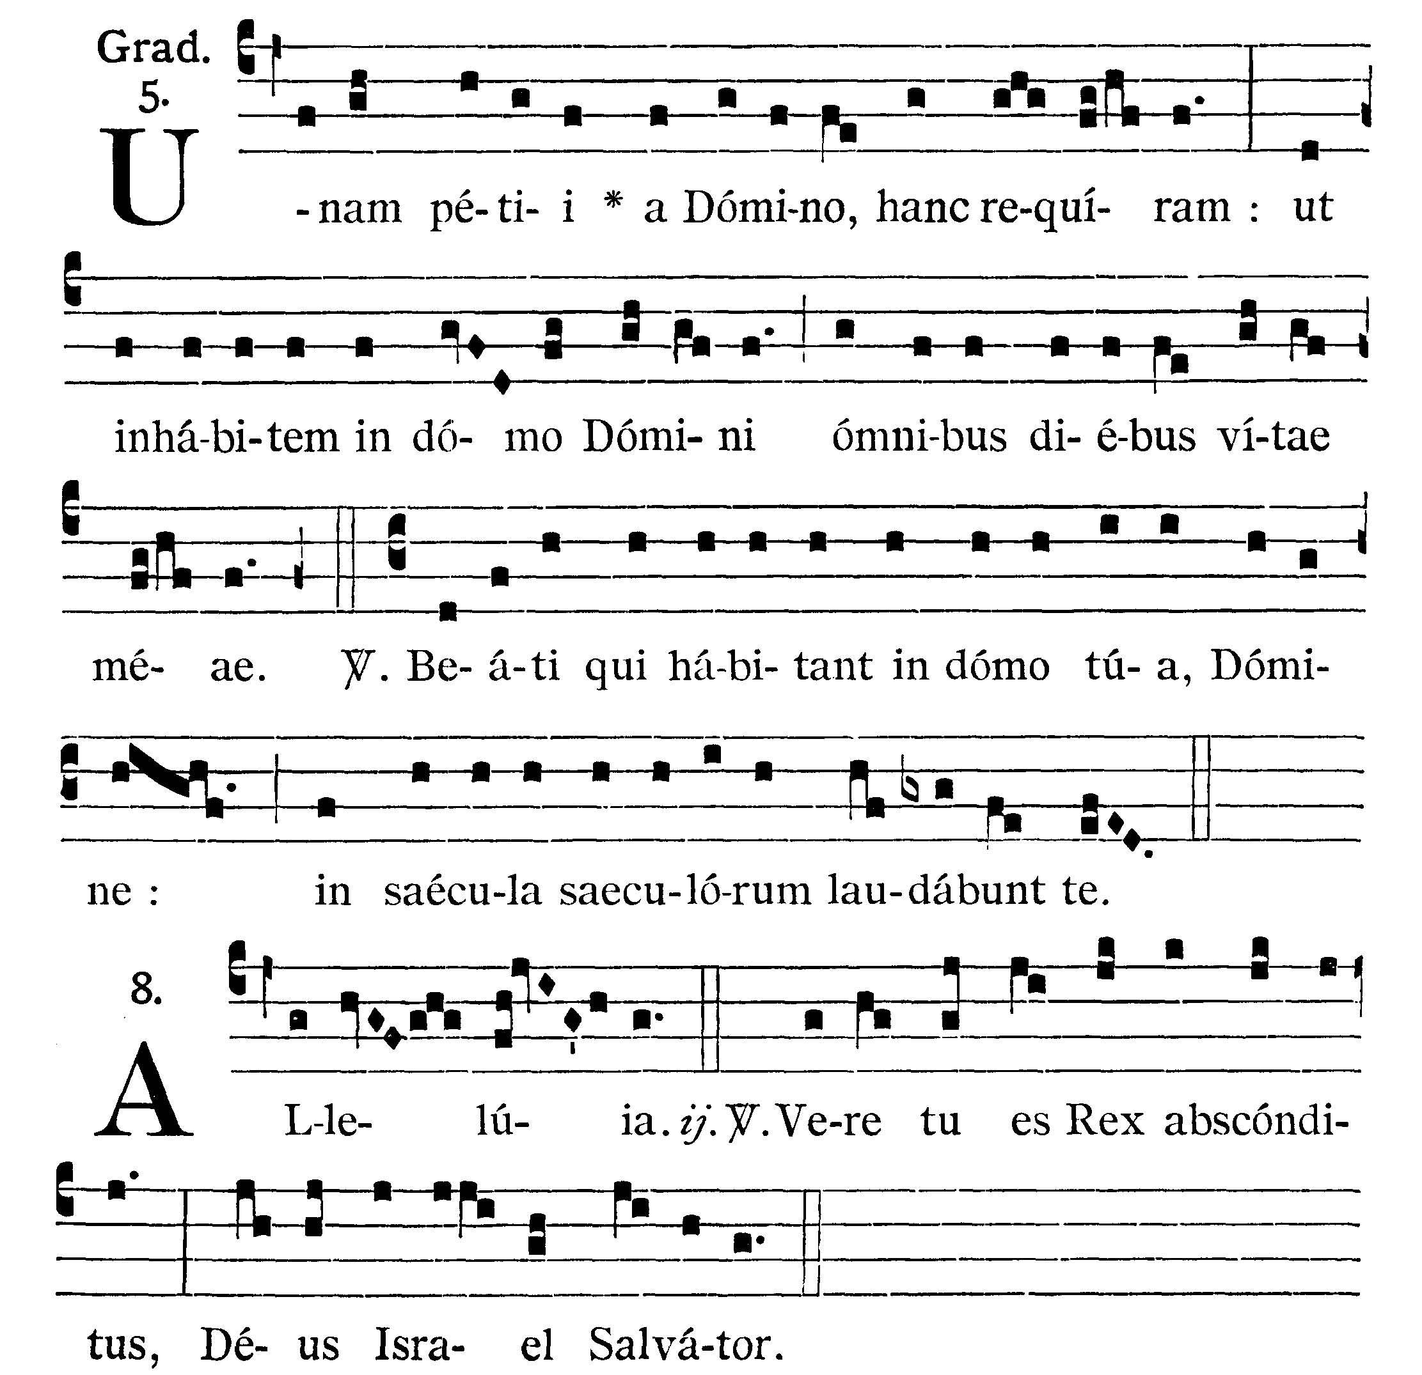
GRADUAL

One thing I have asked of the Lord, this will I seek after: that I may dwell in the house of the Lord all the days of my life. V. (Ps. 88. 5). Blessed are they that dwell in Thy house, O Lord, they shall praise Thee for ever and ever.
Alleluia, alleluia. V. (Isaias 45. 15). Verily Thou art a hidden King, the God of Israel, the Savior. Alleluia.



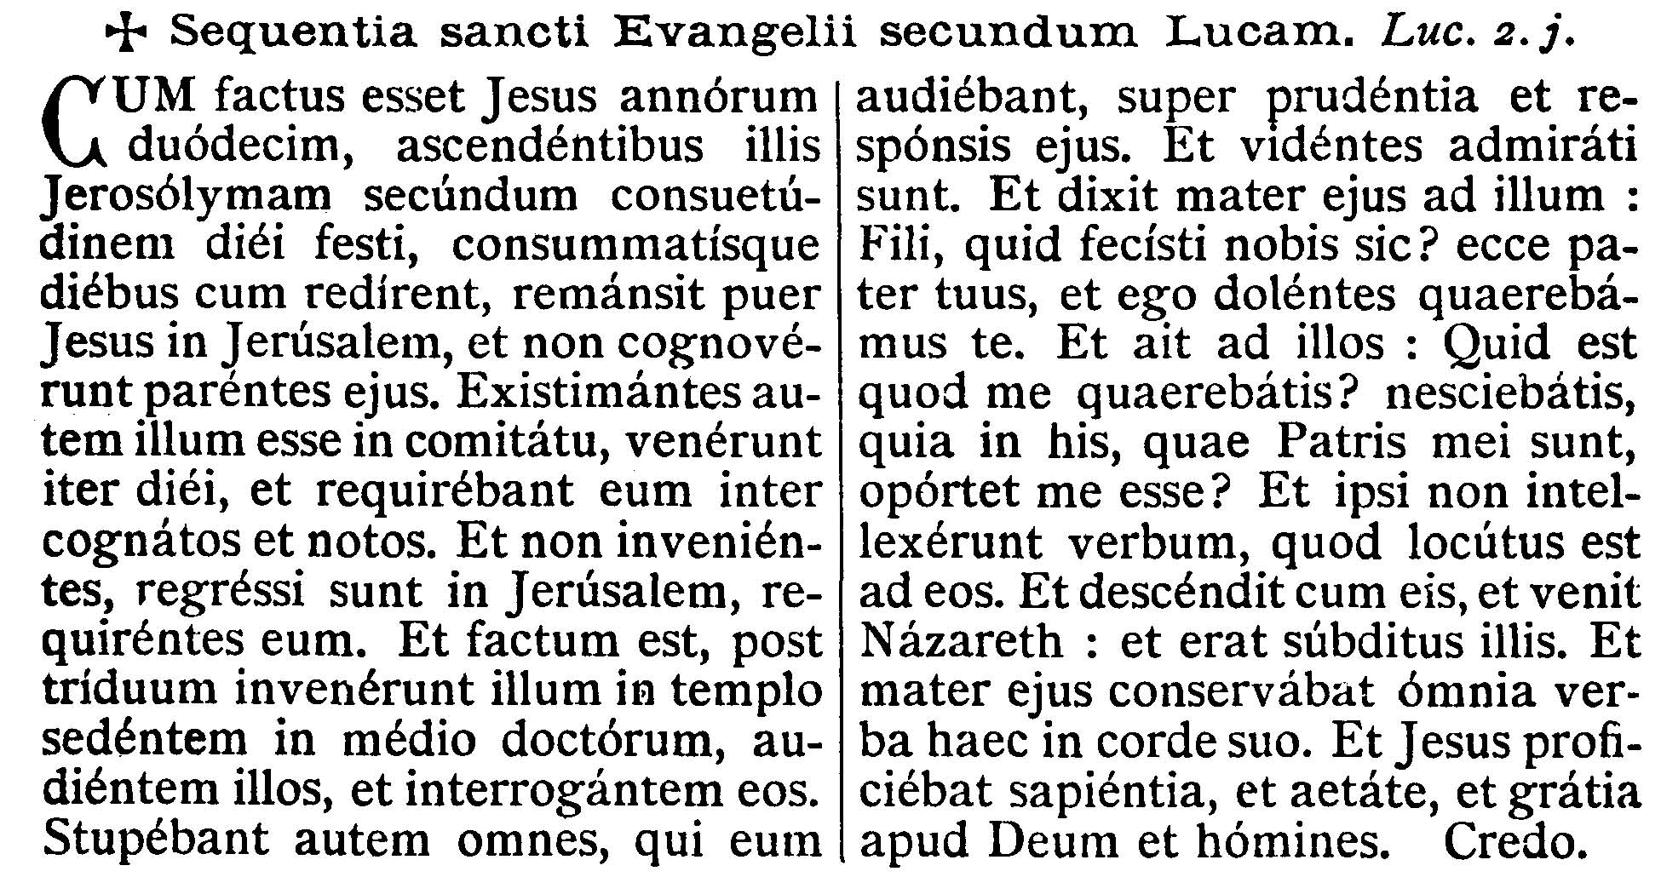
GOSPEL ¤ Luke 2. 42-52
† Continuation of the holy Gospel according to St. Luke.
[The Divine Child Jesus sits in the midst of the doctors who are astonished at His wisdom and His answers. Humility of Jesus. Greatness of Jesus in the Temple and His submission to Mary and Joseph.]
When Jesus was twelve years old, they going up into Jerusalem according to the custom of the feast, and having fulfilled the days, when they returned, the Child Jesus remained in Jerusalem, and His parents knew it not. And thinking that He was in the company, they came a day's journey, and sought Him among their kinsfolk and acquaintences. And not finding Him, they returned into Jerusalem, seeking Him. And it came to pass that after three days they found Him in the Temple, sitting in the midst of the doctors, hearing them and asking them questions. And all that heard Him were astonished at His wisdom and His answers. And seeing Him they wondered. And His Mother said to Him: Son, why hast Thou done so to us? Behold Thy father and I have sought Thee sorrowing. And He said to them: how is it that you sought Me Did you not know that I must be about My Father's business? And they understood not the word that He spoke unto them. And he went down with them and come to Nazareth, and was subject to them. And His Mother kept all these words in her heart. And Jesus advanced in wisdom and age and grace with God and men.

Priest: Dominus Vobiscum
All: Et Cum Spirtu tuo
Preist: Oremus:

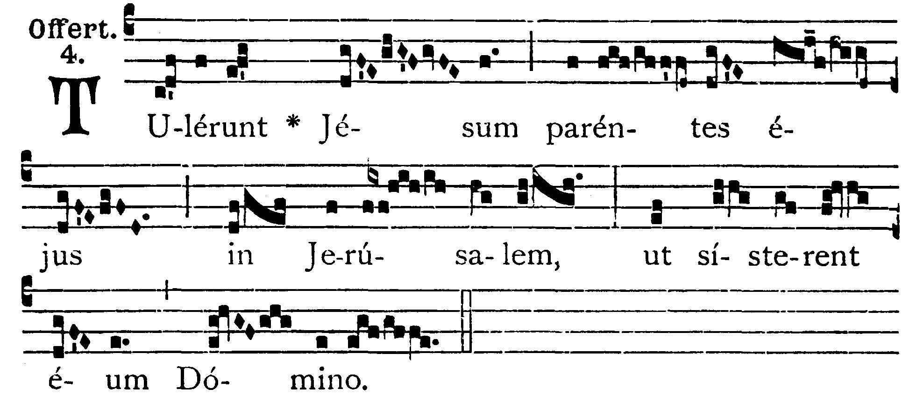

OFFERTORY
The parents of Jesus carried Him to Jerusalem, to present Him to the Lord.

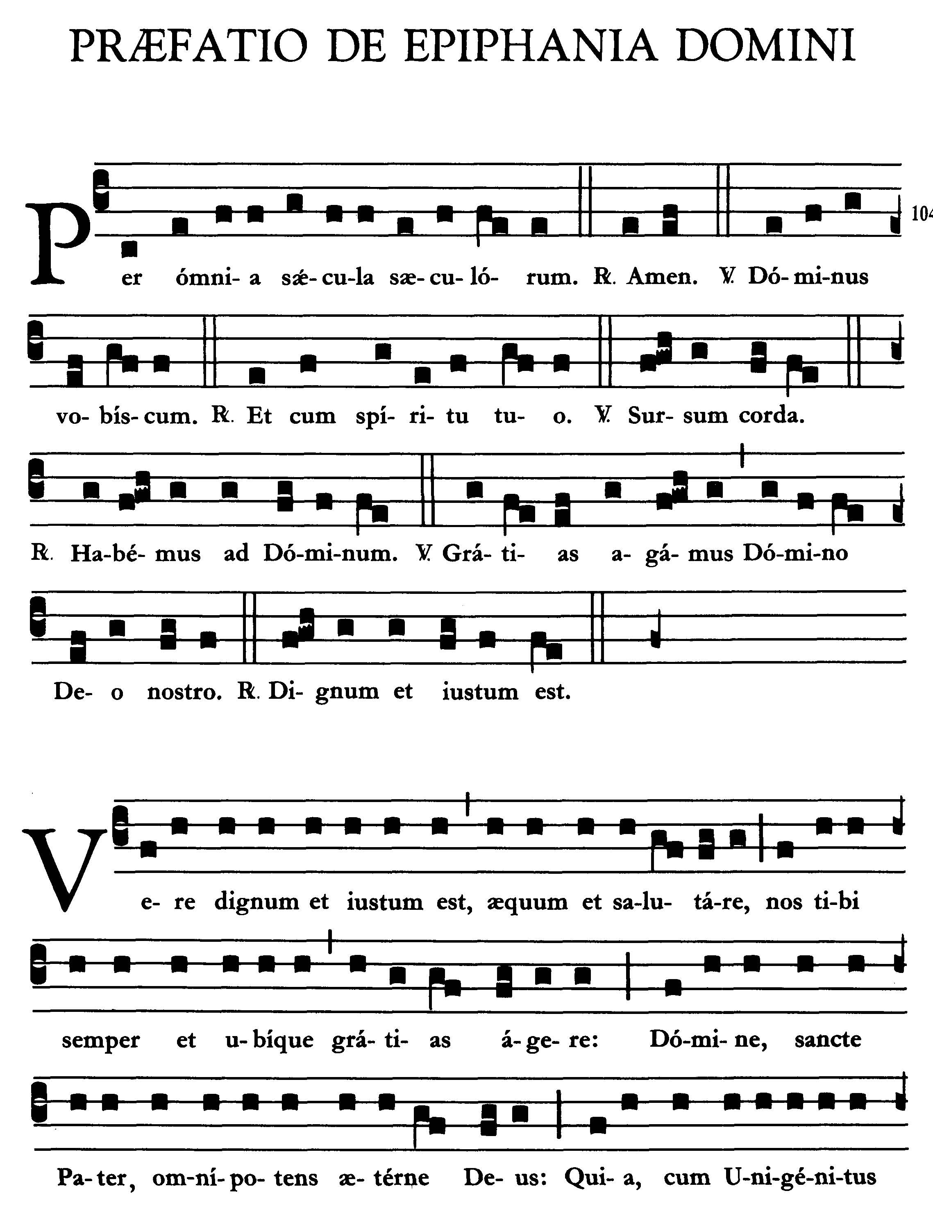
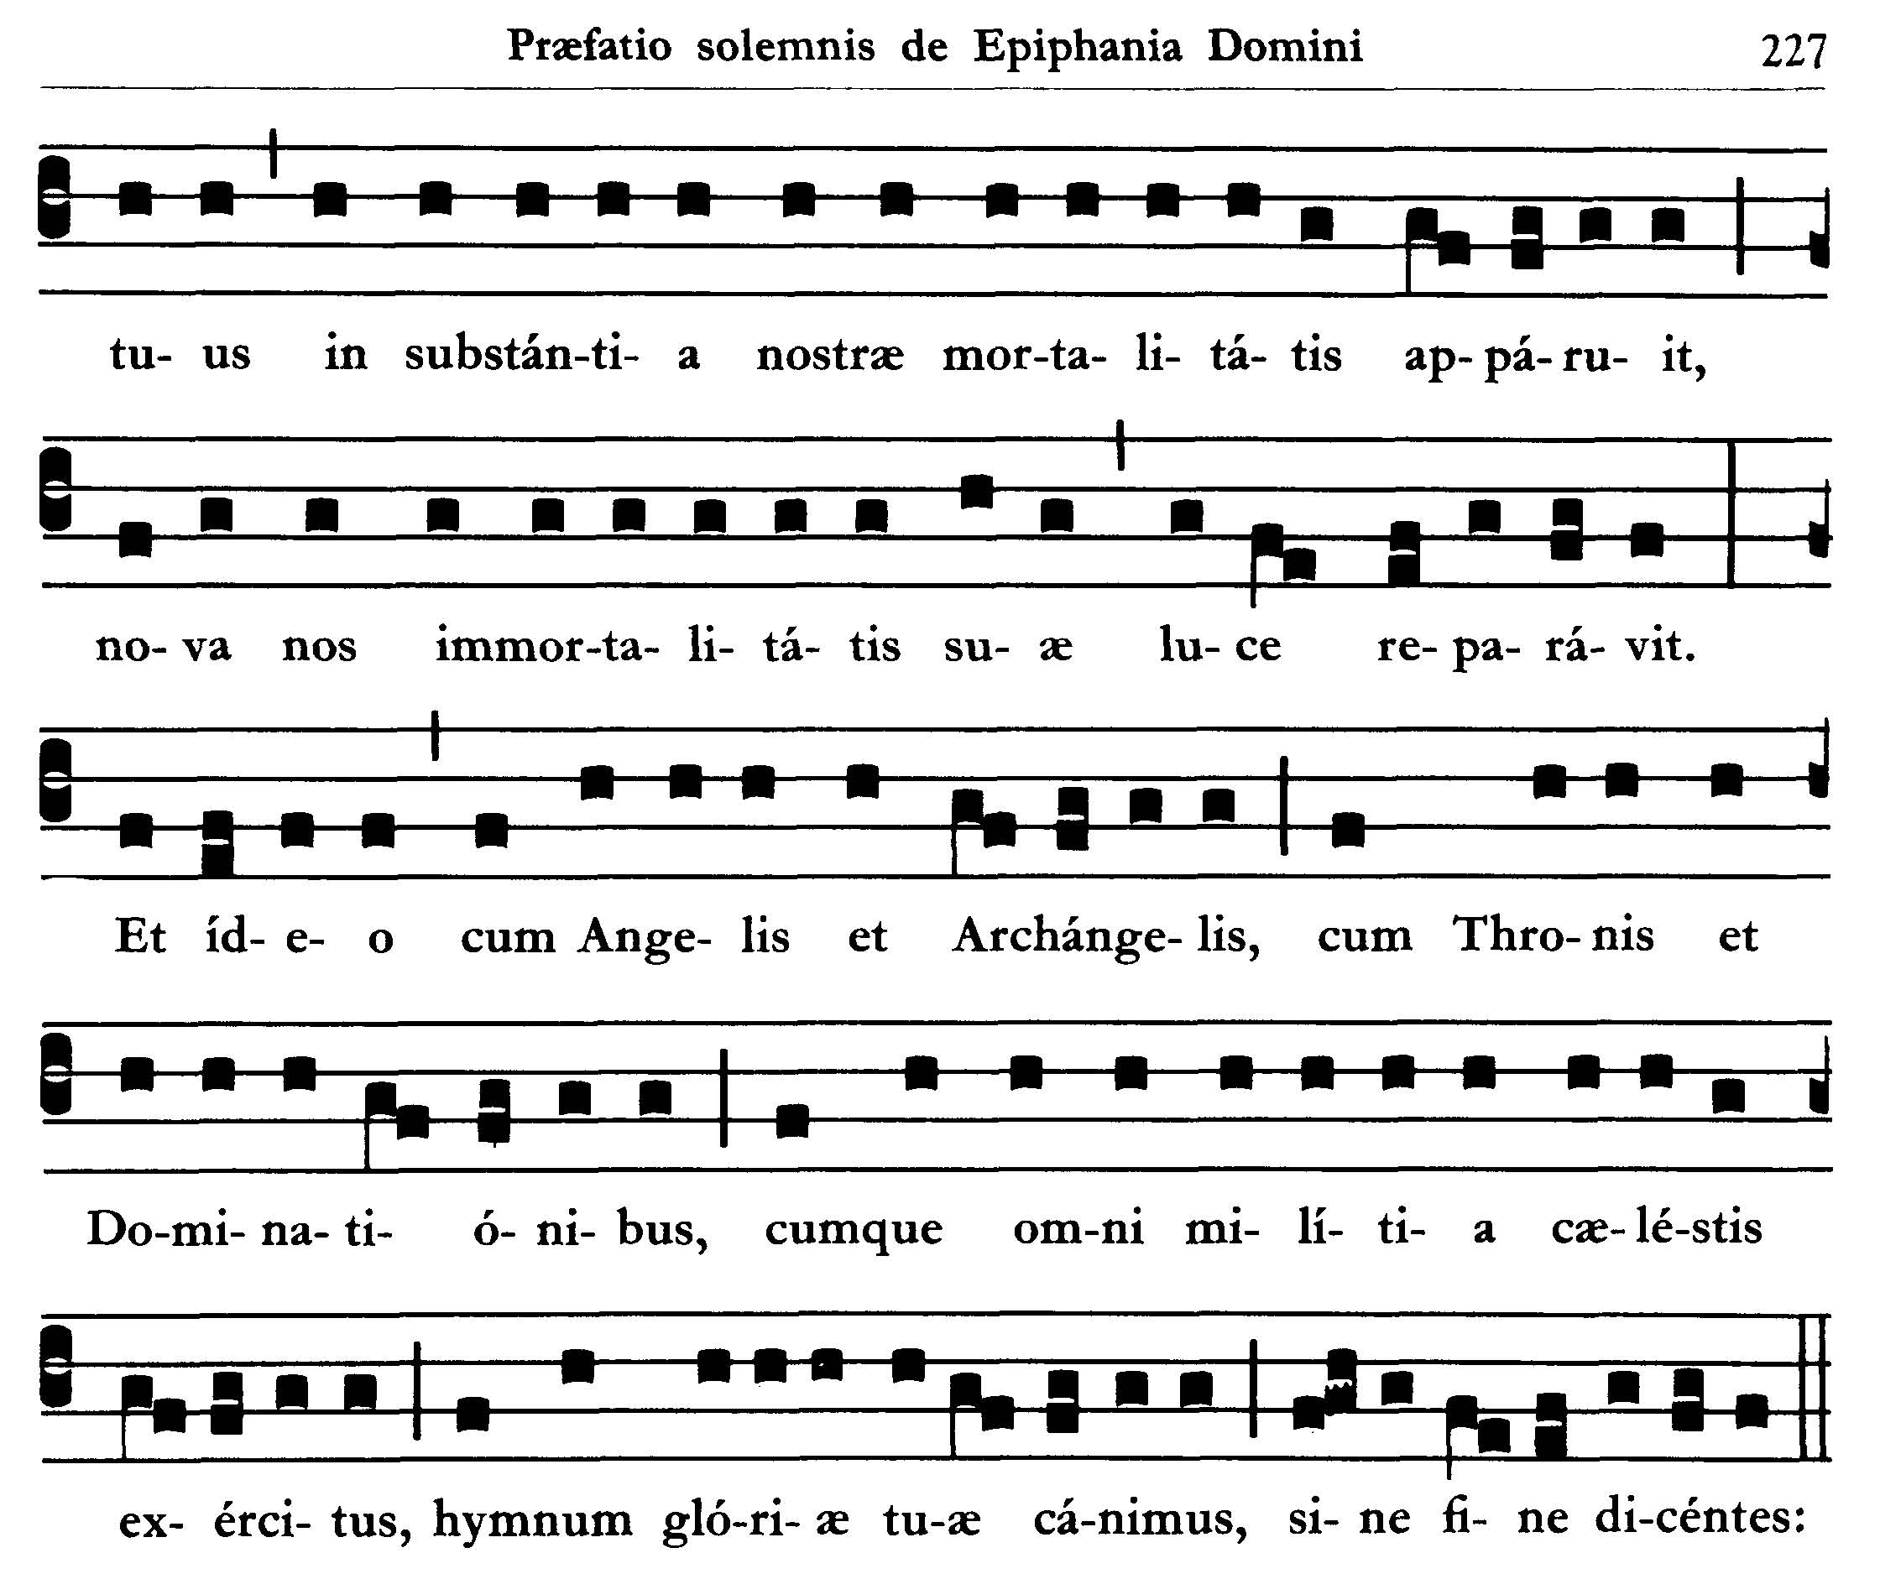
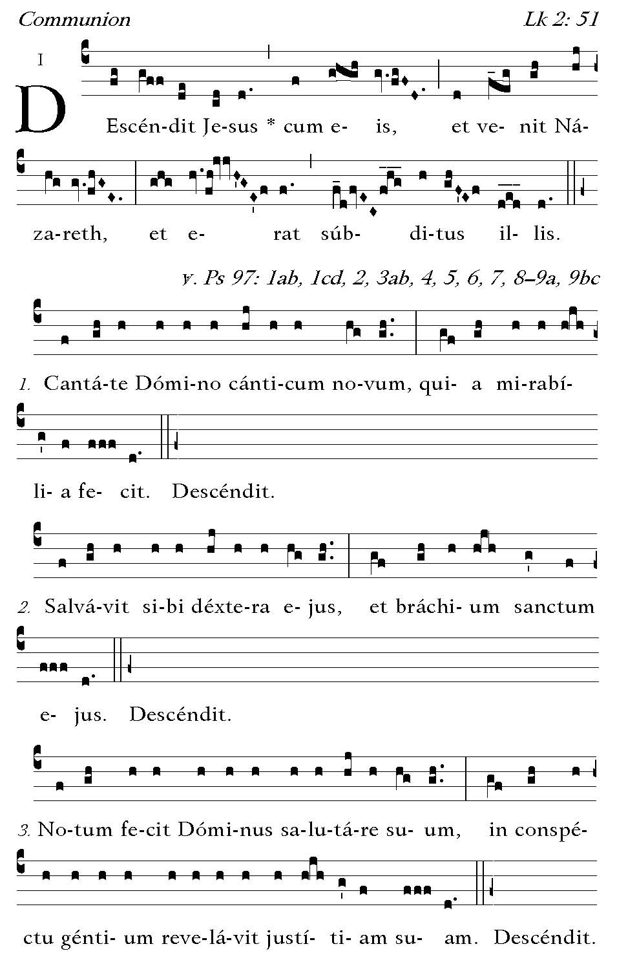
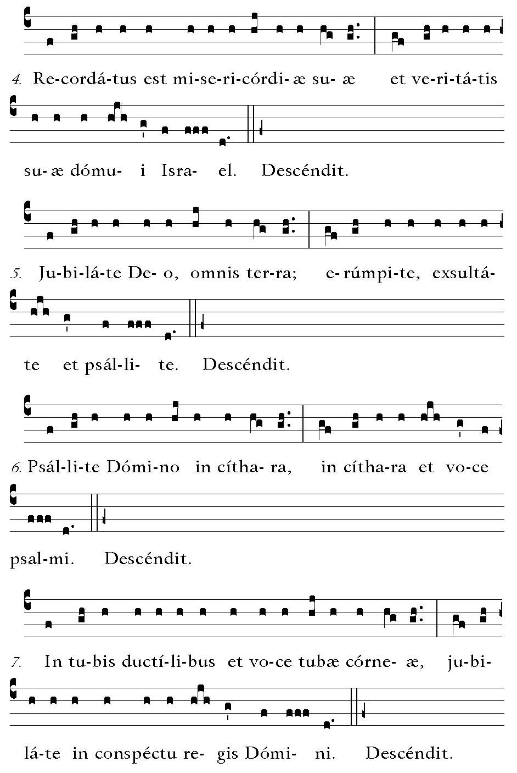
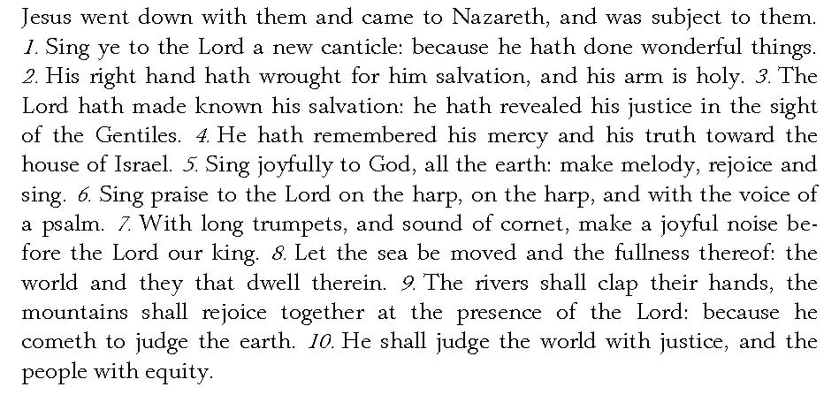

Post Communion
Deo Gratias

