Sexagesima
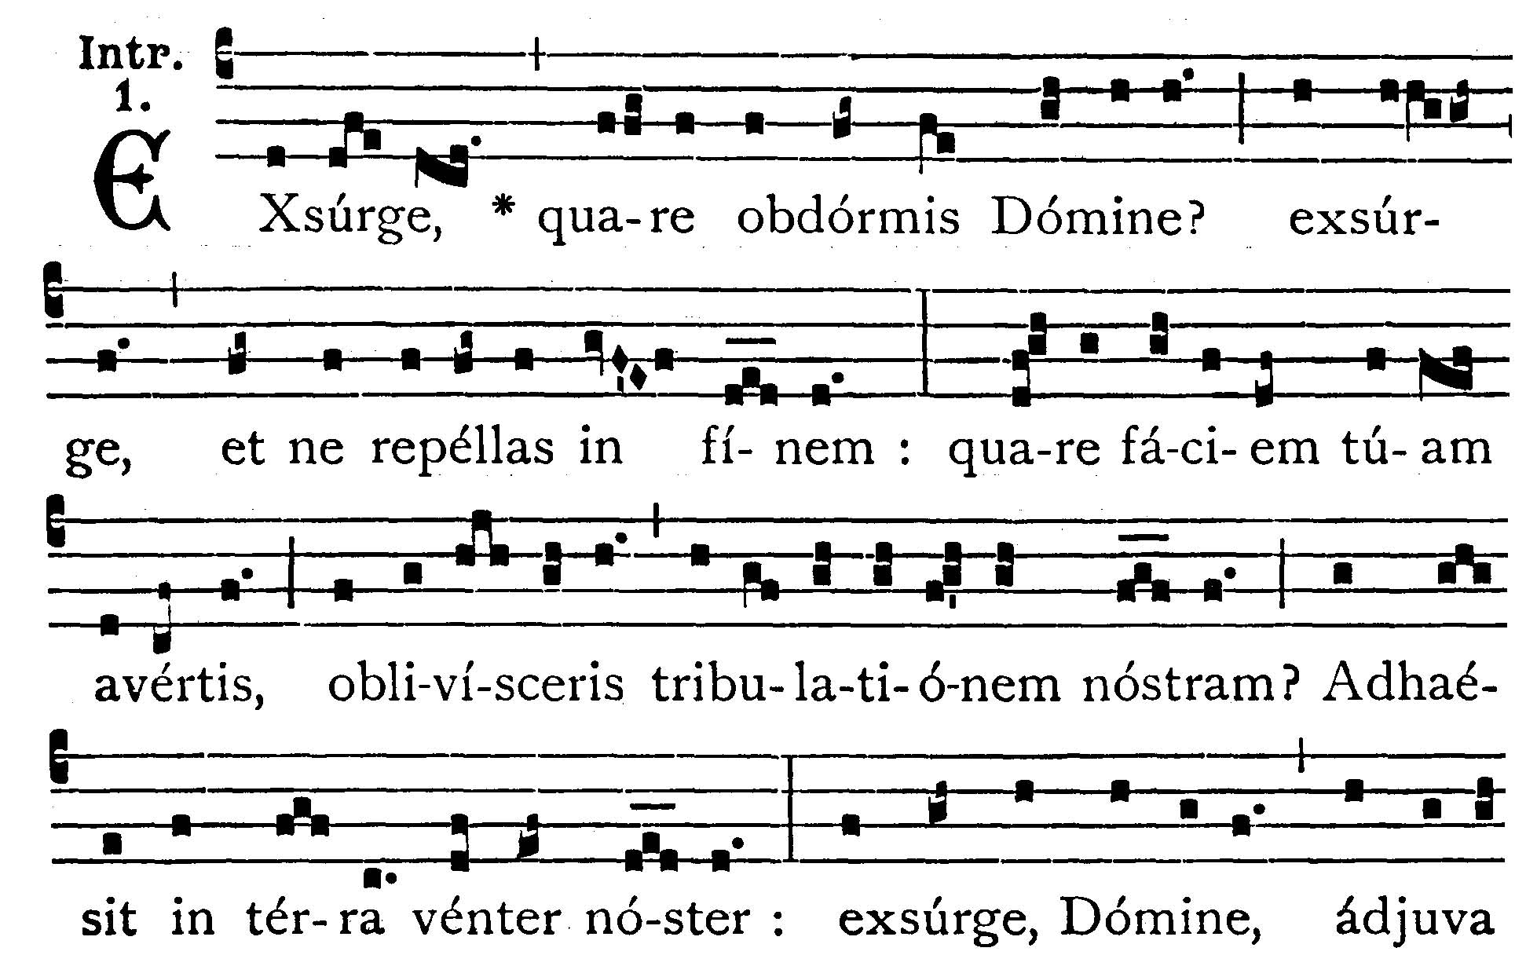
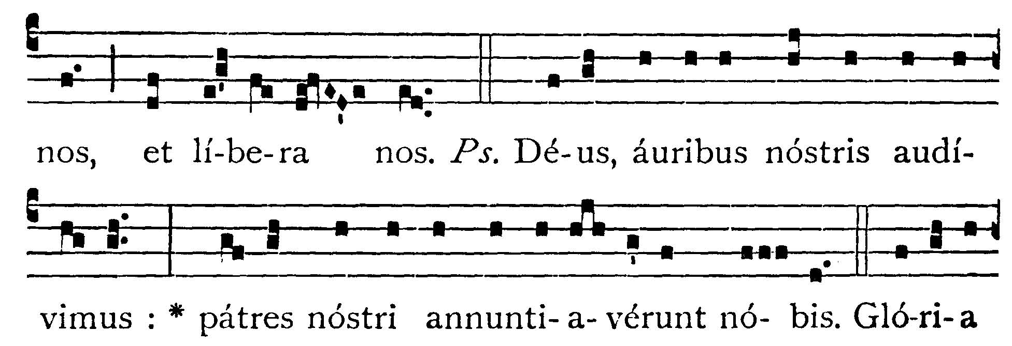
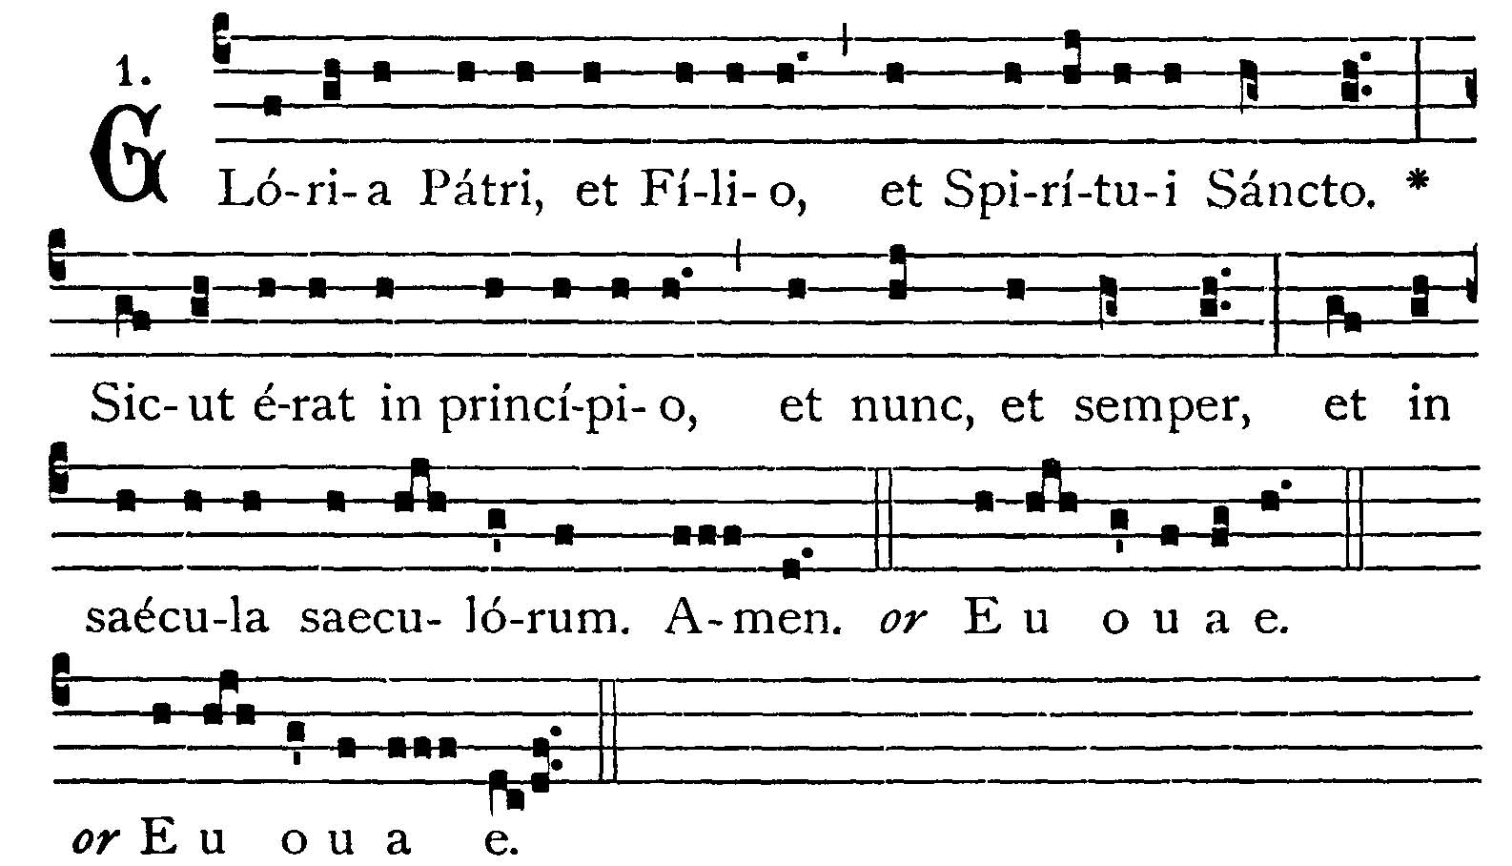
Arise, why sleepest Thou, O Lord? arise, and cast us not off to the end. Why turnest Thou Thy face away, and forgettest our trouble? our belly hath cleaved to the earth: arise, O Lord, help us and deliver us. -- (Ps. 43. 2). We have heard, O God, with our ears: our fathers have declared to us. V.: Glory be to the Father . . . -- Arise, why sleepest Thou, O Lord? . . .


COLLECT.--O God, who seest that we put not our trust in any thing that we do: mercifully grant that by the protection of the Doctor of the Gentiles we may be defended against all adversities. Through our Lord Jesus Christ, Thy Son, who liveth and reigneth . . .

EPISTLE ¤ II Cor. 11. 19-33; 12. 1-9
Lesson from the Epistle of blessed Paul the Apostle to the Corinthians.
[St. Paul tells of his shipwrecks and perils inthe sea, all the torments he endured for the Name of Christ. Let us "therefore glory in our infirmities, that the power of Christ may dwell in us."]
Brethren, You gladly suffer the foolish: whereas yourselves are wise. For you suffer if a man bring you into bondage, if a man devour you, if a man take from you, if a man be lifted up, if a man strike you on the face. I speak according to dishonor, as if we had been weak in the past. Wherein if any man dare (I speak foolishly), I dare also. They are Hebrews, so am I. They are Israelites, so am I. They are the seed of Abraham, so am I. They are the ministers of Christ (I speak as one less wise), I am more: in many more labors, in prisons more frequently, in stripes above measure, in deaths often. Of the Jews five times did I receive forty stripes save one. Thrice was I beaten with rods, once I was stoned, thrice I suffered shipwreck, a night and a day I was in the depth of the sea: in journeying often, in perils of waters, in perils of robbers, in perils from my own nation, in perils from the Gentiles, in perils in the city, in perils in the wilderness, in perils in the sea, in perils from false brethren: in labor and painfulness, in much watching, in hunger and thirst, in fastings often, in cold and nakedness; besides those things which are without, my daily instance, the solicitude for all the Churches. Who is weak, and I am not weak? who is scandalized, and I am not on fire? If I must needs glroy, I will glory of the things that concern my infirmity. The God and Father of Our Lord Jesus Christ, who is blessed for ever, knoweth that I lie not. At Damascus the governor of the nation under Aretas the king, guarded the city of the Damascenes, to apprehend me: and through a window in a basket was I let down by the wall, and so escaped his hands. If I must glory (it is not expedient indeed) but I will come to visions and revelations of the Lord. I know a man in Christ above fourteen years ago, whether in the body I know not, or out of the body, I know not, God knoweth, such a one caught up to the third heaven. And I know such a man, whether in the body or out of the body, I know not, God knoweth: that he was caught up unto paradise, and heard secret words which it is not granted to man to utter. For such a one I will glory: but for myself I will glory nothing but in my infirmities. For though I should have a mind to glory, I shall not be foolish: for I will say the truth: but I forbear, lest any man should think of me above that which he seeth in me, or anything he heareth from me. And lest the greatness of the revelations should exalt me, there was given me a sting of my flesh, and angel of Satan, to buffet me. For which thing, thrice I besought the Lord that it might depart from me. And He said to me: my grace is sufficient for thee: for power is made perfect in infirmity. Gladly therefore will I glory in my infirmities, that the power of Christ may dwell in me.
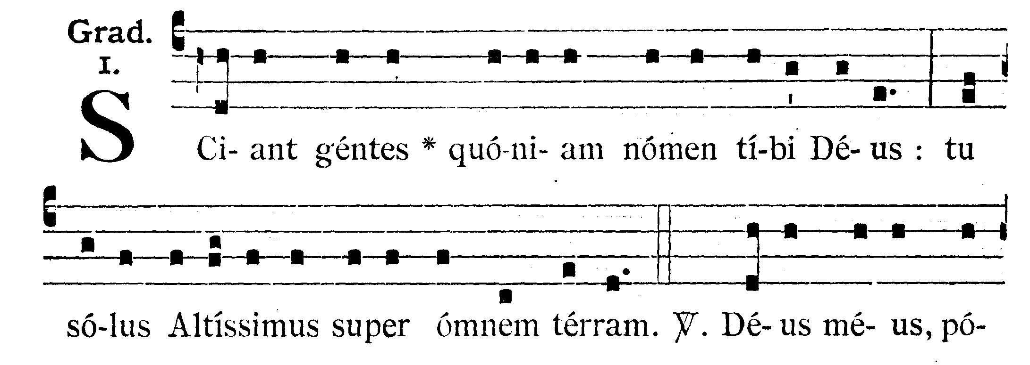
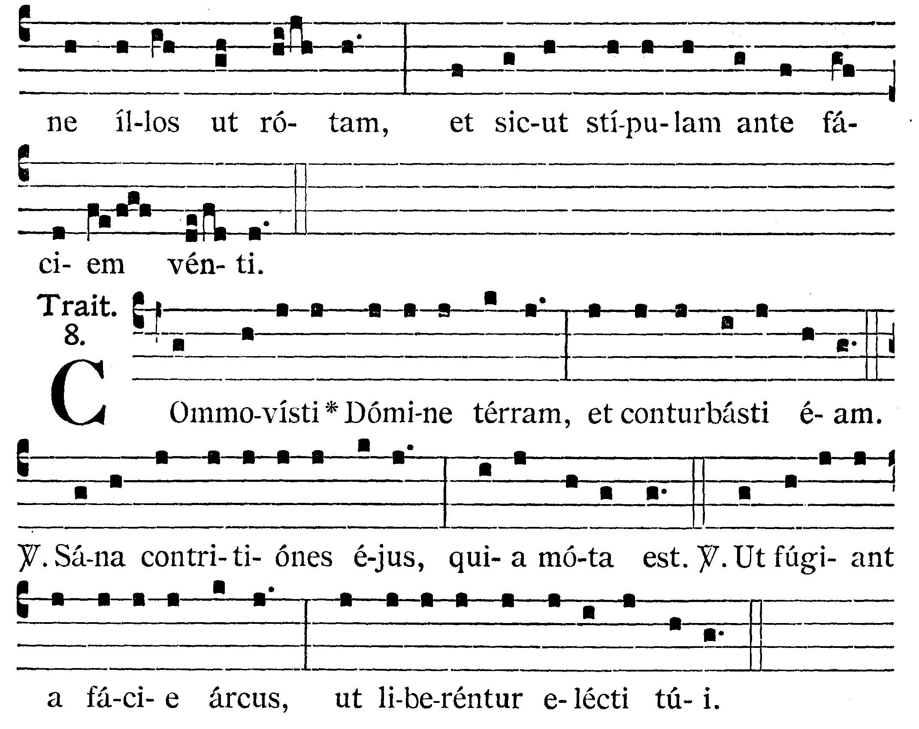
GRADUAL
Let the Gentiles know that God is Thy Name: Thou alone art the Most High over all the earth. V.: O my God, make them like a wheel, and as stubble before the wind.

TRACT
Thou hast moved the earth, O Lord, and hast troubled it. V.: Heal Thou the breaches thereof, for it has been moved. V.: That they may flee from before the bow: that Thine elect may be delivered.


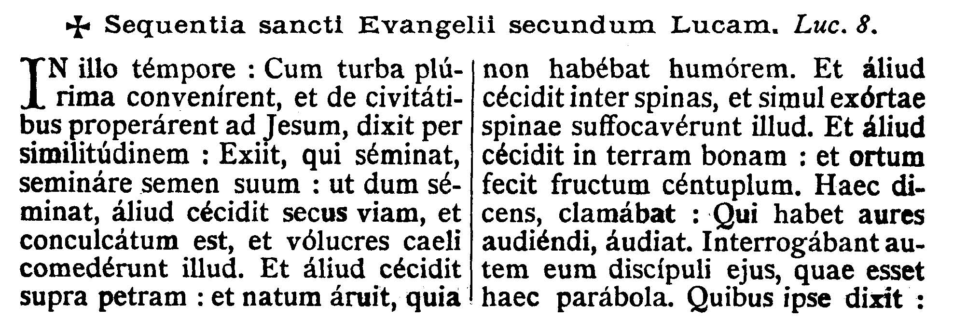
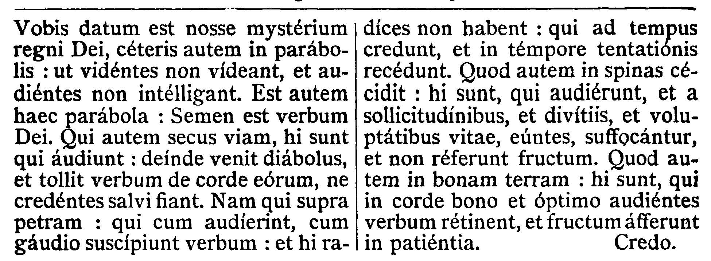
GOSPEL ¤ Luke 8. 4-15
† Continuation of the holy Gospel according to St. Luke.
[Jesus, in the boat, on the shores of the lake of Galilee, preaches the parable of the sower.]
At that time, when a very great multitude was gathered together and hastened out of the cities unto Jesus, He spoke by a similitude: The sower went out to sow his seed: and as he sowed, some fell by the wayside, and it was trodden down, and the fowls of the air devoured it. And other some fell upon a rock: and as soon as it was sprung up, it withered away, because it had no moisture. And other some fell among thorns, and the thorns growing up with it choked it. And other some fell upon good ground: and being sprung up yielded fruit a hundredfold. Saying these things, He cried out: He that hath ears to hear, let him hear. And His disciples asked Him what this parable might be. To whom He said: To you it is given to know the mystery of the kingdom of God, but to the rest in parables: that seeing they may not see, and hearing may not understand. Now the parable is this. The seed is the word of God. And they by the wayside are they that hear: then the devil cometh and taketh the word out of their heart, lest believing they should be saved. Now they upon the rock are they who, when they hear, receive the word with joy; and these have no roots: for they believe for a while, and in time of temptation they fall away. And that which fell away among thorns are they who have heard and, going their way, are choked with the cares and riches and pleasures of this life, and yield no fruit. But on the good ground are they who in a good and perfect heart, hearing the word, keep it, and bring forth fruit in patience.
Priest: Dominus Vobiscum
All: Et Cum Spirtu tuo
Preist: Oremus:
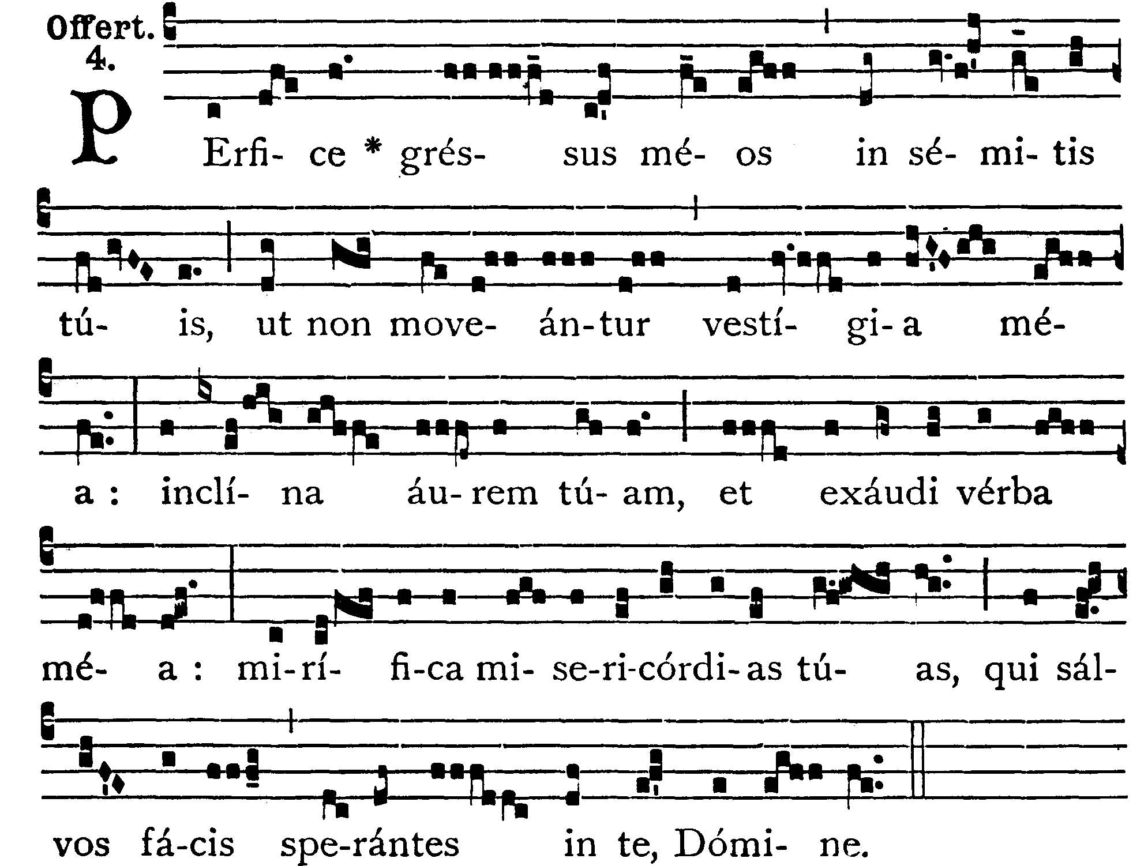
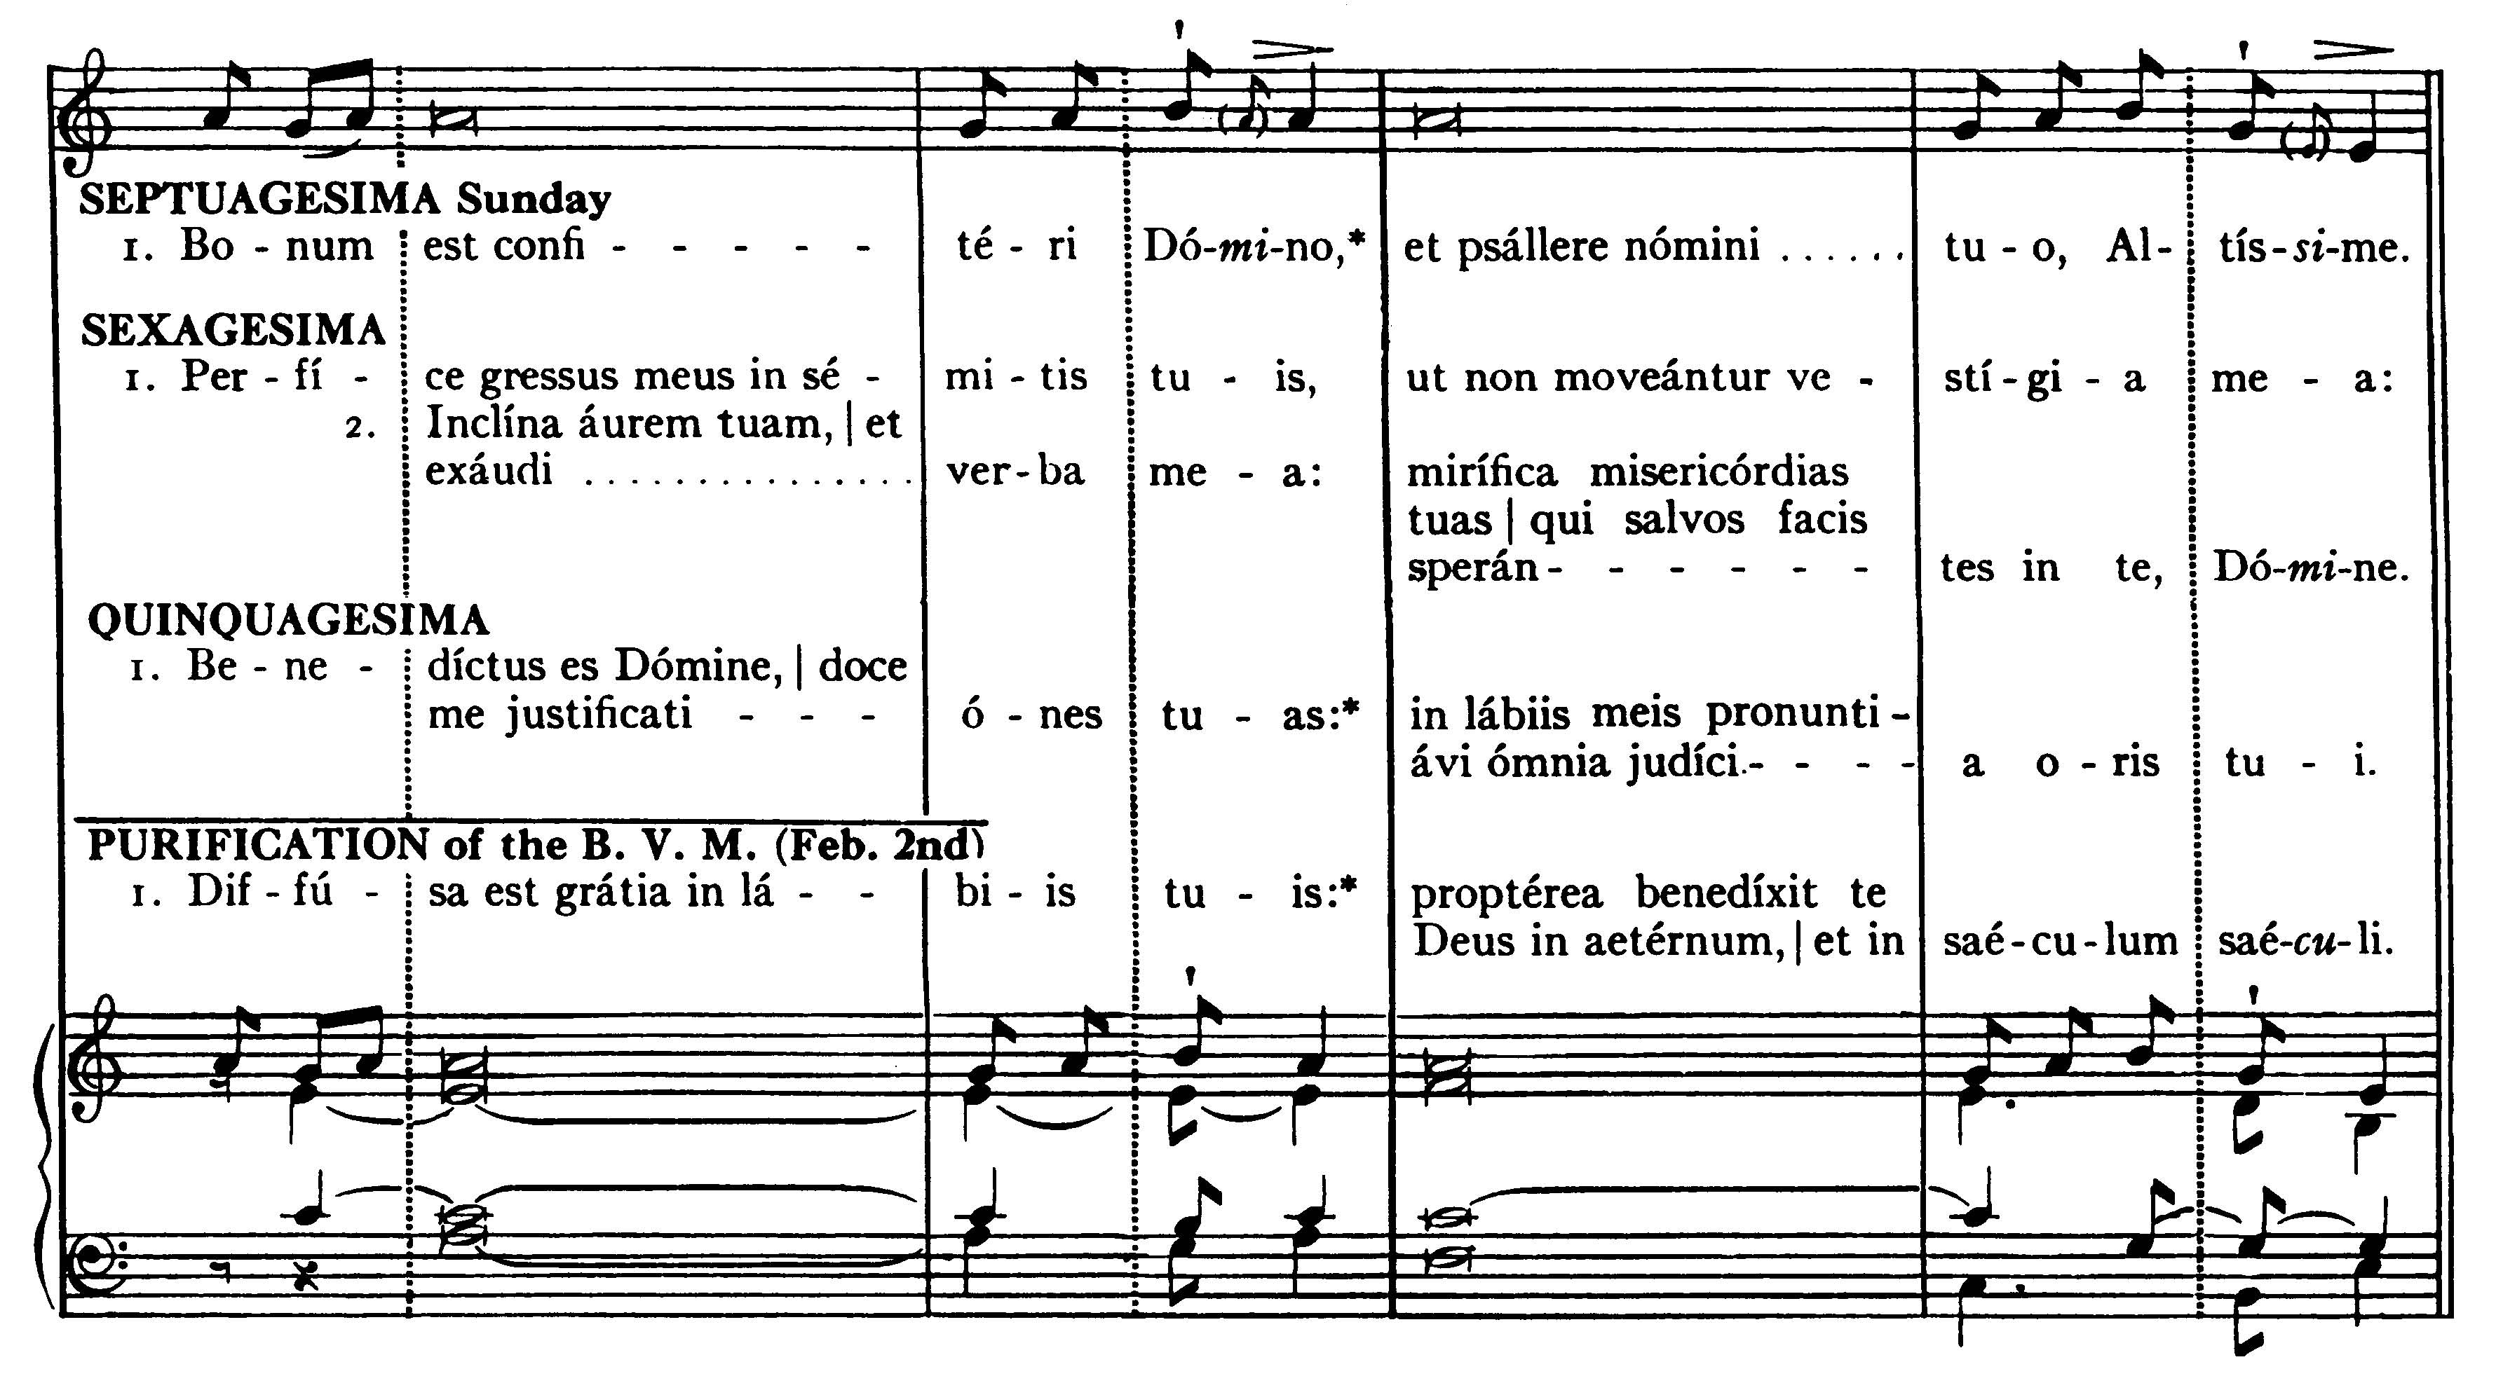
Perfect Thou my goings in Thy paths, that my footsteps be not moved: incline Thine ear, and hear my works: show forth Thy wonderful mercies, Thou who savest them that trust in Thee, O Lord.

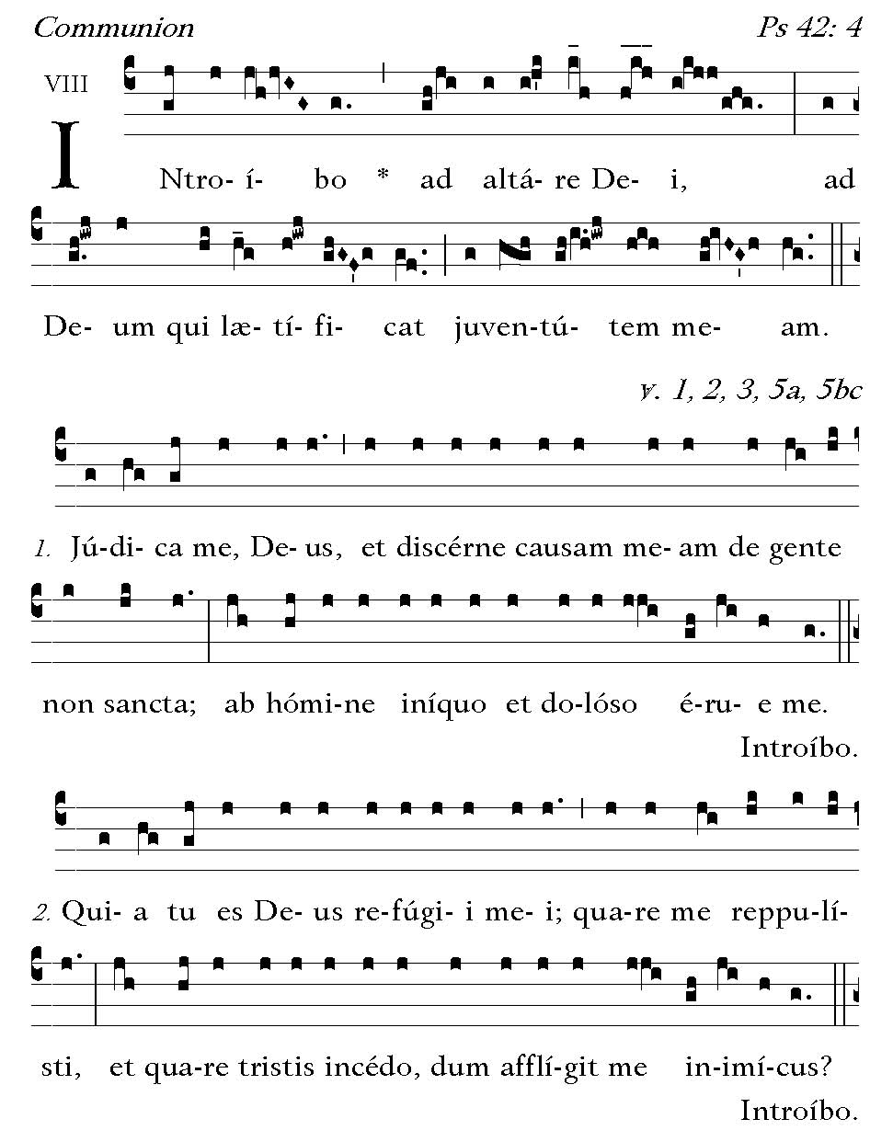
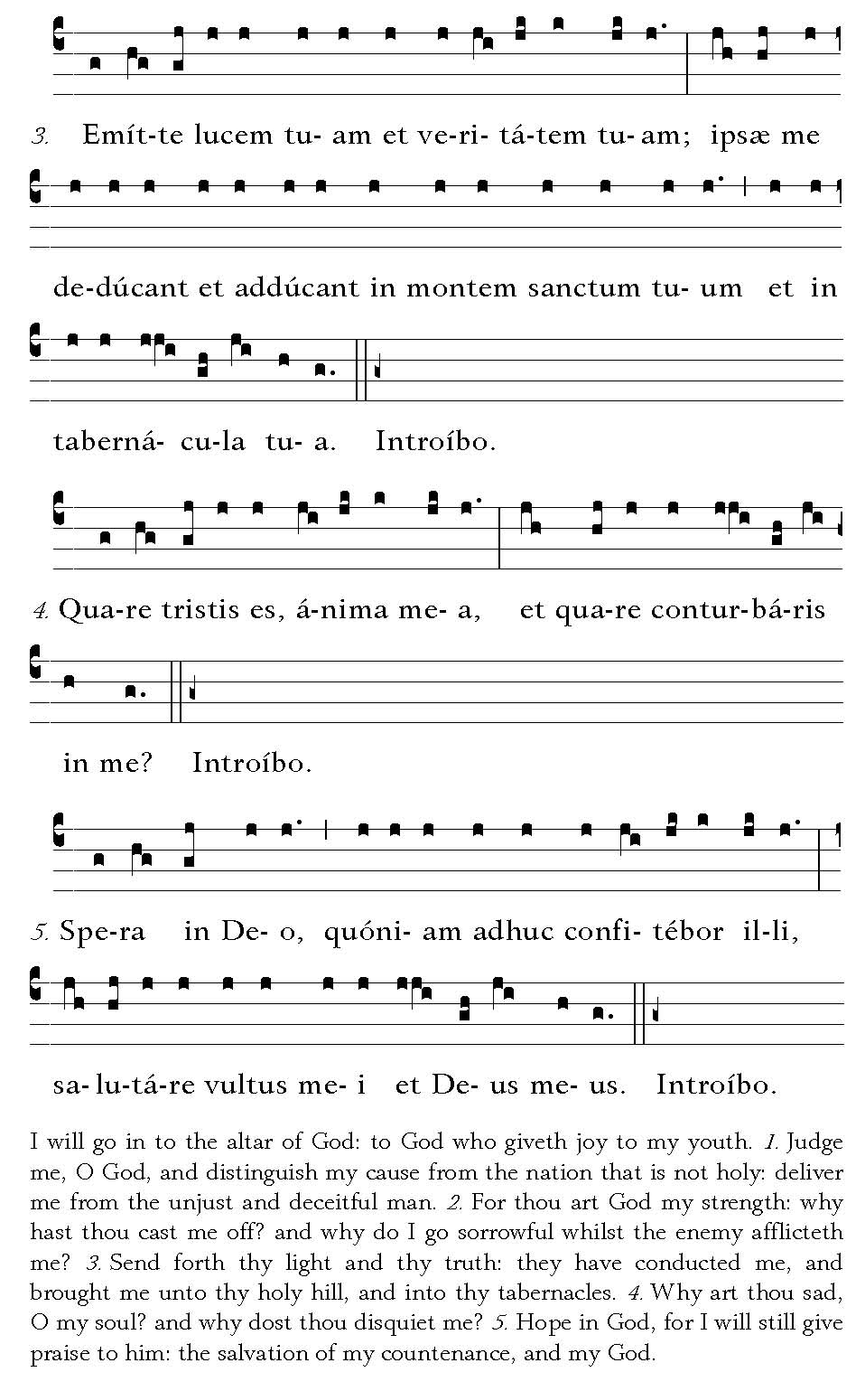

Post Communion
Deo Gratias

